FDA Standard Content Version

Define 1-Day ACUVUE Brand Contact Lenses

Generated from J&J Labeling (August 2014)

“Cover” page includes the following:

Define 1-Day ACUVUE Brand Contact Lenses with Lacreon

etafilcon A Soft (hydrophilic) Contact lenses Cosmetically Tinted
with UV Blocker for Daily Disposable Wear

August, 2014

TABLE OF CONTENTS
1.0 Indications for Use
1.1 Purpose
1.1.1 Single use
1.1.2 Prescription use only
1.1.3 Where used
1.2 Intended Use Population
2.0 Individual Patient Selection Considerations
3.0 Contraindications
4.0 General Warnings and Precautions
4.1 Eye Problems Leading to Vision Loss
4.2 Specific Instructions for Use and Warnings about Water
Activity
4.3 UV Absorption and Radiation Exposure
4.4 Special Precautions for Eye Care Professionals
4.5 Instructions for Patients
4.5.1 Handling precautions
4.5.2 Lens wearing precautions
4.5.3 Lens care precautions
4.5.4 Emergencies
4.5.5 Other topics to discuss with patients
4.5.6 Who should know that the patient is wearing contact lenses?
5.0 Adverse Events
6.0 Device Description
6.1 Available Lens Parameters
Diameter
Center thickness
Base curve
Power range
6.2 Lens Properties
6.3 Oxygen Permeability
6.4 How Supplied
6.5 Theory of Operation
7.0 Instructions for Use
7.2 Preparation
7.2.1 General fitting guidelines
Pre-fitting examination
Initial power determination
7.2.2 Monovision fitting guidelines
Monovision needs assessment
Patient education
Eye selection
Ocular preference determination methods
Refractive error method
Visual demands method
Unilateral vision correction requirement
Near ADD determination
7.3 Use
7.3.1 Base curve selection (trial lens fitting)
Criteria of a properly fit lens
Criteria of a flat fitting lens
Criteria of a steep Fitting lens
7.3.2 Final lens power
7.3.3 Trial lens fitting – monovision
Adaptation
Other suggestions
7.4 After Use
7.4.1 Wearing schedule
7.4.2 Replacement schedule
7.4.3 Lens care directions
Basic instructions
Care for a sticking (non-moving) lens
7.4.4 Patient management
Dispensing visit
Follow-up examinations
Recommended follow-up examination
Recommended procedures for follow-up visits
12.0 Glossary
12.1 Symbols Key
13.0 Resources
Transmittance curves
Citations
14.0 Contact and Reporting Information
15.0 Date of Latest Revision

1.0 Indications for Use
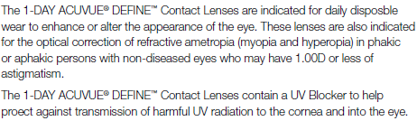
1.1 Purpose
1.1.1 Single use
1.1.2 Prescription use only
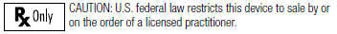
1.1.3 Where used
Indicated for use in any clinical or non-clinical environment.
1.2 Intended Use Population
Indicated for use in the general population.

2.0 Individual Patient Selection Considerations
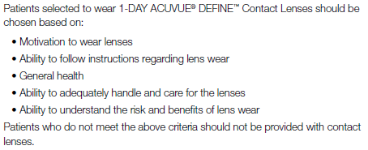
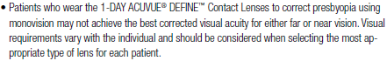

3.0 Contraindications
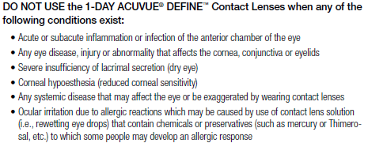
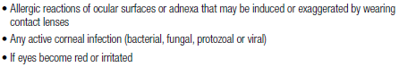

4.0 General Warnings and Precautions
4.1 Eye Problems leading to Vision Loss
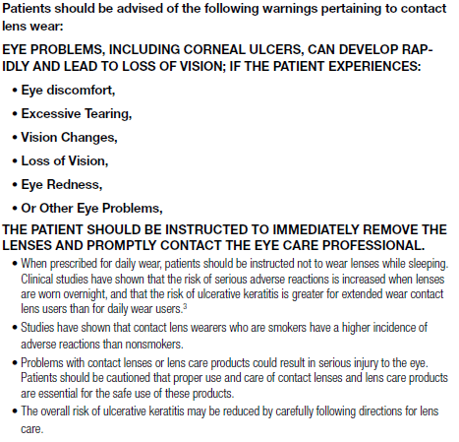

4.2 Specific Instructions for Use and Warnings about Water
Activity
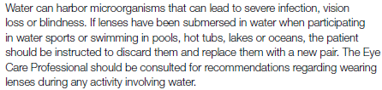

4.3 UV Absorption and Radiation Exposure
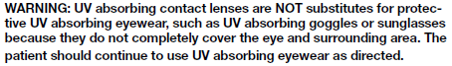
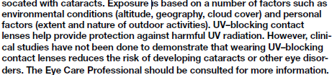

4.4 Special Precautions for Eye Care Professionals
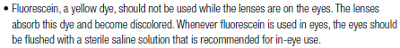
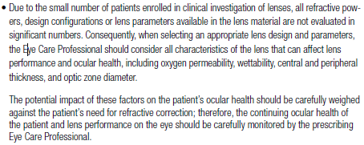

4.5 Instructions for Patients

4.5.1 Handling precautions
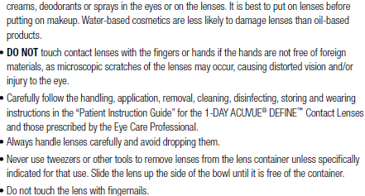

4.5.2 Lens wearing precautions
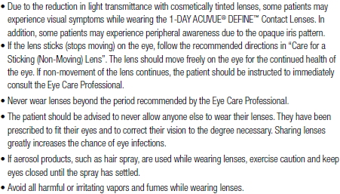

4.5.3 Lens care precautions
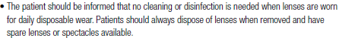

4.5.4 Emergencies
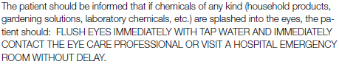

4.5.5 Other topics to discuss with patients
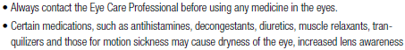
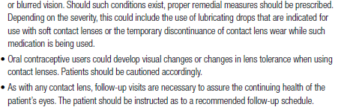
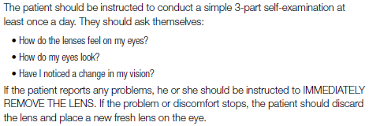
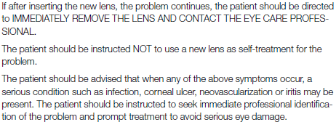

4.5.6 Who should know that the patient is wearing
contact lenses?
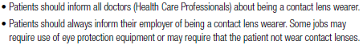

5.0 Adverse Events
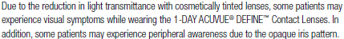
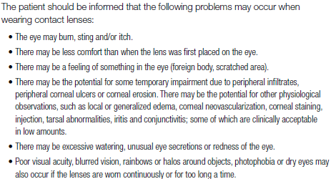

6.0 Device Description
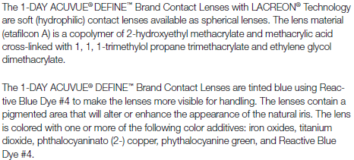
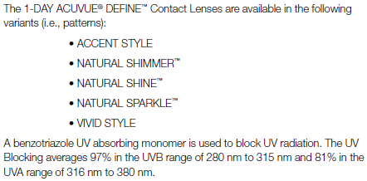
6.1 Available Lens Parameters
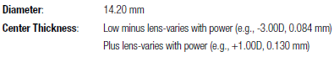
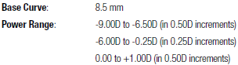

6.2 Lens Properties
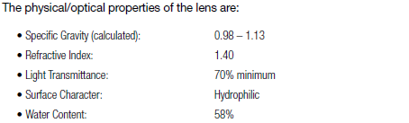

6.3 Oxygen Permeability
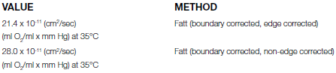

6.4 How Supplied
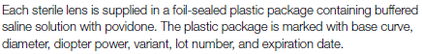

6.5 Theory of Operation
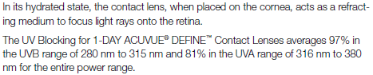

7.0 Instructions for Use
7.2 Preparation
7.2.1 General fitting guidelines

Pre-fitting examination
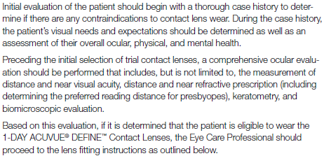
Initial Power Determination
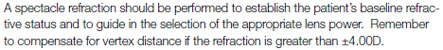

7.2.2 Monovision fitting guidelines
Monovision needs assessment
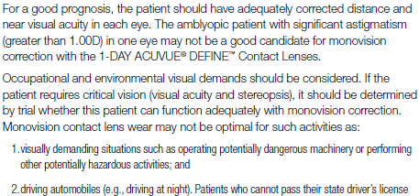

Patient education
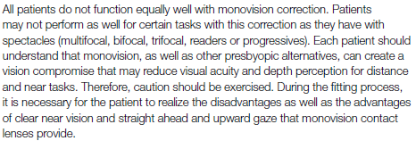

Eye selection
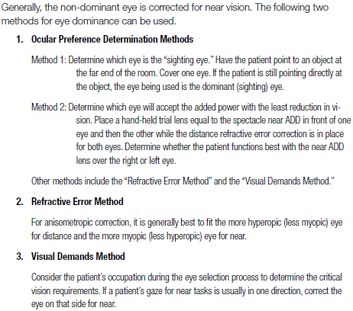

Unilateral vision correction requirement
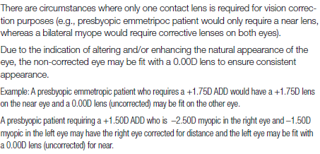

Near ADD determination
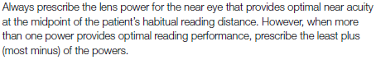

7.3 Use
7.3.1 Base curve selection (trial lens fitting)
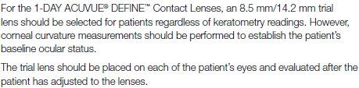

Criteria of a properly fit lens
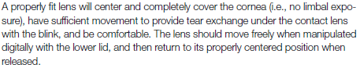

Criteria of a flat fitting lens
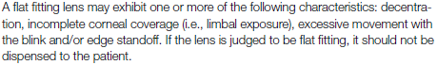

Criteria of a steep fitting lens
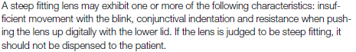

7.3.2 Final lens power
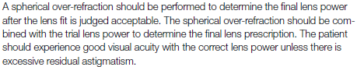
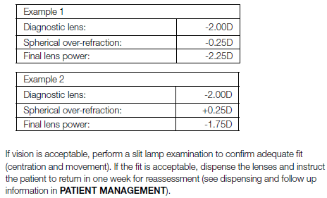

7.3.3 Trial lens fitting – monovision
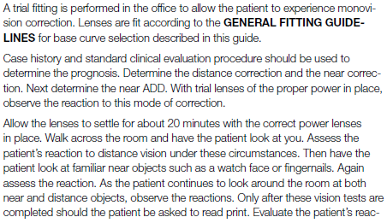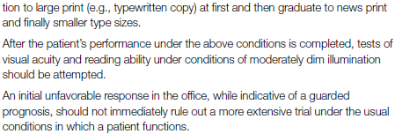

Adaptation
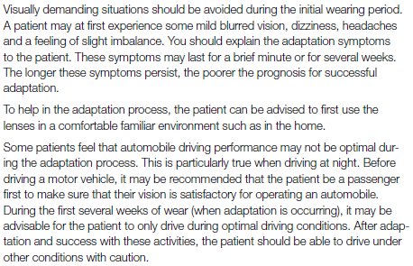

Other suggestions
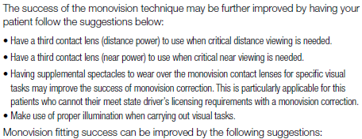
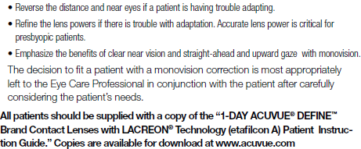

7.4 After Use
7.4.1 Wearing schedule
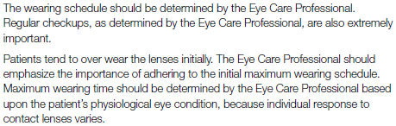
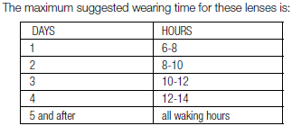

7.4.2 Replacement schedule
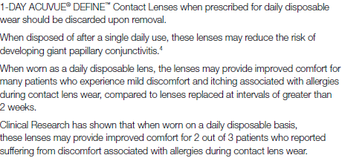

7.4.3 Lens care directions
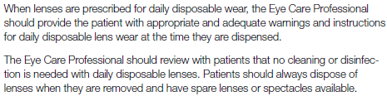
Basic instructions
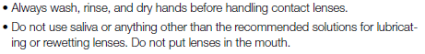
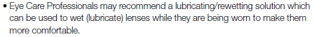

Care for a sticking (non-moving) lens
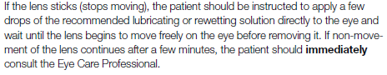

7.4.4 Patient management
Dispensing visit
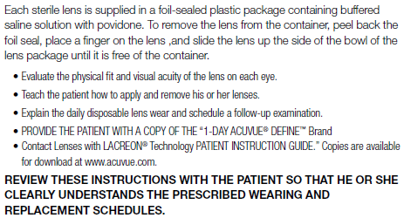

Follow-up examinations
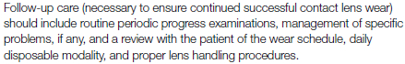
Recommended follow-up examination
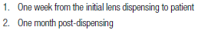

Recommended procedures for follow-up visits
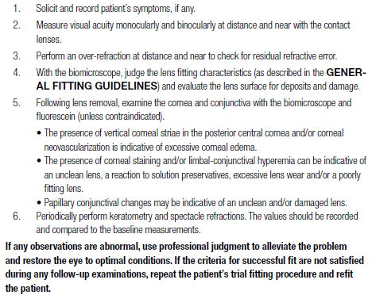

12.0 Glossary
12.1 Symbols Key
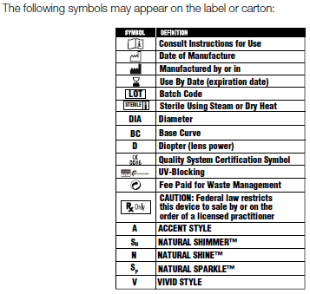

13.0 Resources
Transmittance curves
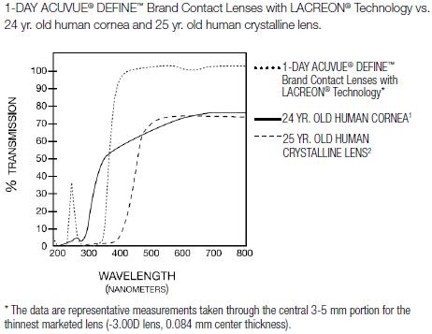

Citations
- Lerman, S., Radient Energy and the Eye, MacMillan, New York, 1980, p.58 figure 2-21
- Waxler, M. Hitchins, V.M., Optical Radiation and Visual Health, CRC Press, Boca Raton, Florida, 1987, p.19, figure 5
- New England Journal of Medicine, September 21, 1989, 321 (12), pp. 773-783
- The CLAO Journal, July 1999, Volume 25, Number 3

14.0 Contact and Reporting Information
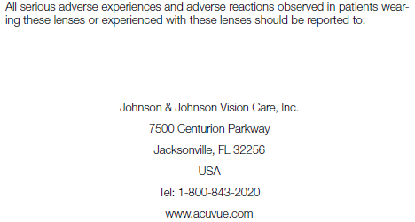

15.0 Date of Latest Revision
