**Summary of LinkedIn recruitment efforts for the cognitive testing of the NSPCP**

Westat will place an advertisement on LinkedIn to try to recruit physicians to participate in cognitive testing. The ad will be targeted to LinkedIn members that list themselves as physicians and that are local to the DC/Rockville area.

Once a potential respondent clicks on the ad, he/she is taken to a “landing page” at Westat. There, he/she can read a little more about the study and enter contact information. See below for the text of the landing page.

**LinkedIn Landing Page:**

**Earn $150 for physicians to test a survey**

Westat is seeking family practice and internal medicine physicians specializing in primary care to participate in a 1.5 hour in-person interview to help test a survey for the National Center for Health Statistics and the CDC**. Interested physicians** **can participate either at their practice or at Westat**.

**Participants will receive $150 for their time.**

Please provide the information below and we will contact you to see if you qualify.

NAME_______________

PHONE NUMBER____________________

EMAIL ADDRESS________________________

Do you prefer to be contacted by phone or email? _______________

Thank you!

***Confirmation of submission page:***

**Thank you!**

Thanks for your interest in this important research for the National Center for Health Statistics! A Westat representative will contact you soon to ask you a few additional questions to see if you qualify and fill you in on the details. We look forward to speaking with you!

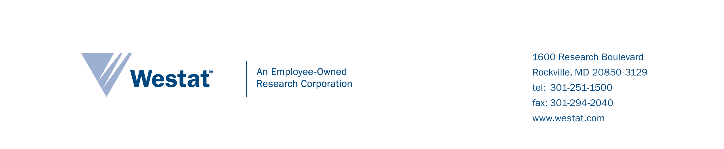

**Paid Research Participants Needed:**

**Primary Care Physicians – Receive $150**

**WHO: Family Practice Physicians and Internal Medicine Physicians Specializing in Primary Care**

Westat would like to schedule and conduct interviews with primary care physicians currently working in medical practices that treat adult patients. For this particular study, obstetricians and gynecologists are excluded. Each interview is scheduled with a single physician.

**WHY: Feedback on a draft survey**

Westat is pretesting a survey for the National Center of Health Statistics and CDC’s Division for Heart Disease and Stroke Prevention and the Division of Diabetes Translation. The survey will be administered to primary care physicians throughout the United States. The purpose of the interviews is to make sure the survey items are easy to understand and answer and are appropriate for different types of medical practices providing primary care to adults. Participants will have the opportunity to help improve an important survey.

**WHAT: In-person interview**

During the interview, participants will complete the pretest survey and answer interviewer questions about the survey items. Interviews will last 1¼ hours. Interviews will be confidential. Participant names and the names of their medical practices will not be included in any interview summaries.

**WHERE and WHEN:** **At your convenience**

Interviews can be scheduled during your nonworking hours (daytime, evenings, Saturdays) either at your practice or at Westat, which is located at 1600 Research Blvd. in Rockville, MD. Interviews will be conducted from mid-April through May.

**Thank You GIFT**

In appreciation for your assistance, you will receive $150.00 at the end of the interview.

**INTERESTED? WANT MORE INFORMATION ABOUT THE STUDY?**

Please email [study email box to come] or call [study toll-free number to come]. If you call and receive voicemail, please leave a phone number or email address where you can be reached during your nonworking hours.

Thank you for your interest!

Please share this flyer with colleagues in other practices providing primary care to adults.