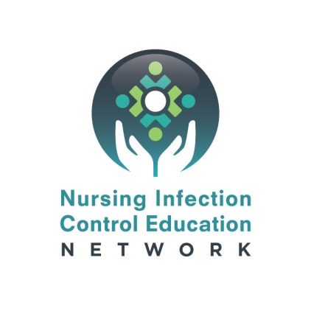

Dear Participant,

We would like to thank you for your participation in the NICE Network in-person conference workshop session, [insert session title]. In order to evaluate the success of this workshop, [insert subcontractor name] is conducting a follow-up survey of all participants. Your response to this survey is crucial in providing the necessary information to ensure that all nurses’ needs were met and that the infection prevention education provided is useful and applicable within your professional space.

Please follow the link below to answer a few brief questions regarding your participation in the [insert session title] session. This evaluation will take no more than 5 minutes of your time.  
  
Thanks for your collaboration. Your response and time is greatly appreciated. Thank you!

Sincerely,

Link: <https://ana.co1.qualtrics.com/jfe/form/SV_6D1Uy5bbHCZ201n>