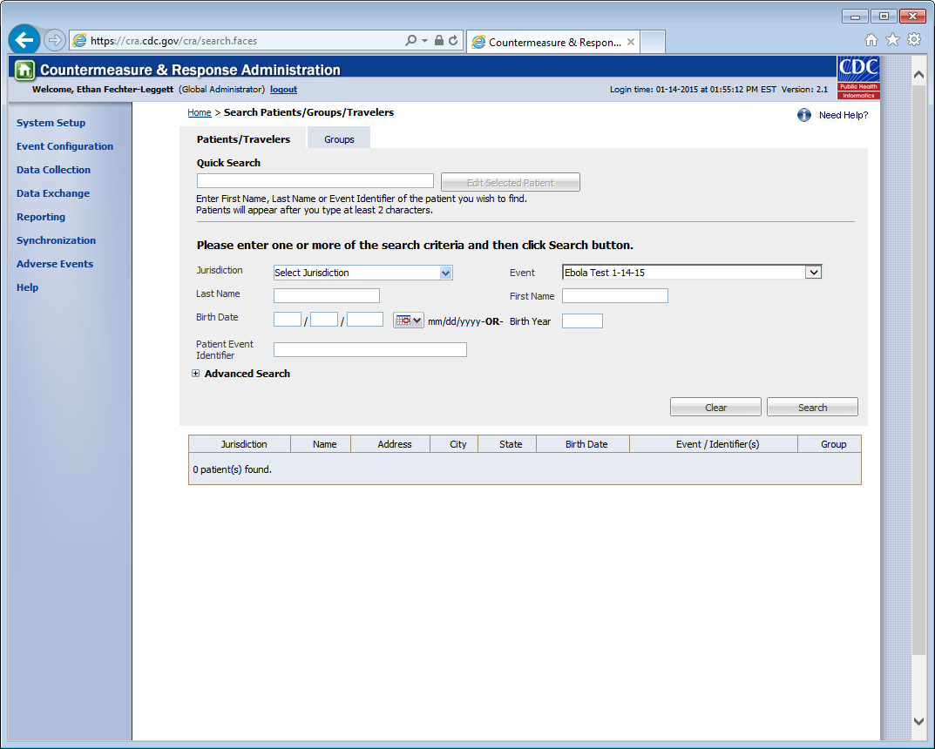
Note to OMB: This is a search screen only, NOT a data entry screen. Respondents will need to enter their Jurisdiction and the Event only to find their travelers. CDC will not ask states to enter name, birth date, or birth year – the inclusion of these variables is a default of the system we are using, but will not be required nor requested of the respondents.

