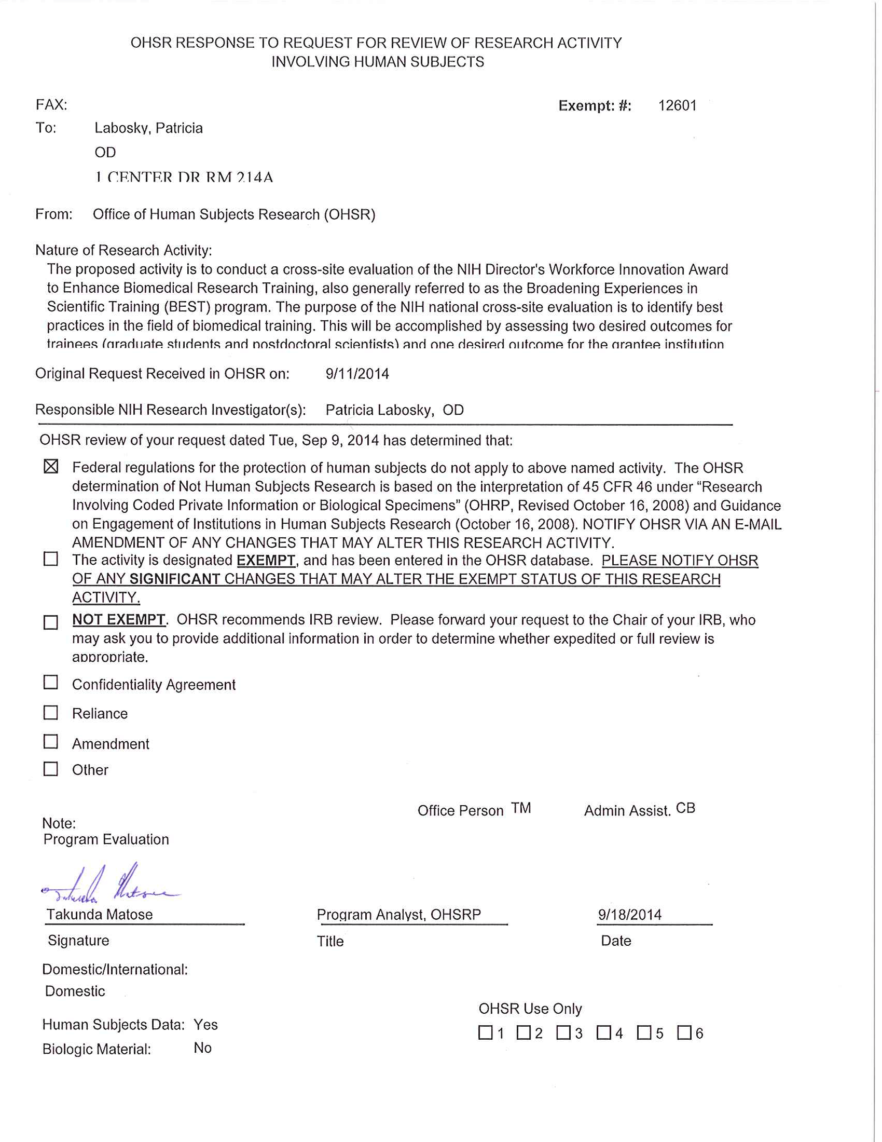

**Attachment A.10.1: Letter from the NIH Office of Human Subjects Research Protections**