**ODPHP: Website Survey Example Screenshots**

OMB Control Number: 0990-0379

**Example Screenshots Overview**

Below are examples from 3 HHS agency websites that use the Voice of Consumer (VoC) survey tool. The screenshots included illustrate how ODPHP website surveys will be situated on the site and how the surveys will be structured at the site level and page level.

**Site-Level Survey Example Screenshots**

**From USA.gov [demo]**

**Pop-up invitation to begin survey**

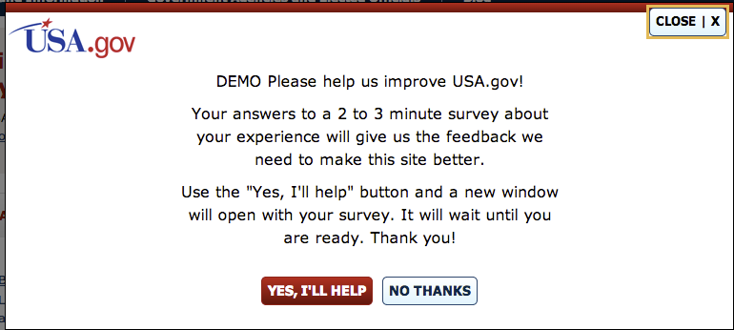

**From StopBullying.gov**

**Invitation to begin survey via link in footer**

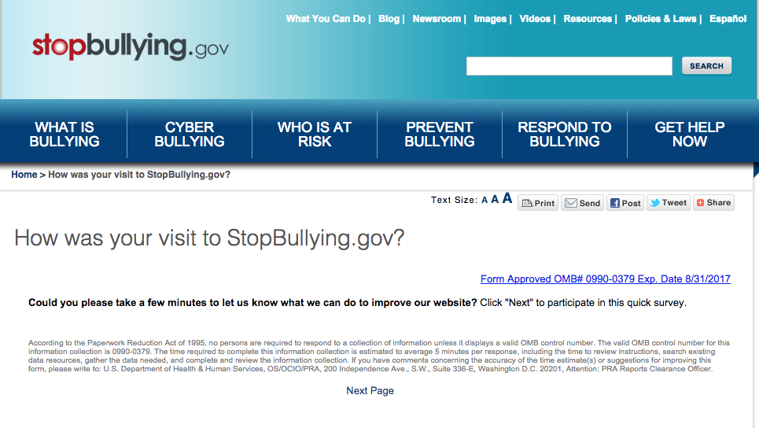

**Sample question page 1**

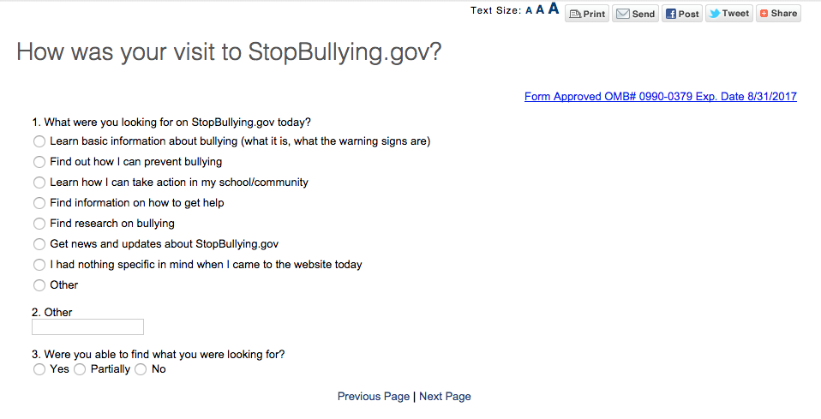

**Sample question page 2**

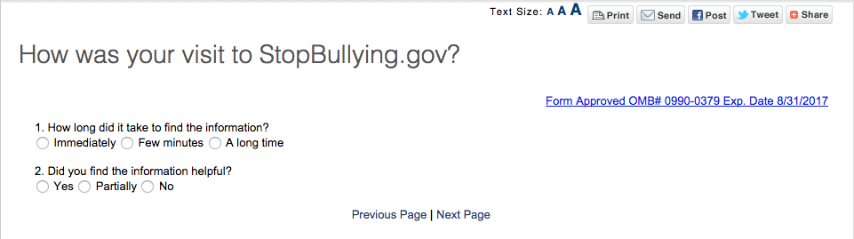

**Page-Level Survey Example Screenshots**

**From Usability.gov**

**Sample first question**

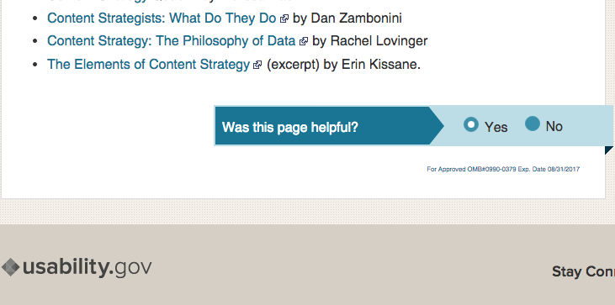

**Sample second question**

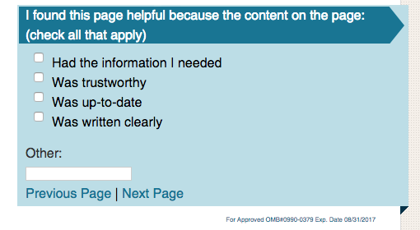

**Sample third question**

