Form Approved

OMB# 0990-0379

Exp. Date 8/31/2017

# Welcome

Welcome to this TreeJack study, and thank you for agreeing to participate!

The activity shouldn't take longer than 10 to 15 minutes to complete.

Your response will help us to organize the content on our website. Find out how on the next page...

# Instructions

**Here's how it works:**

* You will be asked to find a certain item and presented with a list of links.
* Click through the list until you arrive at one that you think helps you complete the task.
* If you take a wrong turn, you can go back by clicking one of the links above.

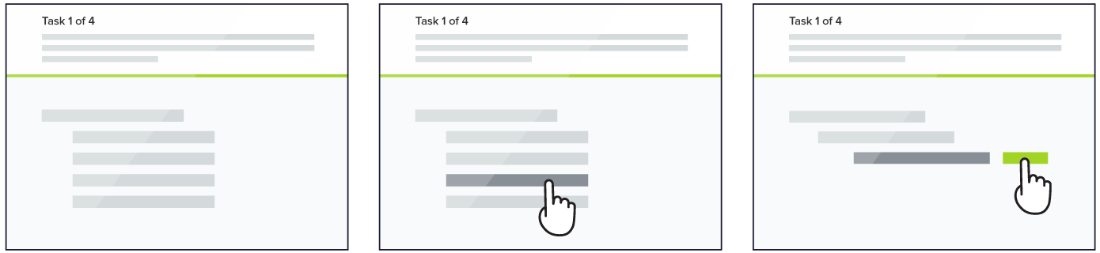

This is not a test of your ability, there are no right or wrong answers.

**That's it, let's get started!**

UserWorks Participant Id#: ________

According to the Paperwork Reduction Act of 1995, no persons are required to respond to a collection of information unless it displays a valid OMB control number. The valid OMB control number for this information collection is 0990-0379. The time required to complete this information collection is estimated to average 15 minutes per response, including the time to review instructions, search existing data resources, gather the data needed, and complete and review the information collection. If you have comments concerning the accuracy of the time estimate(s) or suggestions for improving this form, please write to: U.S. Department of Health & Human Services, OS/OCIO/PRA, 200 Independence Ave., S.W., Suite 336-E, Washington D.C. 20201, Attention: PRA Reports Clearance Officer.

# **Tasks**

## Task #1

**Where would you expect to find information about opioid use?**

* Substance Use Issues > Heroin, Oxy, & Other opioids
* Illegal Substances > Heroin & Other Opioids
* Prescription Substances > Codeine, Oxy, & Other Opioids

## Task #2

**You are looking for information to give to your teenage daughter about the signs of abuse in romantic relationships. Where would you find it?**

* Trauma & Violence > Victim or Witness to Domestic Violence
* Education & Prevention > Domestic Violence

## Task #3

**Where would you expect to find information about the signs and symptoms of binge drinking.**

* Substance Use Issues > Alcohol Consumption & Heavy Use
* Education & Prevention > Alcohol Consumption & Heavy Use
* Non-Prescription & Over the Counter Substances > Alcohol

## Task #4

**You’re looking for information on something that temporarily quickens someone’s mind or allows them to focus on tasks more easily. Where would you expect to find that?**

* Illegal Substances > Cocaine, Meth, & Other Stimulants
* Prescription Substances > Adderall, Ritalin & Other Stimulants
* Non-Prescription & Over the Counter Substances > Caffeine & Energy Drinks
* Substance Use Issues > Cocaine, Meth, & Other Stimulants

### Task #5

**Where would you find information on how to deal with harassment your middle-schooler is experiencing from her classmates on social media.**

* Trauma & Violence > Bullying & School Violence
* Education & Prevention > Bullying & School Violence

### Task #6

**You’re looking for information on the use of industrial or commonly found solvents used to alter someone’s mental state. Where would you find that information within this site?**

* Cosmetics & Household Substances > Paint thinner, Nail Polish Remover & Other solvents

### Task #7

**Where would you find information on ways to persuade your teenage son not to take up smoking.**

* Substance Use Issues > Cigarettes, Cigars, Dip, & Other Tobacco Products
* Non-Prescription & Over the Counter Substances > Tobacco & Nicotine

### Task #8

**You’re looking for information to help you determine if your Dad’s recent forgetfulness is just memory lapses or might be something else. Where would you find that information within this site?**

* Mental Health Issues > Alzheimer’s & Dementia
* Education & Prevention > Alzheimer’s & Dementia

### Task #9

**You’re looking for techniques someone who has been diagnosed with a mental health or substance use issue can apply themselves without the help of a professional.**

* Treatment & Recovery > Self Directed Therapies

### Task #10

**Locate information about programs where the person being treated lives at the facility where she or he is receiving help.**

* Treatment & Recovery > Residential & In-Patient Services

### Task #11

**Please locate information the differences race, sex, sexual orientation, or economic status make in someone’s access to mental health or substance use treatment.**

* Treatment Impacts & Influences > Health Disparities

### Task #12

**You’re looking for requirements on licensing for individual providers of mental health or substance use care. Where would you expect to find that?**

* Credentials, Education, Funding > Credentialing

### Task #13

**Please find information on developing programs aimed at keeping people from engaging in certain behaviors or ways to include such programs into a healthcare approach.**

* Practice Guidelines, Trends, Treatment Planning & Models > Prevention Models

### Task #14

**Please locate information on ways caregivers can develop sensitivity to cultural differences and how that helps them provide better services to people who need mental health or substance use treatment.**

* Credentials, Education, Funding > Cultural Competence

### Task #15

**Please locate information on what a program or facility must do to be officially recognized as being qualified to deliver mental health, substance use, recovery, or reentry services.**

* Administration, Law, Application of Care > Accreditation

## Post Study Questions

Thank you for helping us review the way our new site might be structured. The tasks help us examine how the information on the site is structured and labelled.

We appreciate your time and just have a few more questions to help us learn more about your reactions to what you have seen.

1. Do you feel this is a site you might visit for professional reasons, for personal reasons or both?
   1. Personal
   2. Professional
   3. Both
2. How easy or difficult was it to understand the types of information the site contains?
   1. Very easy
   2. Easy
   3. Neither easy nor difficult
   4. Difficult
   5. Very difficult

Please tell us more about that.

1. How easy or difficult was it to understand the language or labels used within the different sections of the site?
   1. Very easy
   2. Easy
   3. Neither easy nor difficult
   4. Difficult
   5. Very difficult

Please tell us more about that.

1. How confident are you that you were able to find all of the information you sought?
   1. Very confident
   2. Confident
   3. Neutral
   4. Not very confident
   5. Not confident at all

Please tell us more about that.

1. Final comments about the way information was structured within the proposed site?