Appendix 1
BLM Visitor Survey
Visitor Contact Script, Survey Participation Request
OMB CONTROL NUMBER 1040-0001
EXPIRES:

Hi, my name is [ ], and the BLM is conducting an important visitor study. The BLM wants to understand how satisfied visitors are with their experiences at the [specific site name here]. We’re asking a small number of randomly- selected visitors to participate in the study. Your participation is voluntary, and your answers will be confidential and anonymous. You can complete the survey in about 8 minutes. Just place it in this locked drop box when you have completed it.

Your opinion is important to us! Would you be willing to help us out?

If No: Thank you. Enjoy your visit to [specific site name here].

If Yes: Thank you, here’s your survey (hand them the survey, clip board, pencil)
In addition to implementing the survey, the researcher will keep a log noting the following each day:
- Date
- Start and end times for each location
- Number of people approached to take survey
- Number of refusals
- Weather conditions
- General observations of procedures

NOTICES:

- The Privacy Act of 1974 and the regulations at 43 CFR 2.48(d) provide that we furnish you the following information:

Your participation is this survey is voluntary and all of your answers will remain completely
anonymous. To ensure your privacy please do not write your name or address on the survey.
Please carefully read all directions and mark your responses clearly. There are no penalties for not answering any or all of the questions. Your cooperation is extremely important since each person surveyed will represent many others who will not be surveyed. An independent research university will summarize the results to the answers you provide – your responses are voluntary, anonymous and confidential. The information provided will not be used beyond the purposes of this study.

- The Paperwork Reduction Act of 1995 requires us to inform you that:

The Bureau of Land Management will use the comments to improve customer satisfaction with BLM program areas. Your response is voluntary and there is no effect for not providing the information. You do not have to respondent to this or any other Federal-agency sponsored information collection which does not display a currently valid OMB control number. Public reporting burden for this survey is estimated to average 8 minutes per response, including the time for reviewing the instructions, gathering, and maintaining the data, and completing and reviewing the survey. Direct comments regarding this burden estimate or any other aspects of this survey to: U.S. Department of the Interior, Office of Planning and Performance Management, 1849 C Street, NW, Washington, DC 20240.

If you have any questions, please contact Jennifer Hoger Russell, at the University of Idaho, Park Studies Unit either by email jhoger@uidaho.edu or by telephone (208-885-4806). Thank you very much for your help!

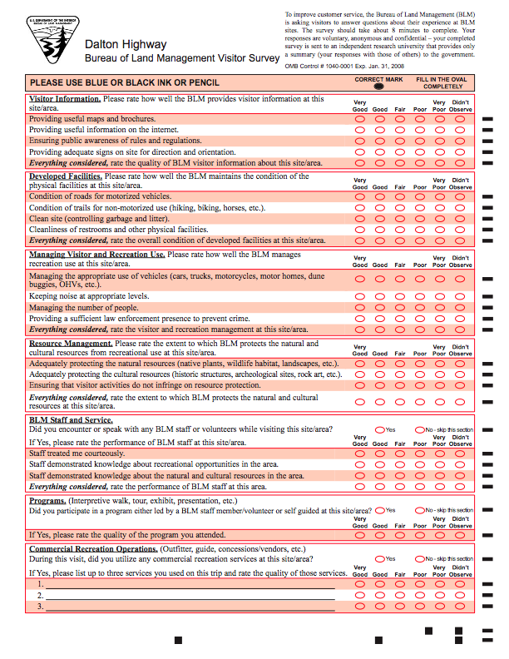
SITE NAME HERE
OMB Control # 1040-0001 Exp.
Appendix 2
Visitor Survey Instrument
(Note: Survey to be printed as a computer scannable folded 8.5 x 11 size page, front/back.)

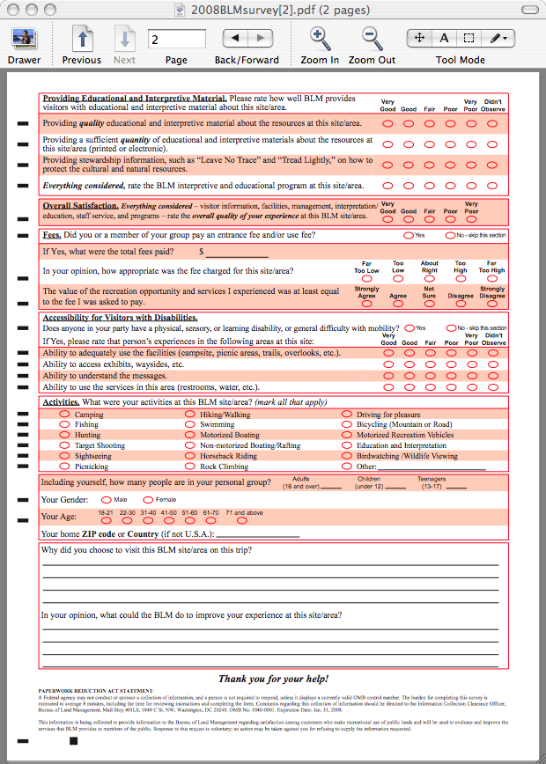

Appendix 2 (continued)
March 31, 2008

Appendix 3
Survey Technician Instructions and Log

BLM Visitor Survey - Instructions for On-Site Visitor Survey Administration

- Since every BLM site is unique, these procedures were developed by the University of Idaho Park Studies Unit (UI PSU) as a general set of guidelines. To ensure that all surveys distributed in the FY10 field season can be aggregated it’s important to follow the guidelines at all sites. However, if you experience problems at your site please contact the UI PSU for suggestions and directions on how to adapt the methods for your site. (contact Jennifer Hoger Russell, 208-885-4806)

- Each site will receive a package containing all the materials necessary for the completion of the survey process. A checklist of materials will be included to ensure each site has the full complement of materials. Please check all materials before beginning survey distribution.

- It is critical that these surveys represent a cross-section of all visitors to your BLM area; i.e. age, race, gender, activity. To reach this cross-section of visitors, select a sampling period (with the guidance of the UI PSU) between 30-60 days. If visitation to your site(s) is low, you can contact the UI PSU for an extension of up to 30 days.

- During the Survey Period, a minimum of 8 sampling days should be used to collect the surveys. A sampling day could consist of a four-hour period of time that may occur in the morning, afternoon, or evening, depending on visitation to that site. This may be extended for areas that have sporadic visitation throughout the day. Select sampling days that represent a mix of weekend days and weekdays spread out across the sampling period. The goal here is to get the biggest mix of visitors possible to reduce the sampling bias.

- Use an objective method of selecting visitors to survey. Instead of just surveying those who appear friendly or approachable or who have extra time to complete a survey, employ one of the following approaches:

- Every nth visitor to exit a specific area
- A visitor at every nth campsite
- Every nth visitor past an imaginary line across a trail

*nth equals a predetermined number, for example- every 4th person, to ensure a randomized sample.

- Give the survey to only one person, 18 years or older, in each group. Do not give the survey to more than one person in each group. Groups should NOT collaborate on responses to survey questions.

- Visitors who wish to volunteer to fill out the survey are NOT allowed in order to maintain a scientific sample. Explain to the visitor that this is a scientific sample that does not allow for volunteers however, their opinions are very important to the BLM and they should be directed to whom they can address their concerns and suggestions. Visitors should be selected to complete the survey after they have spent some time in the area. Visitors will not be able to accurately comment on the area if they have not yet experienced it.

- To ensure confidentiality and security, locked drop boxes will be provided. All completed surveys are to be deposited in the locked drop box by the respondent. Surveys will arrive at the sites folded in half to fit easily into the boxes. Please encourage respondents to not add additional folds in order to maximize drop box space. Do not leave the locked drop boxes unattended at any time.

- Make it easy for visitors to complete the survey. Provide clipboards and pencils. Provide respondents with sufficient time and privacy to fill out the survey. In areas that are hot or have limited shade- set up a hospitality station with water or shade. Have the respondents deposit surveys directly into the box.

- The UI PSU will provide the locked drop boxes to the BLM. Two will arrive at the beginning of the survey with all other survey materials. As the box becomes too full, contact Jennifer Hoger Russell for a replacement (208-885-4806). These boxes will be exchanged via FedEx to maintain efficiency.

- Keep Accurate Records. This is extremely important. Record your progress daily by completing the “Daily Surveyor Report.” At the completion of the survey period, the site coordinator will complete the “Coordinator Report” which will summarize the daily reports. All reports will need to be sent back in the enclosed envelope to Jennifer Hoger Russell at the UI PSU.

- To contact Jennifer Hoger Russell, UI PSU, call: 208-885-4806, email: jhoger@uidaho.edu

- To contact Vicki Josupait, BLM Visitor Satisfaction Survey Lead, call: 303-236-6313, email: victoria_josupait@blm.gov
Appendix 3 (continued)

BLM Visitor Survey – Distribution Log

Date | # Of Surveys Completed |  | # Of visitors asked to do the survey | = | # Of visitors who accepted survey | + | # Of visitors who refused survey | General Comments  (weather, sampling procedure observances)
 |  |  |  | = |  | +
 |  |  |  | = |  | +
 |  |  |  | = |  | +
 |  |  |  | = |  | +
 |  |  |  | = |  | +
 |  |  |  | = |  | +
 |  |  |  | = |  | +
 |  |  |  | = |  | +
 |  |  |  | = |  | +
 |  |  |  | = |  | +
 |  |  |  | = |  | +
 |  |  |  | = |  | +
 |  |  |  | = |  | +
 |  |  |  | = |  | +
 |  |  |  | = |  | +
 |  |  |  | = |  | +
 |  |  |  | = |  | +
 |  |  |  | = |  | +
 |  |  |  | = |  | +
 |  |  |  | = |  | +
 |  |  |  | = |  | +
 |  |  |  | = |  | +
 |  |  |  | = |  | +

Appendix 4
Script & Log Sheet for Non-Response Bias Check

Your site has been selected to conduct a non-response bias check for the BLM National Visitor Satisfaction Survey. This will entail asking three questions of people who declined to fill out the survey. This information will allow the BLM to determine if non-respondents are different from respondents. Your site is one of only a few sites that are collecting this information. It is extremely important that this task be completed consistently and thoroughly. We appreciate your efforts to help us gather this additional information.

The following script and log should be used to collect this information from the people who declined to fill out the survey.

Hi, my name is [ ], and the BLM is conducting an important satisfaction survey. The BLM wants to understand how satisfied visitors are with their experiences at the [specific site name here]. We’re asking a small number of randomly selected visitors to participate in the study. Your participation is voluntary, and, your answers will be confidential and anonymous. You can complete the survey in about 8 minutes. Just place it in this drop box when you have completed it.

Your opinion is important to us! Would you be willing to help us out?

If Yes: Thank you. Here is your survey (hand them the survey, clip board, pencil)

If No: Okay, we have three quick questions for folks who decline to take the survey. Would you be willing to respond to these?

If Yes, continue with the three questions. (record responses in log):
- Including yourself, how many people in your personal group?
- Overall, were you satisfied with your experience here today?
- What’s your zip code?
Also: observe gender of respondent.

Appendix 4 (continued)

Non- Response Log Sheet

Date: __________Location: _________________________________ Interviewer: ________________________

Contact # | Accepted Survey (Yes/No) If No complete columns to right. | # In Group | Primary  Activity | Zip Code | Gender (M/F)  Observed | Volunteered Reason for Declining Survey (e.g., “ too busy”)

