Screenshot of the page that will lead to this submission form.
Climate Change Home Page http://www.nps.gov/subjects/climatechange/index.htm

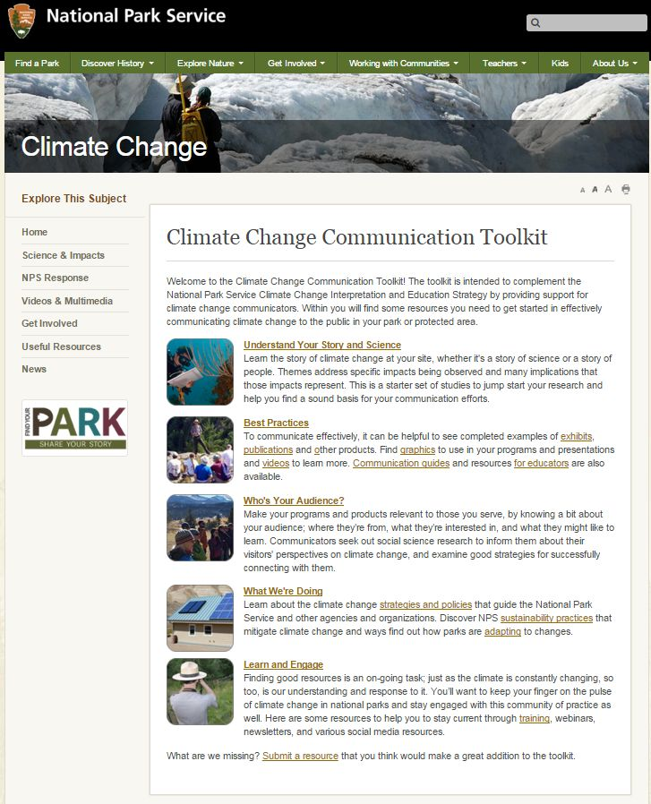

The “Submit a resource” link at the bottom of the page will take you to the following page where the respondent will provide the submission:

This fields on this page include the following and will be emailed to the NPS when submitted:

OMB Control Number 1090-0011
Expires: 08/31/2018

Do you know of an online resource you think would be helpful to include in this toolkit? Use this form to submit an item; staff will periodically review submissions as the toolkit is updated.

- Submission title* [small text field]
- URL/web address (if applicable) [small text field]
- Your email address* [small text field]
- Please provide a brief description of the resource you are submitting.*
[large text field]
- Why do you think this belongs in the toolkit? How does this help you communicate climate change? [large text field]
- What section of the toolkit do you think this best fits? [large text field]
- Additional comments? [large text field]
*indicates required field

Paperwork Reduction Act Statement: We estimate the survey will take you 5 minutes to complete, including time to read instructions, gather information, and complete and submit the survey. We will use the information to develop a web-based online toolkit geared toward helping internal and external audiences (educators and interpreters) interpret and communicate climate change. Your response is voluntary and results will not be shared publicly. We may not conduct or sponsor and you are not required to respond to a collection of information unless it displays a currently valid OMB Control Number. OMB has reviewed and approved this survey and assigned OMB Control Number 1090-0011, which expires 08/31/2018. You may submit comments on any aspect of this information collection to the Information Collection Clearance Officer, National Park Service, 12201 Sunrise Valley Drive (Room 2C114, Mail Stop 242), Reston, VA 20192.

