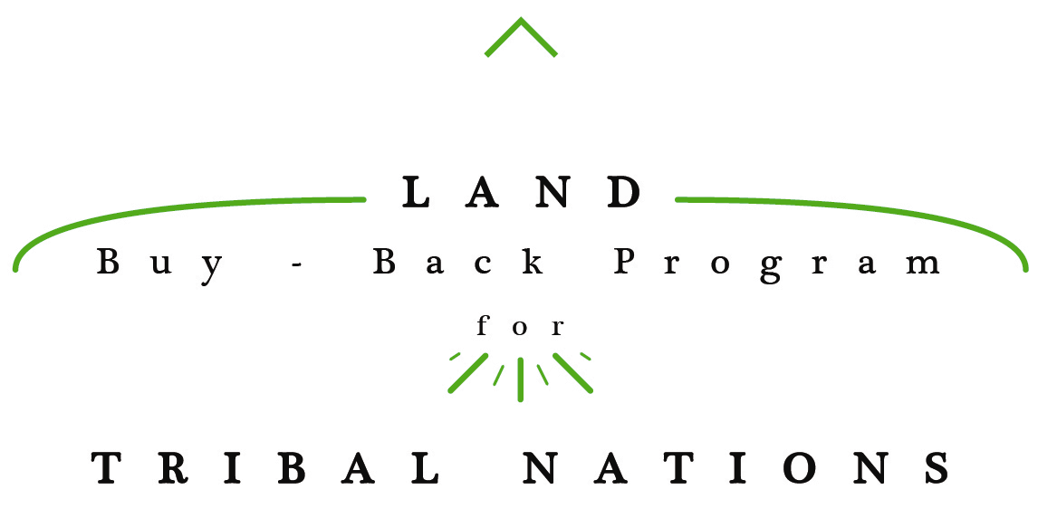

JOHN DOE

P.O. BOX 000­­

POPLAR, MT 59255

SURVEY REGARDING LAND BUY-BACK PROGRAM

Dear JOHN DOE:

Your voice is important, and we would really like to hear from you by ____________. You can help us better serve Indian Country by completing and returning the enclosed survey, which we are sending to you because you should have received a purchase offer for some or all of your fractional land interests from the Land Buy-Back Program for Tribal Nations (Buy-Back Program) in 201X.

As you may know, the Buy-Back Program stems from the historic *Cobell* Settlement Agreement and the Claims Resolution Act of 2010, which provided for a $1.9 billion Trust Land Consolidation Fund to consolidate fractional land interests across Indian Country.

The Buy-Back Program works in partnership with tribal nations to ensure that eligible landowners are aware of their fractional land interests and the unique opportunity they may have to sell them for fair market value. Upon sale, the fractionated land interests are immediately transferred (in trust) directly to the tribe that has jurisdiction, preventing further fractionation. The tribe can then use consolidated lands to benefit the community. For example, tribes have used consolidated lands to start housing projects, build community centers and businesses, or develop infrastructure. Tribes also have used the consolidated land to protect natural resources and foster cultural values.

To build on the success of the Buy-Back Program, we strive to continue to learn and adjust our outreach strategies based on the feedback we receive from individuals and tribal leaders in Indian Country. To that end, **we respectfully ask that you spend a few minutes completing the enclosed survey to help us understand why you did or did not accept your purchase offer and what improvements we could make to better serve landowners. Again, please return the survey by _________.**

Please note, you may still own fractional land interests not covered by the purchase offer you have already received. To inquire about that land, or to indicate your interest in registering as a willing seller, please contact the Trust Beneficiary Call Center at 888-678-6836 or visit your local Office of the Special Trustee for American Indians (OST). The outreach staff is also available to help landowners think about what they will do with the money they receive if they choose to sell or your alternatives if you chose not to sell. More information about financial awareness is located at: https://www.doi.gov/buybackprogram/landowners/financial-awareness.

Thank you for your time and feedback.

Sincerely,

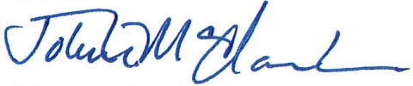

John H. McClanahan

Program Manager