NPS-KEFJ / Formative-at-Exhibits / 5-10-2016 p. 1
OMB Control Number:1090-­‐0011

Invitation to participate:

Script for Random Interviews

Hi, my name is ________________. Today, we are previewing a few prototypes for new exhibits the park is planning for the Visitor Center. May I ask you a few questions about the one that you were just looking at? It should take about 10 minutes of your time today.

If “Yes”: OK. Thank you for agreeing to participate. I would like to ask you a few questions today. Your responses are really important because they will help the park managers understand overall impressions visitors have towards these exhibits. Once we are done the information collect will be used to evaluate the overall utility and effectiveness of these proposed exhibits.

Before we begin, I would like to let you know that this survey has been approved by the Office of Management and Budget. I am also required to tell you that a Federal agency may not conduct or sponsor, and that you are not required to respond to, a collection of information unless it has a currently valid OMB control number. The control number for this collection is 1090-0011. Secondly, your participation is voluntary and your name will never be connected with your individual responses. Finally, if you have any questions about this survey, I have a name and contact number available if you would like to have it. Can we begin?

If No- It is important to us that as many people as possible participate by helping us to collect data that will help us to understand our visitors, even those who do not participate in this study. Would you mind answering a few quick questions?

IF YES-ask the following non-response questions and then end the interview
1) Is this your first visit to Kenai Fjords?
2) Where are you from?
3) How would you rate your overall opinion of the visitor center?
great good OK fair or poor

If No – Thank you and enjoy the rest of your visit.

Script for Invited Interviews

Before we begin, I would like to let you know that this survey has been approved by the Office of Management and Budget. I am also required to tell you that a Federal agency may not conduct or sponsor, and that you are not required to respond to, a collection of information unless it has a currently valid OMB control number. The control number for this collection is 1090-0011. Secondly, your participation is voluntary and your name will never be connected with your individual responses. Finally, if you have any questions about this survey, I have a name and contact number available if you would like to have it. Can we begin?
Today, we are doing a preview of some new exhibits for the Visitor Center. We have invited you here to look at each of the prototype and then be prepared to respond to a short survey that should take more than 10 minutes. You can spend up to 3 minutes with the exhibit. Once we are done the information collect will be used to evaluate the overall utility and effectiveness of these proposed exhibits. I Before I start I am required to tell you that your participation is voluntary and your responses will be anonymous.

NOTE: The PRA statement below will be printed on 3x5 index cards and given to each interviewee at the time they agree to participate.

Paperwork Reduction Act Statement: The Paperwork Reduction Act requires us to tell you why we are collecting this information, how we will use it, and whether or not you have to respond. This information will be used by the National Park Service as authorized by 54 U.S.C. 100101. We will use this information to evaluate the new exhibits for Kenai Fjords Visitor Center. Your response is voluntary. No personally identifiable information is being collected. A Federal agency may not conduct or sponsor, and you are not required to respond to, a collection of information unless it displays a currently valid OMB Control Number. We estimate that it will take about 10 minutes to complete this short on-site survey. You may send comments concerning the burden estimates or any aspect of this information collection to: Kenneth Davis, at Kenneth_Davis@nps.gov (email).

Hi, These are some new prototypes for exhibits here at the Visitor Center. May I ask you a few questions about that one that you just looked at? .

Have you ever been to the Kenai Fjords National Park Visitor Center before today? Yes No
Where do you live? ______________________________
Which exhibit /panel?

1. How would you rate your overall opinion of this exhibit?
great good OK fair or poor

a. [If the respondent replied “great, good or OK” then the interviewer will ask]:
Please tell me what you like most about it?
What and Why? ______________________________________________________________
b. [If the respondent replied “fair or poor” then the interviewer will ask]:
Was there at least one thing about the exhibit you liked?
What and why? ___________________________________________________________________
2. How would you explain the main points of this exhibit to someone who hasn’t seen it?
(alternate: What does this exhibit tell you about the Park?)
____________________________________________________________________________
3. [If rating of great, good or OK ask] What else did you find out that was interesting or surprising to you?
. _____________________________________________________________________________

4. I am going to ask you a series of questions and I would like you to please answer yes or no when prompted.
Do you think that the following can be improved upon? …
[for interactives:] Yes No understanding how to use it? (if yes: what needs to be clearer?) _________________________________________________
[for everything:]
Yes No the terms & language used? (example?) __________________________________
Yes No the visuals? (in what sense?) ___________________________________________
Yes No the size and readability of text?
Yes No how clear the explanations are? (e.g.?) ___________________________________

5. Is there something about this topic that you would like to know that was not addressed here?
_______________________________________________________________________________

Thank you for your help in planning these new exhibits!
========================================================================
Interviewer observations:
1a Including interviewee, how many adults (age 18+) appeared to be in the group?______
1b. How many teens (13-17)? _______
1c. How many small children 12 and under? _______
2. Was the interviewee: ___ male ___female
3. If you were to estimate their age it would be: ___ 20 something ___ 30 something ____ 40 something
___ 50 something - or ____60+
4. Which of these would you use to describe the interviewee’s racial background?
__ Alaska Native or American Indian __ African American or Black
__ Asian __ Native Hawaiian or other Pacific Islander __ White

Date ___________ Day of week ___________ Time ___________ Interviewer ____________

Time ___________ Interviewer ____________

Evaluation Prototype Locations
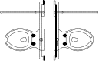
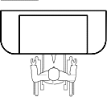
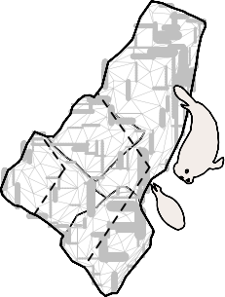
Exhibit Floor Plan

Serac Storage Education Staff

Mech. Storage.

Janitorial Stor.

2 Iceberg Jump

4 Connected Habitats Graphic

3 Sensory Station

1 Inspiration Station

Information Desk
Visitors entering the building see a staffed information desk
directly to the right. Here they may speak with a park ranger
and pick up essential documents and/or devices to support
their visit.

Inspiration Station
A touchscreen monitor mounted near the bench seating asks,
"What about Kenai Fjords inspires you?" Visitors are invited
to post their own photos via social media and browse a
selection of other visitors' inspiring moments. NPS will curate
all content before loading it on screen and will update the
site as needed by using a user-friendly HTML-based interface.

NATIONAL PARK

eget, orci. Phasellus euismod. Nunc tincidunt orci in metus.

Inspiration Station Prototype
The prototype will consist of a computer station with a
mock-up of the Inspiration Station. Visitors will be presented
with the question "What about the Park inspires you?"
Visitors will interact with a "Content Wall" within the
mock-up where they will view pre- loaded photographs of
the park with messages/captions from fictional visitors.
Visitors will then choose what image/message they would
post from the samples provided. The prototype will evaluate
the visitor engagement and interest in providing feedback to
the Park, and will evaluate the effectiveness of the proposed
engagement technique.

Information Desk

Inspiration Station

Glacier Flows
A large photo mural shows off the glacier’s grandeur, texture,
and spectacular color. A push-button listening station
mounted to the mural allows visitors to hear the surprisingly
loud sounds of a glacier - the thunder of calving ice, the
snapping of air bubbles and other impressive rumblings.

Introductory graphics provide an overview of the park’s glaciers and engage visitors with formation, movement, deposition, and change over time. An "Ecosystem Link" story outlines how glacier retreat is affecting the Kittlitz’s murrelet and a "Green View" story discusses how climate change affects glacial mass.

In front of the photo mural, a fun "Iceberg Jump" activity challenges visitors to hop between models of ice chunks sunken below floor level. As visitors jump onto each iceberg they delight in the sound of cracking ice and sloshing water. A digital media module associated with the Glaciers exhibit reveals the behind-the-scenes tools, equipment and field work protocol employed by those who study the park's glaciers.

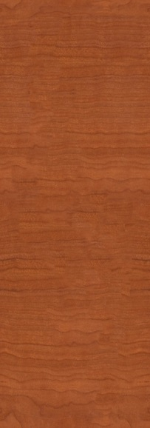
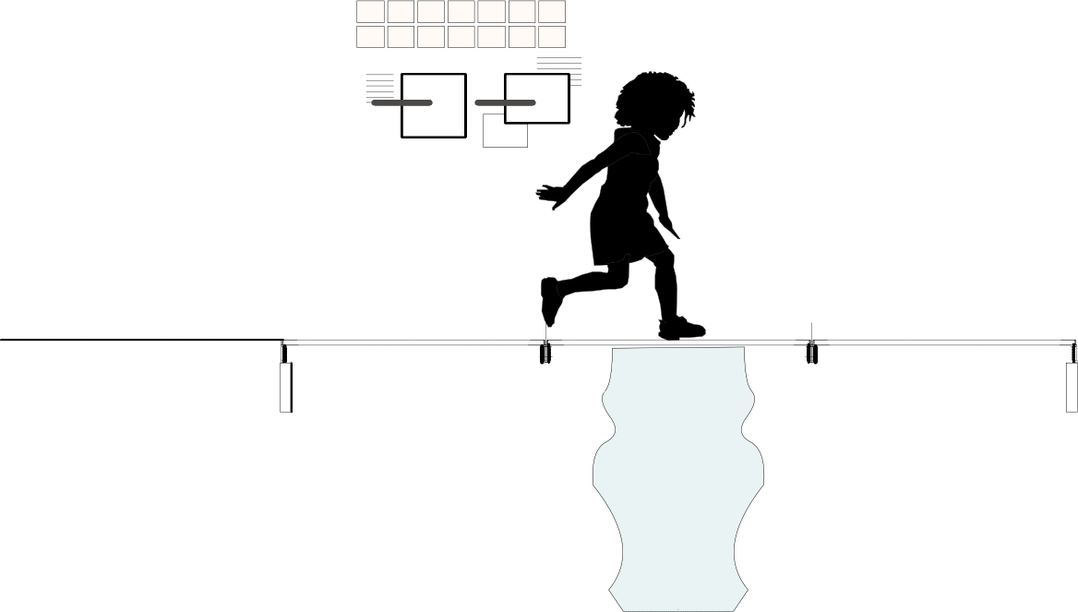
Glacier Overview

Icefield Overview

Icefield Model

Ecosystem Connections
Climate Change
Park Investigations

The Harding
Icefield

Glaciers

Glacier Photo mural

Listening station

Iceberg Jump

Iceberg Jump Prototype
Using a floor graphic to simulate a crevasse in an iceberg and
an informational wall graphic, this prototype will prompt
visitors to jump across the "iceberg." Sound effects will be
manually activated to amplify the effect of the experience.
The evaluation will determine the effectiveness of this gross
motor interactive in conveying basic information about
glacial environments; it will also evaluate the effectiveness of
the design from an ergonomic perspective.

Rocky Shores
This realistic scenic treatment offers a lively setting for visitors
to explore the rocky shores of the Park's fjords. Full of nooks,
ledges, and crevices, models of animal and plant life can be
found around every corner.

Various interpretive elements surround this rich natural scene. Colorful graphic panels highlight the ecosystem dynamics where the rocky cliffs meet the bay. Visitors learn about food webs, common species and their adaptations as well as changing environmental factors. An "Ecosystem Link" story details how rock types influence where animals nest and glaciers flow. Sensory stations allow visitors to experience a few sounds, smells, and textures of the locale. Visitors can
also slide a series of bird egg models to reveal their species of origin, and scat and track "reveals" introduce the evidence or clues that different species often leave behind in the landscape.

Sensory Station Prototype
Using audio recordings and smell canisters, this prototype will
present visitors with options for exploring a lowland fjord
habitat through hearing and smell. Effectiveness of the

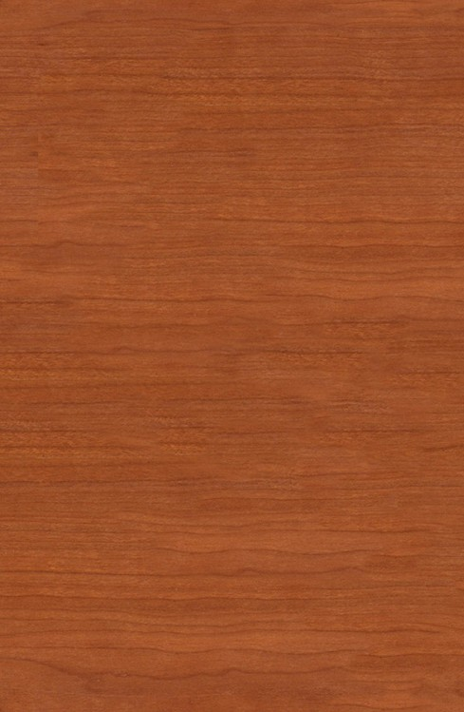
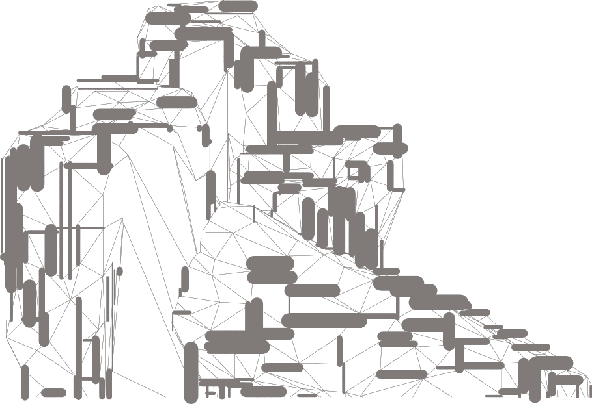
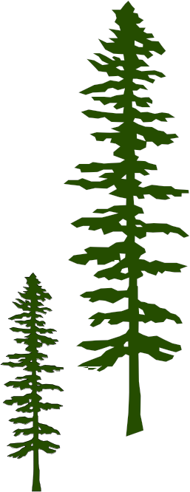
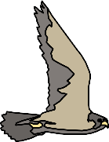
Decorative wall treatment

Scenic treatment with species models

Park Cross-Section

Where

technique for conveying interpretive message points, visitor understanding of the content, and functional performance of the interactives will be evaluated.

Fjord Overview

Icefield Tundra Glacier Forest Intertidal Marine

Fjord Lowland

Scat & track reveals

Sensory Station

Connected Habitats
Stretching across a long span of wall, a diagrammatic
"cross-section" illustration captures the major habitats of the
Park and its transition from high to low elevations: ice field,
alpine, glacier, forest, intertidal, and marine. A miniature
tactile version of the section cut line is also displayed in relief,
allowing visitors to feel the lay of the land.
Past & Present

Interpretive text shares the characteristics and features of each habitat along the cross section and the process of succession. An "Ecosystem Link" story discusses how topography, soil, precipitation, and altitude affect plant communities over time. Lift-and-drops, built into the cross section, share magnified views: for example, an ice worm model for the icefield. Visitors can rotate a series of barrel spinners associated with each habitat to reveal the animals, plants, human history, and geology associated with each

Park Cross-Section
THEATER

Where Ice and Ocean Meet

Next show in 5:28 min

place.
Human History Icefield Tundra Glacier Forest Intertidal Marine

Connected Habitat Graphic Prototype
This prototype will consist of a full scale mock-up of a portion
of an informational graphic including a mechanical
interactive element. Visitors will view the graphic, read the
interpretive text and engage with interactive elements to
evaluate the effectiveness of communication and the
functionality of the interactive element.

Habitat barrel spinners

Magnified views lift & drops
Tactile habitat
cross-section diagram

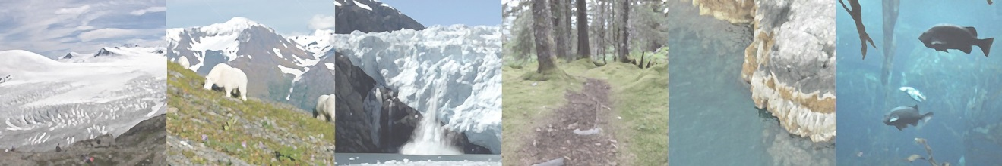
Connected Habitat Graphic

