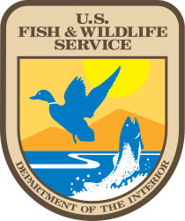

FWS PMDSI Phase

Navigation Model Test Plan

Table of Contents

​1​ Introduction 3
​2​ Recruitment & Participation 3
​3​ Methods 3
​4​ Results 4
​5​ TreeJack Script and Tasks 4
​5.1​ Enthusiasts 6
​5.2​ Influencers - Advocate 7
​5.3​ Influencers - Researcher 8
​5.4​ Influencers - Communicator 10
​5.5​ Managers - Government 11
​5.6​ Managers - Commercial 13
​5.7​ Job Seekers 15
​5.8​ Wildlife I/O 16
​5.9​ Urban Youth Coordinators 17
​7​ Appendix A: Informed Consent 18

​1​ Introduction
US Fish and Wildlife is currently undergoing a website redesign and is seeking user feedback in order to improve the usability, findability, and comprehension of information on the site. The overall goal of acquiring this feedback is to translate users’ actual and potential use of the site into explicit knowledge and design requirements for the redesign.

In order to obtain this feedback, we conducted a contextual inquiry with actual users of the site and produced a report of findings and recommendations. These findings led to a proposed set of two alternative navigational models for an updated organization of the site.
We now are assessing the navigational models using Optimal Workshop’s Treejack software. Treejack is a usability tool used to test information architecture by evaluating the findability of topics. Treejack will present a number of tasks to participants, and participants will click through a proposed model of the site organization to show where they would expect to find particular information. The results of this testing will show us where users expect to find information on the site, which will assist us in reorganizing the website content.

​2​ Recruitment & Participation
We will be working with UserWorks, Inc., a third party recruiting company based in in Silver Spring, MD. They will be identifying and scheduling test participants. We are anticipating that the majority of participants will be from the same pool of individuals that participated in the previous round of user research. FWS will provide UserWorks with the names of some candidates that have consented to participant and who FWS was able to identify more easily than the recruiting firm.

​3​ Methods
There are two separate proposed models for how the website could be organized. In order to best assess these models and avoid any bias by having participants look at multiple models in the same day, we will have all the participants look at each different model on two separate days. The first day of the test half of the participants from each group will test Model 1 and half will test Model 2. On this second day of testing, we will have all participants who tested Model 1 test model 2 and visa-versa.

The scripts found in Section 5 present the tasks that will be requested of participants. We will tailor the number of tasks so that participants will take approximately 20 minutes to complete their session on each of the two days, resulting in 40 minutes total for each participant. Participants will be informed that they will need to login twice on two separate days to receive payment for their participation.

​4​ Results
We will record whether participants make it to the expected place or end up at a different place, and if so, what that place is. We will also be able to tell whether they backtrack along the way. The aggregated results will then be used to determine whether these common tasks are easily accessible in the proposed navigational models and how well the navigational models are used. This will help us determine the best organization for the redesigned site.

​5​ TreeJack Script and Tasks
The questions below will be configured in TreeJack, and all tasks will be presented in random order. TreeJack also includes a welcome message, instructions, and a thank you message.

Instructions
Welcome to this Treejack study and thank you for agreeing to participate! The activity shouldn't take longer than 20 minutes to complete.
Your response will help us to organize the content on our website. Find out how on the next page...

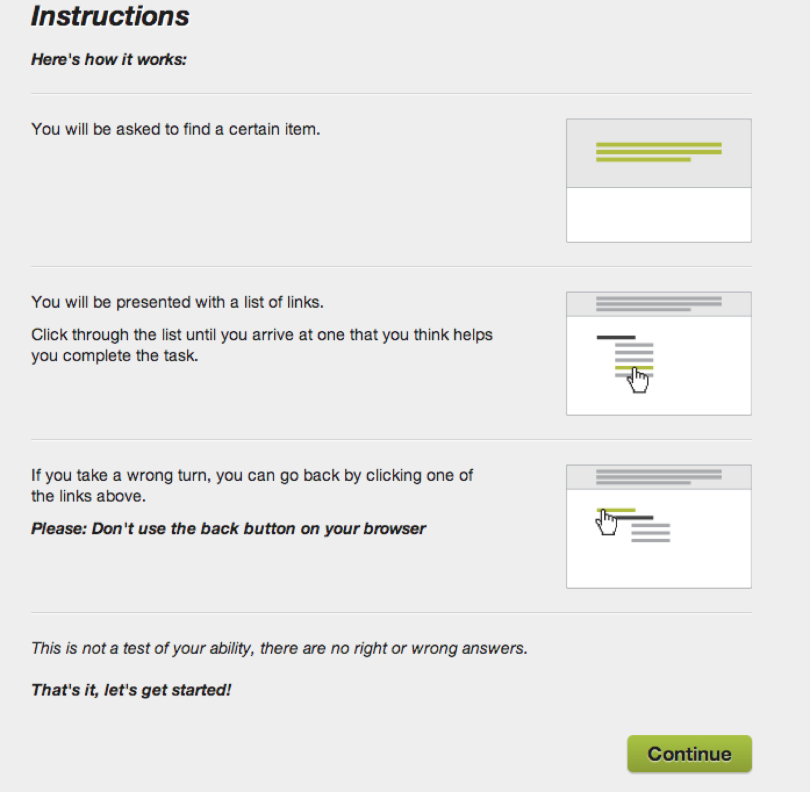

Thank you Message
All done, awesome! Thanks again for your participation. Your feedback is incredibly useful in helping to determine how our content should be organized, so we can make our website easier to use.(Include how they will need to come back in X number of days and how they will be reminded to do so.)
You may now close this window or navigate to another web page.

​5.1​ Enthusiasts
This persona group includes Hunter, Fisher/Angler or Birder/Bird Watcher
Key tasks and content needs include:
- Refuges research (alerts, conditions, wildlife info, maps)
- Relevant news
- Trip planning
- Learning about plants/animals of interest
- Volunteering on a refuge

TESTING TASKS
- Find information to help you plan a visit a refuge
  - VISIT US > National Refuge System OR Find a Facility
  - ABOUT US > Locations
  - I WANT TO…> Plan a visit to a refuge/hatchery
- Find information on purchasing a duck stamp
  - I WANT TO….. > Buy a Duck Stamp
  - SERVICES > Services for me (listed as one of top 5 tasks)
  - SERVICES > I Want To… > Buy a Duck Stamp
- Find information on types of programs FWS offers for youth
  - GET INVOLVED > Youth Programs
  - TOPICS > Engaging the next generation
- Find news stories about FWS volunteers
  - NEWSROOM > News categories (list sample categories)
  - GET INVOLVED > Volunteer Opportunities
- Learn more about a specific plant or animal of interest
  - SPECIES > [Any of the children pages under section C - Find a Species OR Species Categories OR Species Stories]
  - TOPIC > Categories or Candidate Species
  - SPECIES > Species Status Updates
  - I WANT TO … > Check species listing status
- Research volunteering opportunities
  - GET INVOLVED > Volunteer Opportunities
  - ABOUT FWS > Careers
- Find contact details for a Refuge, Fishery or Hatchery in your area
  - ABOUT FWS > Locations > Facility Finder
  - VISIT US > Facility Finder
  - I WANT TO…. > Find contact information
- Learn more about a one of FWS’s national programs such as, Ecological Services, External Affairs, or Business Management and Operations
  - Model 1: ABOUT FWS > Our Organization (Programs and Regions)
Model 2: ABOUT FWS > National Programs
- Find images of a specific plants or animals of interest
  - Model 1: ABOUT FWS > Library > Image library
Model 2: Utility Nav: Library > image library
  - SPECIES > Media Gallery

​5.2​ Influencers - Advocate
This persona group includes Advocate, such as Environmentalists, Conservationists, FWS Partners, NGOs, Non-Profits or “Friends Of”
Key tasks and content needs include:
- Refuge info
- Regulatory info - related to wildlife/plants
- Wildlife data and reports
- Finding specific content types
  - biological opinions
  - habitat conservation plans
  - Peer reviewed papers
  - Habitat conservation plans
  - species management plans
- Finding images
- Stories about species
- Permitting decisions/status
- Species news
- Press releases
- FWS projects by species
- Candidate/Target species
- Partnership organizations
- Contact info
- Research how “average person” can get involved in conservation (volunteer, attend an event)

TESTING TASKS
- Find information to help you plan a visit a refuge
  - VISIT US > National Refuge System OR Find a facility
  - ABOUT US > Locations
  - I WANT TO…> Plan a visit to a refuge/hatchery
- Find Federal register notices
  - Nav Model 1: ABOUT FWS > Laws & Regulations > Active Rule Making
Nav Model 2: Utility Nav - Laws & Regulations > Active Rule Making
  - GET INVOLVED > Public Comments
- Find a type of reference document that is important to you, such as a peer reviewed paper, biological opinion or habitat conservation plan
  - Nav Model 1: ABOUT FWS > Library > Document library
  - Nav Model 2 Utility Nav: Library > Document library
  - SPECIES > Find a species or Species categories, or Species Status Updates
  - I WANT TO…. > Find scientific reports/papers
- Find out about FWS proposed rules and notices that are open for comments
  - GET INVOLVED > Public Comments
  - Nav Model 1: ABOUT FWS > Laws & Regulations > Active Rule Making
Nav Model 2: Utility Nav - Laws & Regulations > Active Rule Making
  - Nav Model 1: ABOUT FWS > Library > Document library
Nav Model 2 Utility Nav: Library > Document library
- Find recent updates on species listing status
  - SPECIES > Species Status Updates
  - SPECIES > Find a Species
- Learn more about a specific plant or animal of interest (Or learn about a specific plant or animal that is a candidate for being listed as endangered)
  - SPECIES > [Any of the children pages under section C - Find a Species OR Species Categories OR Species Stories]
  - TOPIC > Categories or Candidate Species
  - SPECIES > Species Status Updates
  - I WANT TO … > Check species listing status
- Find contact information for a staff person at FWS you are interested in speaking to
  - ABOUT FWS > People > Staff Directory
  - Utility: HELP > Contact Us
- Find images of a specific species of interest
  - Model 1: ABOUT FWS > Library > Image library
Model 2: Utility Nav: Library > image library
  - SPECIES > Media Gallery
  - I WANT TO… > Find Wildlife Photos
- Find press releases about FWS volunteers
  - NEWSROOM > News Categories
  - GET INVOLVED > Volunteer
- Learn about what organizations FWS partners with to help fulfill it’s mission
  - GET INVOLVED > Partnerships

​5.3​ Influencers - Researcher
This persona group includes Researcher, such as Teachers/Professors or Students 18
Key tasks and content needs include:
- Conservation project details
- Refuge info - conducting research at a refuge
  - Trail info
  - Events
  - Current conditions
- Regulatory info
  - Federal register documents
  - Decisions made on endangered species
  - Species regs at all stages in rulemaking process
- Species data sets
  - Fish population data
- SME contact info
- Search by Geo
- Publications
  - Published/Peer reviewed info
  - Gray reports
- Services
  - Grant info
  - Getting a research permit

TESTING TASKS
- Find fish population data sets
  - Model 1: ABOUT FWS > Library > Data sets
Model 2: Utility Nav: Library > Data Sets
  - I WANT TO… > Find Species Data
- Find information to help you plan a visit a refuge
  - VISIT US > National Refuge System OR Find a facility
  - ABOUT US > Locations
  - I WANT TO…> Plan a visit to a refuge/hatchery
- Find Federal register notices
  - Nav Model 1: ABOUT FWS > Laws & Regulations > Active Rule Making
Nav Model 2: Utility Nav - Laws & Regulations > Active Rule Making
  - GET INVOLVED > Public Comments
- Find a type of reference document that is important to you, such as a peer reviewed paper, biological opinion or habitat conservation plan
  - Nav Model 1: ABOUT FWS > Library > Document library
  - Nav Model 2 Utility Nav: Library > Document library
  - I WANT TO…. > Find scientific reports/papers
- How would you register to create an account on FWS.gov?
(FWS now supports individual and company/agency level accounts. Accounts are used to store and manage information such as permits, consultation and financial assistance agreements, and any project related documents and communications.)
  - HOMEPAGE > Register
- Where would you expect to be able to track status on or renew an existing permit application?
  - HOMEPAGE > My Account
- Find contact information for a staff person at FWS you are interested in speaking to
  - ABOUT FWS > People > Staff Directory
  - Utility: HELP > Contact Us
- Find news stories about FWS conservation projects
  - NEWSROOM > News Categories
- Learn about what organizations FWS partners with to help fulfill it’s mission
  - GET INVOLVED > Partnerships
- Find images of a specific species of interest
  - Model 1: ABOUT FWS > Library > Image library
Model 2: Utility Nav: Library > image library
  - SPECIES > Media Gallery

​5.4​ Influencers - Communicator
This persona group includes Communicators, such as Corporate Marketing and Communications Journalists/Reporters, News media, Bloggers, Social media writers/managers or Legislative Assistants
Key tasks and content needs include:
- Nature photos
- Refuge info
  - Events
  - Wildlife available
  - Trail info
- Regulatory info
  - Proposed, open for comments,
  - Federal register documents
- News stories
  - Nature stories
  - Press releases
- Species details
- Draft legislation and/or policy positions (items open for public comment?)
- FWS office locations
- FWS documents
  - Flyway data
- Contact info
- Duck stamps

TESTING TASKS
- Find images of a specific species of interest
  - Model 1: ABOUT FWS > Library > Image library
Model 2: Utility Nav: Library > image library
  - SPECIES > Media Gallery
- Find contact information for a staff person at FWS you are interested in speaking to
  - ABOUT FWS > People > Staff Directory
  - Utility: HELP > Contact us
- Find information to help you plan a visit a refuge
  - VISIT US > National Refuge System OR Find a Refuge
- Find Federal register notices
  - Nav Model 1: ABOUT FWS > Laws & Regulations > Active Rule Making
Nav Model 2: Utility Nav - Laws & Regulations > Active Rule Making
  - GET INVOLVED > Public Comments
- Find out about FWS proposed rules and notices that are open for comments
  - GET INVOLVED > Public Comments
  - Nav Model 1: ABOUT FWS > Laws & Regulations > Active Rule Making
Nav Model 2: Utility Nav - Laws & Regulations > Active Rule Making
  - Nav Model 1: ABOUT FWS > Library > Document library
Nav Model 2 Utility Nav: Library > Document library
- Find a type of reference document that is important to you, such as flyway data, biological opinion or habitat conservation plans
  - Nav Model 1: ABOUT FWS > Library > Document library
  - Nav Model 2 Utility Nav: Library > Document library
  - I WANT TO…. > Find scientific reports/papers
- Find information on purchasing a duck stamp
  - I WANT TO….. > Buy a Duck Stamp
  - SERVICES > Services for me (listed as one of top 5 tasks) OR SERVICES > I Want To… > Buy a Duck Stamp
- Find contact details for a field office in your area
  - ABOUT FWS > Locations > Facility Finder
  - VISIT US > Facility Finder
- Find images of a specific species of interest
  - Model 1: ABOUT FWS > Library > Image library
Model 2: Utility Nav: Library > image library
  - SPECIES > Media Gallery
  - I WANT TO… > Find Wildlife Photos

​5.5​ Managers - Government
This persona group includes Federal, State and Local Government Land & Wildlife Resource Managers
Key tasks and content needs include:
- Logging in
- My documents, and project details (permits, financial assistance, consultations, agreements)
- My reporting (related to open applications for permits or active project reporting
- Regulatory info
- Policy guidelines - Species details and guidance - trying to find tree cutting restrictions specific to your geography related to species X
- Search by Geo
- SME contact info
- Species info
  - by geo
  - Profiles
  - Recovery plans
  - Survey Data
  - Biological Opinions
  - Listing status
- Services
  - Consultation, - Section 7, HCPs, Section 10,
  - Permitting
  - Financial assistance
  - Fish trading
- Documents
  - Species distribution maps
  - ECOS document library?
- Images of species
- Training

TESTING TASKS
- How would you register to create an account on FWS.gov?
(FWS now supports individual and company/agency level accounts. Accounts are used to store and manage information such as permits, consultation and financial assistance agreements, and any project related documents and communications.)
  - HOMEPAGE > Register
- Where would you expect to be able to track status on or renew an existing permit application or submit required annual reporting documentation
  - HOMEPAGE > My Account
- Find contact information for a staff person at FWS you are interested in speaking to
  - ABOUT FWS > People > Staff Directory
  - Utility: HELP > Contact Us
  - SPECIES > Find a species > Species Detail
- Learn more about a specific plant or animal of interest (Or learn about a specific plant or animal that is a candidate for being listed as endangered)
  - SPECIES > [Any of the children pages under section C - Find a Species OR Species Categories OR Species Stories]
  - TOPIC > Categories or Candidate Species
  - SPECIES > Species Status Updates
  - I WANT TO … > Check species listing status
- Learn more about Section 7 Consultation services
  - SERVICES > Services for me (listed as one of top 5 tasks)
  - SERVICES > I Want To… > Get Consultation
  - SERVICES > Consultation
- Find Federal register notices
  - Nav Model 1: ABOUT FWS > Laws & Regulations > Active Rule Making
Nav Model 2: Utility Nav - Laws & Regulations > Active Rule Making
  - GET INVOLVED > Public Comments
- Learn more about Financial assistance options available to support your project work
  - NOTE: Use this question only for state and local government participants, not federal
  - SERVICES > Services for me (listed as one of the top 5 tasks)
SERVICES > Financial Assistance
SERVICES > I want to… > Find financial assistance
- Find out about FWS proposed rules and notices that are open for comments
  - GET INVOLVED > Public Comments
  - Nav Model 1: ABOUT FWS > Laws & Regulations > Active Rule Making
Nav Model 2: Utility Nav - Laws & Regulations > Active Rule Making
  - Nav Model 1: ABOUT FWS > Library > Document library
Nav Model 2 Utility Nav: Library > Document library
- Learn about training options provided by FWS
  - GET INVOLVED > Education and Training
  - I WANT TO...Find training

​5.6​ Managers - Commercial
This persona group includes Commercial Landowners or Developers
Key tasks and content needs include:
- Species info by Geo
- Services
  - Consultation - Section 10, HCP, CCA or CCAA?
  - Permitting - application and status tracking
    - Take permit form
    - Take permit reporting form
    - Salvage permit
  - Financial assistance
- Logging in
- My account - documents and project details
- Regulatory info
  - Red registry documents
  - Ruling comments (active and historical?)
- SME contact info
- Stories - related to consultation, permitting, financial assistance - important to them
- Documents
  - Multi-species conservation plans
  - Habitat conservation plans
  - Conservation models
  - Species Occurrence data and distribution maps

TESTING TASKS
- How would you register to create an account on FWS.gov?
(FWS now supports individual and company/agency level accounts. Accounts are used to store and manage information such as permits, consultation and financial assistance agreements, and any project related documents and communications.)
  - HOMEPAGE > Register
- Where would you expect to be able to track status on or renew an existing permit application or submit required annual reporting documentation
  - HOMEPAGE > My Account
- Find contact information for a staff person at FWS you are interested in speaking to
  - ABOUT FWS > People > Staff Directory
  - Utility: HELP > Contact Us
  - SPECIES > Find a Species > Species Details
- Learn more about a specific plant or animal of interest (Or learn about a specific plant or animal that is a candidate for being listed as endangered)
  - SPECIES > [Any of the children pages under section C - Find a Species OR Species Categories OR Species Stories]
  - TOPIC > Categories or Candidate Species
  - SPECIES > Species Status Updates
  - I WANT TO … > Check species listing status
- Learn more about Consultation services
  - SERVICES > Services for me (listed as one of top 5 tasks)
  - SERVICES > I Want To… > Get Consultation
  - SERVICES > Consultation
- Learn more about Financial assistance options available to support your project work
  - NOTE: Use this question only for state and local government participants, not federal
  - SERVICES > Services for me (listed as one of the top 5 tasks)
SERVICES > Financial Assistance
SERVICES > I want to… > Find financial assistance
- Find Federal register notices
  - Nav Model 1: ABOUT FWS > Laws & Regulations > Active Rule Making
Nav Model 2: Utility Nav - Laws & Regulations > Active Rule Making
  - GET INVOLVED > Public Comments
- Find news stories about successful conservation projects
  - NEWSROOM > News Categories

​5.7​ Job Seekers
This persona group includes people seeking Full-Time employment
Key tasks and content needs include:
- Learn about FWS mission
- national program overviews
- Field office details
- Role descriptions
- Related job responsibilities
- Scientific and technical details related to job responsibilities
- Contact info
- Job listings
- Research future Job responsibilities
- Look for news stories about FWS employees working in the field
- Wildlife photos

TESTING TASKS
- Learn out about FWS’s mission and vision
  - ABOUT FWS > Mission & Vision
- Learn more about a one of FWS’s national programs such as, Ecological Services, External Affairs, or Business Management and Operations
  - Model 1: ABOUT FWS > Our Organization (Programs and Regions)
Model 2: ABOUT FWS > National Programs
- Find information on a field office where you are interested in working
  - ABOUT FWS > Locations > Facility Finder
  - VISIT US > Facility Finder
- Find a role description for a job you are interested in
  - ABOUT FWS > Working With Us
  - I WANT TO…> Find a job/internship
- Find news stories about FWS employees working in the field
  - NEWSROOM > In the Field news category
- Look for photos of wildlife FWS protects
  - Nav Model 1: Utility Nav - Library > Search or Images Category/content type
Nav Model 2: ABOUT FWS > Library > Search or Images Category/content type
  - SPECIES > Species finder > Species Search Results > Species Details
  - I WANT TO… > Find Wildlife Photos
- Search for FWS staff that have the same job title you are applying for
  - ABOUT FWS > People
- Explore topics on conservation
  - TOPICS > Categories or Conservation
  - NEWSROOM > Categories or Conservation

​5.8​ Wildlife I/O
This persona group includes Animal Records Managers, Regulatory Affairs Managers, Import/Export Managers or Production Assistants
Key tasks and content needs include:
- Designated port info
- Researching species info
- Understanding rules and regulations
- Species taxonomy/synonyms
- Locating accurate import/export content outside of eDec
- Import/Export related forms
- Permit forms
- FWS news/updates
- Species listing status
- Species recovery info
- Logging in
- My documents, and project details (permits)

TESTING TASKS
- Find a list of designated ports (or a designated port near me)
  - About FWS > Locations (facilities) > Facility finder > Designated Port
- Find common name or scientific name of a species
  - SPECIES > Find a Species > Species Details
- Find a import or export permit/license form OR Designated Port Exception Permit
  - SERVICES > Services for me (listed as one of top 5 tasks)
  - SERVICES > I Want To… > Find a Permit/License Application
  - SERVICES > Importing/Exporting
- Find rules and regulations about a specific species
  - SPECIES > Find a Species > Species Details > Related Rules & Regulations
  - Nav Model 1: ABOUT FWS > Laws & Regulations > Active Rule Making
Nav Model 2: Utility Nav - Laws & Regulations > Active Rule Making
  - GET INVOLVED > Public Comments
- Find out what species have had recent listing status updates
  - SPECIES > Status Updates
  - SPECIES > Find a Species > Species Details
  - Nav Model 1: ABOUT FWS > Laws & Regulations > Active Rule Making
Nav Model 2: Utility Nav - Laws & Regulations > Active Rule Making
- Find import/export information
  - Model 1: ABOUT FWS > Organization > Directorate
Model 2: ABOUT FWS >Programs > Law Enforcement
  - SERVICES > Importing/Exporting
  - I WANT TO… > Find import/export fees
- How would you register to create an account on FWS.gov?
(FWS now supports individual and company/agency level accounts. Accounts are used to store and manage information such as permits, consultation and financial assistance agreements, and any project related documents and communications.)
  - HOMEPAGE > Register
- Where would you expect to be able to track status on or renew an existing permit application?
  - HOMEPAGE > My Account

​5.9​ Urban Youth Coordinators
Targeting urban youth via organizations, schools and nonprofits that are focused on providing youth programs targeting this demographic - Inner city after school programs (schools/after school program companies - city, region, national) - Boys/Girls Clubs (Jack/Jill)- - Scouting Organizations - YMCA - Environmental Educational Centers (DC Public/Charter schools) - High school teacher - City and county rec departments - State FW agencies - National fraternities and sororities (Latino or African American)
Key tasks and content needs include:
- Educational materials
- Understanding what programs/services FWS provides for youth
- Service/Volunteer opportunities for kids and adults
- Access to knowledgeable staff willing to take time and interact with kids
- Language specific program info (out of scope)
- Information on how FWS is helping take care of the environment
- Help with species identification (plants and animals)
- Information on Refuges and their programs for kids
- News stories about youth involved in conservation activities
- Events in your area
- Internship opportunities
- Partnership opportunities

TESTING TASKS
- Learn about the benefits of becoming an FWS partner
  - GET INVOLVED > Partnerships
- Find information on types of programs FWS offers for youth
  - GET INVOLVED > Youth Programs
  - TOPICS > Engaging the next generation
- Find news stories about FWS volunteers
  - NEWSROOM > News categories
- Learn more about a specific plant or animal of interest
  - SPECIES > [Any of the children pages under section C - Find a Species OR Species Categories OR Species Stories]
  - TOPIC > Categories or Candidate Species
  - SPECIES > Species Status Updates
  - I WANT TO … > Check species listing status
- Research volunteering opportunities
  - GET INVOLVED > Volunteer Opportunities
- Find contact details for a Refuge, Fishery or Hatchery in your area
  - ABOUT FWS > Locations > Facility Finder
  - VISIT US > Facility Finder
- Find contact information for FWS staff who may be interested in speaking with students about endangered species and/or conserving the environment
  - ABOUT FWS > People > Staff Directory
  - Utility: HELP > Contact Us
- Find information on internships with FWS
  - Concept 1: ABOUT FWS > Working With Us > Internships
Concept 2: Utility: Working With Us > Internships
- Find educational materials for kids
  - GET INVOLVED > Youth Programs
  - TOPICS > Engaging the next generation
  - GET INVOLVED > Education & Training

​7​ Appendix A: Informed Consent
The following consent form will be used by UserWorks, Inc. to help confirm that all participants have freely and voluntarily agreed to participate in our study:

CONSENT FORM TEXT
I freely and voluntarily consent to participate in this research study.

I understand that my participation is completely voluntary and that I may withdraw my consent and discontinue my participation at any time without penalty.

I understand that my answers and opinions about finding information on a website will be collected during this study. I authorize the findings from this evaluation to be released to the research and development team of this site with the provision that my name will not be associated with any of the results.

I have been given the right to ask questions concerning the procedures to be employed during this study and to have these procedures explained to my satisfaction.

If you have any logistical questions (e.g. participating in the study) please contact:
Cynthia Taylor
UserWorks, Inc
phone: 301-431-0500 or 1-888-558-7872
email: info@userworks.com

If you have any technical issues during the study please contact
Maria Taylor
Limina AO, LLC
Phone: 202.269.9064 x704
Email: mtaylor@limina.co

