Request for Approval under the “DOI Generic Clearance for the Collection of Qualitative Feedback on Agency Service Delivery”

OMB Control Number: 1090-0011

TITLE OF INFORMATION COLLECTION: Assessment of USGS science for next-generation infrastructure needs

PURPOSE: As an agency within DOI, USGS performs the science the Nation needs on its lands, waters and ecosystems. We characterize our Nation’s natural assets and threats by sampling and mapping them; we monitor to provide situational awareness; we model to provide forecasts, and we communicate these products to industry and to the public. When these four elements are wisely focused, they provide our American enterprise with the right tools for the challenges we face together. The Nation trusts these tools because, since 1879, we have provided facts without advocacy. In short, USGS provides knowledge before national action.

The USGS faces challenges to that mission. Our American enterprise is changing as the economy evolves. This matters. USGS needs to adapt our focus so we continue to provide the right service to this evolving enterprise.
The US Geological Survey (USGS) requires feedback on the question of what national science knowledge we need to plan and build the next generation of our Nation’s infrastructure. This research will solicit views of our current quality of service, and point towards science needs from a broad cross-section of our national infrastructure enterprise, including public and private industry leaders in infrastructure planning, construction and financing.

DESCRIPTION OF RESPONDENTS: This feedback on USGS service will solicit input from the Nation’s public and private industry leaders in infrastructure planning, construction and financing. The research will include analysis of the infrastructure science needs by specific categories including engineering & construction, government, insurance and financing.

TYPE OF COLLECTION: (Check one)

[ ] Customer Comment Card/Complaint Form [x] Customer Satisfaction Survey
[ ] Usability Testing (e.g., Website or Software) [ ] Small Discussion Group
[ ] Focus Group [ ] Other: ______________________

CERTIFICATION:

I certify the following to be true:
- The collection is voluntary.
- The collection is low-burden for respondents and low-cost for the Federal Government.
- The collection is non-controversial and does not raise issues of concern to other federal agencies.
- The results are not intended to be disseminated to the public.
- Information gathered will not be used for the purpose of substantially informing influential policy decisions.
- The collection is targeted to the solicitation of opinions from respondents who have experience with the program or may have experience with the program in the future.

Name:________________________________________________

Jonathan Stock, Ph.D.
Director, USGS Innovation Center
345 Middlefioeld Road, MS973
Menlo Park, CA 94025
jstock@usgs.gov
M: (415) 652-7347

To assist review, please provide answers to the following questions:

Personally Identifiable Information:
- Is personally identifiable information (PII) collected? [ ] Yes [X] No
- If Yes, is the information that will be collected included in records that are subject to the Privacy Act of 1974? [ ] Yes [ ] No
- If Applicable, has a System or Records Notice been published? [ ] Yes [ ] No

Gifts or Payments:
Is an incentive (e.g., money or reimbursement of expenses, token of appreciation) provided to participants? [ ] Yes [X] No (If yes, please explain.)

BURDEN HOURS

Category of Respondents | No. of Respondents | Participation Time | Burden
Private sector | 1000 | 5 min | 83 hrs
Totals | 1000 | 5 min | 83 hrs

FEDERAL COST: The estimated annual cost to the Federal government is $20,000.

If you are conducting a focus group, survey, or plan to employ statistical methods, please provide answers to the following questions:

The selection of your targeted respondents
- Do you have a customer list or something similar that defines the universe of potential respondents and do you have a sampling plan for selecting from this universe? [X] Yes [ ] No

If the answer is yes, please provide a description of both below (or attach the sampling plan). If the answer is no, please provide a description of how you plan to identify your potential group of respondents and how you will select them.

Vendor CG-LA will use its email list of Infrastructure community to distribute a web-based survey. They estimate a 4% return rate on ~ 25,000 email list. The questions will be formatted as shown on the top of the following page.

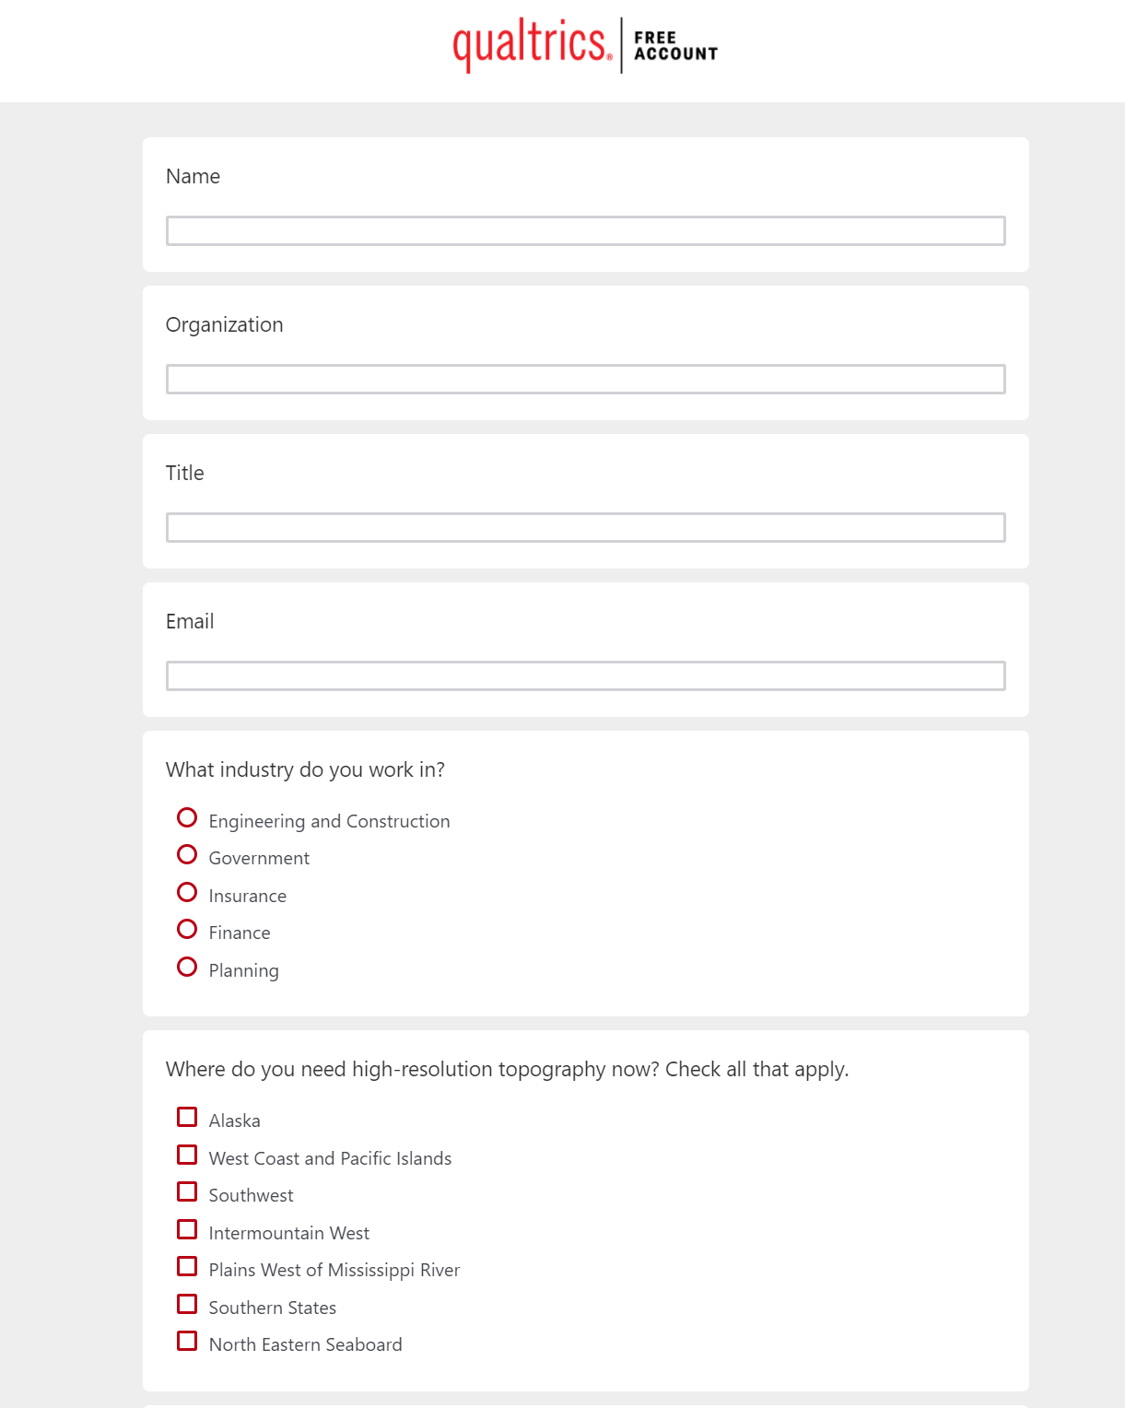

Administration of the Instrument
- How will you collect the information? (Check all that apply)
[X] Web-based or other forms of Social Media
[ ] Telephone
[ ] In-person
[ ] Mail
[ ] Other, Explain

- Will interviewers or facilitators be used? [ ] Yes [X] No

Please make sure that all instruments, instructions, and scripts are submitted with the request.

INSTRUCTIONS

TITLE OF INFORMATION COLLECTION: Provide the name of the collection that is the subject of the request. (e.g., Comment card for soliciting feedback on xxxx)

PURPOSE: Provide a brief description of the purpose of this collection and how it will be used. If this is part of a larger study or effort, please include this in your explanation.

DESCRIPTION OF RESPONDENTS: Provide a brief description of the targeted group or groups for this collection of information. These groups must have experience with the program.

TYPE OF COLLECTION: Check one box. If you are requesting approval of other instruments under the generic, you must complete a form for each instrument.

CERTIFICATION: Please read the certification carefully. If you incorrectly certify, the collection will be returned as improperly submitted or it will be disapproved.

Personally Identifiable Information: Provide answers to the questions.

Gifts or Payments: If you answer yes to the question, please describe the incentive and provide a justification for the amount.

BURDEN HOURS:
Category of Respondents: Identify who you expect the respondents to be in terms of the following categories: (1) Individuals or Households; (2) Private Sector; (3) State, local, or tribal governments; or (4) Federal Government. Only one type of respondent can be selected.
No. of Respondents: Provide an estimate of the Number of respondents.
Participation Time: Provide an estimate of the amount of time required for a respondent to participate (e.g., fill out a survey or participate in a focus group)
Burden: Provide the Annual burden hours: Multiply the Number of responses and the participation time in minutes and divide by 60.

FEDERAL COST: Provide an estimate of the annual cost to the Federal government.

If you are conducting a focus group, survey, or plan to employ statistical methods, please provide answers to the following questions:

The selection of your targeted respondents. Please provide a description of how you plan to identify your potential group of respondents and how you will select them. If the answer is yes, to the first question, you may provide the sampling plan in an attachment.

Administration of the Instrument: Identify how the information will be collected. More than one box may be checked. Indicate whether there will be interviewers (e.g., for surveys) or facilitators (e.g., for focus groups) used.

Please make sure that all instruments, instructions, and scripts are submitted with the request.

