- How often do you travel between China and the United States of America?

□ Never
□ Occasionally (less than once per year)
□ 1-3 times per year
□ More than 3 times per year

- How confident are you in your understanding of what wildlife products, including medicinals and souvenirs, can be legally transported between China and the U.S.?

Not confident | A little confident | Not sure | Somewhat confident | Very confident

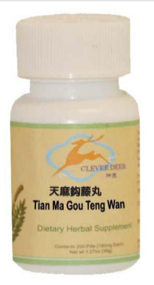
- Do you think these items are always legal to import into the US?

Not confident | A little confident | Not sure | Somewhat confident | Very confident

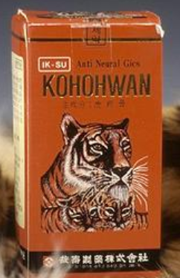
Not confident | A little confident | Not sure | Somewhat confident | Very confident

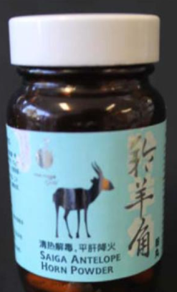

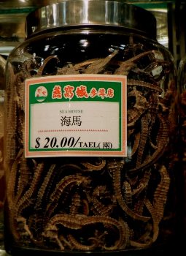

Not confident | A little confident | Not sure | Somewhat confident | Very confident

Not confident | A little confident | Not sure | Somewhat confident | Very confident

Not confident | A little confident | Not sure | Somewhat confident | Very confident

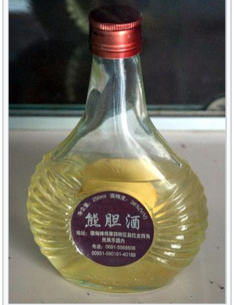

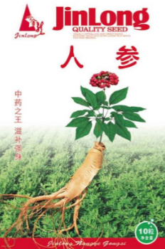
Not confident | A little confident | Not sure | Somewhat confident | Very confident

- How confident are you that you could find accurate information to determine whether wildlife and wildlife products can be legally brought into the U.S. from China?

Not confident | A little confident | Not sure | Somewhat confident | Very confident

- If you knew it would protect endangered animals and plants, how likely or unlikely would it be for you to ask questions about souvenirs and goods before buying them in China?

Very Unlikely | Unlikely | Neutral | Likely | Very Likely | Not Sure

- If you knew that an item could be potentially confiscated in customs, how would it impact your decision to buy it during your trip?

□ Increase chance of buying
□ Decrease chance of buying
□ No impact

- Where would it be most helpful for you to obtain information about the legality of transporting wildlife products from China into the U.S.?

□ Directly from vendors
□ From airlines, cruiselines, and other transportation companies
□ From websites when booking my travel
□ From hotels
□ From travel websites and books
□ From tour operators
□ Other: ____________________________________________
□ Not sure

