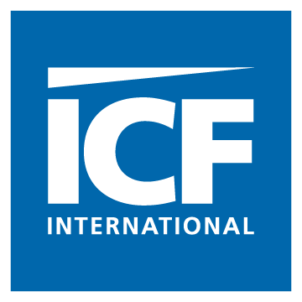

Recommended Sites for 408(b) (2) Focus Groups

The original plan of conducting focus groups in eight locations has been revised due to the desire to conduct two additional focus groups. One of these additional focus groups will consist only of fiduciaries of medium-sized plans, and one will consist only of fiduciaries of large-sized plans. To accommodate this request, ICF will now conduct six focus groups for small plans, instead of the original plan of eight groups of small plan fiduciaries. ICF’s plan is to conduct these eight focus groups in four different geographic locations, and to conduct two focus groups per day in each of the four locations.

Based the analysis previously conducted by ICF of the Form 5500 data, we propose the following four locations for conducting the focus groups:

1. Atlanta, Georgia. Atlanta will represent the Southeast United States. Atlanta was selected over Columbia, South Carolina and Durham, North Carolina because plans in Atlanta have particularly high average expenses ($73,000 per plan) and a higher proportion of participants file Form 5500 (18 percent) versus the short form than in Columbia (13 percent) and Durham (16 percent).

2. Chicago, Illinois. Chicago is the third most populous city in the United States, after New York City and Los Angeles. With 2.7 million residents, it is the most populous city in the American Midwest. Due to their large population base, either Chicago, Illinois or Los Angeles, California will likely host the focus group session for the fiduciaries of large-size plans.

3. Los Angeles, California. Los Angeles was chosen over other California Metropolitan Statistical Areas (MSAs) (Sacramento, San Diego, and San Francisco) because plans in Los Angeles have the highest average annual plan expenses ($90,000) of the MSAs reviewed. As noted in the previous bullet, Los Angeles may host the focus group session for the fiduciaries of large-size plans.

4. Washington, DC. Washington, DC will represent the Mid-Atlantic region and was chosen over the three surrounding office locations (Baltimore, MD; Charleston, WV; and Richmond, VA) for its low percentage of profit-sharing plans (91 percent versus the 96 percent national average).

