**RECS National Pilot**

**Respondent Contact Materials**

**1. Prenotification 8.5X5.5” Postcard**

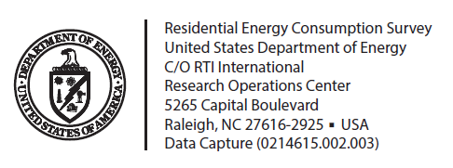

Dear Resident,

I am writing to ask your help in a nationwide study being conducted by the United States Department of Energy. Through this study, we will learn how Americans use energy in their homes—information that is not available anywhere else. This information is critical to understanding future energy needs and improving efficiency.

Next week, you will receive an invitation to complete the 2015 Residential Energy Consumption Survey. The invitation will include $5 in cash as a thank you in advance. Your household is one of only a small number that have been randomly selected to participate. When the invitation arrives, please follow the instructions and complete the questionnaire promptly to ensure that households like yours are represented in this study.

If you would like more information on the study, please visit: [www.eia.gov/consumption/residential/](http://www.eia.gov/consumption/residential/)

Many Thanks!

Tom Leckey

Director, Office of Energy Consumption and Efficiency Statistics

U.S. Energy Information Administration,

United States Department of Energy

RESIDENT

[RECIPIENT ADDRESS]

[CITY, ST ZIP]

**2a. Survey Mailing 1 Cover Letter**

**CAWI/PAPI and CAWI Version**

**Department of Energy**

**Washington, DC 20585**

**$5 is included now as a thank you in advance!**

**We will send [$10/$20] when you complete the questionnaire.**

RESIDENT

[STREET ADDRESS]

[CITY, STATE ZIP]

Dear Resident,

I am writing to ask for your help in a nationwide study being conducted by the United States Department of Energy. Through this study, we will learn how Americans use energy in their homes—information that is not available anywhere else. This information is critical to understanding future energy needs and improving efficiency.

Please help us with this study by completing the 2015 Residential Energy Consumption Survey. This study concerns the energy usage in homes across the United States. Your household is one of only a small number that have been randomly selected to participate.

If you have access to the Internet, please go to the following website, enter your Web Survey ID, and complete the online questionnaire:

**Website: RECS.rti.org**

**Web Survey ID: [StudyID]**

It will take about 30 minutes to complete. We have included $5 as a thank you in advance for your participation. As an additional thank you, we will mail you [$10/$20] once you are finished. Although your participation is voluntary, your answers will make sure that households like yours are represented in this study.

Thank you in advance for your assistance with this important study!

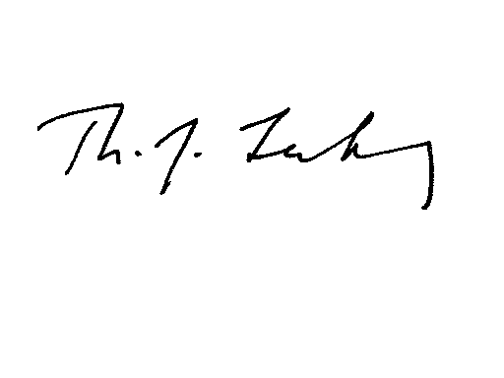Sincerely,

Tom Leckey

Director, Office of Energy Consumption and Efficiency Statistics

U.S. Energy Information Administration

United States Department of Energy

**2b. Survey Mailing 1 Cover Letter**

**Choice Version**

**Department of Energy**

**Washington, DC 20585**

**$5 is included now as a thank you in advance!**

**We will send [$10/$20] when you complete the questionnaire.**

RESIDENT

[STREET ADDRESS]

[CITY, STATE ZIP]

Dear Resident,

I am writing to ask for your help in a nationwide study being conducted by the United States Department of Energy. Through this study, we will learn how Americans use energy in their homes—information that is not available anywhere else. This information is critical to understanding future energy needs and improving efficiency.

Please help us with this study by completing the 2015 Residential Energy Consumption Survey. This study concerns the energy usage in homes across the United States. Your household is one of only a small number that have been randomly selected to participate.

If you have access to the Internet, please go to the following website, enter your Web Survey ID, and complete the online questionnaire:

**Website: RECS.rti.org**

**Web Survey ID: [StudyID]**

If you prefer you may complete the enclosed questionnaire and return it in the postage-paid envelope.

It will take about 30 minutes to complete. We have included $5 as a thank you in advance for your participation. As an additional thank you, we will mail you [$10/$20] once you are finished. Although your participation is voluntary, your answers will make sure that households like yours are represented in this study.

Thank you in advance for your assistance with this important study!

Sincerely,

Tom Leckey

Director, Office of Energy Consumption and Efficiency Statistics

U.S. Energy Information Administration

United States Department of Energy

**2c. Survey Mailing 1 Cover Letter**

**Choice+ Version**

**Department of Energy**

**Washington, DC 20585**

**$5 is included now as a thank you in advance!**

**We will send [$10/$20] when you complete the questionnaire and a bonus $10 (for total of [$20/$30]) if you complete the questionnaire online instead of using the paper form.**

RESIDENT

[STREET ADDRESS]

[CITY, STATE ZIP]

Dear Resident,

I am writing to ask for your help in a nationwide study being conducted by the United States Department of Energy. Through this study, we will learn how Americans use energy in their homes—information that is not available anywhere else. This information is critical to understanding future energy needs and improving efficiency.

Please help us with this study by completing the 2015 Residential Energy Consumption Survey. This study concerns the energy usage in homes across the United States. Your household is one of only a small number that have been randomly selected to participate.

If you have access to the Internet, please go to the following website, enter your Web Survey ID, and complete the online questionnaire:

**Website: RECS.rti.org**

**Web Survey ID: [StudyID]**

If you prefer you may complete the enclosed questionnaire and return it in the postage-paid envelope.

It will take about 30 minutes to complete. We have included $5 as a thank you in advance for your participation. As an additional thank you, we will mail you [$10/$20] for completing and returning the enclosed questionnaire or [$20/30] for completing the questionnaire online]. Although your participation is voluntary, your answers will make sure that households like yours are represented in this study.

Thank you in advance for your assistance with this important study!

Sincerely,

Tom Leckey

Director, Office of Energy Consumption and Efficiency Statistics

U.S. Energy Information Administration

United States Department of Energy

**3a. Postcard Reminder**

**CAWI/PAPI and CAWI Version**

|  |  |
| --- | --- |
| RESIDENT  [RECIPIENT ADDRESS]  [CITY, ST ZIP] |  |
|  |
|  |

Dear Resident,

Last week, I mailed you a letter asking you to complete an online questionnaire about household energy use.

If you or someone in your household has already completed the questionnaire, please accept my sincere thanks. If not, please do so today.

The website for the study and your Web Survey ID is enclosed. If you have any questions, please call us at 1-866-800-9177.

Many thanks,

Tom Leckey

Director, Office of Energy Consumption and Efficiency Statistics

U.S. Energy Information Administration

United States Department of Energy

United States Department of Energy

|  |  |
| --- | --- |
|  |  |
|  |
|  |

**Website: RECS.rti.org**

**Web Survey ID: [StudyID]**

**We will send [$10/$20] when you complete the questionnaire.**

**3b. Postcard Reminder**

**Choice and Choice+ Version**

|  |  |
| --- | --- |
| RESIDENT  [RECIPIENT ADDRESS]  [CITY, ST ZIP] |  |
|  |
|  |

Dear Resident,

Last week, I mailed you a package asking you to complete a questionnaire about household energy use.

If you or someone in your household has already completed the questionnaire, please accept my sincere thanks. If not, please do so today. The website for the study and your Web Survey ID is again enclosed. If you prefer paper, a printed questionnaire and postage-paid return envelope was provided in the previous package.

If you have any questions, please call us at 1-866-800-9177.

Many thanks,

Tom Leckey

Director, Office of Energy Consumption and Efficiency Statistics

U.S. Energy Information Administration

United States Department of Energy

|  |  |
| --- | --- |
|  |  |
|  |
|  |

**Website: RECS.rti.org**

**Web Survey ID: [StudyID]**

**[We will send $10 when you complete the questionnaire./We will send $20 when you complete the questionnaire. We will send $10 when you complete the questionnaire and a bonus $10 (for total of 20 if you complete the questionnaire online instead of using the paper form./We will send $20 when you complete the questionnaire and a bonus $10 (for total of $30) if you complete the questionnaire online instead of using the paper form.]**

**4a. Survey Mailing 2 Cover Letter**

**Web First, Web Only, and Choice Versions**

**4a. Survey Mailing 2 Cover Letter**

**CAWI Version**

**Department of Energy**

**Washington, DC 20585**

**We will send [$10/$20] when we receive your completed questionnaire.**

RESIDENT

[STREET ADDRESS]

[CITY, STATE ZIP]

Dear Resident,

Recently, I sent you a letter asking for your help with a study about household energy use.

If you or someone in your household has already completed the 2015 Residential Energy Consumption Survey please accept my sincere thanks. If not, please complete it online by going to the website below.

**Website: RECS.rti.org**

**Web Survey ID: [StudyID]**

It will take about 30 minutes to complete. As a thank you for participating, we will send you [$10/$20] when you are finished.

If you have any questions, please call us toll-free at 1-866-800-9177.

Thank you in advance for your assistance with this important study!

Sincerely,



Tom Leckey

Director, Office of Energy Consumption and Efficiency Statistics

U.S. Energy Information Administration

United States Department of Energy

**4b. Survey Mailing 2 Cover Letter**

**CAWI/PAPI and Choice Version**

**Department of Energy**

**Washington, DC 20585**

**We will send [$10/$20] when we receive your completed questionnaire.**

RESIDENT

[STREET ADDRESS]

[CITY, STATE ZIP]

Dear Resident,

Recently, I sent you a letter asking for your help with a study about household energy use.

If you or someone in your household has already completed the 2015 Residential Energy Consumption Survey please accept my sincere thanks. If not, please complete it online by going to the website below.

**Website: RECS.rti.org**

**Web Survey ID: [StudyID]**

If you prefer you may complete the enclosed questionnaire and return it in the postage-paid envelope.

It will take about 30 minutes to complete. As a thank you for participating, we will send you [$10/$20] when you are finished.

If you have any questions, please call us toll-free at 1-866-800-9177.

Thank you in advance for your assistance with this important study!

Sincerely,



Tom Leckey

Director, Office of Energy Consumption and Efficiency Statistics

U.S. Energy Information Administration

United States Department of Energy

**4c. Survey Mailing 2 Cover Letter**

**Choice+ Version**

**Department of Energy**

**Washington, DC 20585**

**We will send [$10/$20] when you complete the questionnaire and a bonus $10 (for total of [$20/$30]) if you complete the questionnaire online instead of using the paper form.**

**.instead of using the paper form].**

RESIDENT

[STREET ADDRESS]

[CITY, STATE ZIP]

Dear Resident,

Recently, I sent you a letter asking for your help with a study about household energy use.

If you or someone in your household has already completed the 2015 Residential Energy Consumption Survey please accept my sincere thanks. If not, please complete it online by going to the website below.

**Website: RECS.rti.org**

**Web Survey ID: [StudyID]**

If you prefer you may complete the enclosed questionnaire and return it in the postage-paid envelope.

It will take about 30 minutes to complete. As a thank you for participating, we will send you [$10/$20] for completing and returning the enclosed questionnaire or [$20/30] for completing the questionnaire online.

If you have any questions, please call us toll-free at 1-866-800-9177.

Thank you in advance for your assistance with this important study!

Sincerely,



Tom Leckey

Director, Office of Energy Consumption and Efficiency Statistics

U.S. Energy Information Administration

United States Department of Energy

**5a. Reminder Postcard**

**CAWI Version**



**We will send [$10/$20] when we receive your completed questionnaire.**

**SPANISH TRANSLATION**

RESIDENT

[RECIPIENT ADDRESS]

[CITY, ST ZIP]

**Website: RECS.rti.org**

**Web Survey ID: [StudyID]**

Dear Resident,

A few weeks ago, I contacted you about participating in a study about energy use in homes. Your participation is vital to understanding U.S. energy needs.

Please complete the questionnaire online using the website and the Web SurveyID printed on the inside of this postcard. We will send you [$10/$20] when we receive your completed questionnaire.

We will begin summarizing results of the study in the coming weeks. It is important to include households like yours for our results to be accurate.

If you would like more information about the study, please visit the study website at [www.eia.gov/consumption/residential/](http://www.eia.gov/consumption/residential/) or call us toll-free at 1-866-800-9177.

Many Thanks!

Tom Leckey

Director, Office of Energy Consumption and Efficiency Statistics

U.S. Energy Information Administration,

United States Department of Energy

**5b. Reminder Postcard**

**CAWI/PAPI and Choice Version**



**We will send [$10/$20] when we receive your completed questionnaire.**

**SPANISH TRANSLATION**

RESIDENT

[RECIPIENT ADDRESS]

[CITY, ST ZIP]

**Website: RECS.rti.org**

**Web Survey ID: [StudyID]**

Dear Resident,

A few weeks ago, I contacted you about participating in a study about energy use in homes. Your participation is vital to understanding U.S. energy needs.

Please complete the questionnaire online using the website and the Web SurveyID printed on the inside of this postcard. If you prefer you may instead complete the questionnaire we recently sent and return it in the postage-paid envelope provided. We will send you [$10/$20] when we receive your completed questionnaire.

We will begin summarizing results of the study in the coming weeks. It is important to include households like yours for our results to be accurate.

If you would like more information about the study, please visit the study website at [www.eia.gov/consumption/residential/](http://www.eia.gov/consumption/residential/) or call us toll-free at 1-866-800-9177.

Many Thanks!

Tom Leckey

Director, Office of Energy Consumption and Efficiency Statistics

U.S. Energy Information Administration,

United States Department of Energy

**5c. Reminder Postcard**

**Choice+ Version**



**We will send [$10/$20] when you complete the questionnaire and a bonus $10 (for total of [$20/$30]) if you complete the questionnaire online instead of using the paper form.**

RESIDENT

[RECIPIENT ADDRESS]

[CITY, ST ZIP]

Dear Resident,

A few weeks ago, I contacted you about participating in a study about energy use in homes. Your participation is vital to understanding U.S. energy needs.

Please complete the questionnaire online using the website and the Web SurveyID printed on the inside of this postcard. If you prefer you may instead complete the questionnaire we recently sent and return it in the postage-paid envelope provided. We will send you [$10/$20] when we receive your completed questionnaire by mail or [$20/$30] if you complete the survey online instead.

We will begin summarizing results of the study in the coming weeks. It is important to include households like yours for our results to be accurate.

If you would like more information about the study, please visit the study website at [www.eia.gov/consumption/residential/](http://www.eia.gov/consumption/residential/) or call us toll-free at 1-866-800-9177.

Many Thanks!

Tom Leckey

Director, Office of Energy Consumption and Efficiency Statistics

U.S. Energy Information Administration,

United States Department of Energy

**Website: RECS.rti.org**

**Web Survey ID: [StudyID]**

**6a. Final Survey Mailing Cover Letter**

**(via UPS)**

**CAWI Version**

**Department of Energy**

**Washington, DC 20585**

**We will send [$10/$20] when we receive your completed questionnaire.**

RESIDENT

[STREET ADDRESS]

[CITY, STATE ZIP]

Dear Resident,

In recent weeks, I have sent you an invitation to participate in a research study about your household’s energy usage. To the best of our knowledge, we have not yet received your responses. With your help, this study will provide information about household energy usage across the United States that can be used to understand our future energy needs and improve efficiency.

Please complete the questionnaire online by going to the website below.

**Website: RECS.rti.org**

**Web Survey ID: [StudyID]**

It will take about 30 minutes to complete. As a thank you for participating, we will send you [$10/$20] [when you are finished. Your responses are voluntary and will be kept confidential. If you have any questions about this study, please call us toll-free at 1-866-800-9177. This is the last time we will contact you.

Thank you so much for your help with this very important study!

Many thanks,

Tom Leckey

Director, Office of Energy Consumption and Efficiency Statistics

U.S. Energy Information Administration

United States Department of Energy

**6b. Final Survey Mailing Cover Letter**

**(via UPS)**

**CAWI/PAPI and Choice Version**

**Department of Energy**

**Washington, DC 20585**

**We will send [$10/$20] when we receive your completed questionnaire.**

RESIDENT

[STREET ADDRESS]

[CITY, STATE ZIP]

Dear Resident,

In recent weeks, I have sent you an invitation to participate in a research study about your household’s energy usage. To the best of our knowledge, we have not yet received your responses. With your help, this study will provide information about household energy usage across the United States that can be used to understand our future energy needs and improve efficiency.

Please complete the questionnaire online by going to the website below.

**Website: RECS.rti.org**

**Web Survey ID: [StudyID]**

If you prefer, you may complete the enclosed questionnaire and return it in the postage-paid envelope provided.

It will take about 30 minutes to complete. As a thank you for participating, we will send you [$10/$20] when you are finished. Your responses are voluntary and will be kept confidential. If you have any questions about this study, please call us toll-free at 1-866-800-9177. This is the last time we will contact you.

Thank you so much for your help with this very important study!

Many thanks,

Tom Leckey

Director, Office of Energy Consumption and Efficiency Statistics

U.S. Energy Information Administration

United States Department of Energy

**6c. Final Survey Mailing Cover Letter**

**(via UPS)**

**CAWI/PAPI and Choice Version**

**Department of Energy**

**Washington, DC 20585**

**We will send [$10/$20] when you complete the questionnaire and a bonus $10 (for total of [$20/$30]) if you complete the questionnaire online instead of using the paper form.**

RESIDENT

[STREET ADDRESS]

[CITY, STATE ZIP]

Dear Resident,

In recent weeks, I have sent you an invitation to participate in a research study about your household’s energy usage. To the best of our knowledge, we have not yet received your responses. With your help, this study will provide information about household energy usage across the United States that can be used to understand our future energy needs and improve efficiency.

Please complete the questionnaire online by going to the website below.

**Website: RECS.rti.org**

**Web Survey ID: [StudyID]**

If you prefer, you may complete the enclosed questionnaire and return it in the postage-paid envelope provided.

It will take about 30 minutes to complete. As a thank you for participating, we will send you [$10/$20] for completing and returning the enclosed questionnaire or [$20/30] for completing the questionnaire online. Your responses are voluntary and will be kept confidential. If you have any questions about this study, please call us toll-free at 1-866-800-9177. This is the last time we will contact you.

Thank you so much for your help with this very important study!

Many thanks,

Tom Leckey

Director, Office of Energy Consumption and Efficiency Statistics

U.S. Energy Information Administration

United States Department of Energy

**7. Cover Letter for Thank You/Post-paid IncentiveDepartment of Energy**

**Washington, DC 20585**

RESIDENT

[STREET ADDRESS]

[CITY, STATE ZIP]

Dear Resident,

We recently received your response to our questionnaire about household energy use, the 2015 Residential Energy Consumption Survey. Thank you very much for assisting us with this study.

We have enclosed [$10/$20/$30] for you as a way of saying thanks. We greatly appreciate your participation in this study!

Sincerely,

Tom Leckey

Director, Office of Energy Consumption and Efficiency Statistics

U.S. Energy Information Administration

United States Department of Energy

**8. Envelope Images**

1. #10 envelope

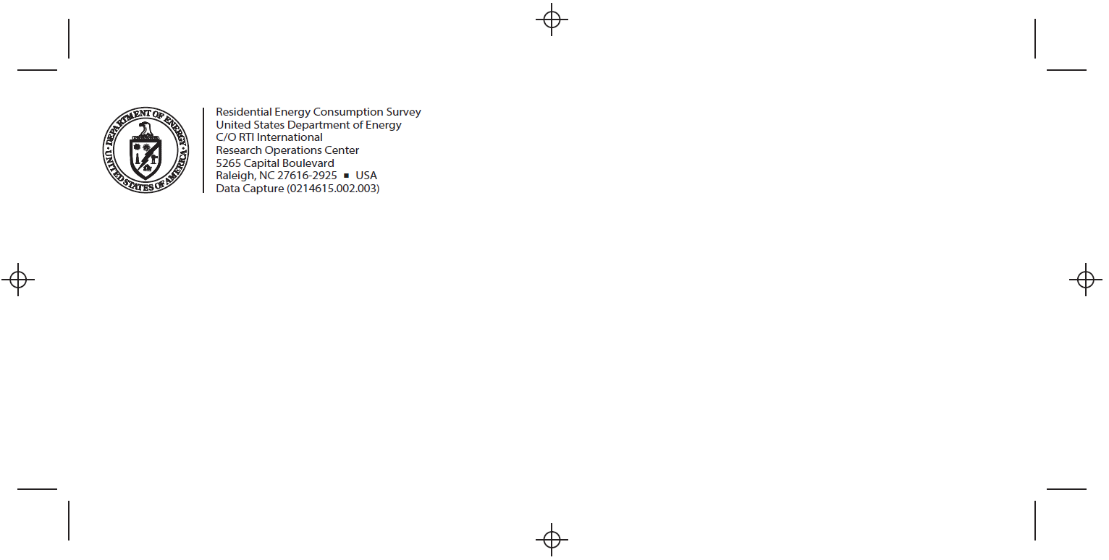

1. 9x12 outer envelope return address

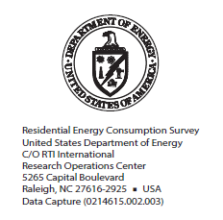

1. 9X12 BRE

