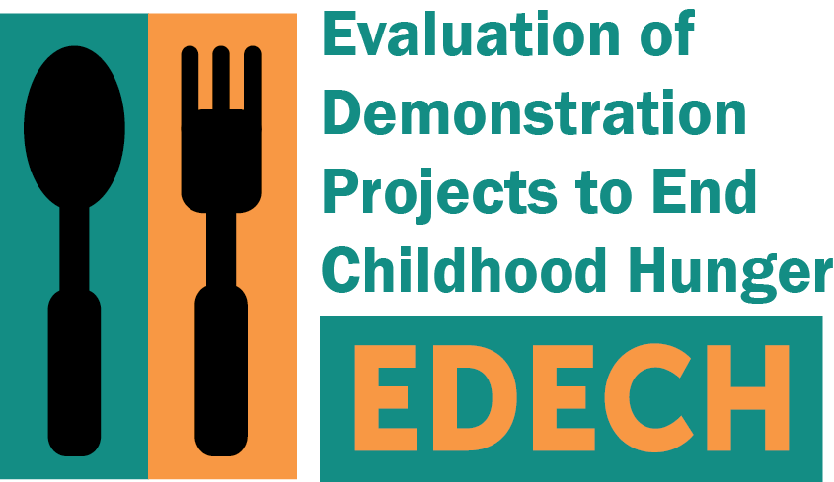

OMB Control No: 0584-XXXX

Expiration date: XX/XX/XXXX

Fall 2015

Dear [PARENT/GUARDIAN],

The U.S. Department of Agriculture’s Food and Nutrition Service (FNS) is asking for your help with a very important study, the Evaluation of Demonstration Projects to End Childhood Hunger (EDECH). [(IF NAVAJO NATION: You have consented to take; IF VIRGINIA: You received a letter with consent information about taking) part in a telephone survey for this study.] This evaluation will help us learn more about how projects like [DEMONSTRATION PROJECT] can help families feed their children. [DEMONSTRATION DESCRIPTION.] FNS has hired Mathematica Policy Research to conduct the evaluation.

(IF KENTUCKY OR NEVADA: If you agree to be in the study, we will ask you to complete two 30 to 35-minute phone surveys. The surveys are about your household’s experiences related to food. One survey is taking place now and one will be a year from now. We will also collect data about you from [DEMONSTRATION PROJECT]. The data will include information such as the benefits you may receive. We will use the data to describe the effect that [DEMONSTRATION PROJECT] and others like it have on households with children. We will not share information that identifies you or your household outside our study team.)

Your participation is very important to this study. **Please call [STUDY PHONE #] and complete the survey by [DATE].** The survey will take about 30 to 35 minutes to complete. It will ask about your household’s food-related experiences. If you participate,we will send you $30 as a thank you.

(IF KENTUCKY OR NEVADA: Mathematica takes your privacy very seriously. One risk of being in the study is that information about you might not stay private. We have taken steps to prevent this. We have strict rules to keep your data safe. We will remove names from any information we collect. No one from [GRANTEE AGENCY] will be allowed to see any of your answers from the phone survey.)

Participation in the study is completely voluntary. You do not have to take part. You can choose not to answer one or more questions. All of your answers to the questions will be kept private.

If you have any questions (IF KENTUCKY OR NEVADA:, or if you do not want to be in the study), please call our staff toll-free at [STUDY PHONE #] or email us at [STUDY EMAIL ADDRESS]. We look forward to speaking with you. [IF KENTUCKY OR NEVADA: If you have questions about your rights as a study volunteer, you can call (IF NEVADA: New England IRB at 1-800-232-9570; IF KENTUCKY: (contact information for IRB of accord))].

Sincerely,

Sarah Forrestal

EDECH Survey Director

*According to the Paperwork Reduction Act of 1995, an agency may not conduct or sponsor, and a person is not required to respond to, a collection of information unless it displays a valid OMB control number. The valid OMB control number for this information collection is 0584-XXXX. The time required to complete this information collection is estimated to average 3 minutes per response, including the time for reviewing instructions, searching existing data sources, gathering and maintaining the data needed, and completing and reviewing the collection of information.*