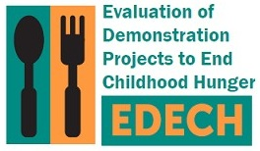

OMB Control No: 0584-XXXX

Expiration Date: XX/XX/XXXX

Fall 2015

Dear [PARENT/GUARDIAN],

Recently, we contacted you about participating in a telephone survey for the Evaluation of Demonstration Projects to End Childhood Hunger (EDECH). The U.S. Department of Agriculture’s Food and Nutrition Service (FNS) is funding this evaluation to learn about how projects like [DEMONSTRATION PROJECT] can help families feed their children. FNS has hired Mathematica Policy Research to conduct the evaluation.

Your participation is very important to this study, but we have not yet heard from you. Please call [STUDY PHONE #] toll-free to complete the survey. The survey asks about your household’s food-related experiences. This includes shopping for food and taking part in nutrition programs. To thank you for completing the 30 to 35-minute survey, we will send you $30. Please contact us by [DATE].

We value your input and we hope to hear from you. However, taking part in the study is voluntary – you can choose to take part or not. During the interview, you can skip any question you do not want to answer or that makes you feel uncomfortable. All of your answers to the questions will be kept safe and private.

Please call our toll-free number [STUDY PHONE #] or email us at [STUDY EMAIL ADDRESS] with any questions you have. We look forward to hearing from you.

Sincerely,

Sarah Forrestal

EDECH Survey Director