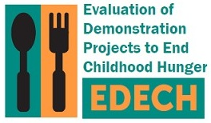

OMB Control No: 0584-XXXX

Expiration Date: XX/XX/XXXX

Fall 2015

Dear [PARENT/GUARDIAN],

Recently, we spoke with you about taking part in a telephone survey for the Evaluation of Demonstration Projects to End Childhood Hunger (EDECH), funded by the U.S. Department of Agriculture’s Food and Nutrition Service (FNS). This important study will provide information to help us learn about how [DEMONSTRATION PROJECT] and others like it can help families feed their children.

There are many households taking part in programs like [DEMONSTRATION PROJECT], but we can’t talk to them all. We have selected only some households to share their experiences. Your input matters and we want your voice to be heard. Each household that agrees to take part in the study will represent others with similar experiences. We understand your time is valuable, and can schedule the survey for a time that is convenient for you. To thank you for completing the 30 to 35-minute phone survey, we will send you $30.

An interviewer will contact you soon. We hope you decide to take part in the study. However, participation is completely voluntary. During the survey, you can choose to skip any question you do not want to answer or that makes you feel uncomfortable. All your answers to the questions will be kept private.

If you have any questions, or would like to complete the survey, please call our staff toll-free at [STUDY PHONE #]. You can also email us at [STUDY EMAIL ADDRESS]. We look forward to speaking with you.

Sincerely,

Sarah Forrestal

EDECH Survey Director