Appendix 1: Screenshots: NUPC Database Browser Based User Interface (Food Manufacturers and Distributors)

Login Screen

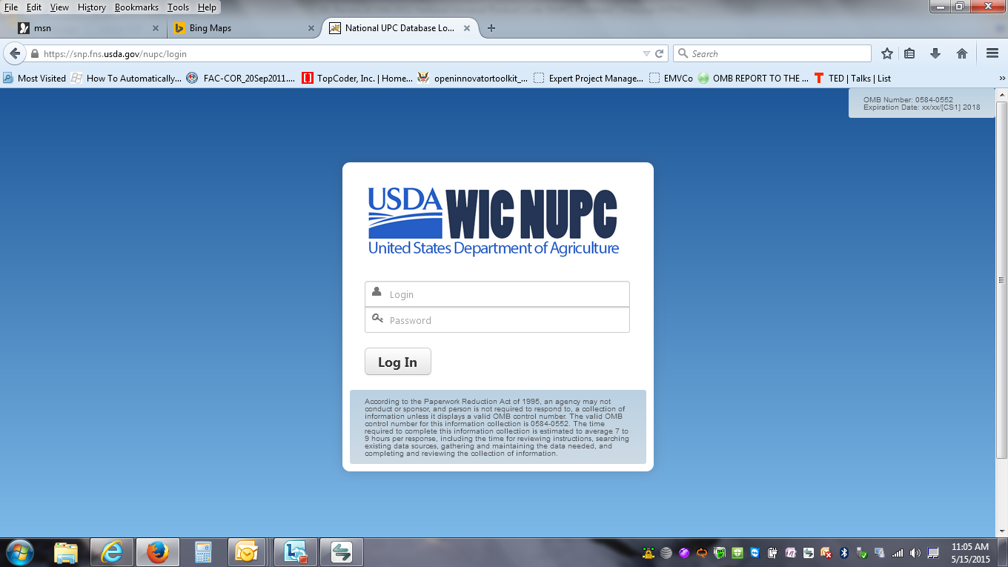

Home Page

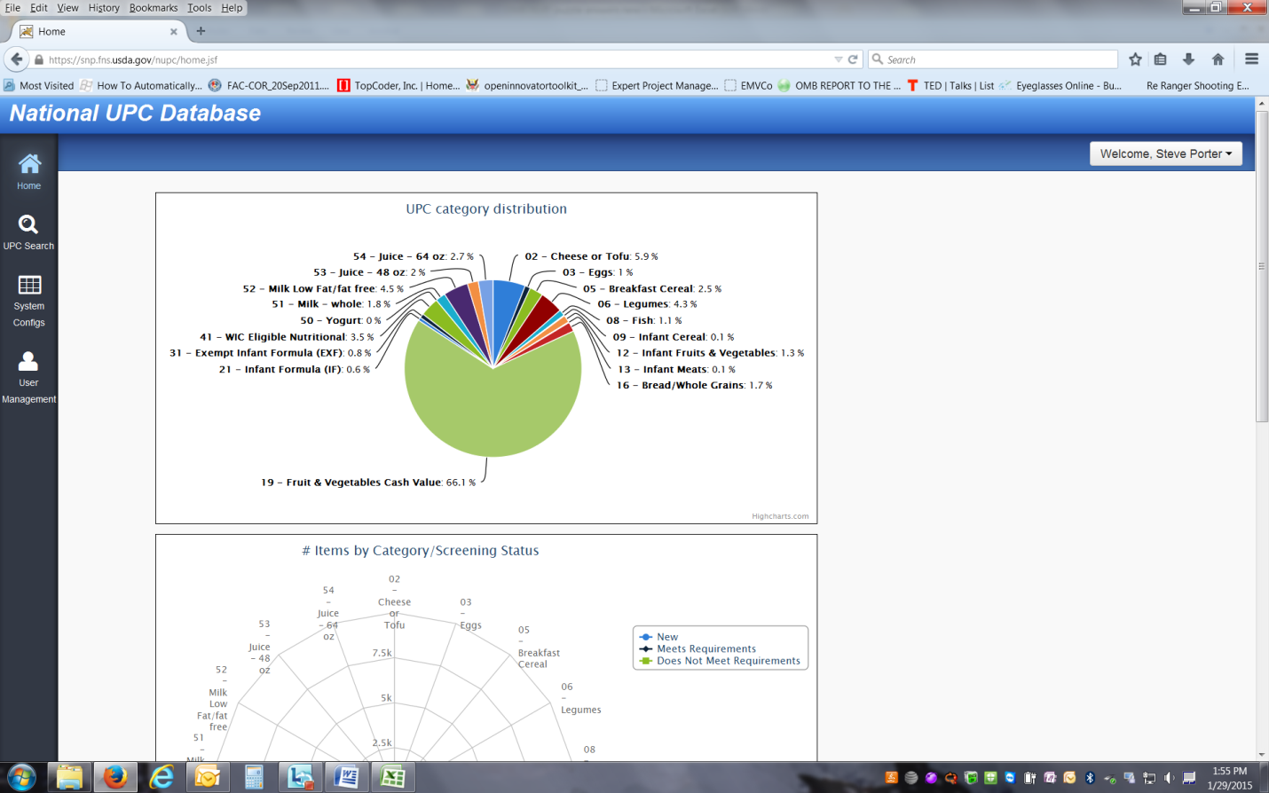

Search Screen

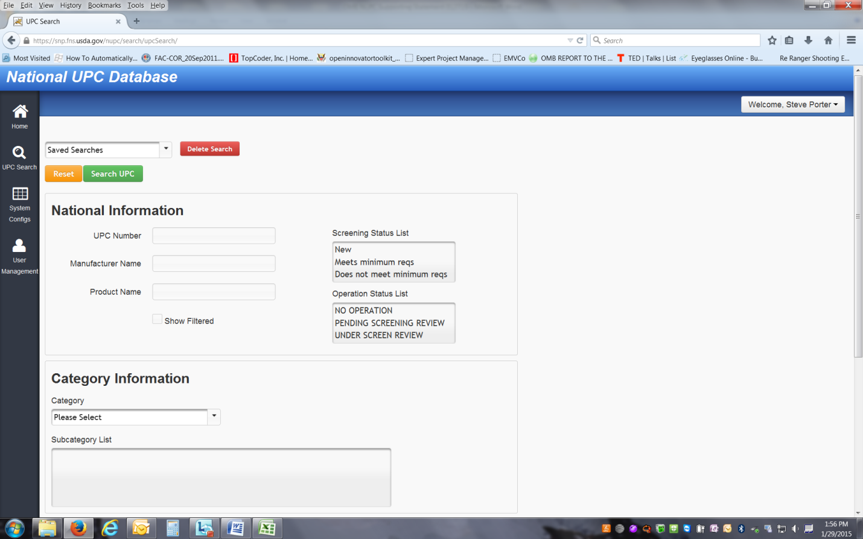

Search Results

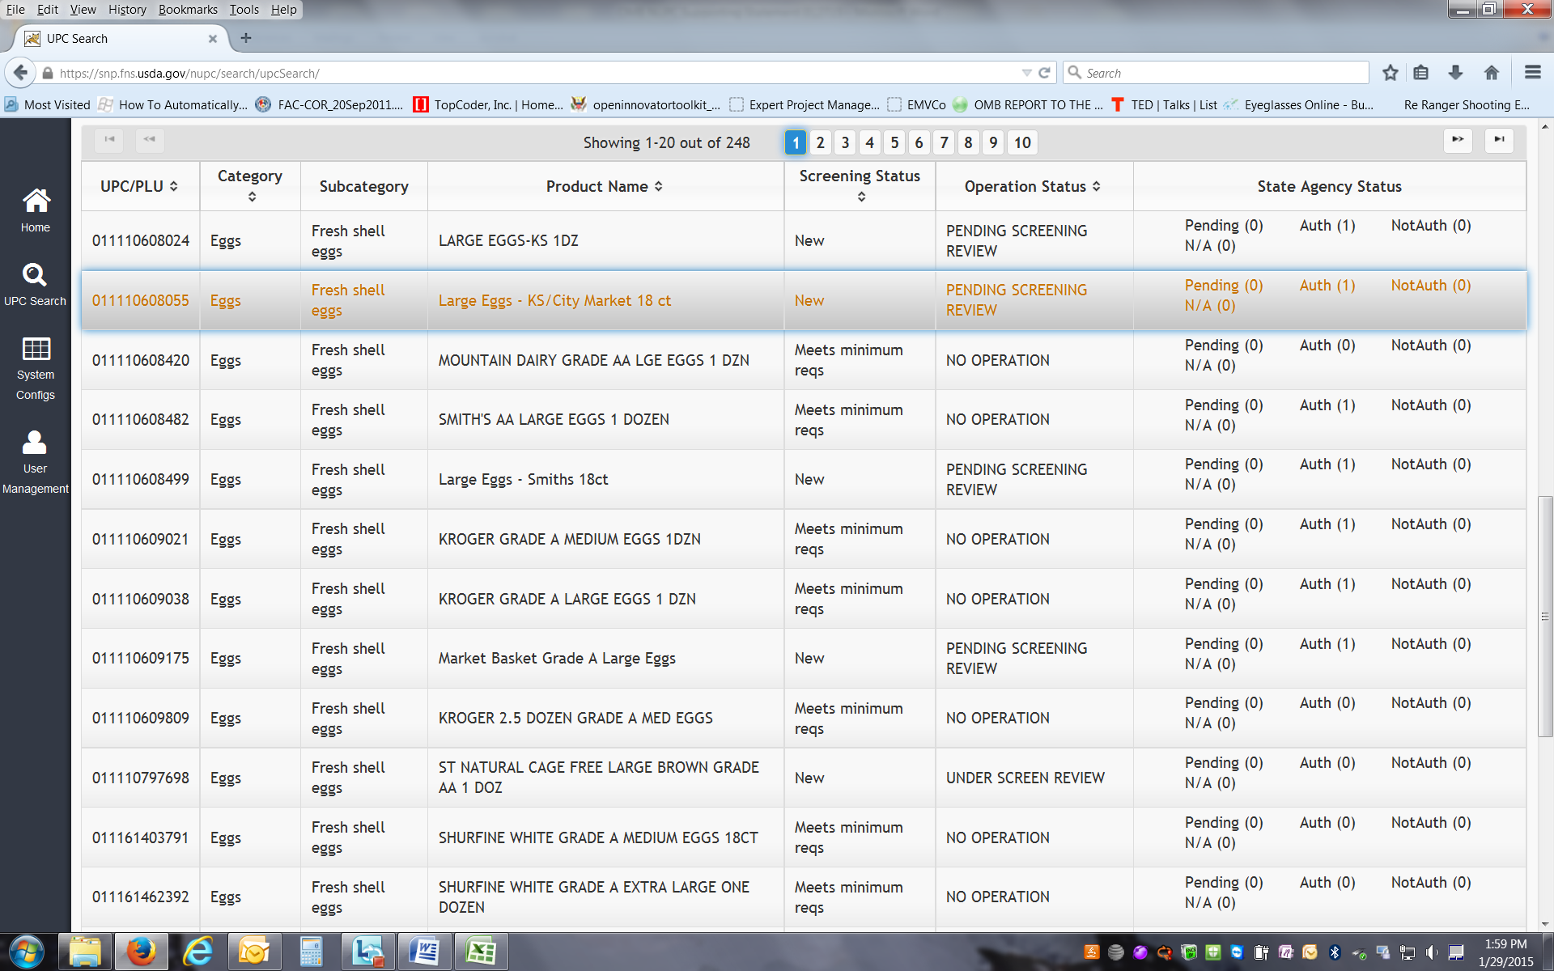

Individual Product Screen – UPC details

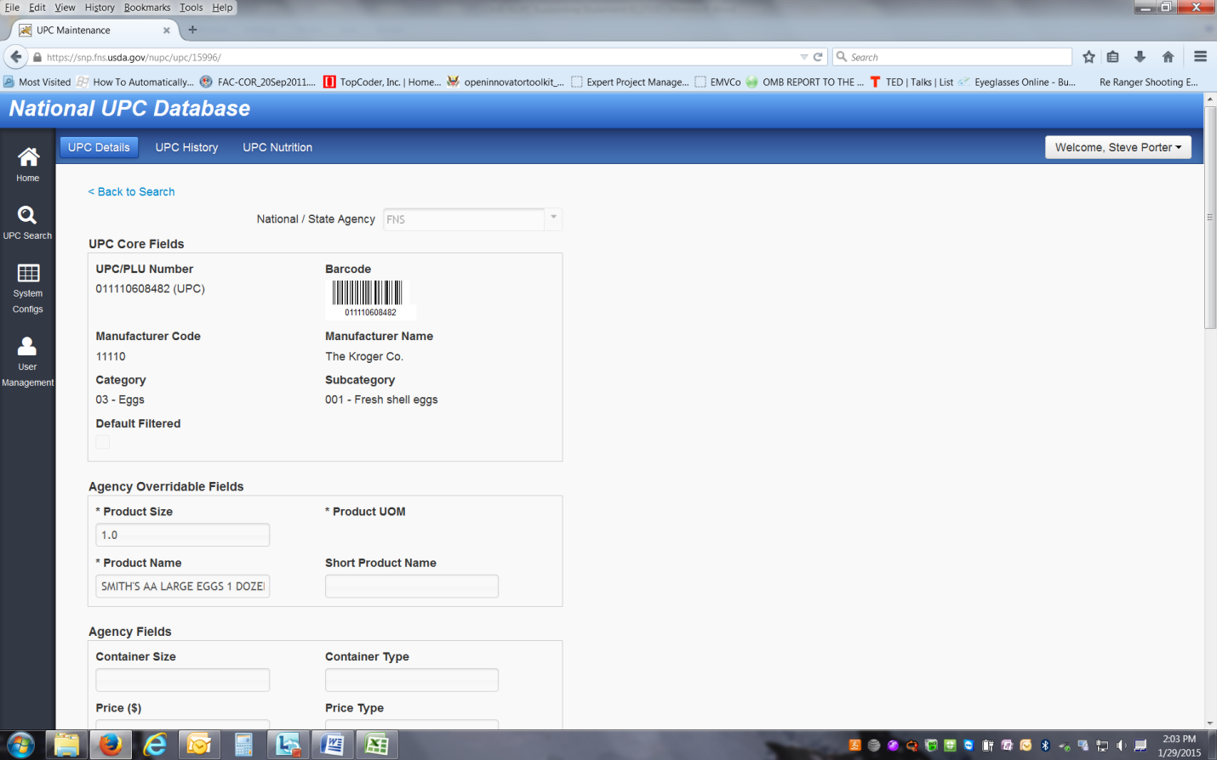

Individual Product Screen – UPC History

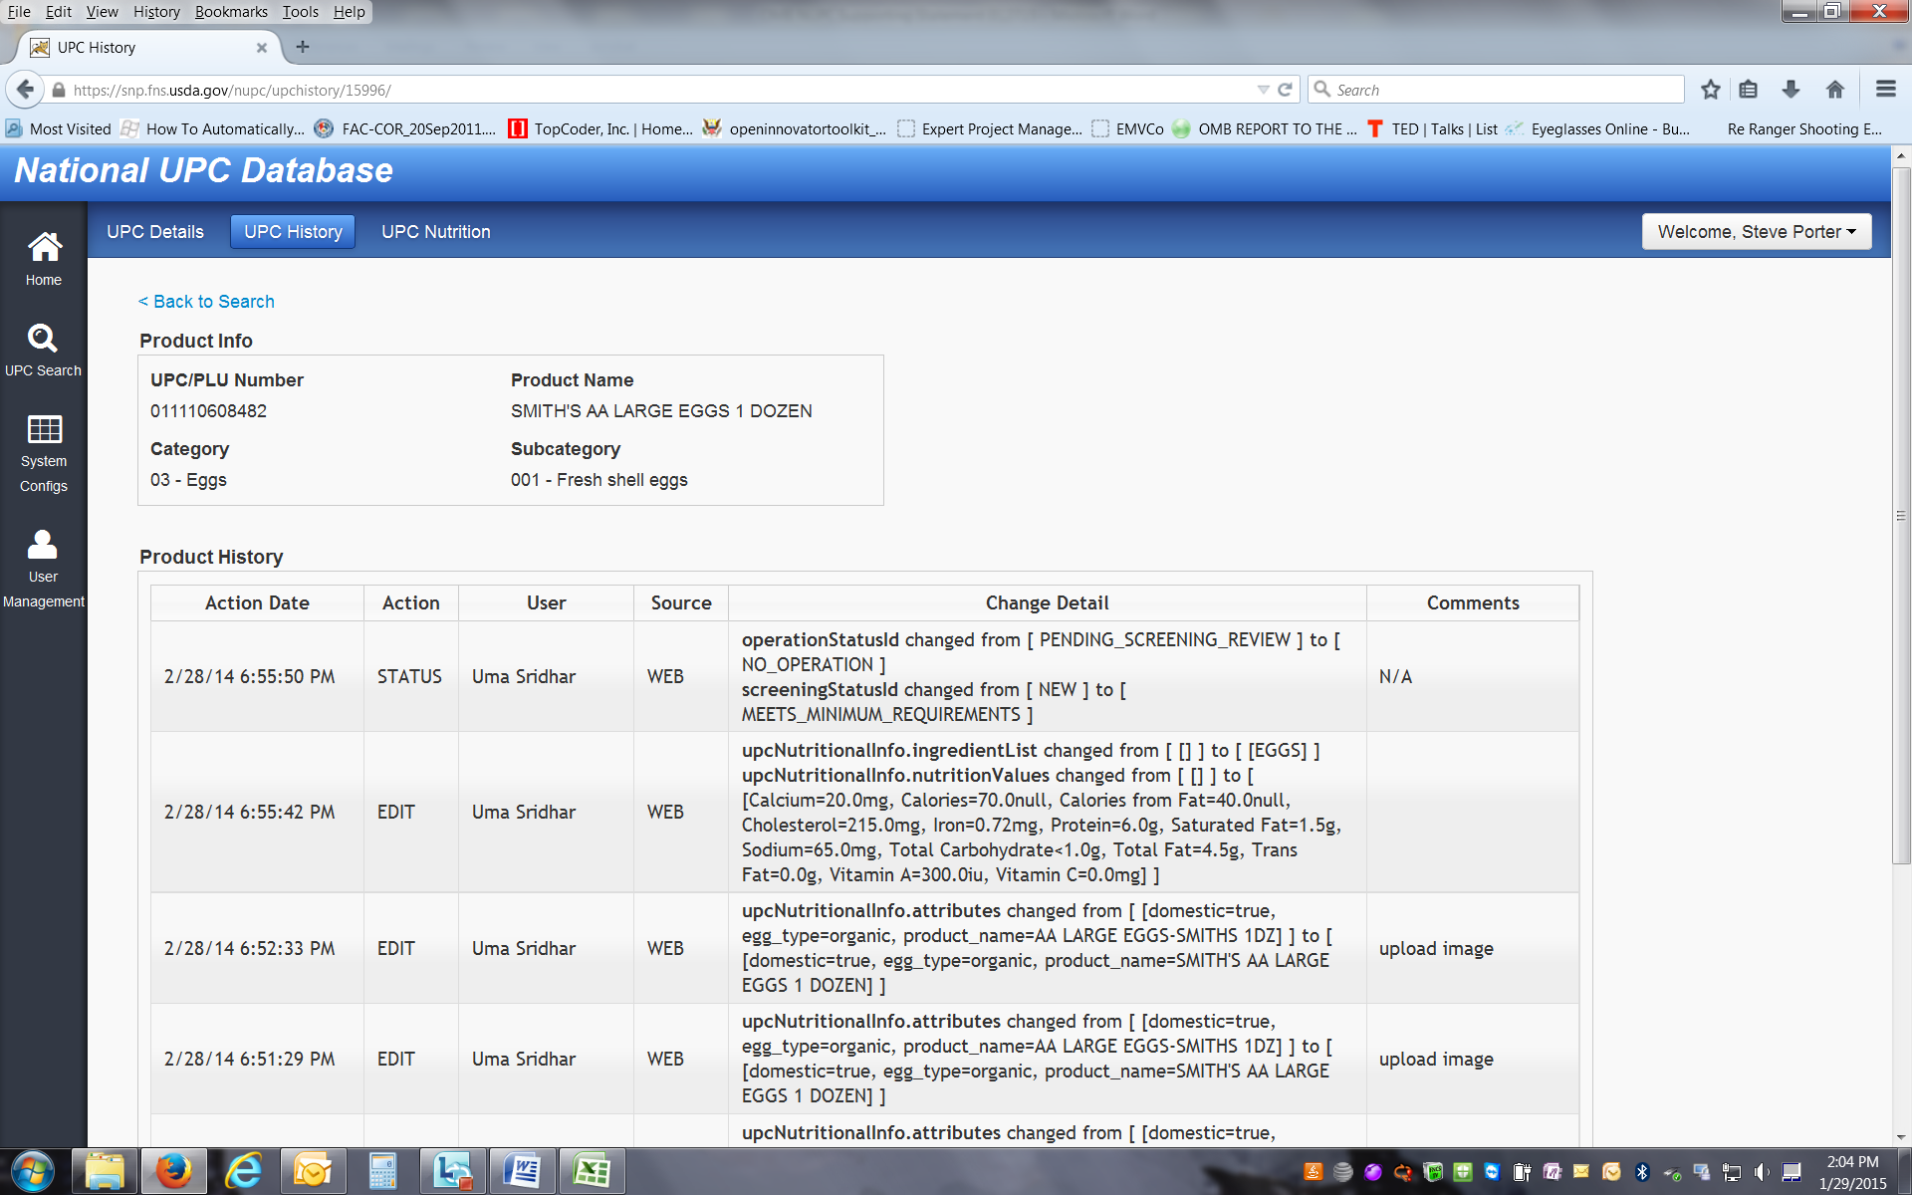

Individual Product Screen – UPC Nutrition

