**Appendix 2: Screenshots: NUPC Database Browser Based User Interface (Authorized Vendors)**

Login Screen

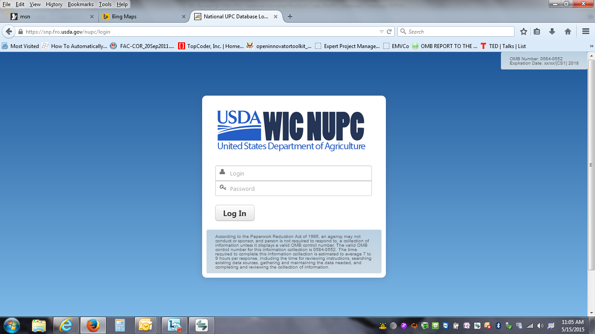

Home Page

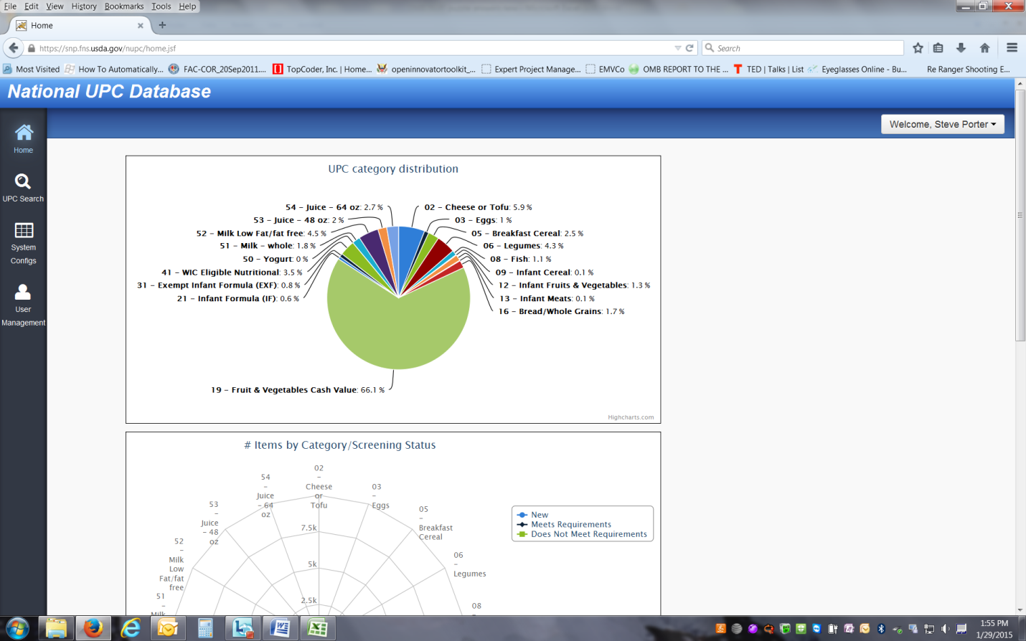

Search Screen

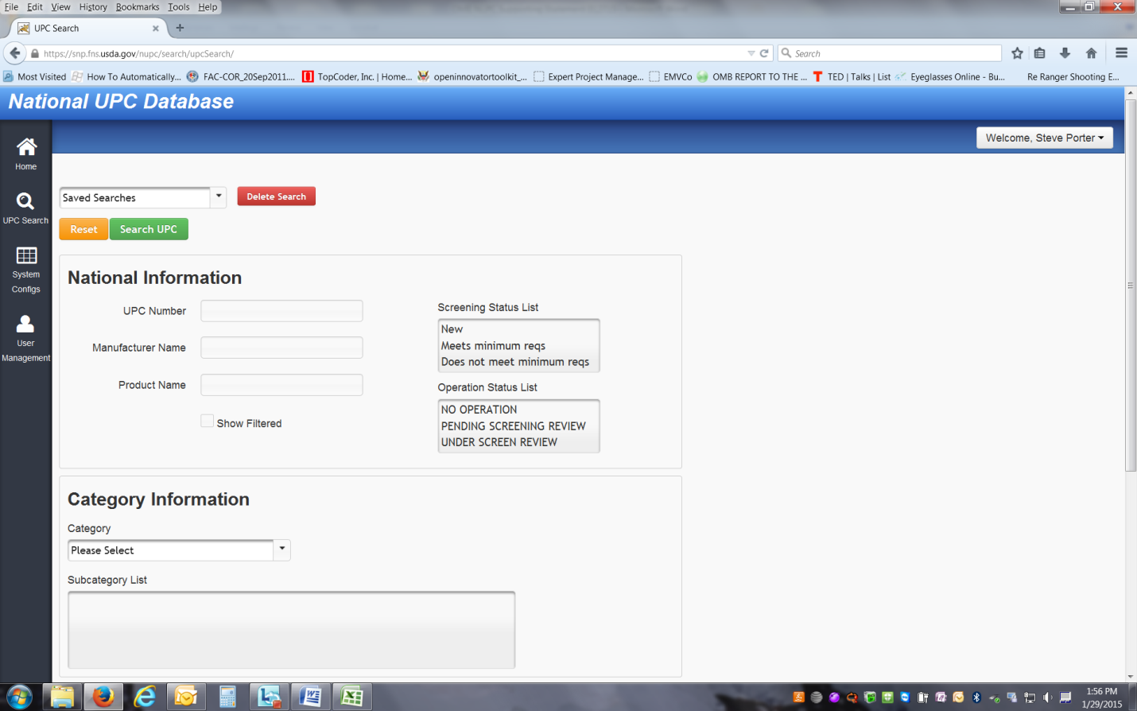

Search Results

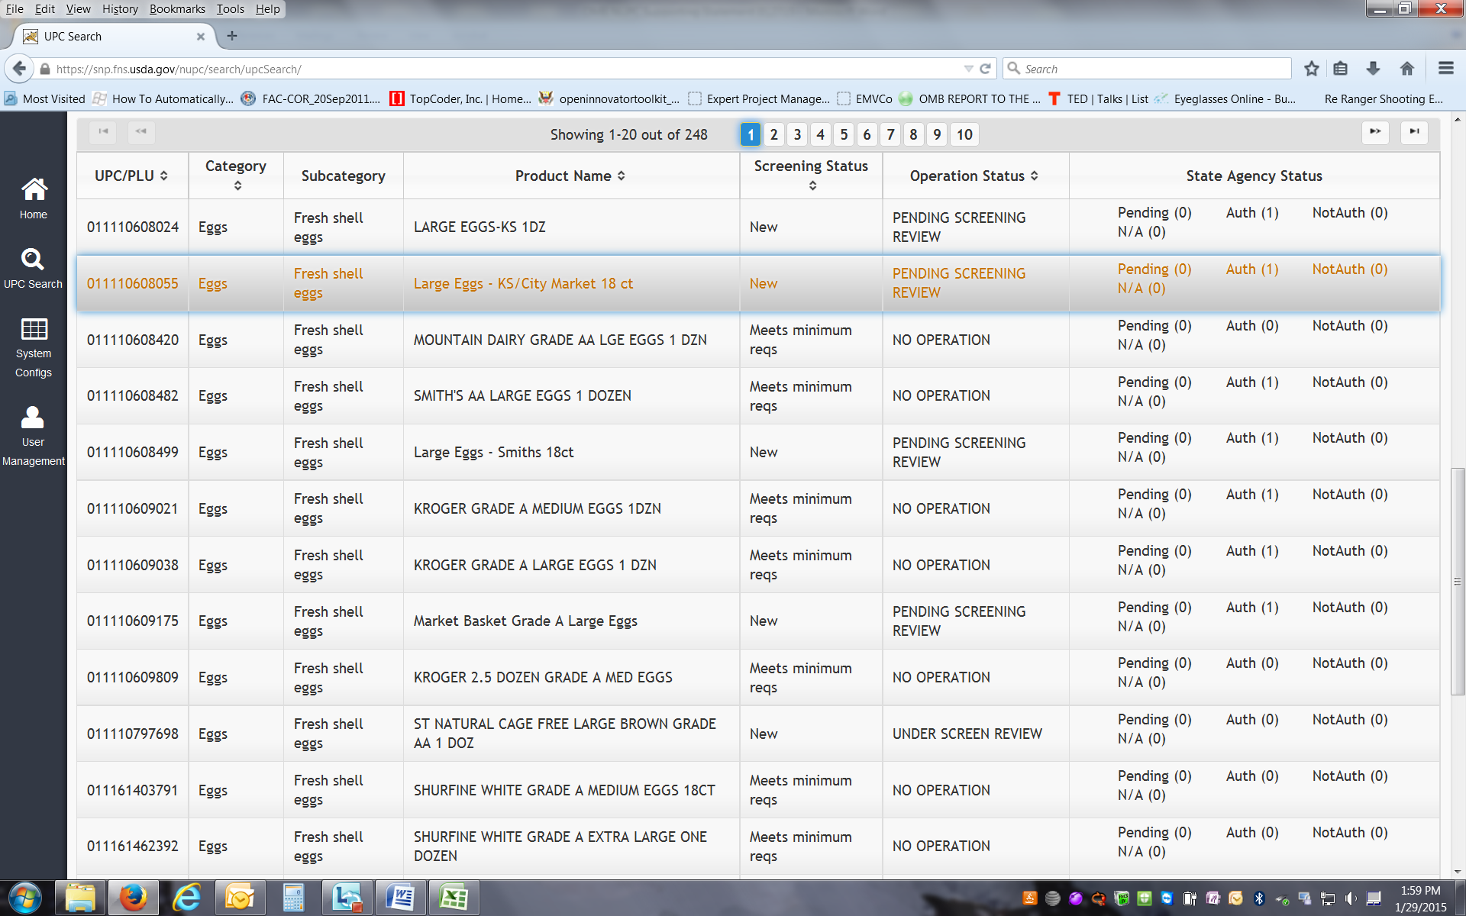

Individual Product Screen – UPC details

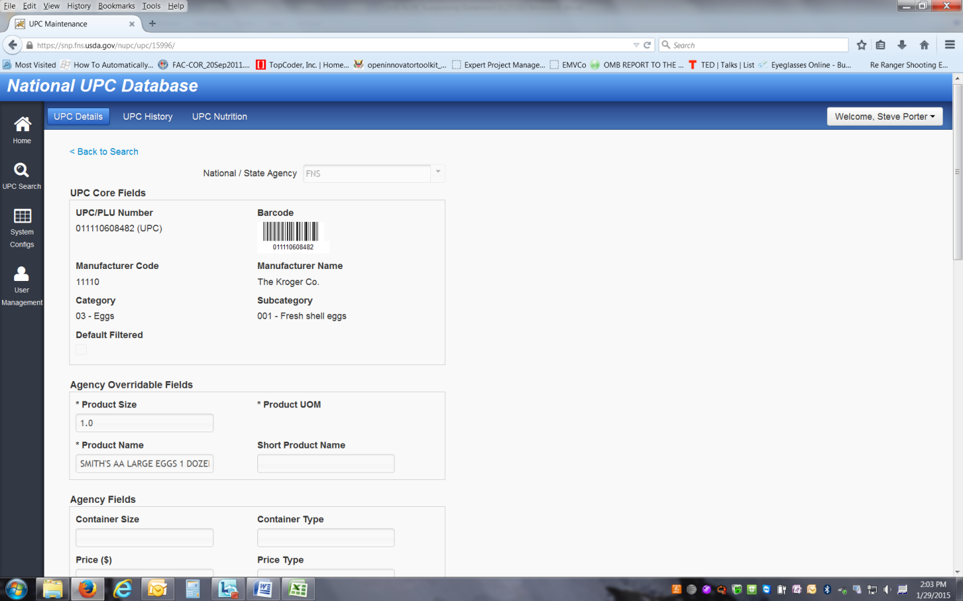

Individual Product Screen – UPC History

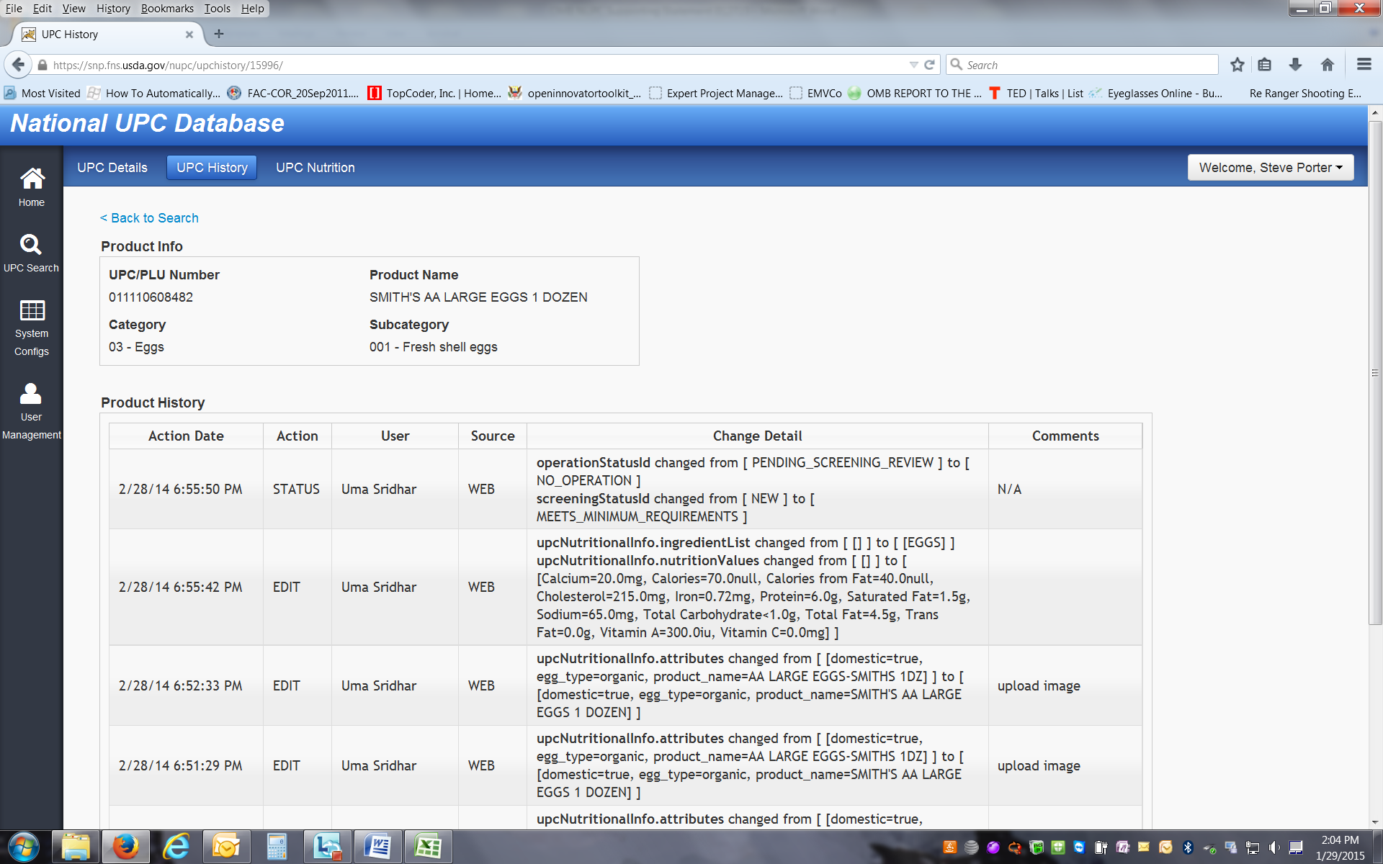

Individual Product Screen – UPC Nutrition

