Enclosure 2: Survey Screens

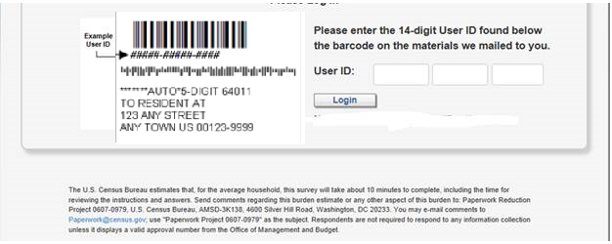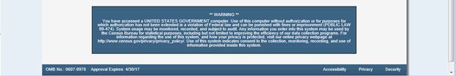
Figure 1: OMB number and expiration will be updated to: OMB # 0607-0971 expiration date=10/31/2015 on this screen and future screens.

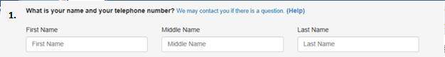
Version 1 Telephone Entry:
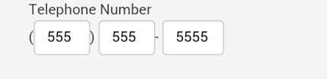
Version 2 Telephone Entry:
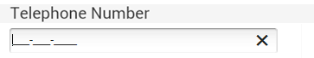

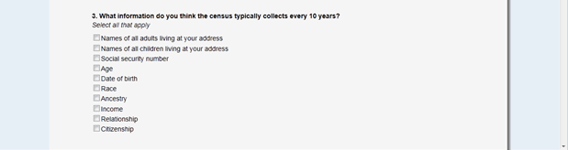
Figure 2: Figures 2 – 5 have questions that are on one long scroll. You can see the placement of the telephone question and the differences in format by version. All these questions and formats (except for Telephone Version 2) have been approved by OMB for a prior study or Census test.

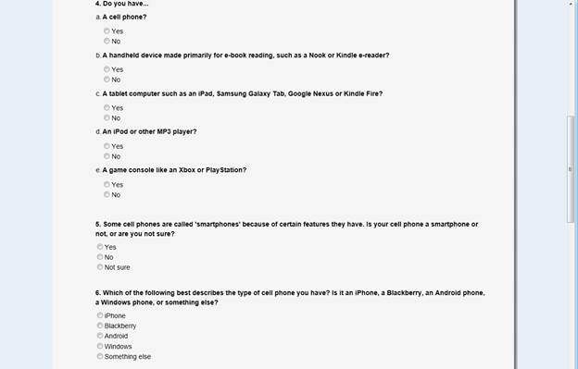
Figure 3: Continuation - (Version 1 and 2) All these questions and formats have been approved by OMB for a prior study or Census test.

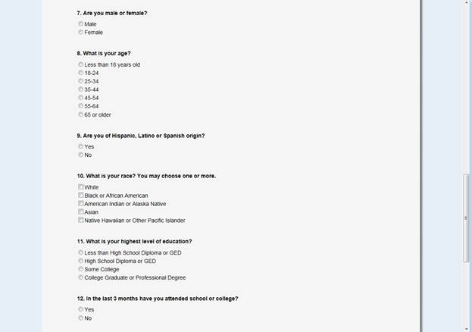
Figure 4: Continuation (Version 1 and 2) All these questions and formats have been approved by OMB for a prior study or Census test.

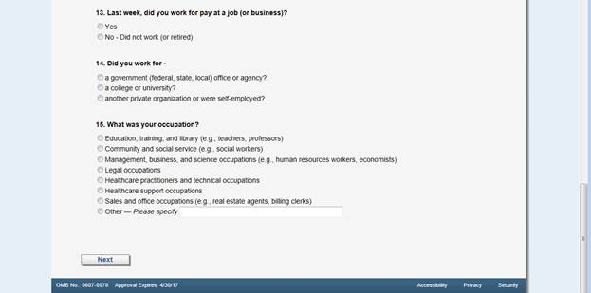
Figure 5: End of first screen. (Version 1 and 2) All these questions and formats have been approved by OMB for a prior study or Census test.

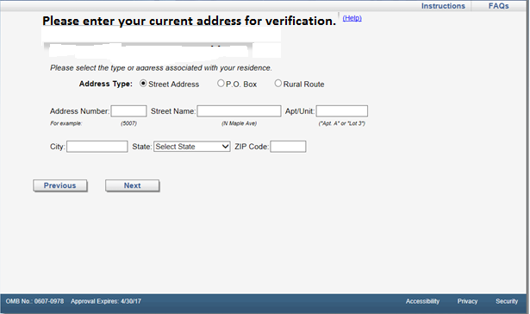Figure 6: Default address screen. (Version 1 and 2) This statement/question is new.

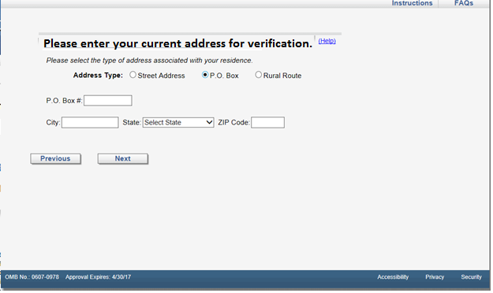
Figure 7: If respondent selects the P.O. Box radio button. (Version 1 and 2.)

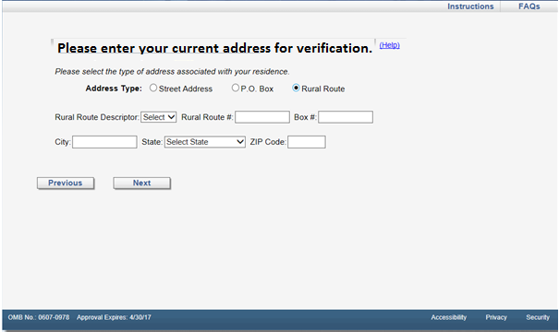

Figure 8: If respondent selects the Rural Route radio button (Version 1 and 2)

- What message(s) in the mailing materials motivated you to complete this online survey?
Select all that apply.

Conserving natural resources
Saving taxpayer money
Benefits for my community, city or state
Uses of the data collected
Addresses are randomly selected
Responses are required by law
Answers are kept confidential
An interviewer might come to my door
Signed by the Director of the U.S. Census Bureau

2. Do you have any additional comments on the mailing materials you received for this survey?

Figure 9: Opinion page (New questions) (Version 1 and 2.)

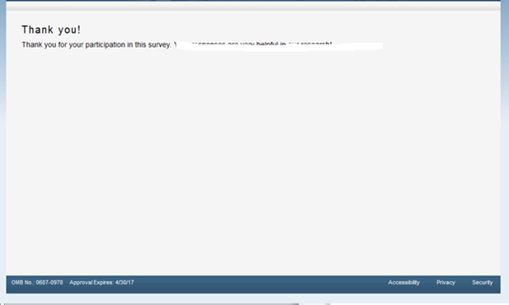
Figure 10: Thank you screen after submitting (Version 1 and 2.)

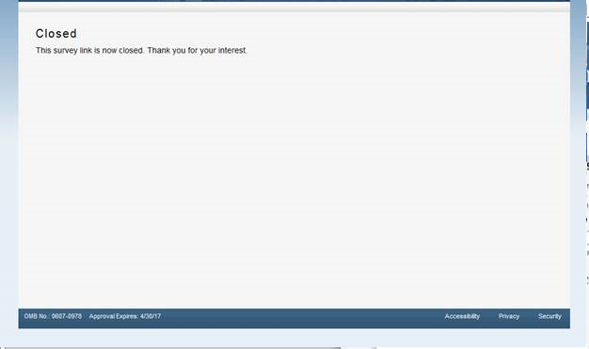
Figure 11: Screen when survey is closed out or when have previously entered survey. ( Version 1 and 2.)

