**2015 Captia**

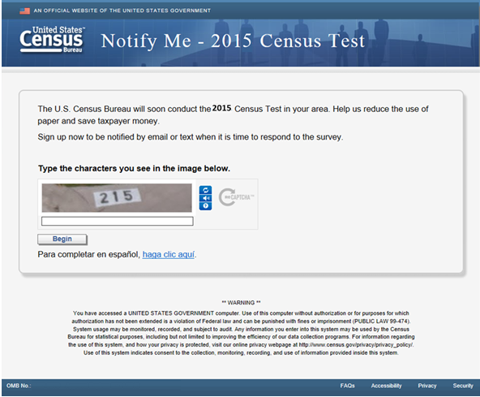

**2015 Name and Phone**

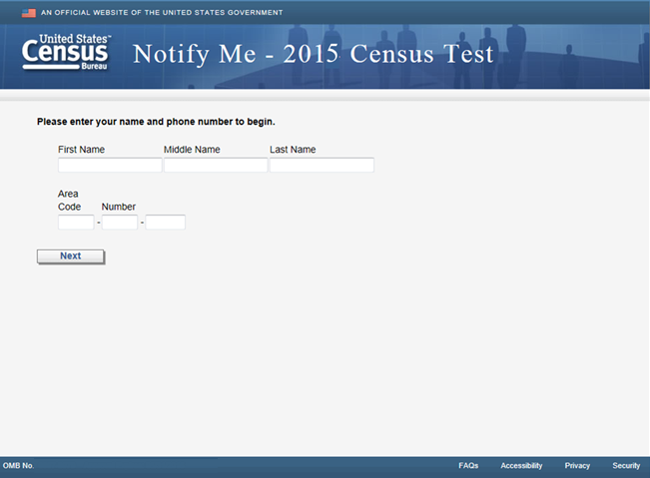

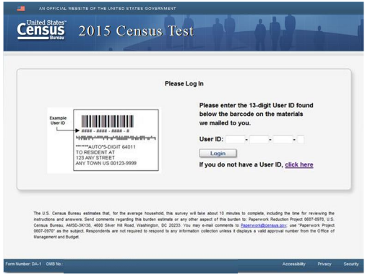

An instruction will be added to the screen with the burden estimate of 3 minutes

**2015 Address**

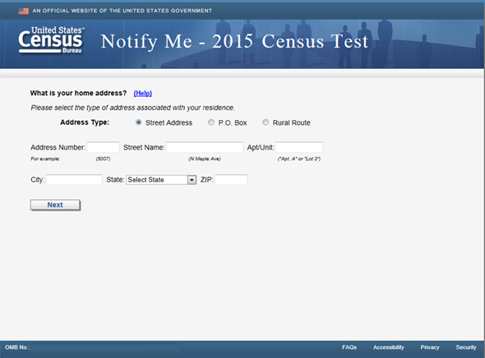

**2015 How to Notify**

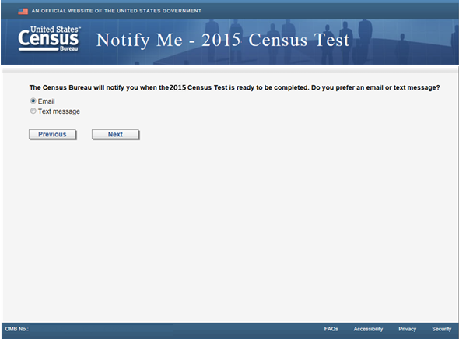

**2015 Email Address**

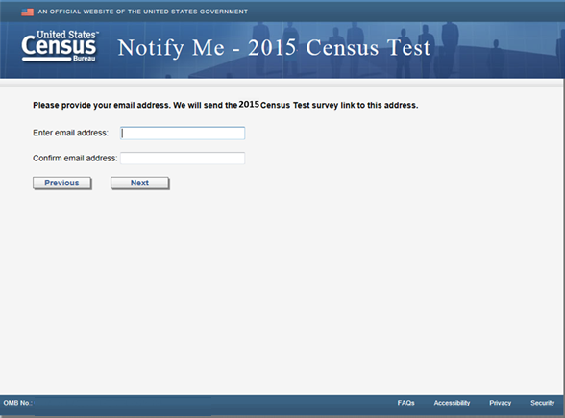

**2015 Cell Phone Notify Me**

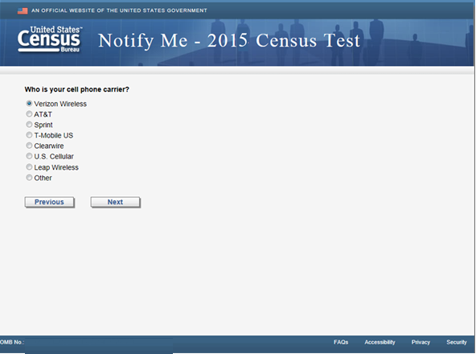

**2015 Cell Number**

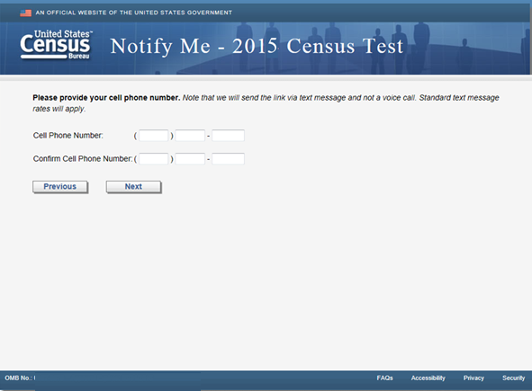

**2015 Hear About Notify Me**

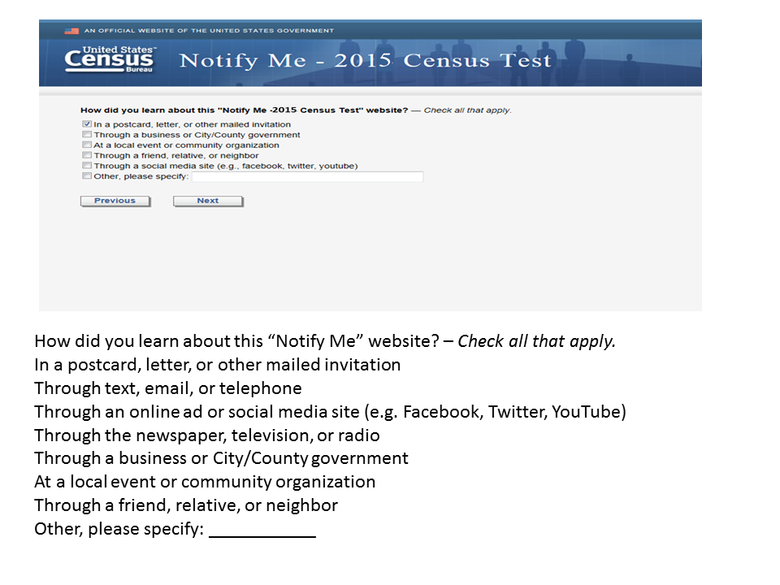

**2015 Thank you Notify Me**

