ATTACHMENT 11 – WELCOME TO THE STUDY LETTER

[DATE]

[Name] Attention: [age] year old [gender] resident
[STREET ADDRESS]
[CITY], [STATE] [ZIP]

Dear [Name]:

Thank you for returning your household’s completed Evaluation of the Fresh Empire Campaign on Tobacco (EFECT) survey. Households who returned a completed survey have an opportunity to participate in an in-person interview that will ask questions about attitudes towards tobacco and media use.
RTI International, a nonprofit organization, was selected to conduct this interview. In the next few days, a Field Representative from RTI International will be in your area to interview your child who completed the first survey. The interviewer will carry an identification card like the example shown below.
A limited number of people were randomly chosen to represent the population of the United States. Your child cannot be replaced. If your household chooses not to take part, your experiences and views—as well as the thousands of people you represent—will not be heard.
Your child’s answers to the survey questions will be combined with the answers of thousands of other people and reported only as overall numbers. To further protect your privacy, the survey is set up so that your child records most of their own answers—the interviewer never sees or hears them. Also, your child can always refuse to answer any question.
This interview will take about [30 minutes for the pre-campaign survey; 45 minutes for the post-campaign survey] to complete. The interview is conducted in your home on a laptop computer. Everyone who completed the interview will receive $25 in exchange for their time.
To ensure the accuracy of survey results, we need to interview as many eligible youth aged 12 to 17 as we can. The results of this study will help policy makers and researchers understand media use among today’s youth as well as their attitudes and beliefs about tobacco use.
Your help is critical to the success of this study, and we are happy to work around your schedule so that you and your child can be included. Please feel free to call me to set up an interview time—the interview can also be done at another location such as a public library.
Thank you for your time. I hope you and your child will choose to take part in this very important and useful study.

Sincerely,
[FS NAME], Field Supervisor

P.S. Please, if you have any questions or would like to set up an appointment, call me toll-free at [TOLL-FREE NUMBER].

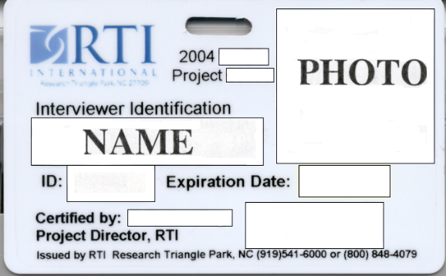

You will be contacted by: _________________________________________ Interviewer Name

Paperwork Reduction Act Statement: The public reporting burden for this information collection has been estimated to average 1 minute per response to read the welcome letter (the time estimated to read and review). Send comments regarding this burden estimate or any other aspects of this information collection, including suggestions for reducing burden, to PRAStaff@fda.hhs.gov.

