*NSFG 2015-2018 OMB Attachment D10 OMB No. 0920-0314*

**DEPARTMENT OF HEALTH & HUMAN SERVICES Public Health Service**

## Centers for Disease Control

**and Prevention (CDC)**

**Memorandum**

Date October 10, 2014

From Katrina F. Trivers, PhD, MSPH, Epidemiologist, Division of Cancer Prevention and Control, National Center for Chronic Disease Prevention and Health Promotion, CDC

Subject Uses of National Survey of Family Growth (NSFG) Data

To Anjani Chandra, PhD, Project Officer, NSFG, National Center for Health Statistics (NCHS), CDC

In collaboration with our colleagues from the National Center for Health Statistics (NCHS), the Division of Cancer Prevention and Control is supporting the development and addition of cancer related questions to the National Survey of Family Growth (NSFG). These questions will assess personal cancer history, family history of breast cancer, knowledge of cancer risk factors, and breast and cervical cancer screening practices. These data will be used to investigate how having a history of cancer early in life may impact families, interpersonal relationships and the use of reproductive health services. The NSFG is the only nation-wide survey with detailed data on men and women’s experience with marriage, relationships, cohabitation, and family issues such as infertility and use of infertility services, and as such, this represents first of its kind data.

The data to be gathered from these questions will address congressional interest in breast cancer among young women (EARLY act), attached. This act authorized CDC to do research and develop activities related to breast cancer in younger women. While mammography is not generally recommended for the average woman prior to the age of 40, anecdotal evidence suggests mammography may be occurring among young women. The breast cancer screening questions and others on family history and knowledge about risk factors will provide timely national estimates on such behaviors and knowledge among young women and are vital for education and intervention efforts, as undertaken as part of the EARLY act.

Cervical cancer screening questions will assess adherence to changed guidelines. For example, all guidelines say to start screening at age 21 or later, regardless of age of onset of sexual activity, but previous surveys have lacked information on sexual history, so we have been unable to address these issues. Also, the Institute of Medicine guidelines for clinical preventive services recommend annual well woman exams but cervical cancer screening intervals are extended to every 3-5 years, so we would like to measure what services (non-evidence based and evidence-based) are being provided to women.

The NSFG is an ideal survey to ask these kinds of questions given its focus on reproductive-aged people and the inclusion of a variety of measures that other surveys (e.g., BRFSS and NHIS) do not measure such as sexual history and use of reproductive health services.

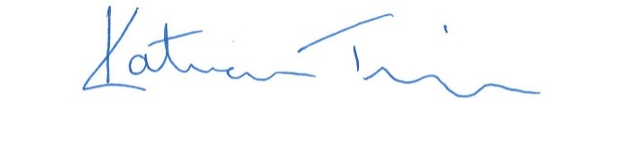

Katrina Trivers

[fph1@cdc.gov](mailto:fph1@cdc.gov), 770-488-1086