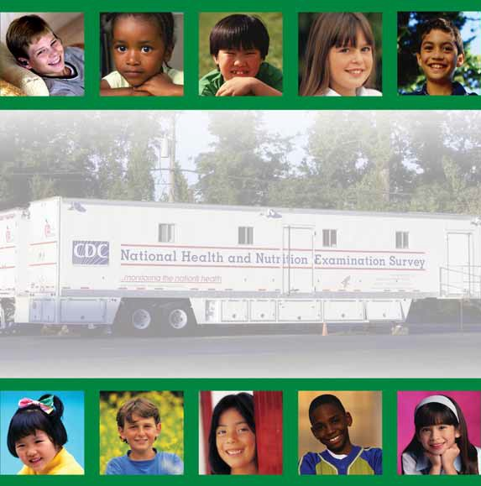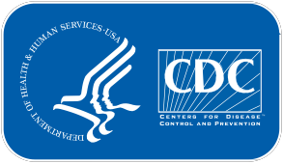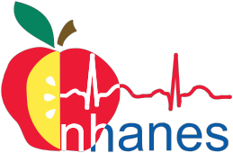National Center for Health Statistics
Attachment 5b

National Health and
Nutrition Examination Survey

Examination Assent Brochure,
7–11 Years of age

Let's Improve Our Health

Examination Assent Brochure

This booklet contains facts
National Health and Nutrition Examination Survey
for you about the National Health and Nutrition Examination Survey

2

The National Health and Nutrition
About Your Exam
Examination Survey (NHANES) studies the

health and diet of people in this country.

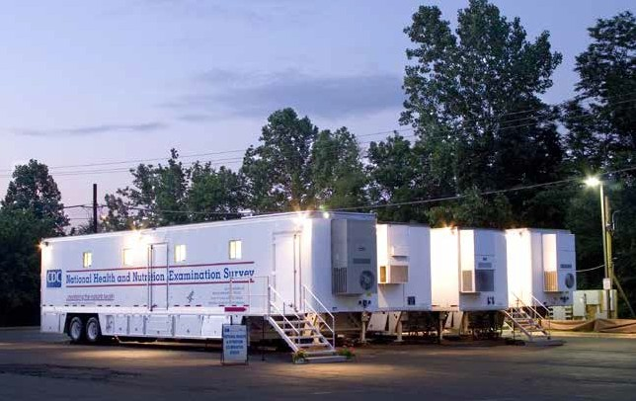The survey will look at how young people grow
and develop. We will ask questions about what your body looks like. We will look at special health problems that may affect kids.

We go all over the United States in these vans.

3

The exam is like going to the doctor. Your exam
National Health and Nutrition Examination Survey
will help us find out more about the health of children your age.

We will ask questions about what you eat and drink.

You will change into
special exam clothes at the exam center.

4

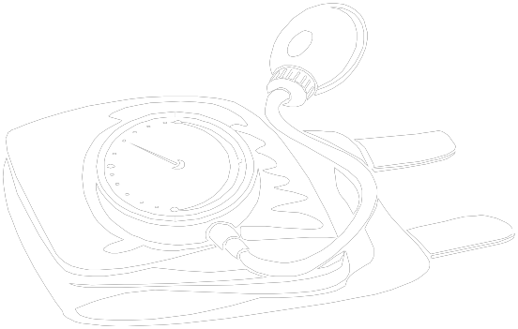Our doctor will take
your pulse.
We will take your blood
pressure.
About Your Exam

5

4

3

2

We will see how much
you weigh and how tall you are.
We will look at your
teeth.

5

We will check your blood
National Health and Nutrition Examination Survey
and urine in our lab.

We will send you and
your parents a report on your exam.

6

Our staff will answer
About Your Exam
any questions you have.

We would like you to go to our mobile
exam center vans for an exam. You will help us learn more about all children in the United States.

7

Notes
8

National Health and Nutrition Examination Survey

For more information about the National Center for
Health Statistics, contact:

Information Dissemination Staff
National Center for Health Statistics
3311 Toledo Road, Room 5419
Hyattsville, Maryland 20782

Telephone: 1–800–CDC–INFO (1–800–232–4636) TTY: 1–888–232–6348
Online request from : http://www.cdc.gov/info
Internet: http://www.cdc.gov/nchs

For more information about the National Health and Nutrition Examination Survey you may visit the NHANES Website at: http://www.cdc.gov/nhanes.

CS246239 (06/2014)

