OMB #0925-XXXX
Expiration date: XX/XXXX
Public reporting burden for this collection of information is estimated to average 30 minutes per response, including the time for reviewing instructions, searching existing data sources, gathering and maintaining the data needed, and completing and reviewing the collection of information. An agency may not conduct or sponsor, and a person is not required to respond to, a collection of information unless it displays a currently valid OMB control number. Send comments regarding this burden estimate or any other aspect of this collection of information, including suggestions for reducing this burden, to: NIH, Project Clearance Branch, 6705 Rockledge Drive, MSC 7974, Bethesda, MD 20892-7974, ATTN: PRA (0925-XXXX). Do not return the completed form to this address.

The External Face of ePASS

NIH requires applicant institutions and grantees to request Prior Approval for some specific actions as required by NIH policy. Such approvals must be obtained before undertaking the proposed activity or spending NIH funds. NHLBIs’ Electronic Prior Approval Submission System (ePASS) was developed to accommodate the external submission and in-house processing of these requests.

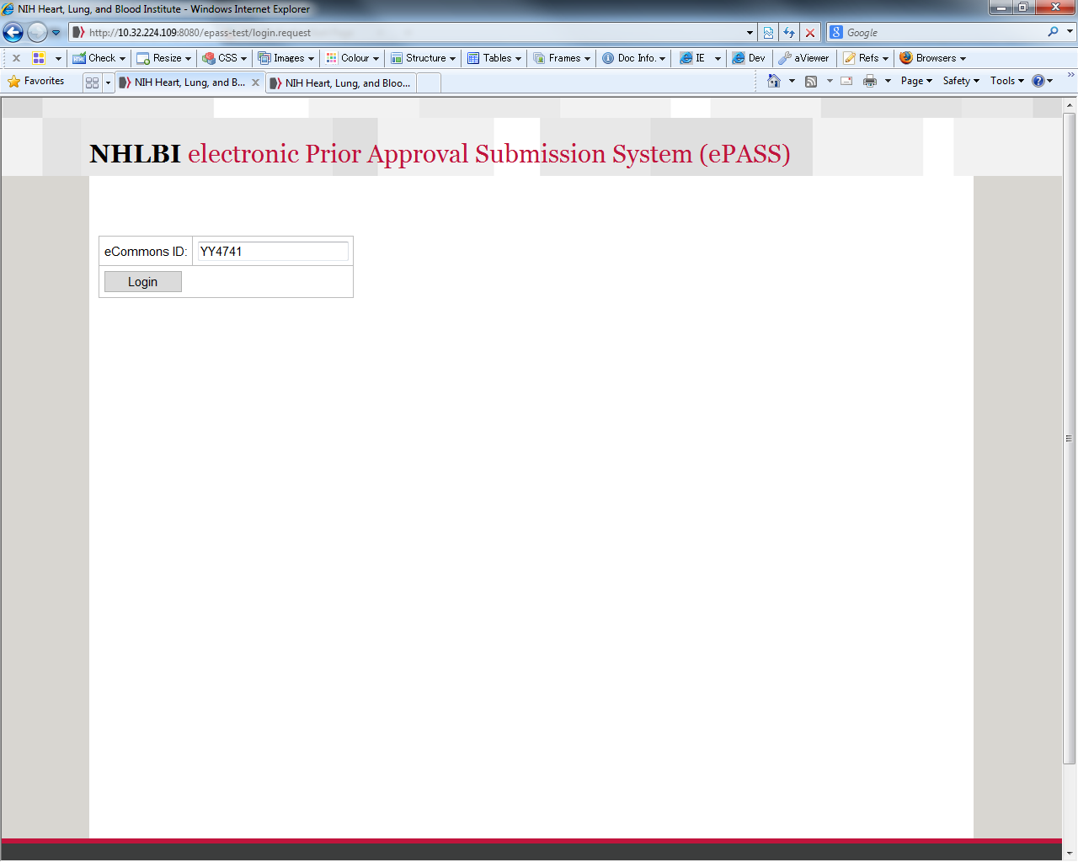
This is the login site (see Figure 1 – ePASS Login Screen left) for NHLBI’s ePASS on the externally facing landing page. The grantee business official (AOR) will login using their Commons ID that will prompt a search function for various queries. The AOR can select what action they would like to take such as requesting the following Prior Approvals: 1) No Cost Extension, 2) Carryover 3) Change of PI/Key Personnel, 4) Change in Effort of Key Personnel, 5) NRSA Waiver and 6) Change of Scope. The AOR will only be able to take action on grants within their authority as defined by their Commons profile.

Figure 1 - Begin Your Search
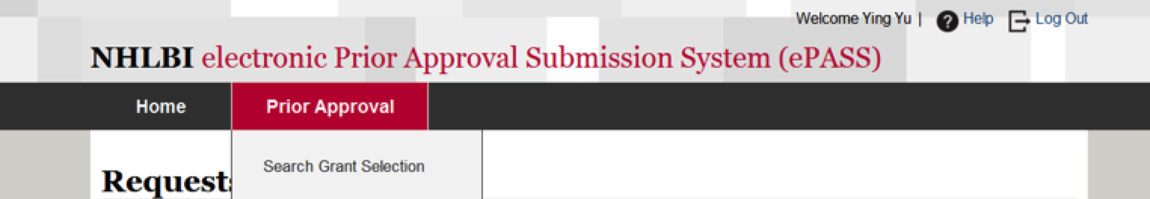
Figure 1 - ePASS Login Screen
The following set of screens walk you through the submission of a No Cost Extension (NCE) request after the Grantee/AOR searches for and selects a grant.
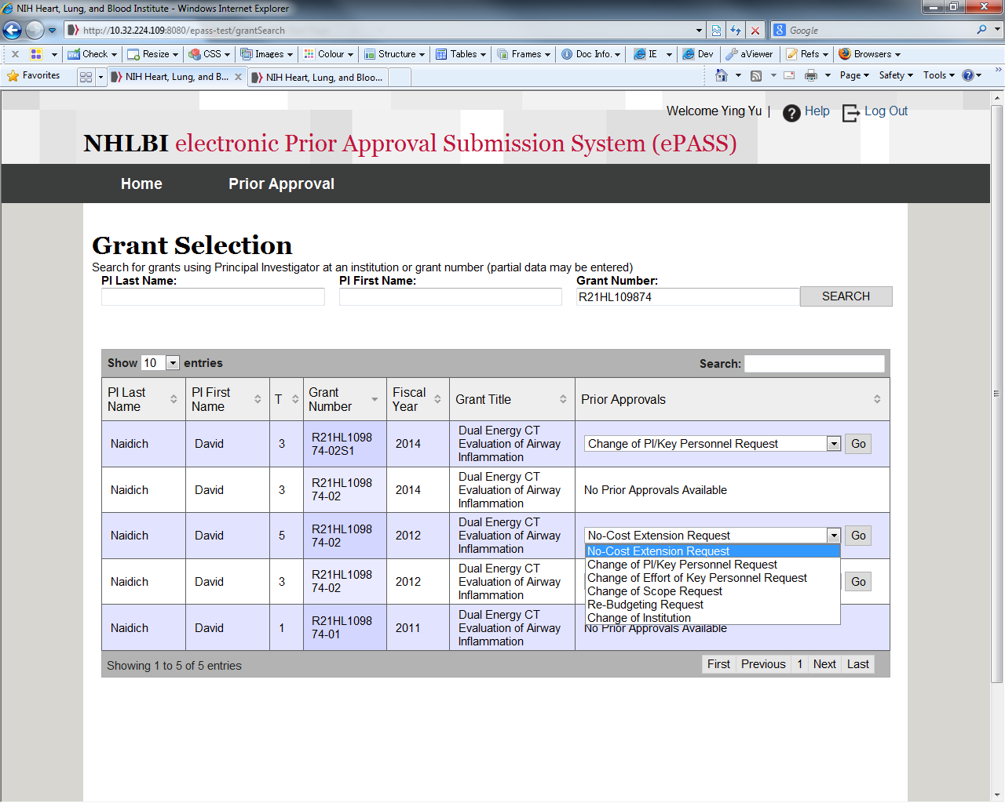
Definition of a No Cost Extension: An extension of a project period without additional funds.
Search

The Grantee can search for their grant by entering the PI Last Name, PI First Name or Grant Number. If there are existing grants in the system that match the search criteria, ePASS displays the results of the search and the type of actions that can be executed for each grant.
Figure 3 Initiating a No Cost Extension Request

After selecting No Cost Extension from the Prior Approvals dropdown and clicking on ‘Go,’ the Grantee/ AOR is taken to the form shown in Figures 4 and 5 below.
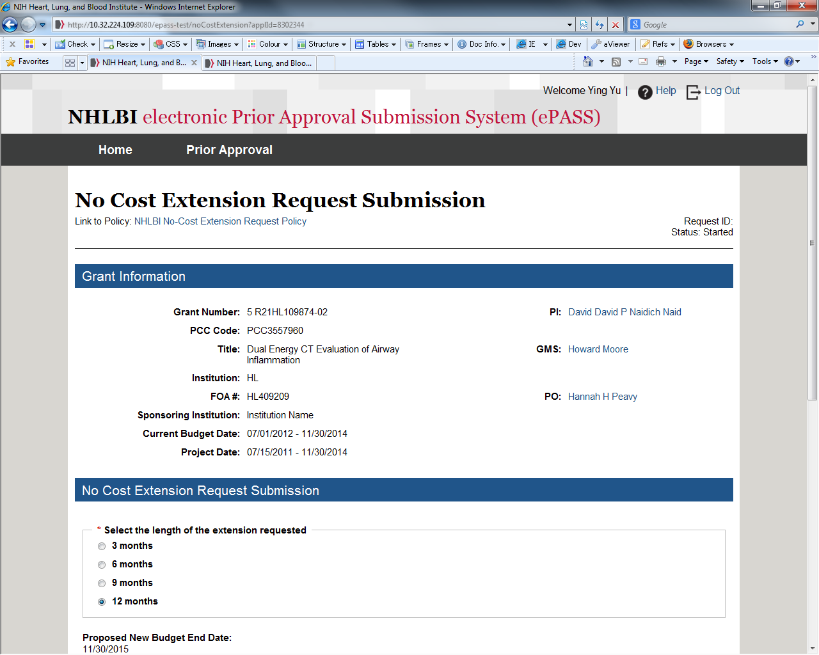
The top area of the form self-populates basic grant information along with a link to the relevant NIH policy. The form (see Figure 4 - top half of the NCE form, left) requires that the AOR select the length of the extension being requested and the system will recalculate and display the new budget/project end date. The AOR is then asked to enter the amount of unobligated funds remaining, attach an interim progress report, and ensure that IRB/IACUC assurances are valid (see Figure 5 - bottom half of the NCE form below). The system will perform a check to ensure that all information is complete at “submit request”.
Grant Identifier
Policy Link
Figure 4 - No Cost Extension Request Form

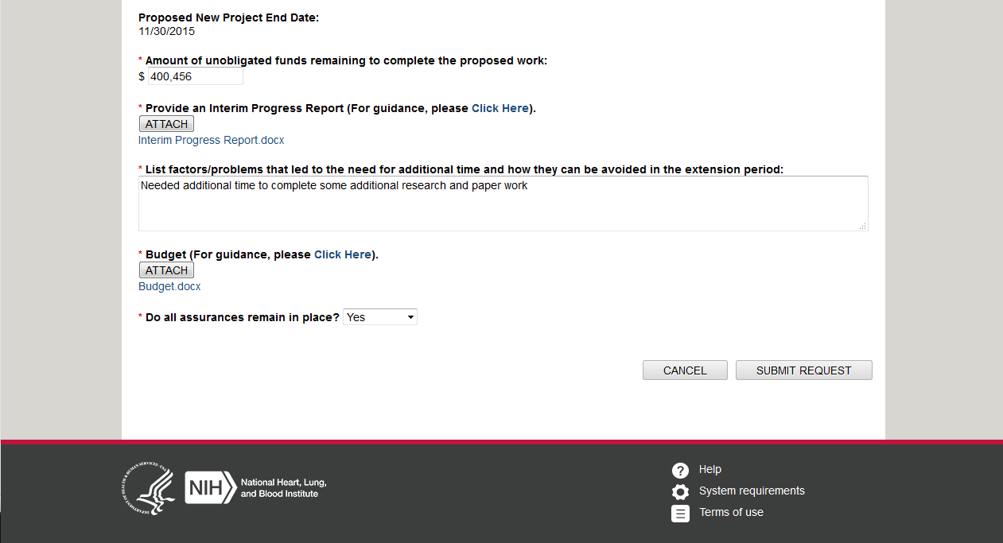
Grantee/AOR
Input

Figure 5 - No Cost Extension Form

In-house ePASS Processing of a No Cost Extension
When all requirements are met, the request generates a workflow task for NIH staff associated with that grant. The Program Official (PO) and Grants Management Specialist (GMS) will see the task appear as “pending” in their home page dashboard or as an e-mail. There will be NIH login verification in order to proceed with the completion of the task.
Figure 6 - Pending Tasks for the GMS
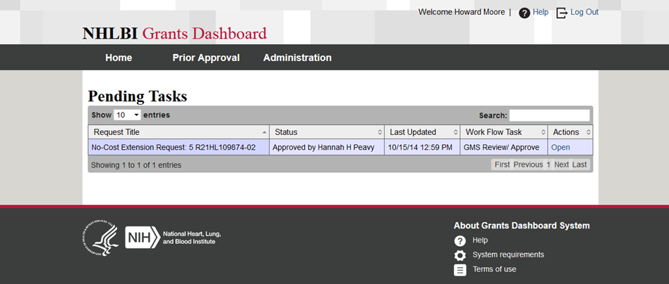
Pending Tasks list (see Figure 6, right) the request title, status of the request, when the request was last updated, where the request is in the workflow and the actions that can be taken. The screens that follow show the path a request for a No Cost Extension takes when under review by the GMS. Similar screens have been designed for the PO to complete the workflow process.
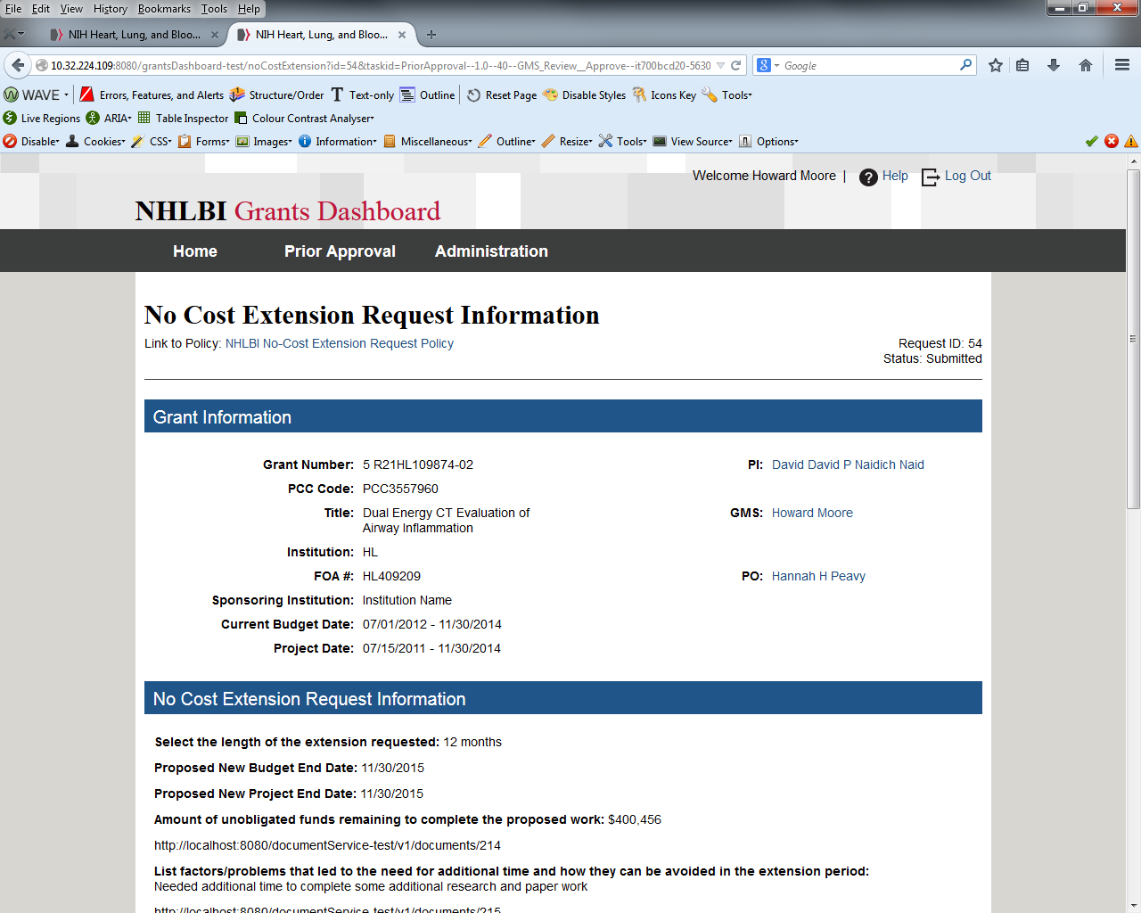
After opening the item in Pending Tasks, the GMS can view and analyze the information provided by the grantee and make a determination to Save, Hold, Deny or Approve. The PO can review the information entered by the Grantee (see Figure 7a, below) request concurrently and both will be able to view a history of the actions taken in processing the request, the date of the action, where the action is in the workflow, who performed the action, the status of the request and any previously entered comments (see Figure 7b, below).

NCE Information

Figure 7a - No Cost Extension Information Entered by the Grantee

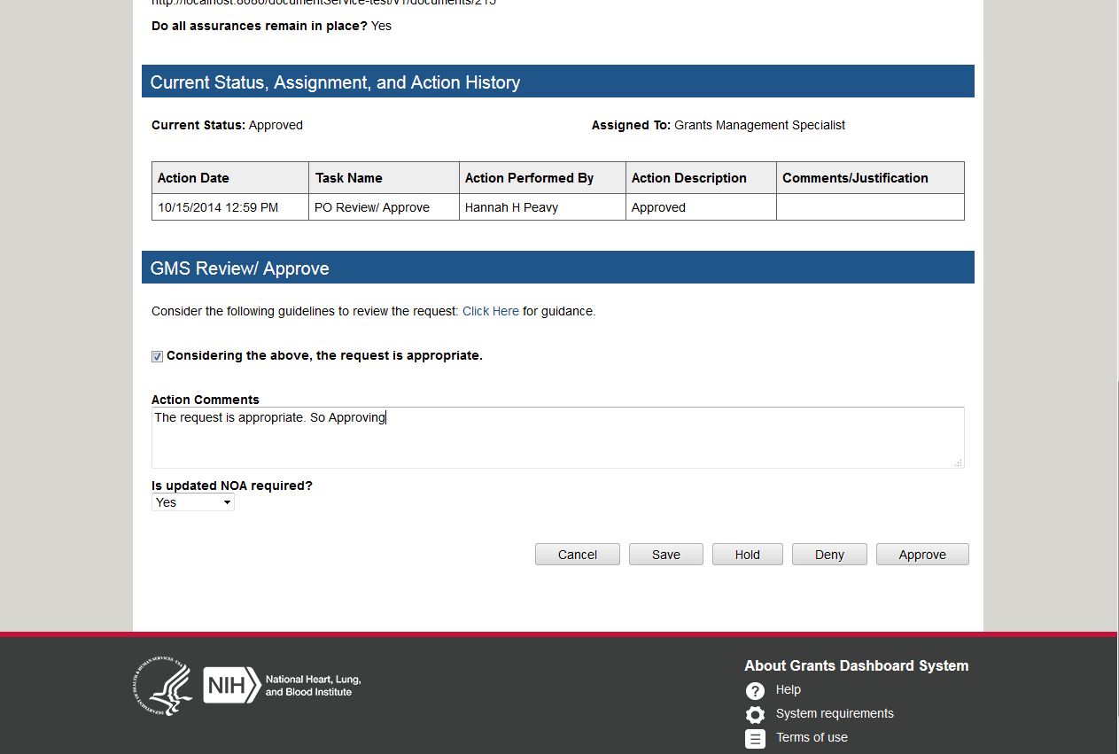

GMS /PO Decision

Action History

Figure 7b - No Cost Extension Review Page (GMS View w/ history)

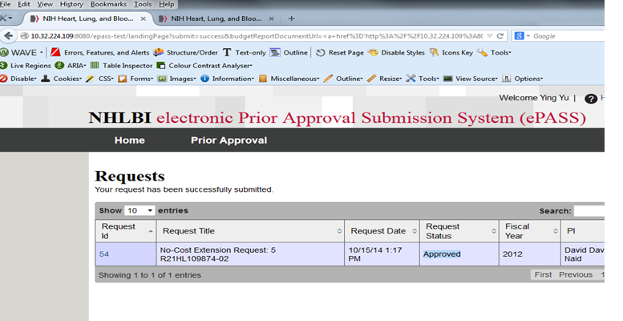
After the PO and GMS reach a final decision, a standardized response is returned to the AOR and the ePASS record is updated (See Figure 8 below.)

NCE Status Approved

Figure 9 – No Cost Extension Status Marked Approved

The request with supporting documentation will be (automatically) uploaded to the official grant file.
The workflow processes for the other types of requests are very similar with flexibility for additional roles if Team Leader or Branch Chief approvals are necessary.

