Internet Change of Address (ICOA) Screenshots

Overview of Pages in ICOA
Screen Number | Screen Name
Application Pages
coa001 | Information About Changing Your Address
coa002 | Acknowledgement for Change of Address Services
coa003 | Public Agreement
coa004 | The Collection and Use of Information from Your Application
coa006 | Your Information
coa007 | Your New Address
coa008 | When Will This Change Happen
coa009 | Verify Your Information
coa010 | Confirmation
coa011 | The Next Person's Turn
coa012 | Change of Address Survey
coa013 | Frequently Asked Questions
Message Pages
msg051 | Cookies Not Enabled
msg021 | How to Update Your Address or Telephone Number If You Cannot Change It Online
msg001 | Internet Security Policy
msg002 | The Information You Entered Does Not Match Our Records
msg004 | The Information You Entered Does Not Match Our Records
msg006 | This Service Is Not Available At This Time
msg037 | Unable to Process Your Request
msg008 | We Are Processing Your Request
msg005 | We Cannot Process Your Request At This Time
msg007 | You Have Reached the Limit on the Number of Requests
msg003 | Your Session Has Expired

COA001 Information About Changing Your Address
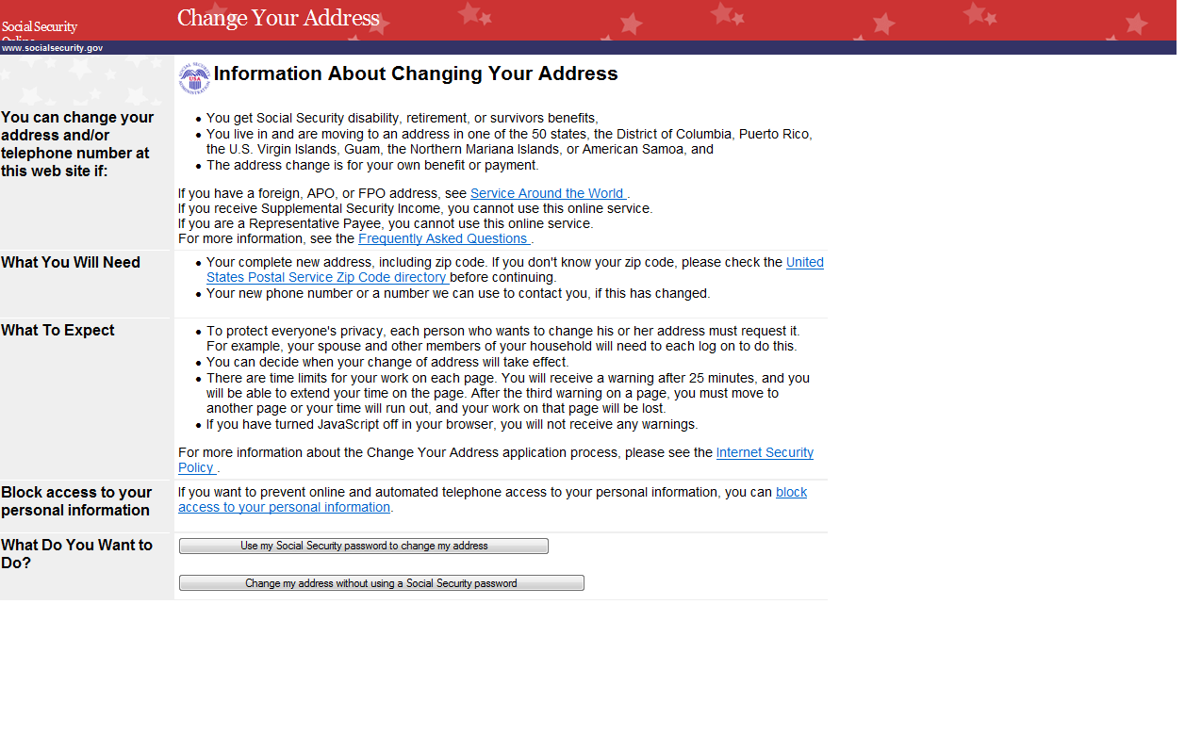

COA002 Acknowledgement for change of Address Services

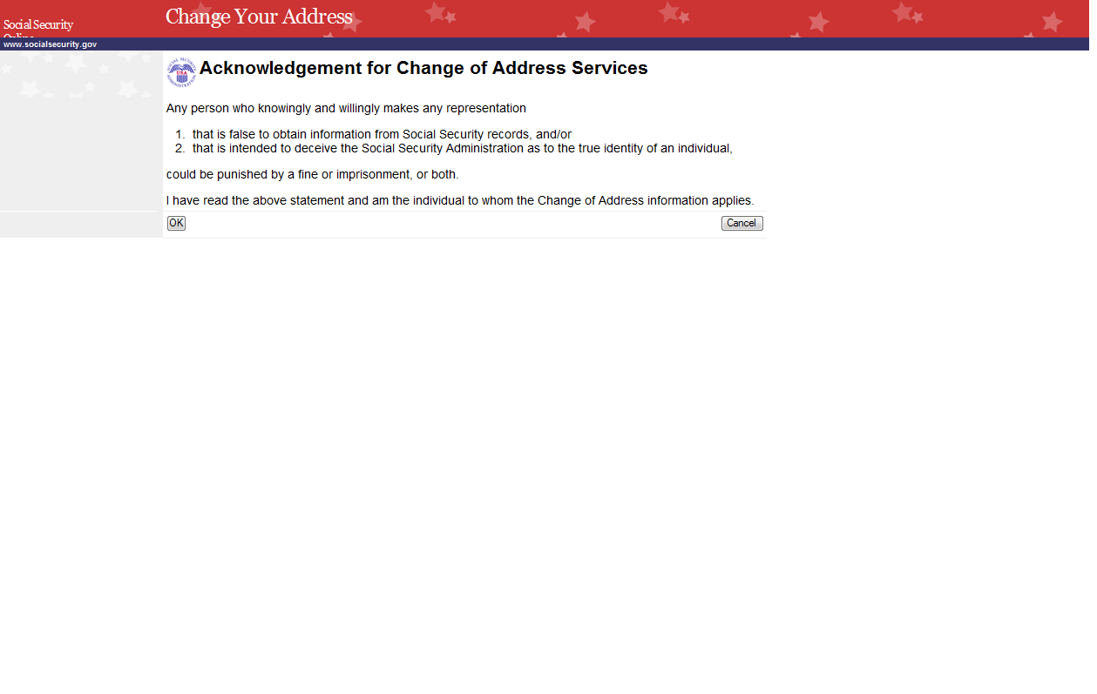

COA003 Public Agreement
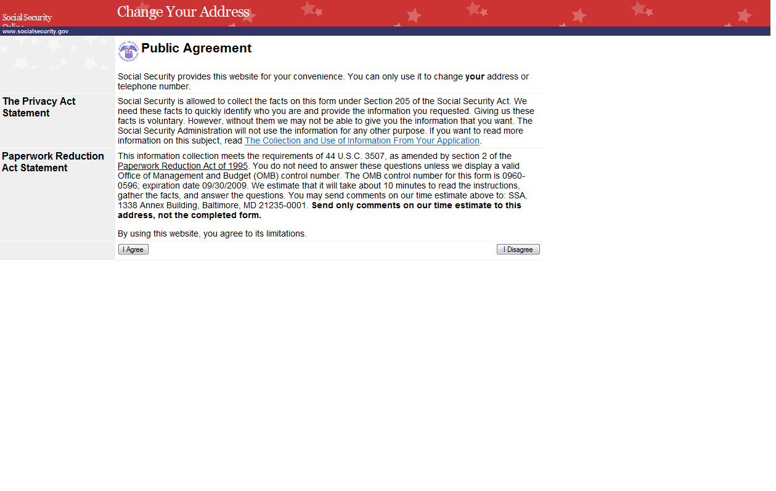

COA004 The Collection and Use of Information from Your Application
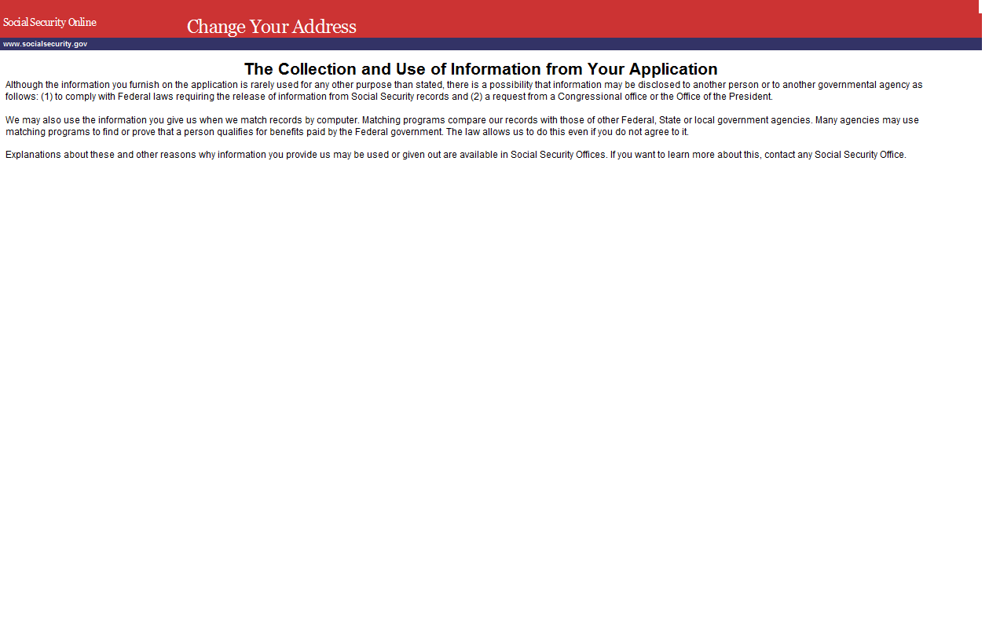

COA006 Your Information
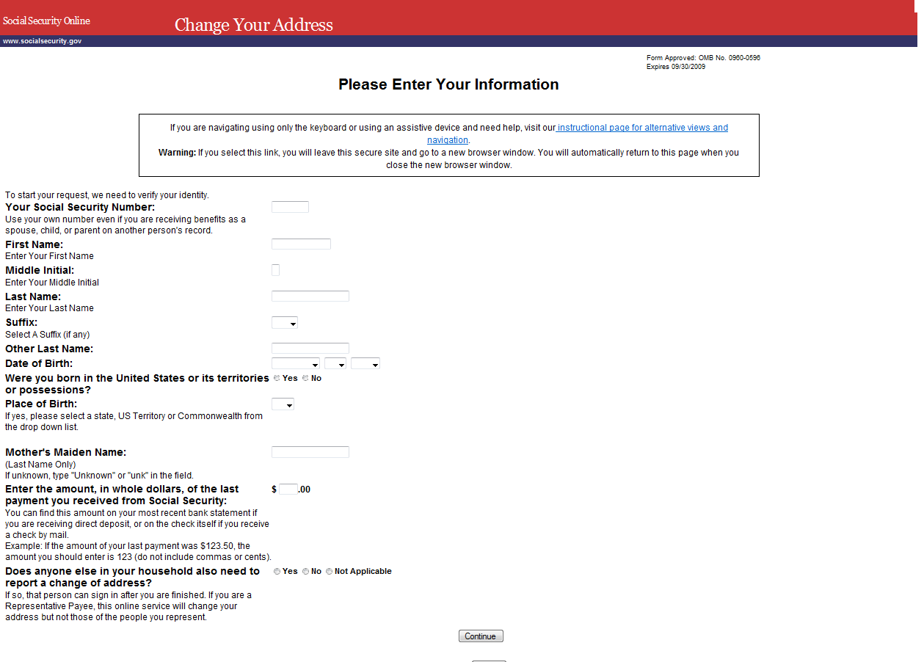

COA007 Your New Address
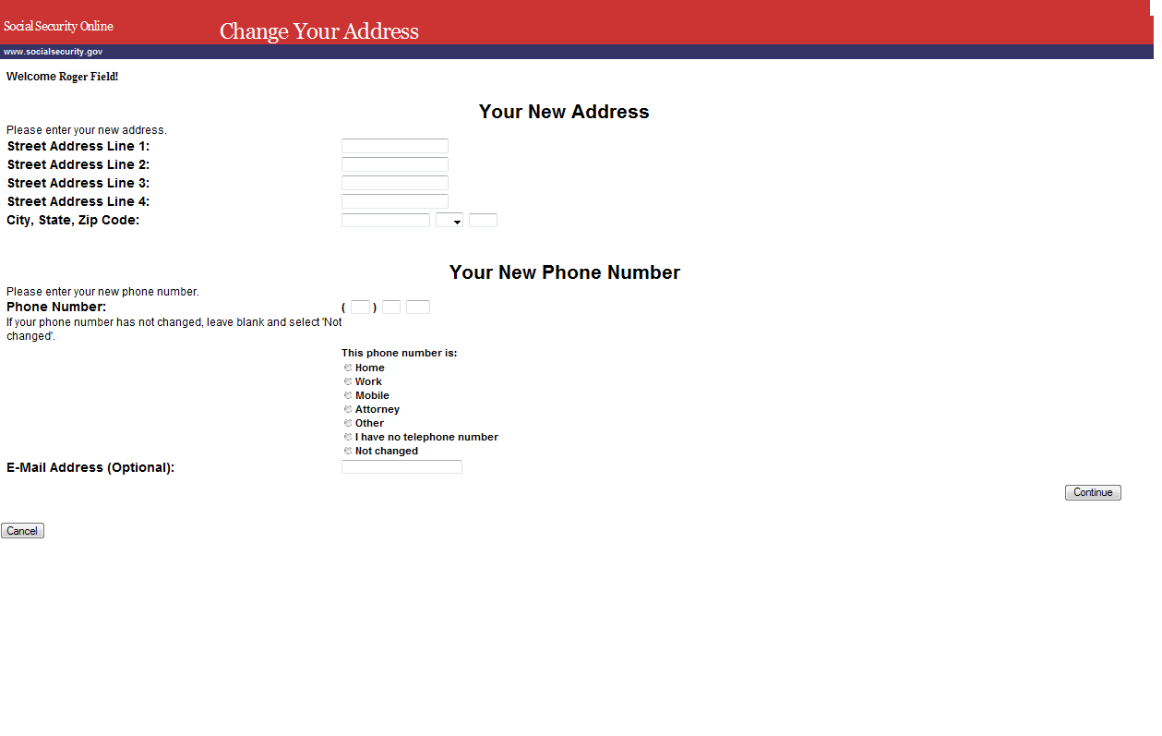

COA008 When Will This Change Happen
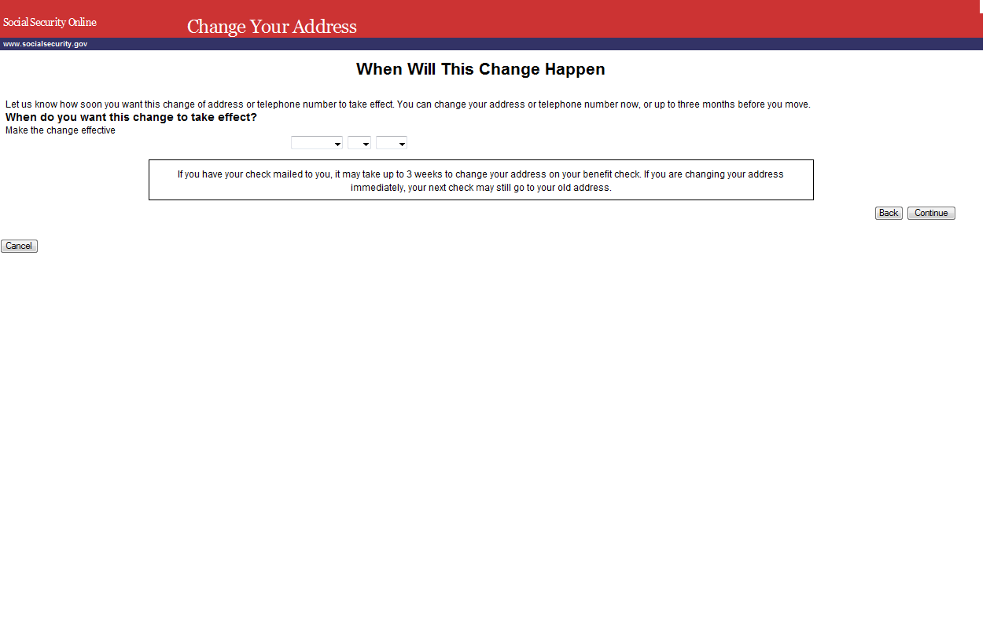

COA009 Verify Your Information
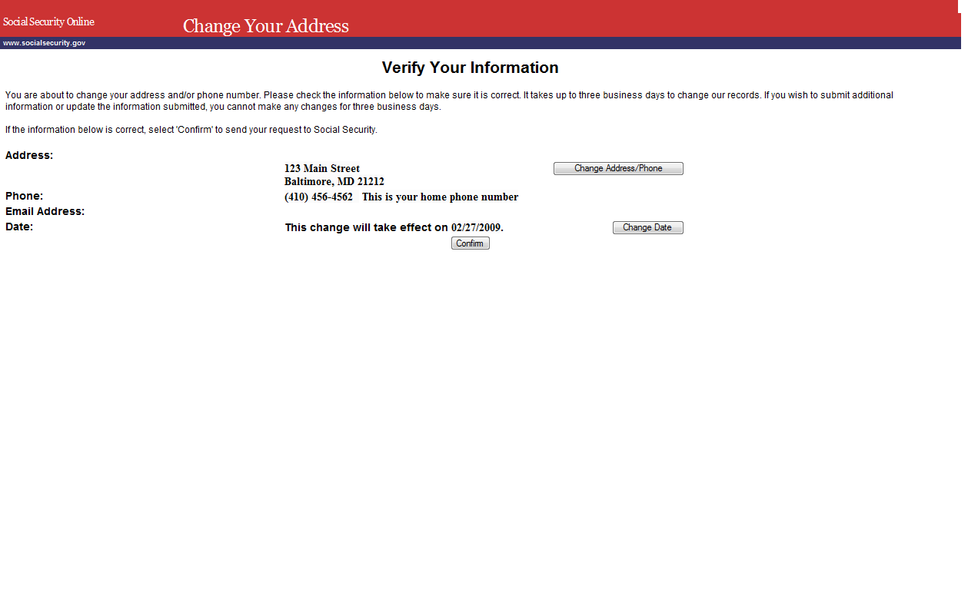

COA010 Confirmation
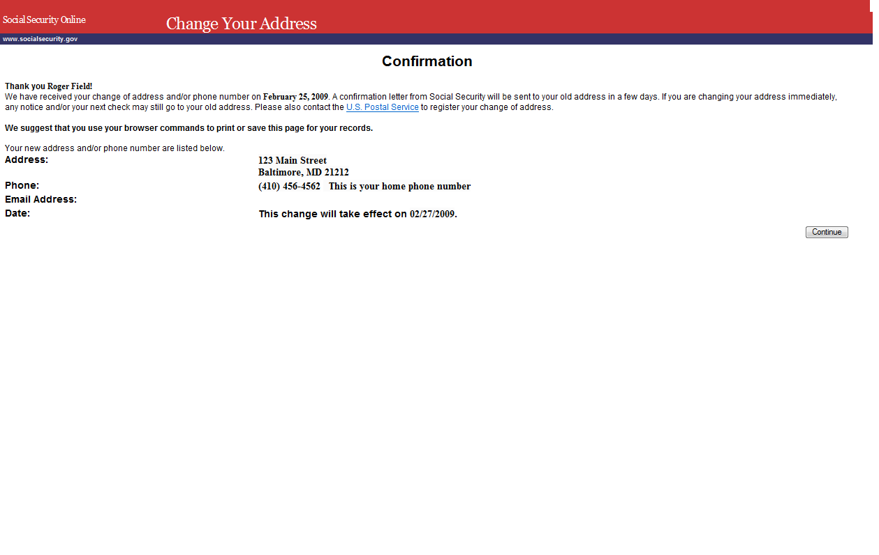

COA011 The Next Person’s Turn
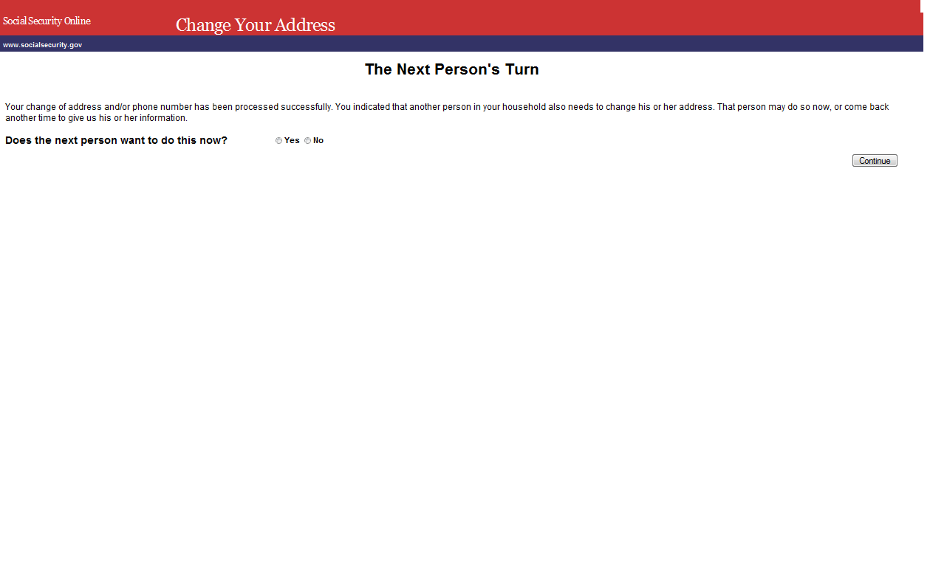

COA012 Change of Address Survey
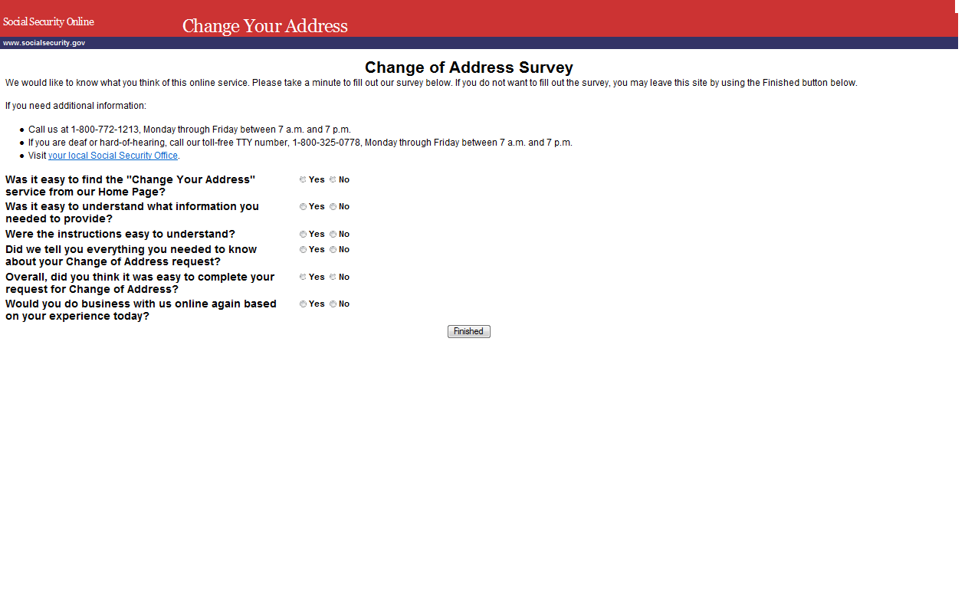

COA013 Frequently Asked Questions
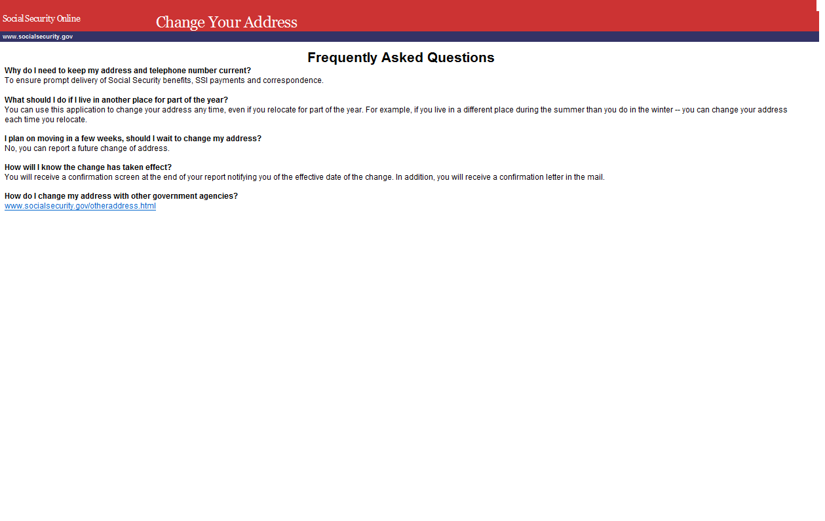

MSG051 Cookies Not Enabled
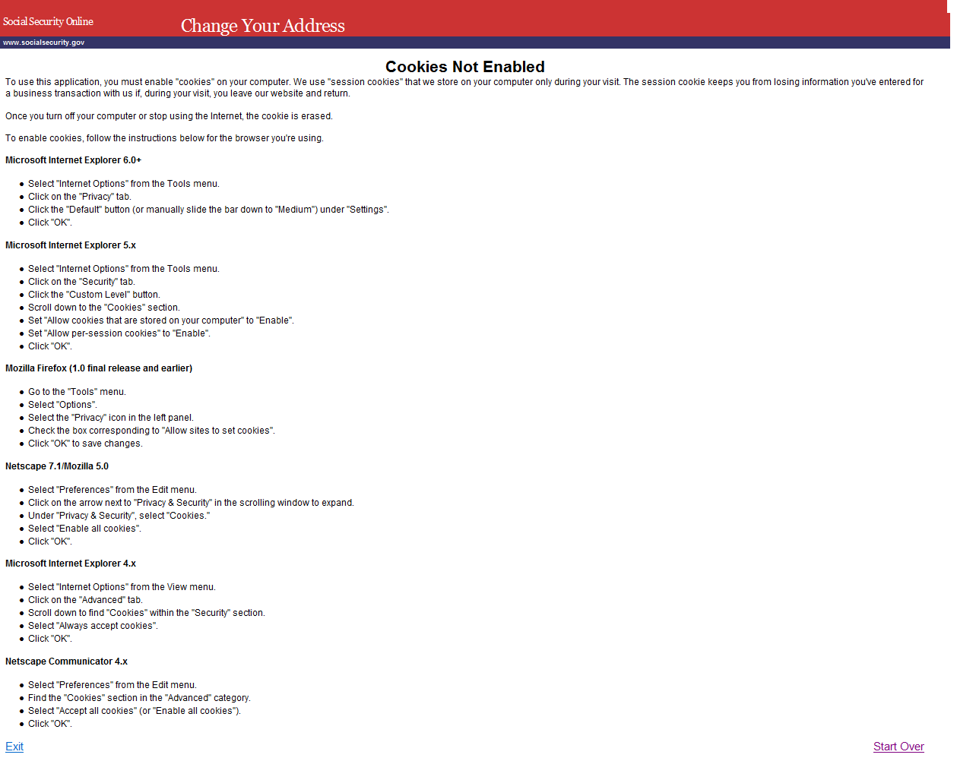

MSG021 How to Update Your Address or Telephone Number If You Cannot Change It Online
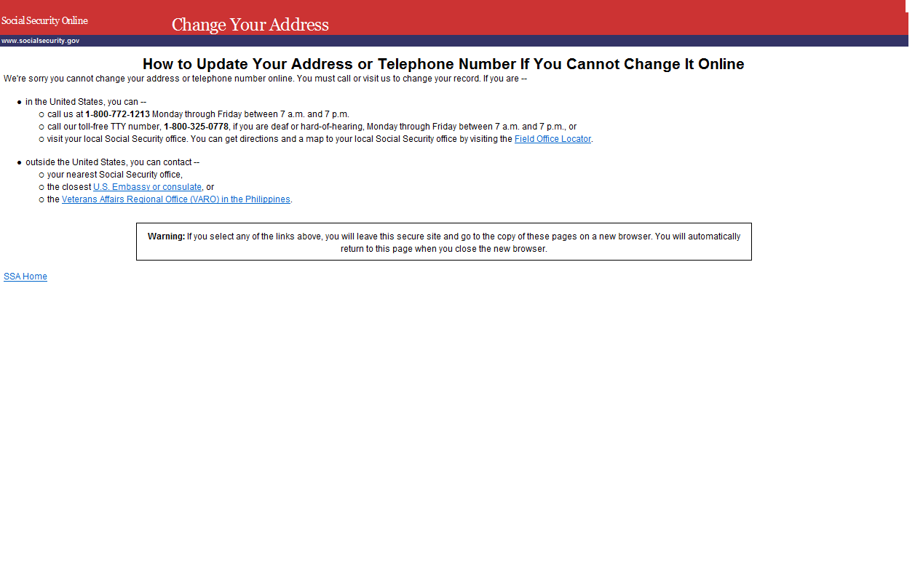

MSG001 Internet Security Policy
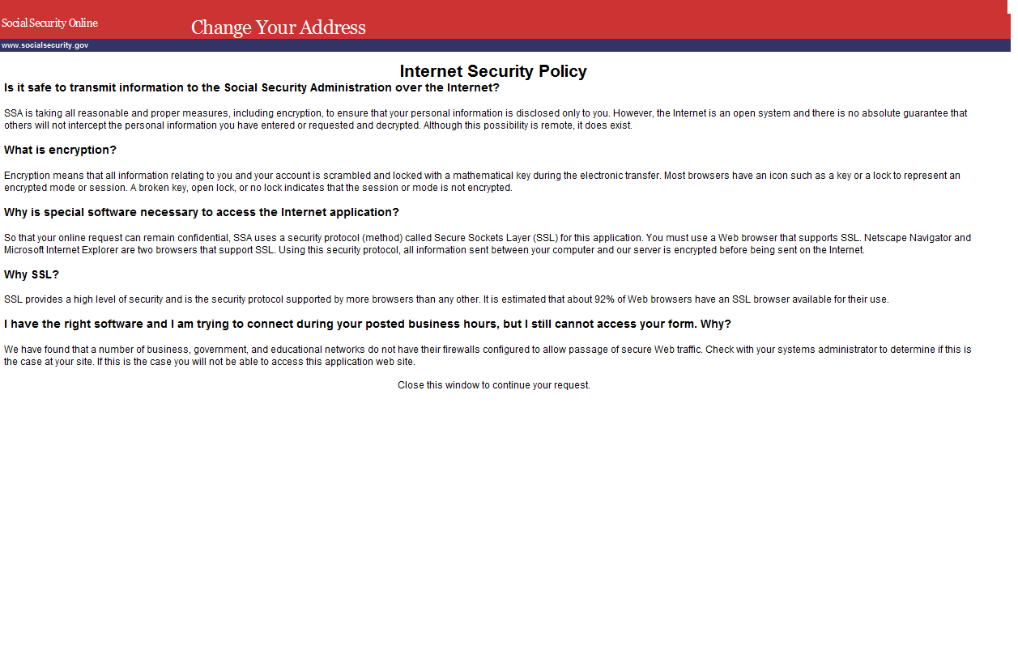

MSG002 The Information You Entered Does Not Match Our Records
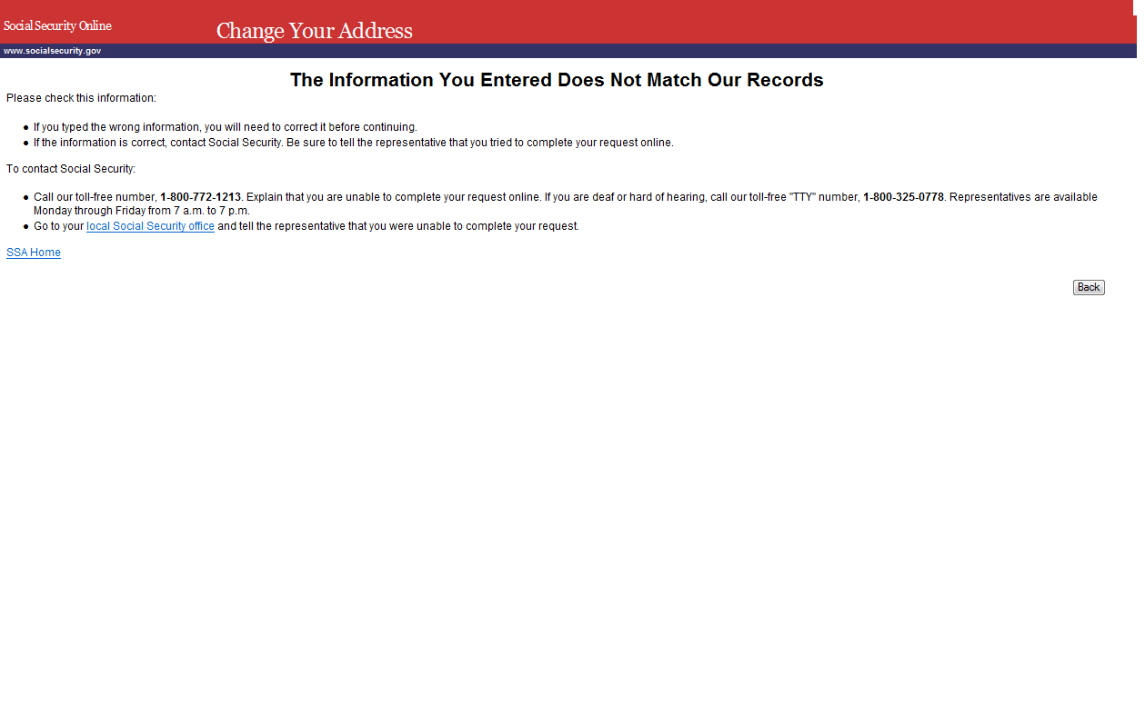

MSG004 The Information You Entered Does Not Match Our Records
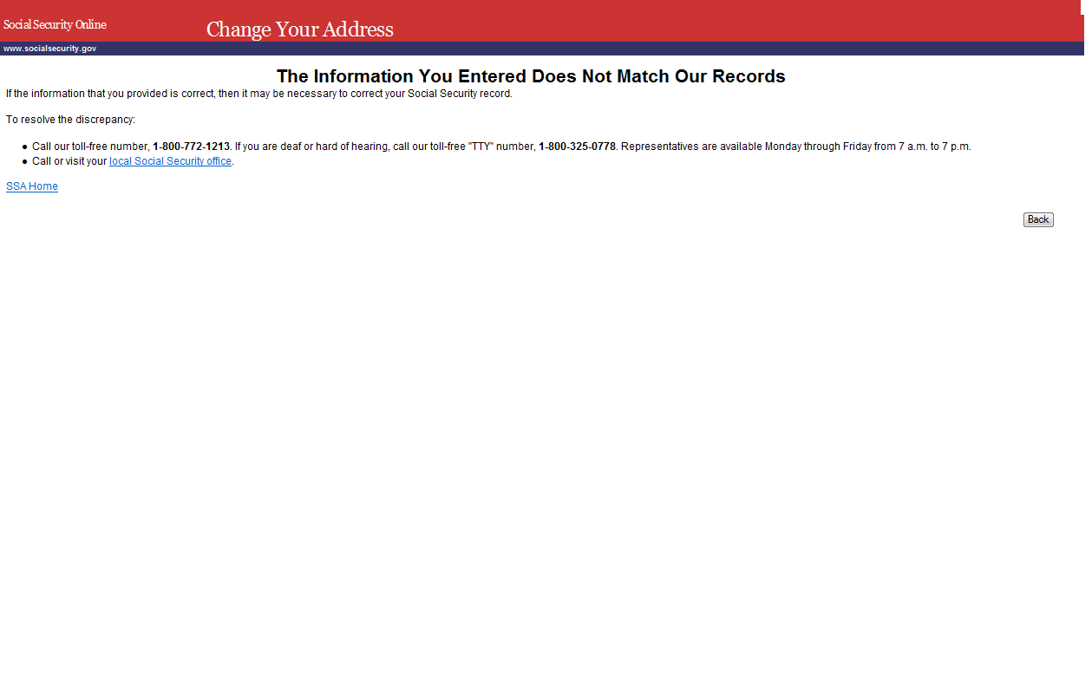

MSG006 This Service Is Not Available At This Time
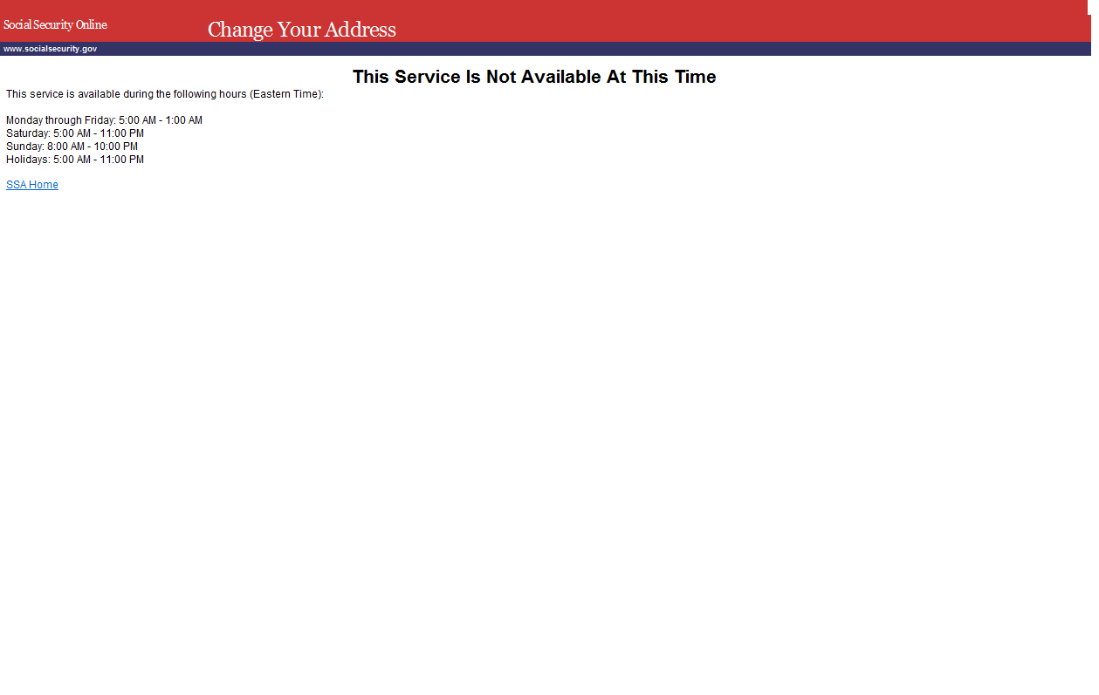

MSG037 Unable to Process Your Request
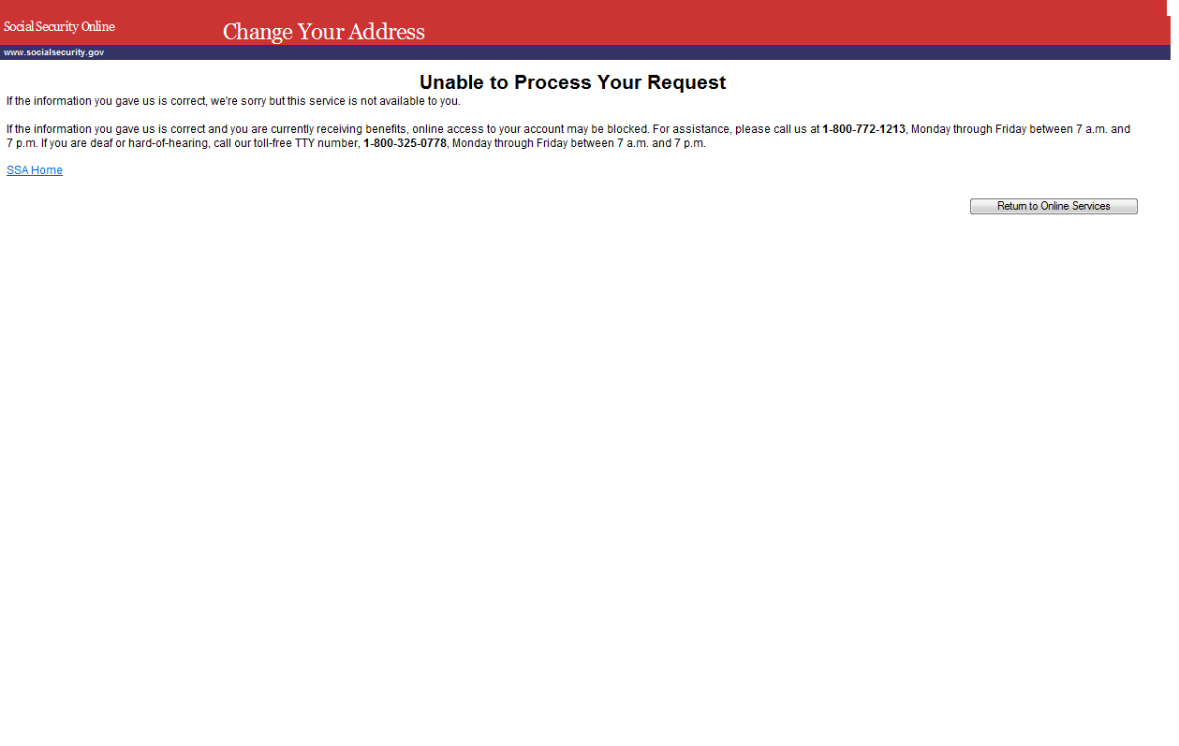

MSG008 We Are Processing Your Request
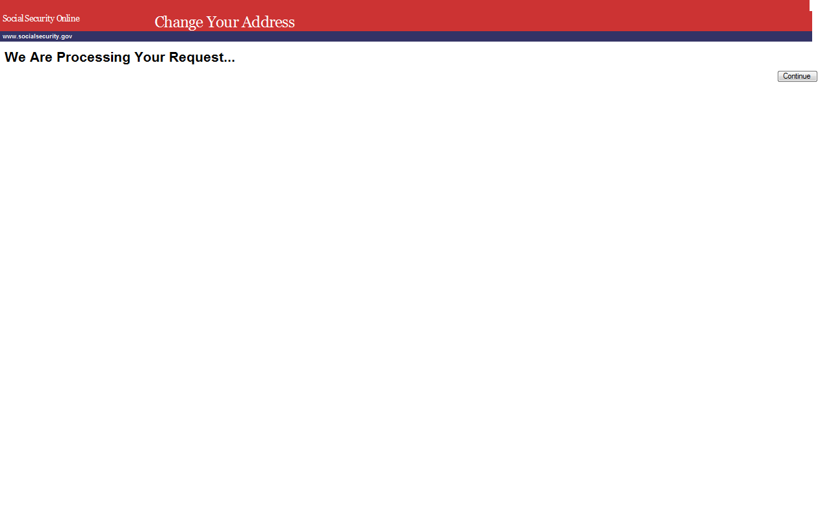

MSG005 We Cannot Process Your Request At This Time
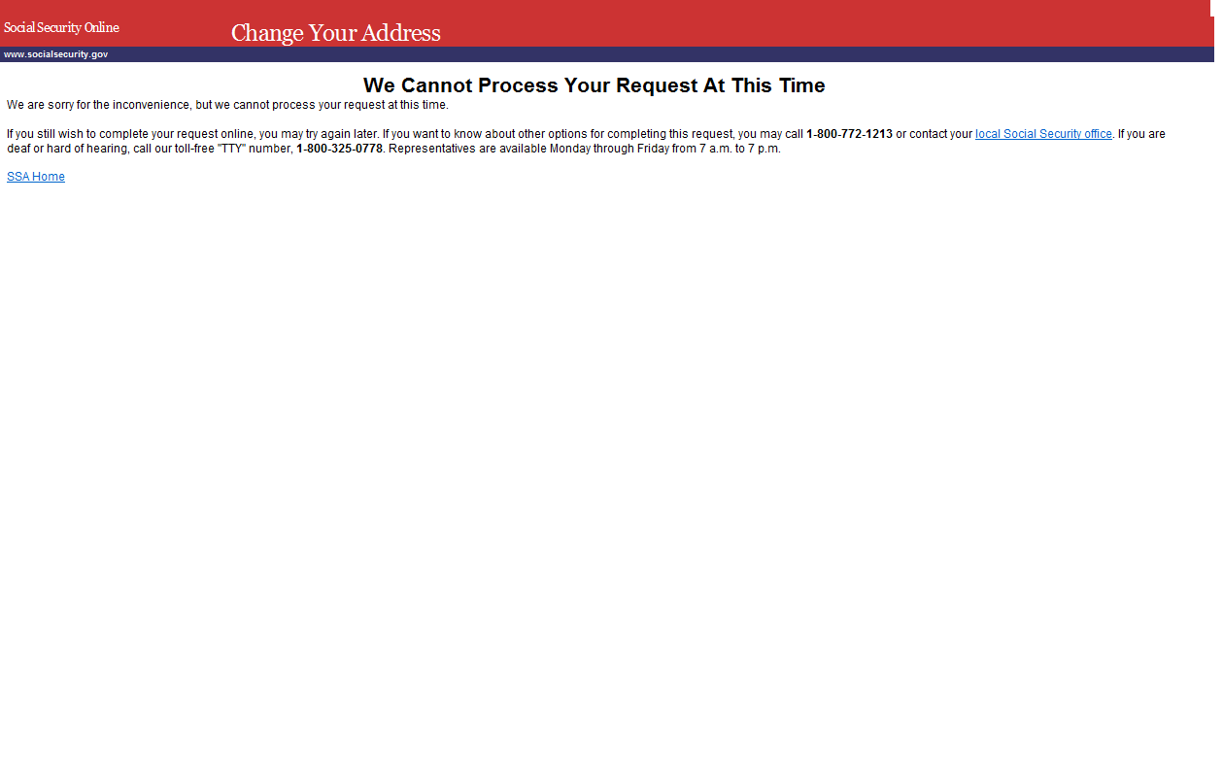

MSG007 You Have Reached the Limit on the Number of Requests
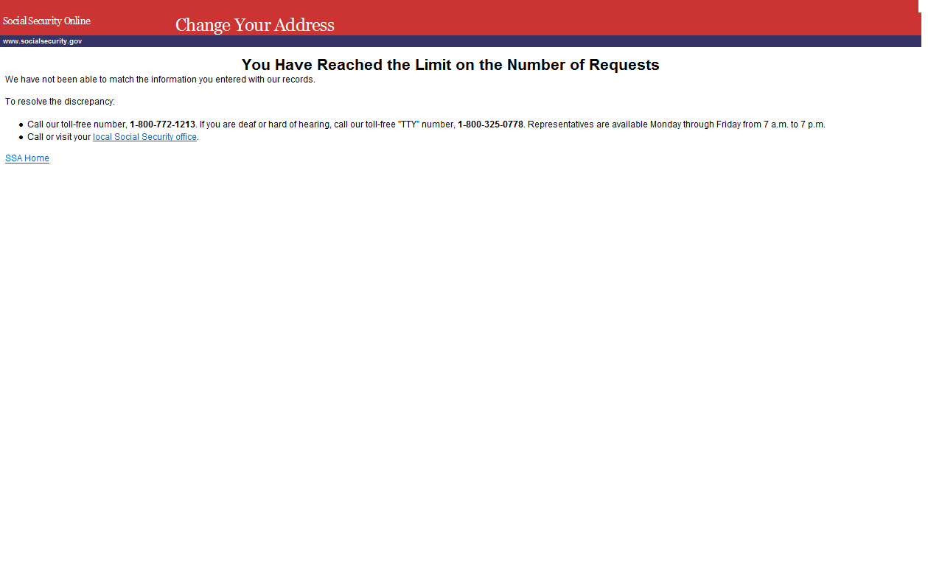

MSG003 Your Session Has Expired
