APPOINTED REPRESENTATIVE REGISTRATION via INTERNET

- Select “Create Log in Account”
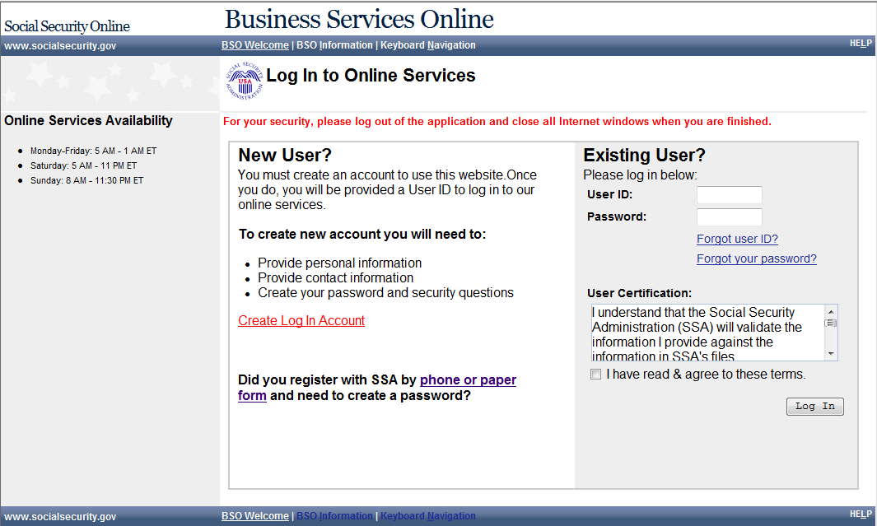
- Accept the Attestation 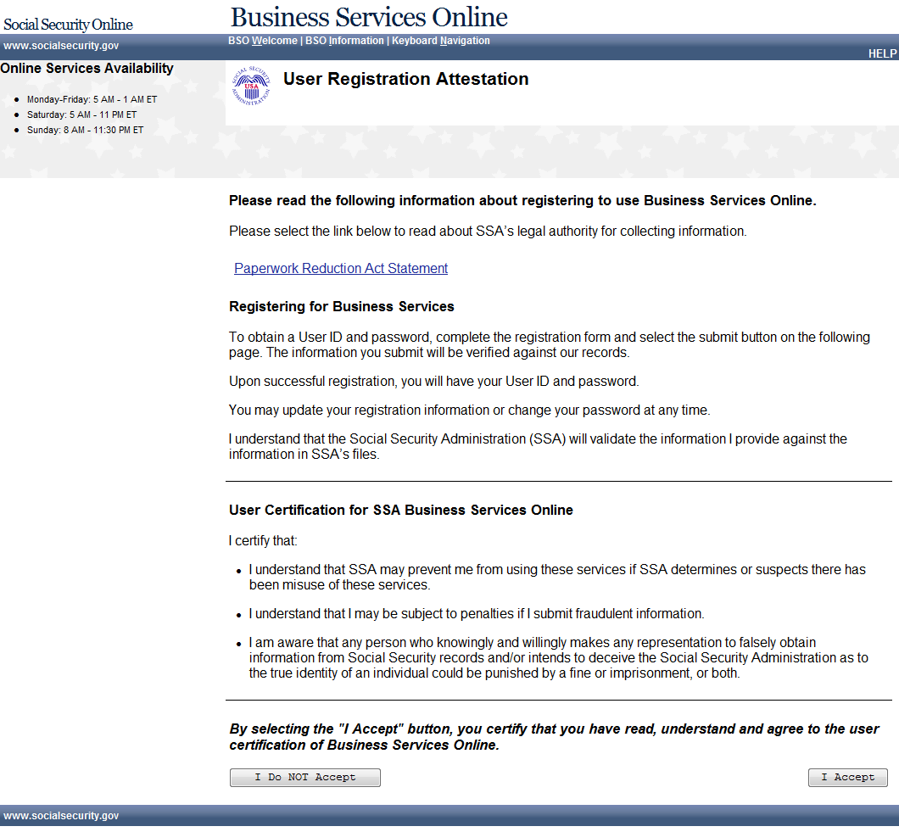

- Add user information
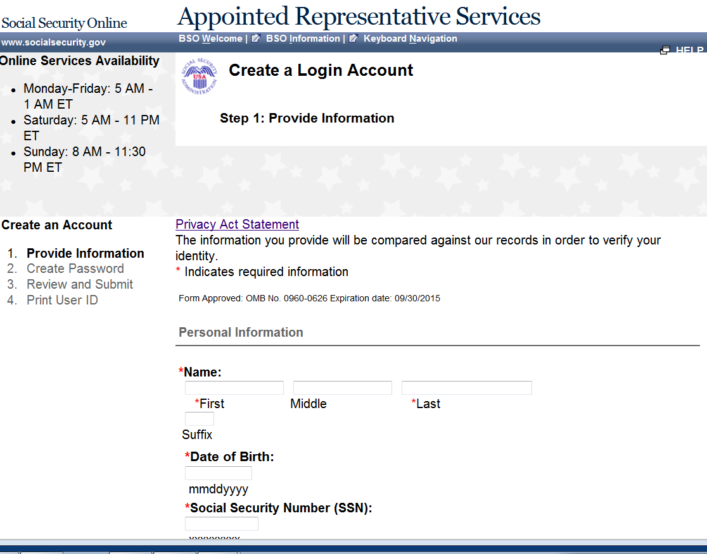
Form Approved: OMB No. 0960-0596 Expiration Date: 09/30/2015
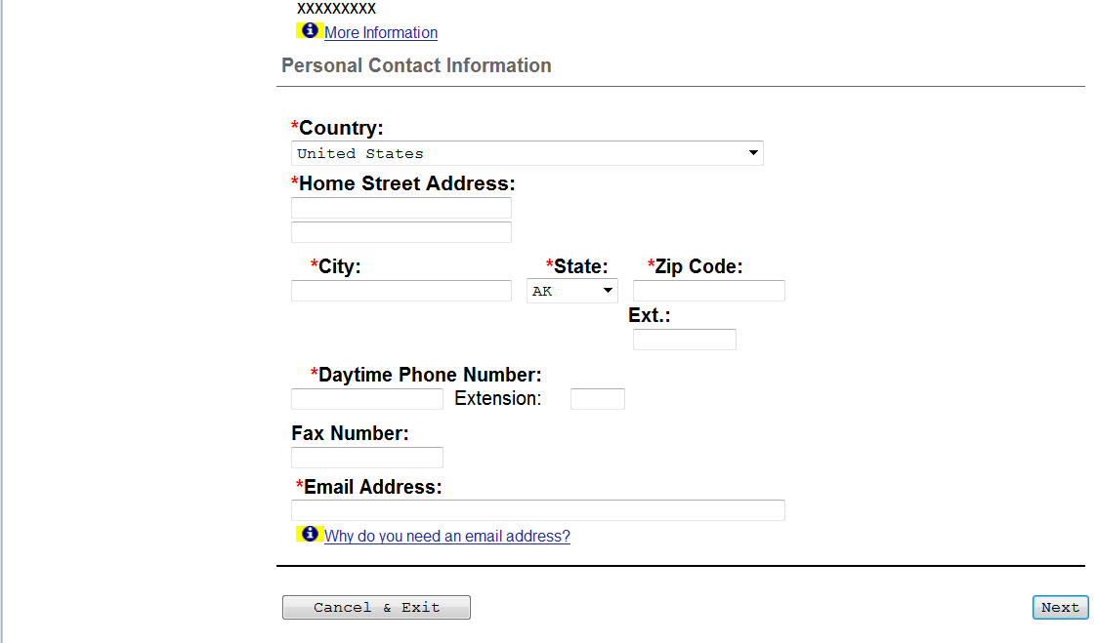

- Enter password and KBA questions and answers 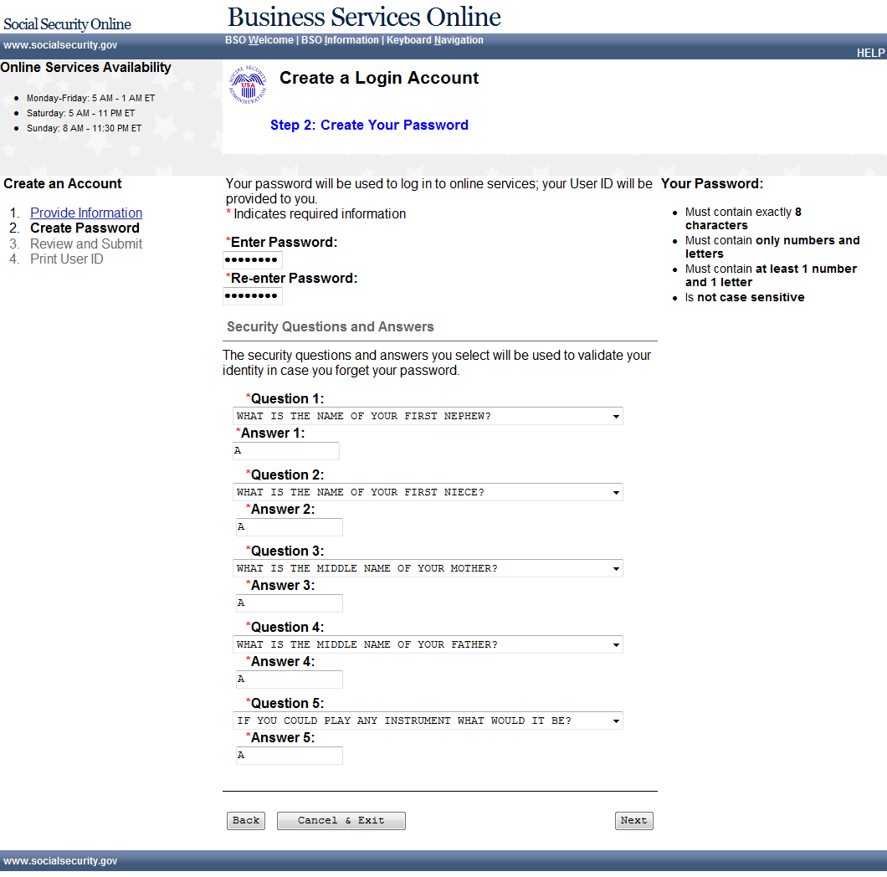
- Review your information and accept the certification 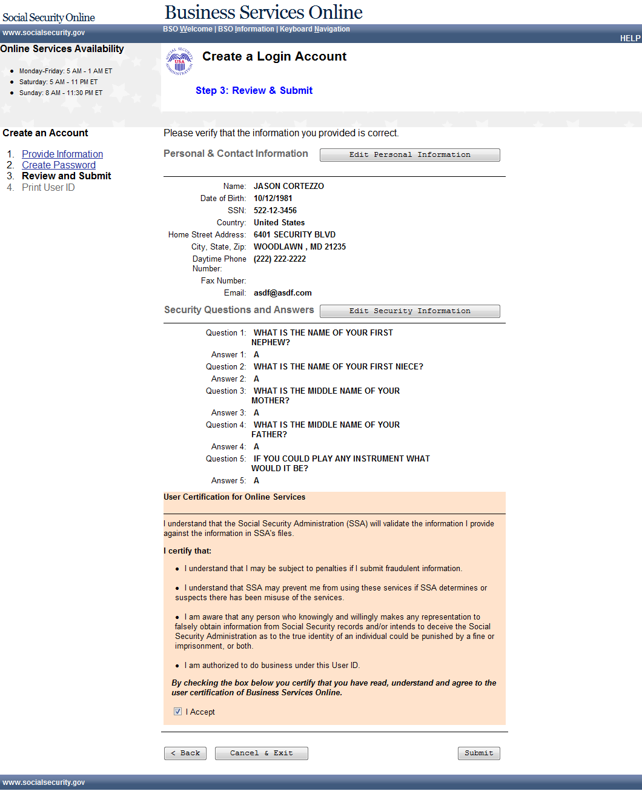
- Note down your new user id, you can print a receipt if desired 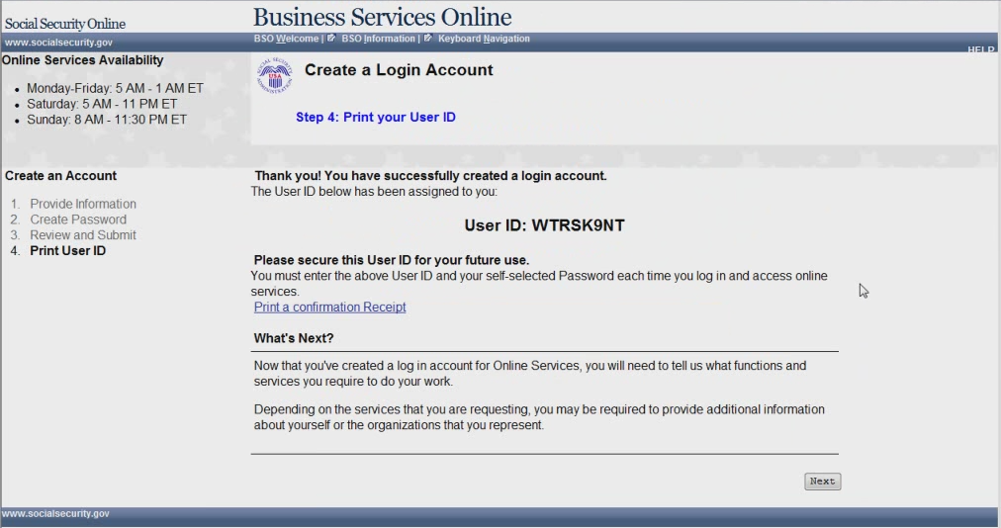
- Appointed Rep MENU - No services
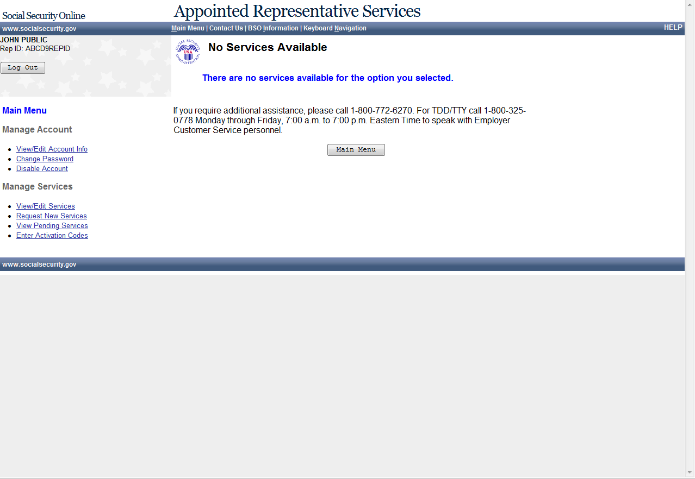

8. Appointed Rep MENU – only for Appointed Reps (This screen will be removed.)
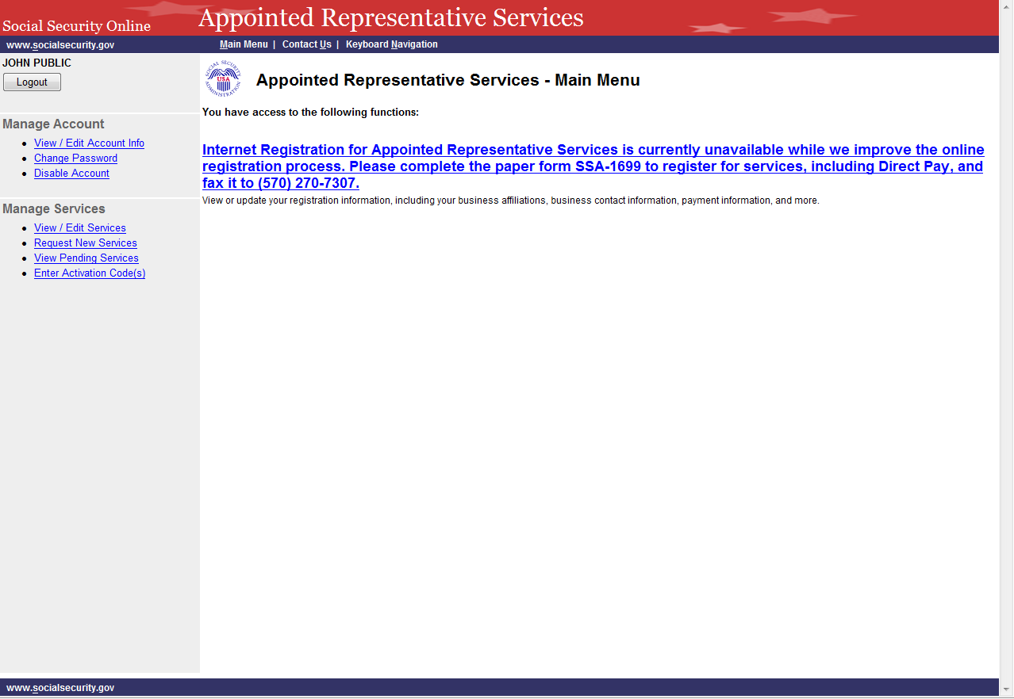

9. Appointed Rep MENU – Electronic Folder Request
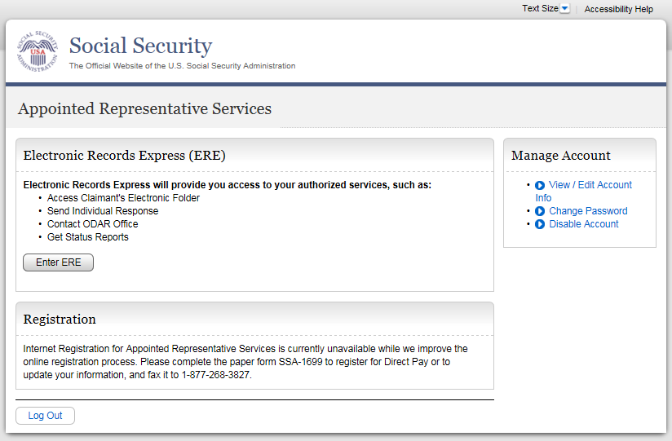

10. Enter a Text-Enabled Phone Number
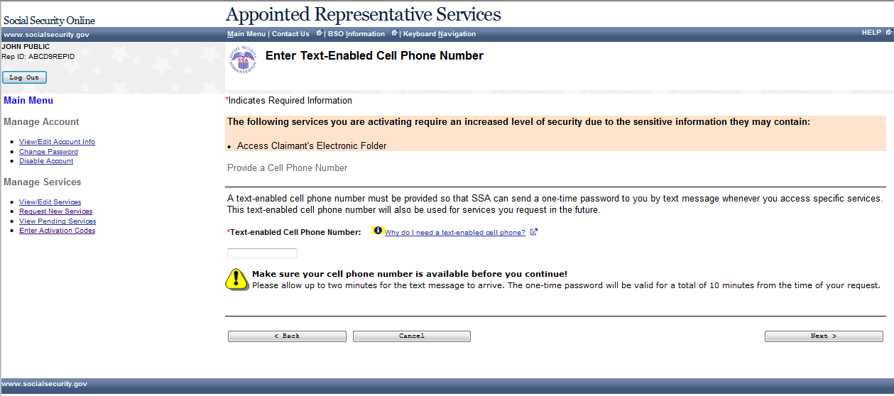
11. Enter code activation
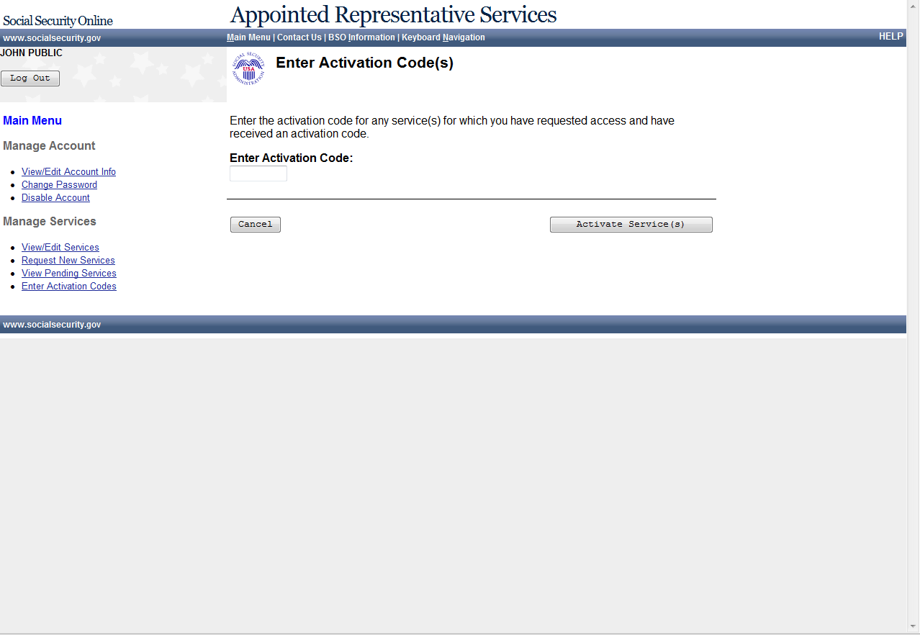
12. Enter activation confirmation
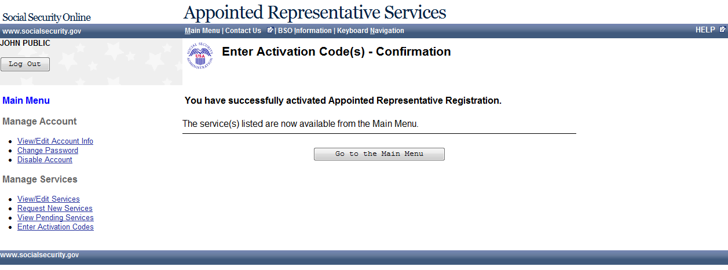

13. No service available

14. Paperwork Reduction Act Statement

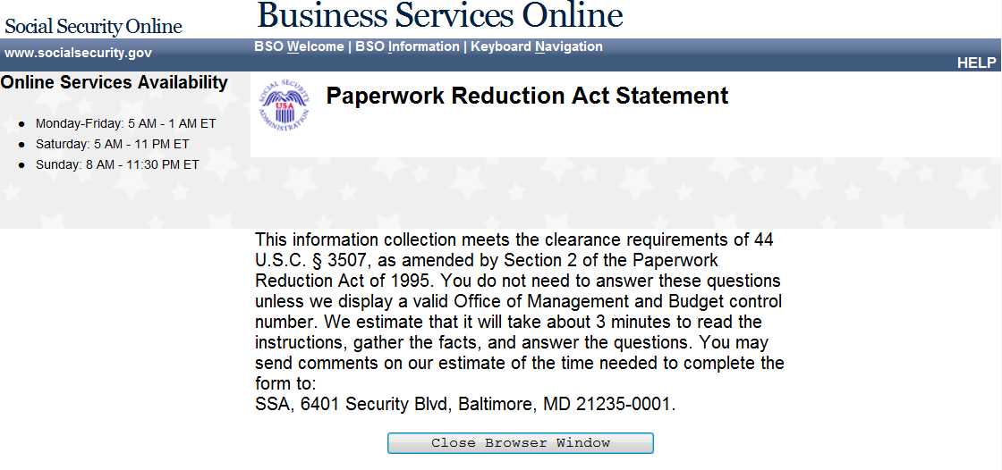

15. Privacy Act Statement

Privacy Act Statement
Collection and Use of Personal Information

Sections 205(a) and 1106 of the Social Security Act, as amended, authorize us to collect this information to allow you access to our online applications. We will use the information you provide to register you, your company, or authorized employee(s) to use our Business Services Online (BSO).
Furnishing us this information is voluntary. However, failing to provide us with all or part of the information could prevent us offering you access to our BSO suite of services.
We rarely use the information you supply for any purpose other than for registration and granting access to our BSO suite of services. However, we may use the information for the administration of our programs including sharing information:
- To comply with Federal laws requiring the release of information from our records (e.g., to the Government Accountability Office and Department of Veterans Affairs); and,
- To facilitate statistical research, audit, or investigative activities necessary to ensure the integrity and improvement of our programs (e.g., to the Bureau of the Census and to private entities under contract with us).
A list of when we may share your information with others, called routine uses, is available in our Systems of Records Notice entitled, Master Files of Social Security Number (SSN) Holders and SSN Applications (60-0058). Additional information about the BSO suite of services, routine uses of information, programs, and systems are available online at www.socialsecurity.gov or at your local Social Security office.
We may share the information you provide to other agencies through computer matching programs. Matching programs compare our records with records kept by other Federal, State, or local government agencies. We can use the information from these matching programs to establish or verify a person’s eligibility for federally funded or administered benefit programs and for repayment of payments or delinquent debts under these programs.

