Form E O=000000 C=000000 B=00000
OMB#1205-0421 Occupation Title
Expires: 6/30/2015 Web site username: 000000000000E
Ver.: 1/13 – 01 Web site password: knowledge000

Some Important Questions
About The Knowledge Required
For Your Occupation

Please return your completed questionnaire in the enclosed envelope to:

RTI Research Operations Center, 5265 Capital Blvd. Raleigh, NC 27616-2925
Sponsored by: The U.S. Department of Labor and the National O*NET Consortium
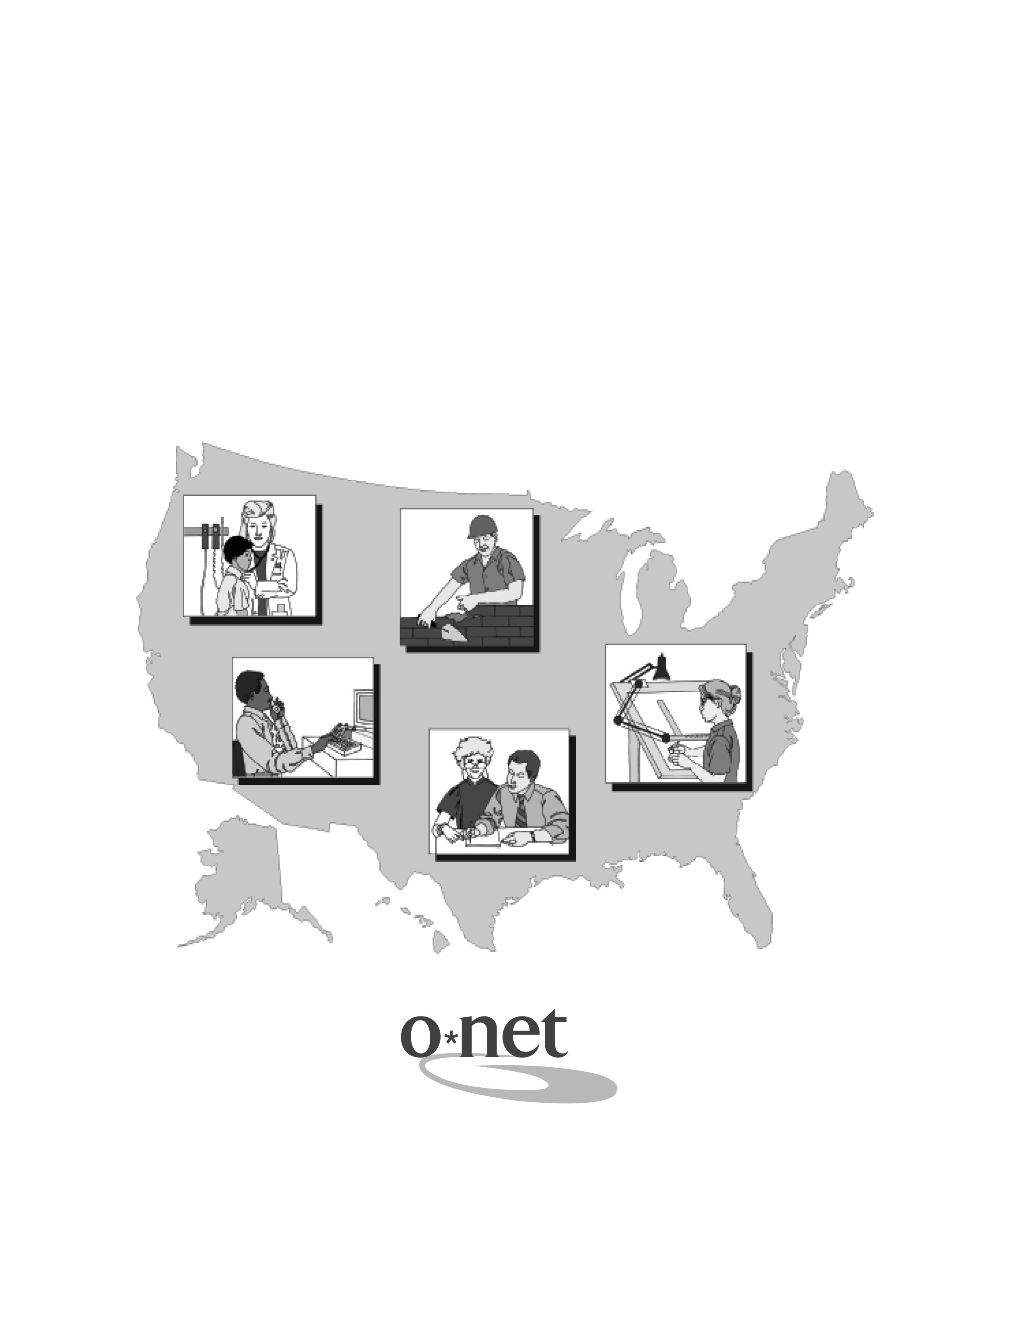

Persons are not required to respond to this collection of information unless it displays
a currently valid OMB control number. Respondents' obligation to reply to these
reporting requirements is voluntary. Public reporting burden for this collection of
information is estimated to average 30 minutes per response, including the time for
reviewing instructions, and completing and reviewing the collection of information.
Send comments regarding this burden estimate or any other aspect of this collection
of information, including suggestions for reducing this burden to the U.S. Department
of Labor, Office of Workforce Investment, Attn: O*NET Project, Frances Perkins
Building, Mail StopC4526, 200 Constitution Ave., NW, Washington, DC 20210 (OMB
Control Number 1205-0421).

Return to:

Research Triangle Institute
Research Operations Center
ATTN: O*NET Data Receipt
5265 Capital Boulevard
Raleigh, NC 27616-2925

Persons are not required to respond to this collection of information unless it
displays a currently valid OMB control number. Respondents' obligation to reply to
these reporting requirements is voluntary. Public reporting burden for this
collection of information is estimated to average 25 minutes per response,
including the time for reviewing instructions, and completing and reviewing the
collection of information. Send comments regarding this burden estimate or any
other aspect of this collection of information, including suggestions for reducing
this burden to the U.S. Department of Labor, Office of Workforce Investment, Attn:
O*NET Project, Frances Perkins Building, Mail Stop S4231, 200 Constitution Ave.,
NW, Washington, DC 20210 (OMB Control Number 1205-0421).

Return to: Research Triangle Institute
Research Operations Center
ATTN: O*NET Data Receipt
5265 Capital Boulevard
Raleigh, NC 27616-2925

