U.S. Department of Labor  Bureau of Labor Statistics | Occupational Requirements Survey | 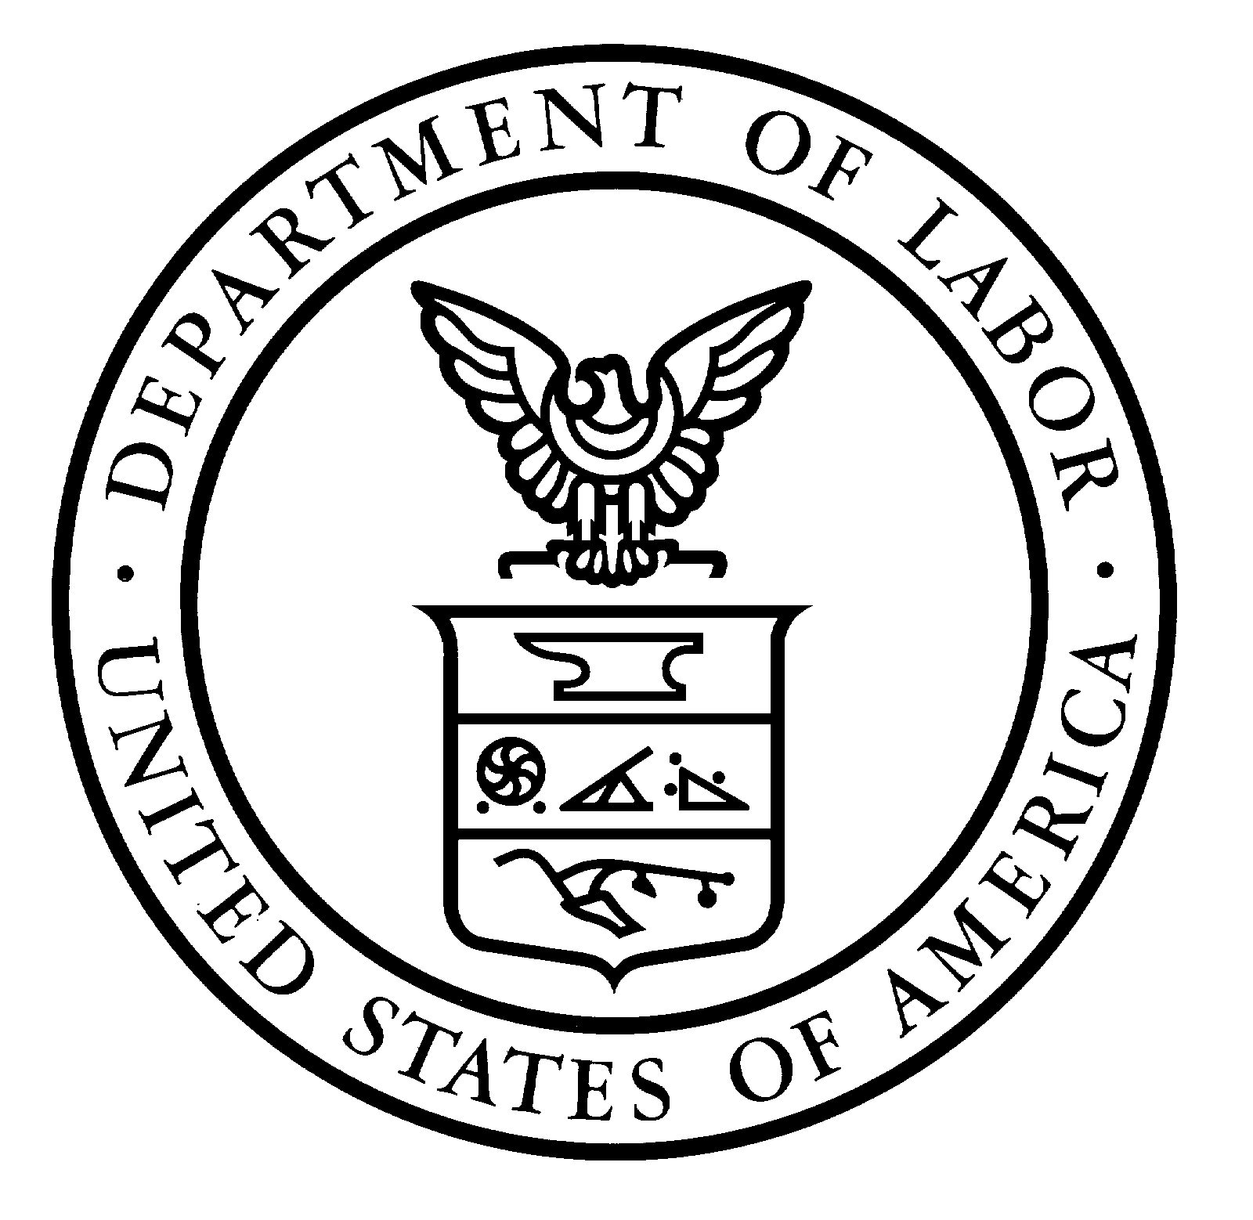

The Bureau of Labor Statistics, its employees, agents, and partner statistical agencies, will use the information you provide for statistical purposes only and will hold the information in confidence to the full extent permitted by law. In accordance with the Confidential Information Protection and Statistical Efficiency Act of 2002 (Title 5 of Public Law 107-347) and other applicable Federal laws, your responses will not be disclosed in identifiable form without your informed consent. | This report is authorized by law, 29 U.S.C. 9. Your voluntary cooperation is needed to make the results of this survey comprehensive, accurate and timely. | O.M.B. #1220-0188  Expires 10/31/2015
We estimate that it will take an average of 85 minutes to complete this form, including time for reviewing instructions, searching existing data sources, gathering and maintaining the data needed, and completing and reviewing this information. If you have any comments regarding this estimate or any other aspect of this survey including suggestions for reducing this burden, please send them to the Bureau of Labor Statistics, Office of Compensation and Working Conditions (1220-0188), 2 Massachusetts Avenue N.E., Washington, D.C. 20212. You are not required to respond to the collection of information unless it displays a currently valid OMB control number.
Occupational Requirements Survey – Job Observation Pre-test Recording Form

PRINT ADDITIONAL COPIES OF PAGES 2-4, AS NEEDED.

*Indicates elements that are measured
This page left intentionally blank for notes.

