Contents

Login Page (option 1) 2

Login Page (Option 2) 3

About: 4

Key Individual Tab 6

Location of all Key Personnel, Key Individual 9

1. FAQ Page 9

2. Key Individual Tab 9

3. Review and Submit Tab 10

4. 4184 Form 11

5. Help Page 11

4184 form 16

# 

# Login Page

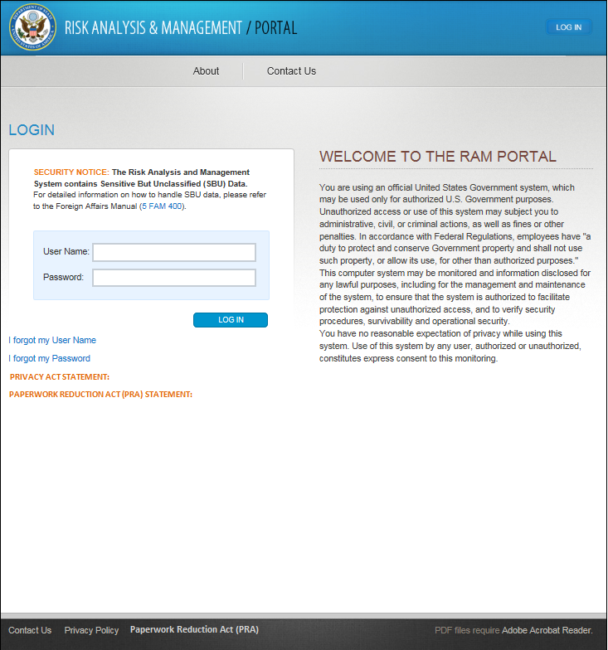

# About:

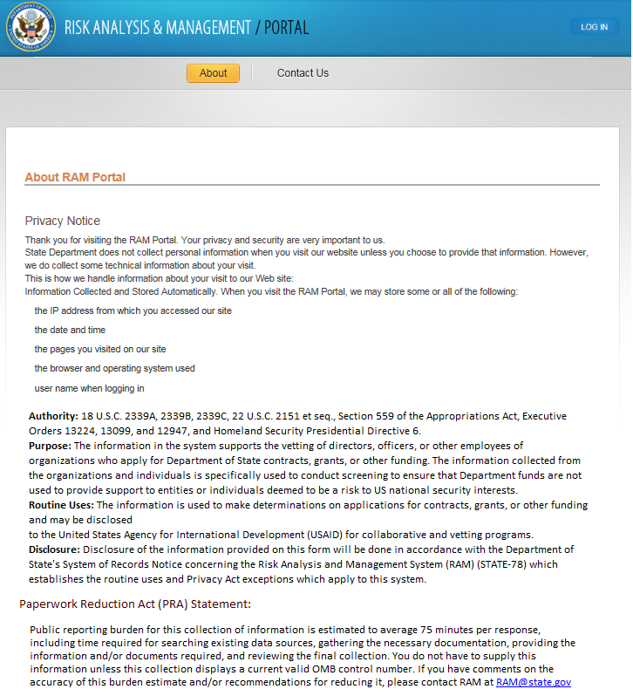

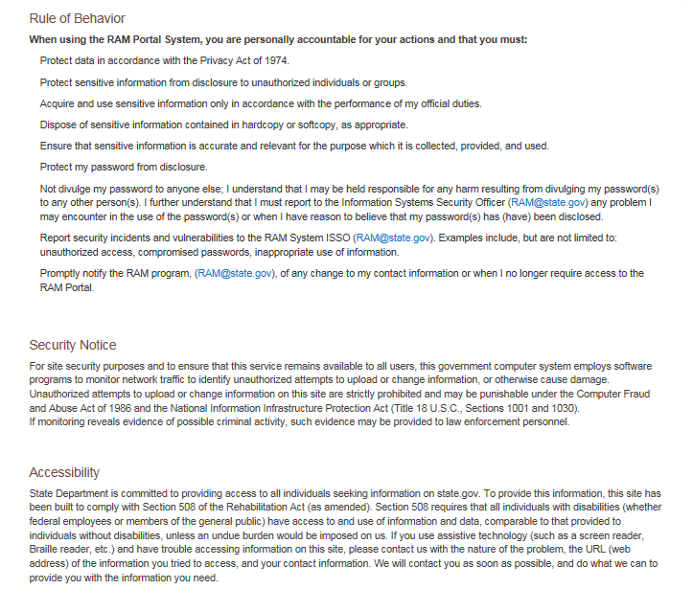

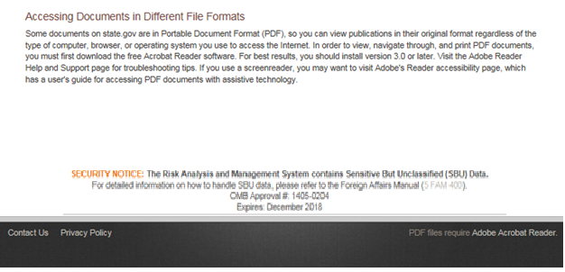

# Key Individual Tab

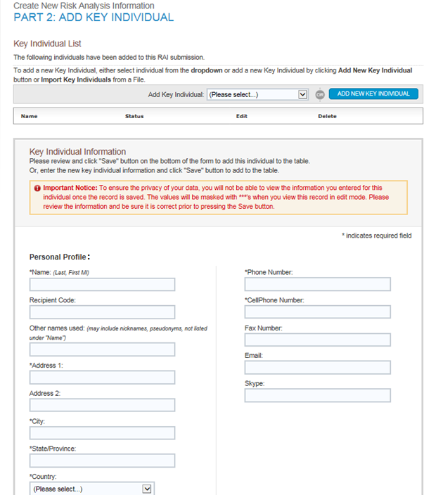

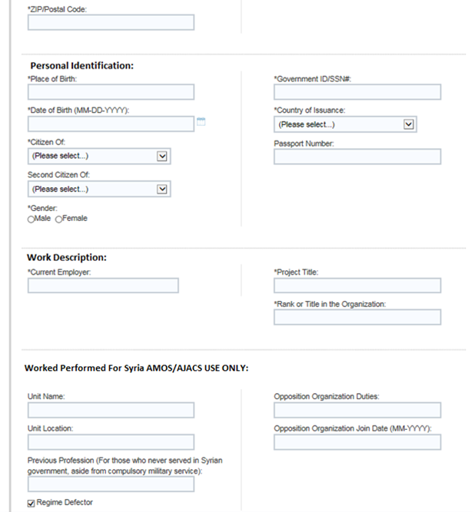

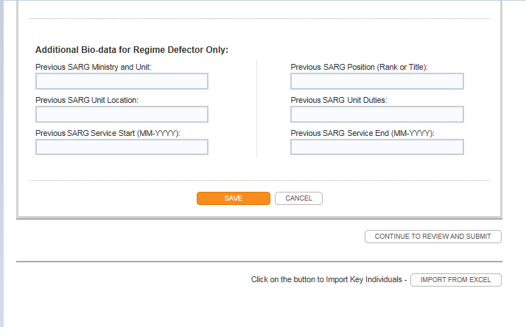

# Location of all Key Personnel, Key Individual

1. FAQ Page

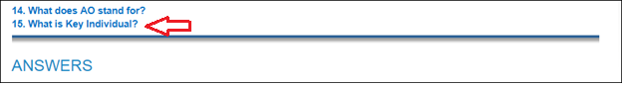



1. Key Individual Tab
   1. 11 mentions of Key Individual before adding a New Key Individual.
      1. Added error statement as well.

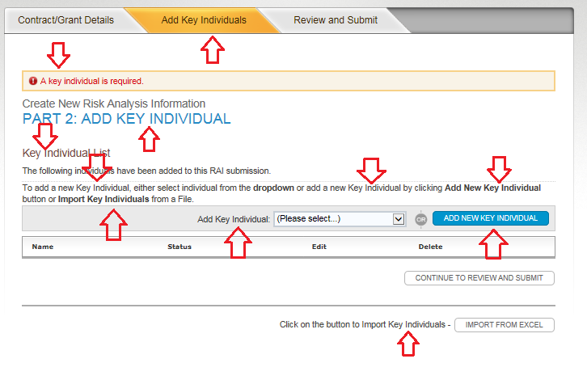

* 1. Adding Key Individual information

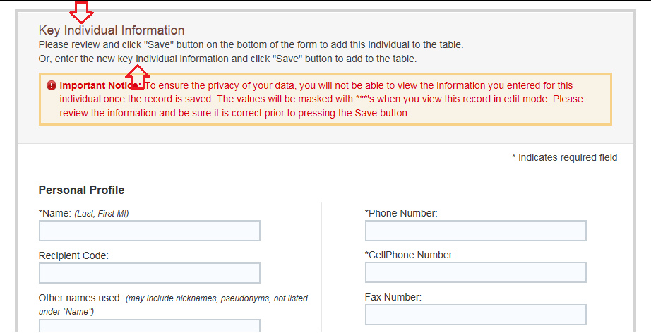

1. Review and Submit Tab

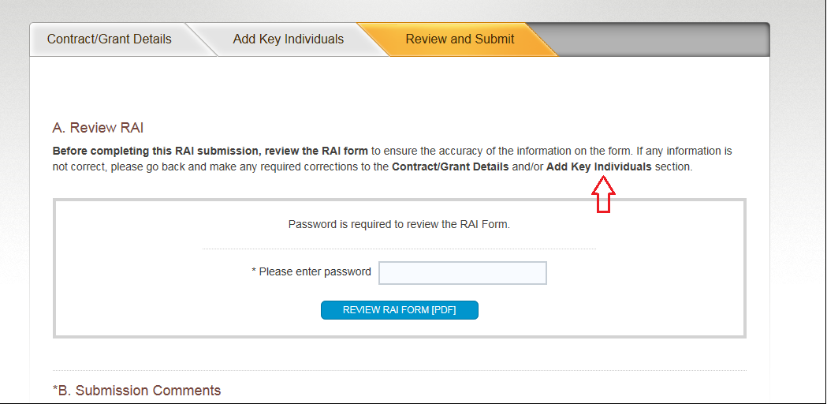

1. 4184 Form

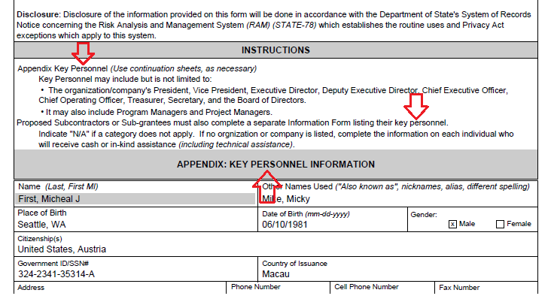

1. Help Page
   1. Message section

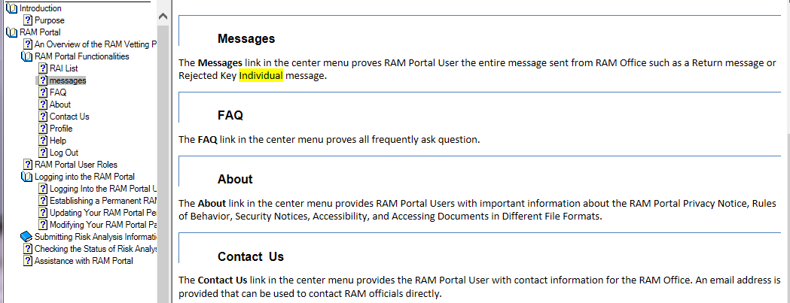

* 1. RAM Portal User Roles

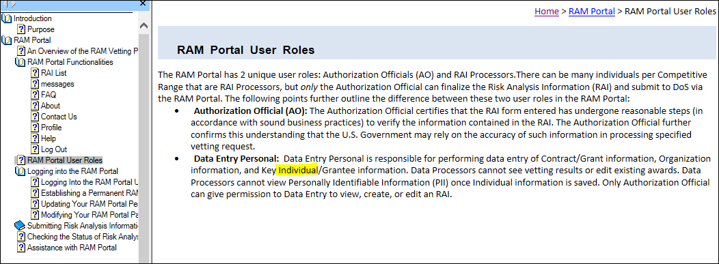

* 1. Adding Key Individuals (ignoring image from help)

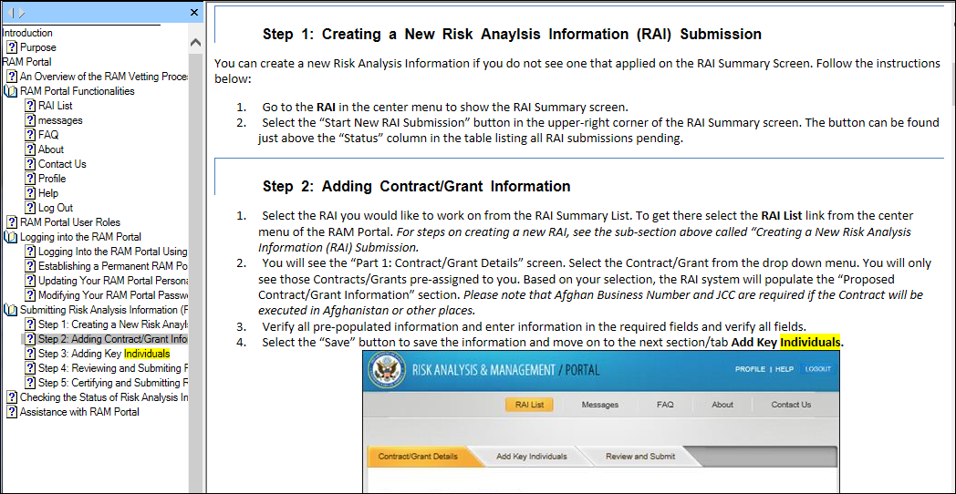

* 1. Adding key Individuals (Continue 1)

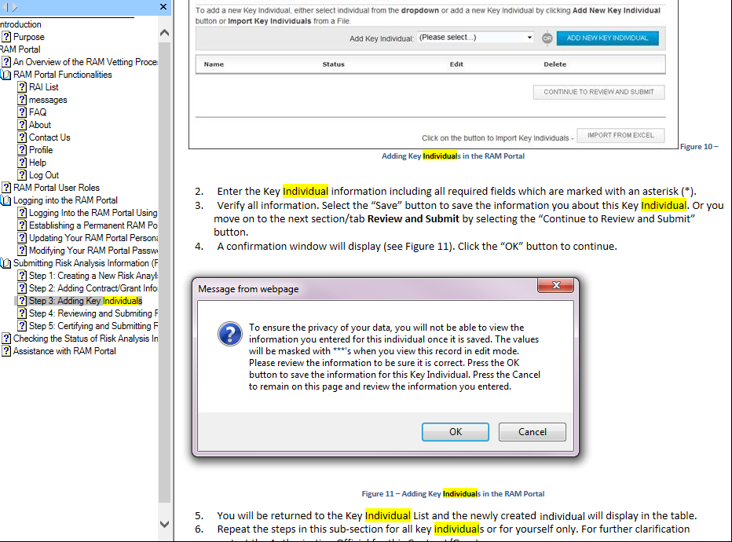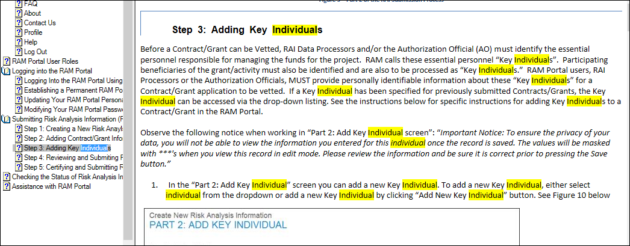

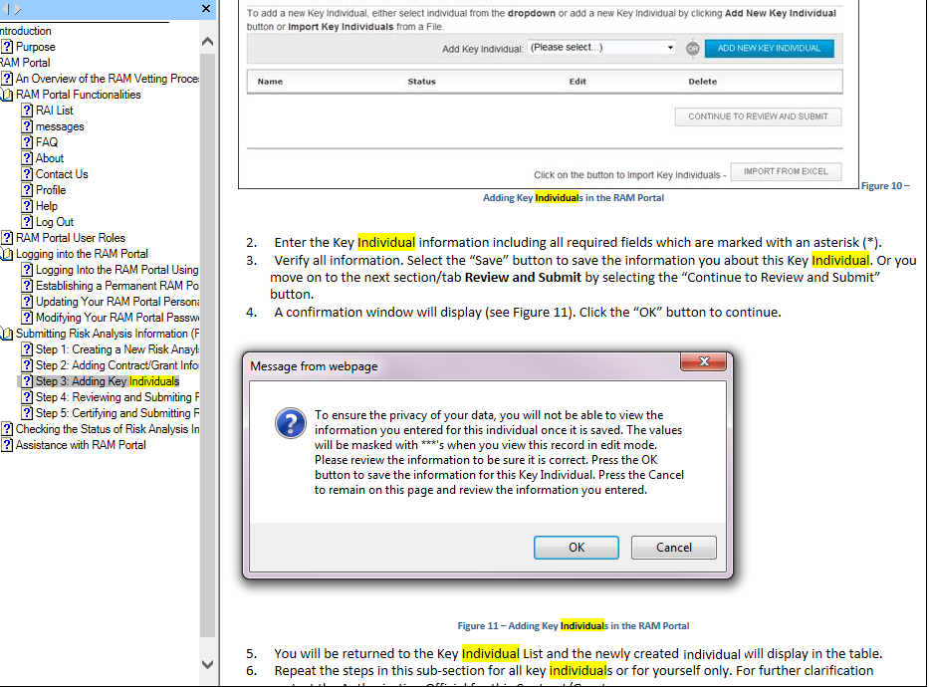

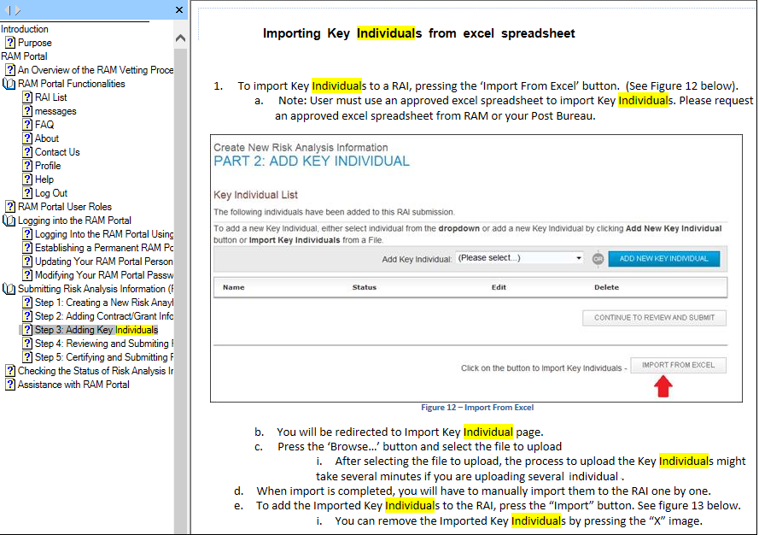

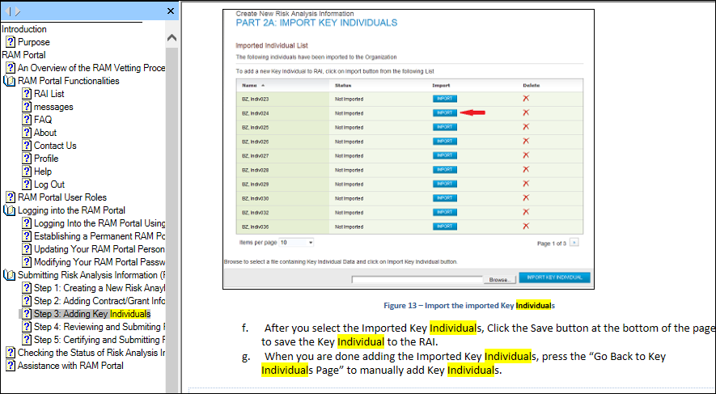

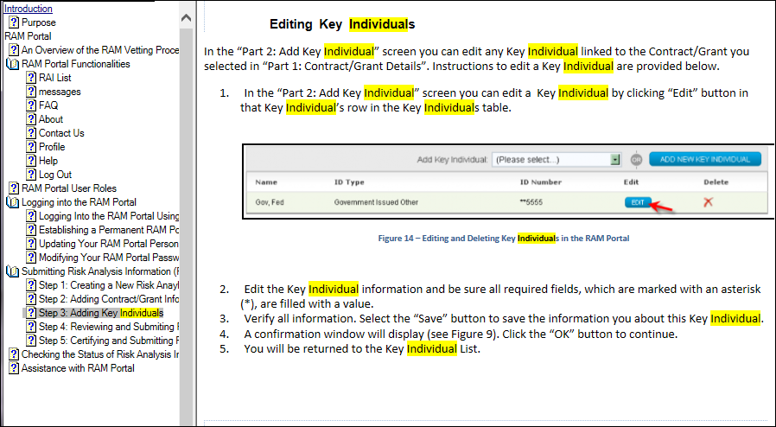

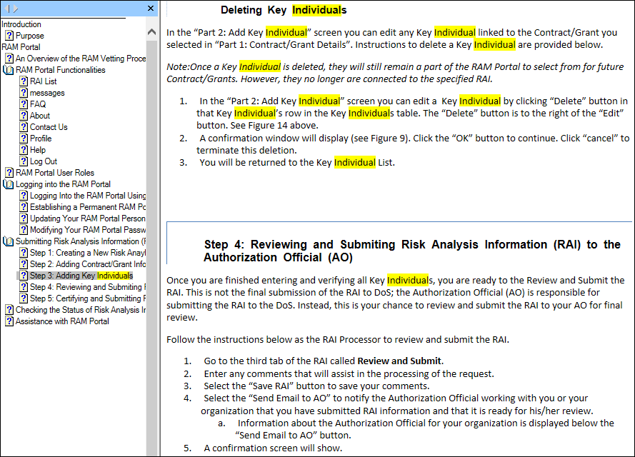

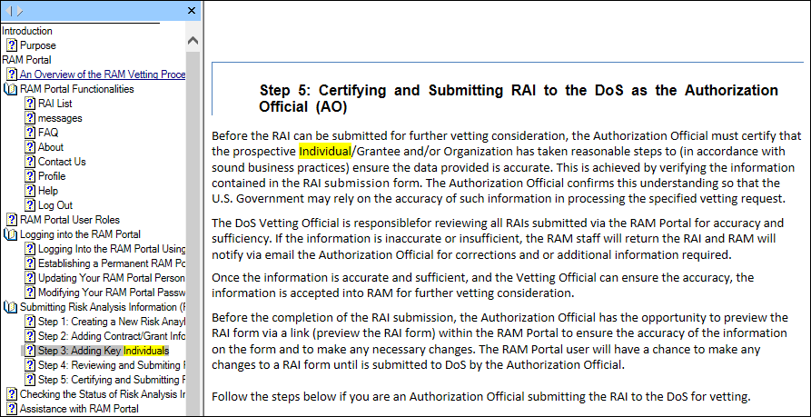

* 1. Checking the Status of Risk Analysis Information

