Narrative of Changes Table
The purpose of the Narrative of Changes Table is to demonstrate changes to a collection since the previous approval.

Collection Title: INDIVIDUAL COMPLAINT OF EMPLOYMENT DISCRIMINATION
OMB Control No.: 1610-0001
Current Expiration Date: 08/31/2014
Collection Instrument(s): DHS Form 3090-1

Description of Change:
DHS is proposing to make one change to the DHS compliant form. This change is the addition of a new checkbox that says “gender identity” as a sub-category under the existing checkbox that says “sex” on the form. Gender identity discrimination is a form of sex discrimination, which is covered under Title VII. So this information is already included in data gathered in EEO complaints; adding the separate check box just more clearly identifies a sub-category. This form modification is in accordance with new instructions from EEOC -- requiring all government agencies to specifically identify this type of information on our complaint forms.

Location on the form | Current version | Proposed Revision
16. Mark below ONLY the bases you believe were relied on to take the actions described in Item 15. | 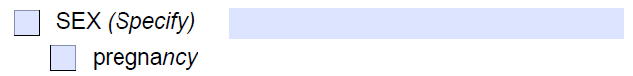 | 