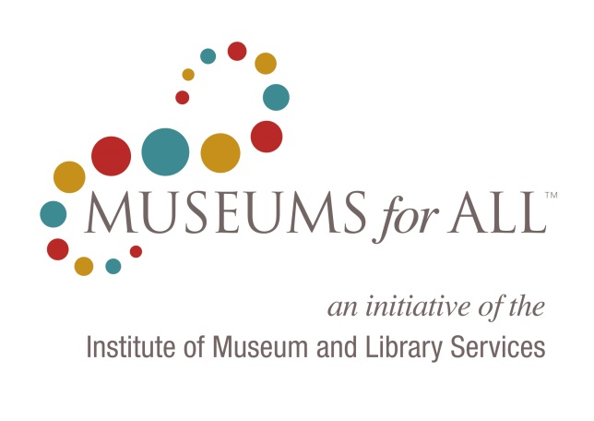
Program Feedback

Museum Name
Describe your experience with the Museums for All program.

Which of the following Museums for All resources have been useful to you?
Yes | No
⃝ | ⃝ | Website
⃝ | ⃝ | Logo Files
⃝ | ⃝ | Logo Usage Guide
⃝ | ⃝ | Window Cling
⃝ | ⃝ | Downloadable Materials
⃝ | ⃝ | Training Recommendations Document
⃝ | ⃝ | Press Release Template

Which of these resources were particularly useful? Why were they beneficial to your Museums for All program?

Do you have any additional comments about the resources that have been offered through the Museums for All program?

What additional resources would you like to see offered to make Museums for All more successful for your museum?
Yes | No
⃝ | ⃝ | Webinars
⃝ | ⃝ | Language for Fundraising
⃝ | ⃝ | Posters
⃝ | ⃝ | Web Banners
⃝ | ⃝ | Other
 |  | Please specify:

 | 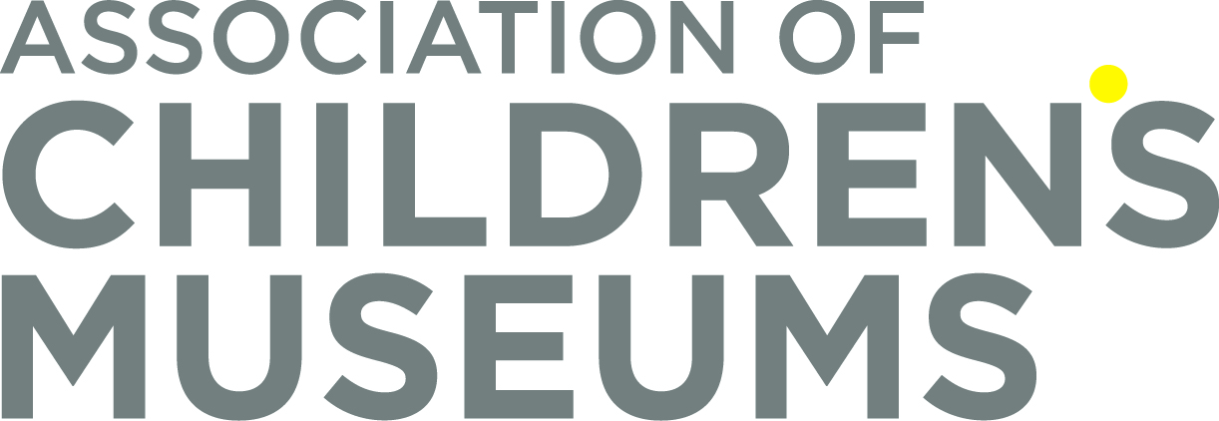

The OMB control number, ####-###, expires on MM/DD/YYYY. The Institute of Museum and Library Services may not conduct or sponsor, and a person is not required to respond to, an information collection unless it displays a currently valid OMB control number.

