Appendix A.2:
Participant handouts

Participant Handout 1—English

Safe Handling Instructions Label (Actual Size)
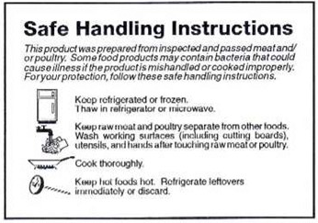

Safe Handling Instructions Label (Enlarged)
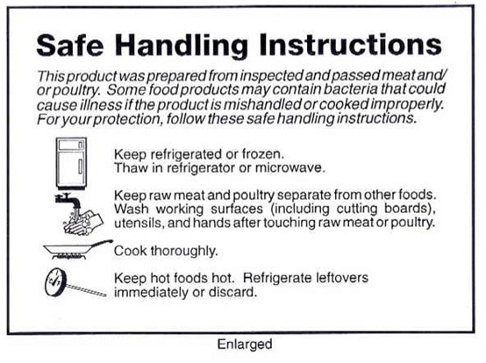
Participant Handout 1—Spanish
Safe Handling Instructions Label (Actual Size)

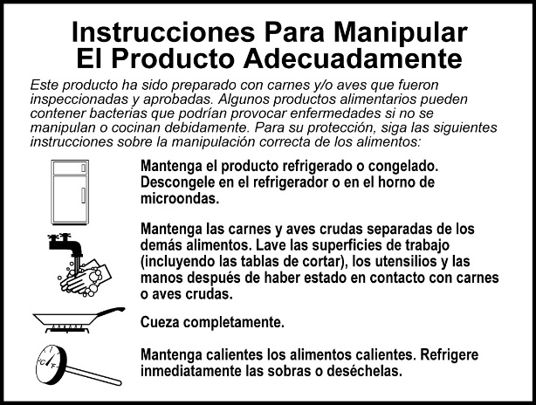

Safe Handling Instructions Label (Enlarged)
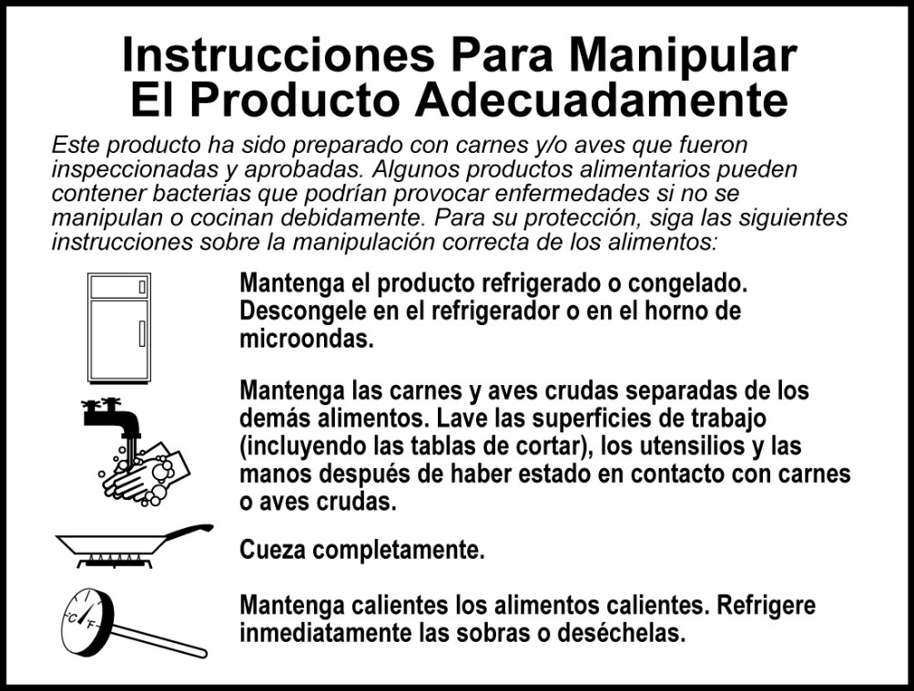

Participant Handout 2
Endpoint Temperatures
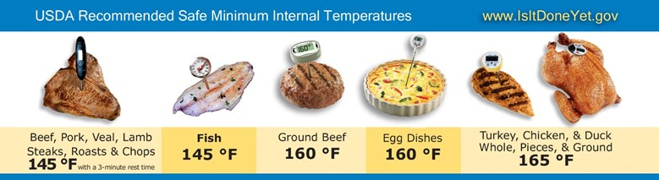

Participant Handout 3
Food Safe Families® Logo
