North Pacific Catcher-Processor

Social Survey

>> Factory Crew and Combis<<
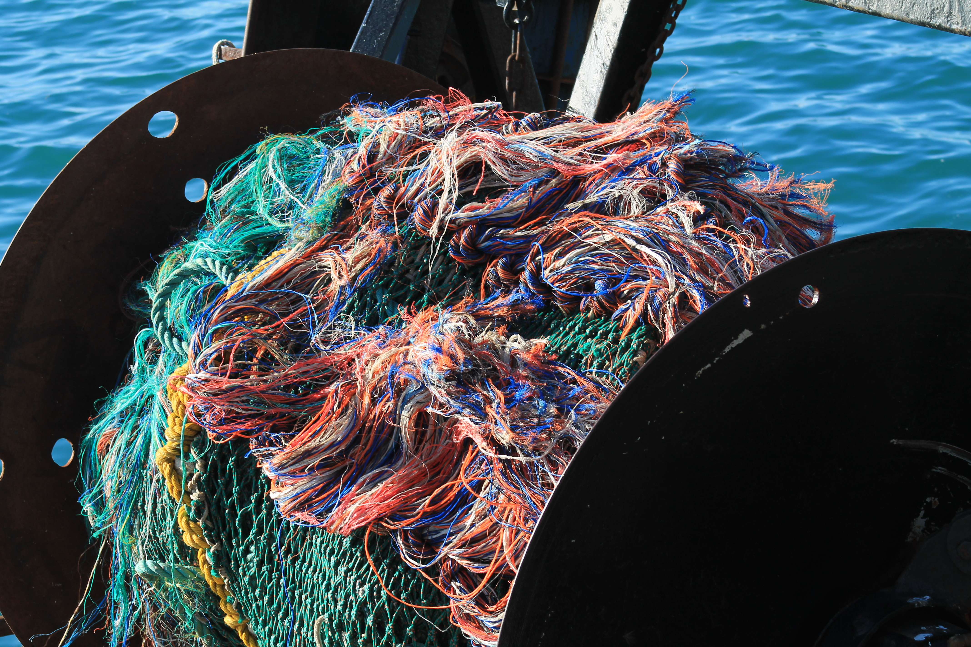
Photo Credit: Keeley Kent

Sponsored by:
NOAA Fisheries (National Marine Fisheries Service)
Alaska Fisheries Science Center
Economics and Social Science Research Program

Questions?

Please Contact Amber Himes-Cornell, AFSC Social Scientist
Phone: (206) 526-4221
Email: amber.himes@noaa.gov

OMB Control No.: XXXX-xxxx EXPIRATION DATE: XX/XX/20XX

This survey is voluntary. ALL RESPONSES ARE CONFIDENTIAL

SURVEY INFORMATION

WHAT IS THE PURPOSE OF THE STUDY? This study aims to collect social and cultural information catcher processor companies and their employees participating in the Gulf of Alaska (GOA) Groundfish Trawl Fishery. The study will collect baseline data in 2015 to generate a description of people in the sector before the approval and implementation of a substantial change in the management of the GOA Groundfish Trawl Fishery. After implementation we will repeat the study at various intervals. We can then compare the results from each study to update the baseline data on the industry, and better understand any changes or social impacts that have occurred in the industry. In addition to this survey, the North Pacific Fishery Management Council is expected to collect economic data about the fishery through an economic data collection program.

WHO IS CONDUCTING THIS STUDY? This study is being conducted by the Economics and Social Science Research Program (ESSRP) at the Alaska Fisheries Science Center (AFSC), National Marine Fisheries Service (NMFS), National Oceanic and Atmospheric Administration (NOAA). The primary mission of the ESSRP is to provide economic and socio-cultural information that will assist NMFS in meeting its stewardship responsibilities. This means we study human society as it relates to marine resources, inclusive of commercial fishing.

HOW IS THIS STUDY FUNDED? This project is funded by the NMFS.

HOW WILL THIS STUDY BE USED? The information collected in this study will be used to understand the impacts of fishery management measures, and to inform fishery management in the future. The aggregated results of the survey will be publically available, but individual survey responses are confidential. It will also improve the NMFS’ ability to analyze the impacts of fishery management actions on fishing communities, consistent with Magnuson-Stevens Fishery Conservation Act National Standard 8 and Executive Order 12898 – the Environmental Justice Initiative.

HOW IS THIS SURVEY ORGANIZED? This survey is one of three that have been created for the catcher processor sector. Each survey is aimed at a specific type of respondent: company management, shipboard management and deck crew, and processing line workers. This survey is aimed at processing line crew and combis. The survey contains questions aimed at understanding your personal demographics, your personal fishing and processing history, your work on catcher processors and with your current company.

WHO DOES THIS STUDY INCLUDE? This study includes the employees of catcher processor vessels that fish in the GOA Groundfish Trawl fishery and individuals at the management level of each company.

HOW LONG WILL IT TAKE? This survey takes most people 30 minutes to complete.

ARE MY ANSWERS CONFIDENTIAL? This is a confidential survey. Analysis of the survey results will be anonymous. All of the information will be aggregated as well. Information in this survey will be subject to the confidentiality requirements of the National Marine Fisheries Service per MSA Sec. 402(b) and the NOAA Administrative Order NAO 216-100, and will not be provided or presented in any way as to identify individual respondents. Please see next page for more information.

DO I HAVE TO PARTICIPATE? Your participation and input is very important and will help us to better understand the unique opportunities and challenges of this fishery and its impact on the catcher processor sector. However, this is a voluntary survey and you may choose to skip any question or end at any point in the survey.

HOW WAS MY NAME OBTAINED? Depending on your role with the catcher processor, your name was obtained through ownership of a vessel, websites, through your employer, or through third party referrals.

Thank you for your participation!
Please contact Amber Himes-Cornell, AFSC Social Scientist for more information.
Contact information: amber.himes@noaa.gov, or by phone: (206) 526-4221

Filled out by survey administrator
Code number: ___________________ Name of survey administrator: ___________________
Survey Location: _____________________________ Date: ___________________________
Notes: ____________________________________________________________________

SURVEY INSTRUCTIONS

All answers given in this survey should reflect your own perception of the commercial fishing industry based on your personal experience and knowledge.
- Please ask questions at any time. Feel free to ask the researcher who is working with you or contact Amber Himes-Cornell at amber.himes@noaa.gov or (206) 526-4221.
- Please follow directions carefully.
- Please DO NOT write your name anywhere on this survey, only on the blue form provided.
- Please mark one answer per question unless otherwise specified. Please write clearly.
- If you are unable to answer the question or it does not apply to you, please make sure to select the ‘do not know’ or ‘NOT APPLICABLE’ box from the options provided.
- If you chose to not answer a question for any reason, please write a notation next to the question in the margin if an appropriate option (ex. NOT APPLICABLE) is not provided in the question.
  - Please mark boxes clearly.
In electronic survey versions, check boxes can be selected and unselected with a click of the mouse.
If you mark an answer incorrectly, please draw a horizontal line through the incorrect answer and check the correct answer.
THANK YOU FOR YOUR TIME AND PARTICIPATION

EXPLANATION OF CONFIDENTIALITY
The information you provide will be kept confidential to the extent possible per the Magnuson-Stevens Fishery Conservation and Management Act (as amended) Sec 402(b) and NOAA Administrative Order NAO 216-100, Protection of Confidential Fisheries Statistics. In addition, in the event of a Freedom of Information Act (FOIA) request, we will protect the confidentiality to the extent possible under the Exemption 4 of the FOIA. To support the confidentiality of this research the following processes are in place:
- Your name will not be included on the survey document. It will be tracked in an alternate document to reduce duplication, to account for your participation in the survey, and code your name as needed for the data analysis. Access to this document will be limited to researchers working on this study and protected via confidentiality agreements.
- All personal names provided on the survey document as answers to questions, will be viewed only by the study researchers. The names will either be coded with a descriptor such as ‘X Community Fisherman’ or assigned a code such as ‘A1’ as an identifier. The type of code that will be applied to the data for each applicable question may vary based on the question itself or the associated analysis of question.
- As researchers write final reports and publish the findings of this research, your responses will be combined with responses from other participants so that no single individual may be identified.

SECTION 1. DEMOGRAPHICS

- What is the name of the vessel you currently work on?

- What is your gender?
Male
Female

- What is your age?
years old

- What is your race? Please mark all that apply.
American Indian or Alaska Native
Asian (including the Philippines)
Black or African American
Native Hawaiian or Other Pacific Islander
White/Caucasian
Other (Please specify): __________________________________________________
I prefer not to answer

- Are you Hispanic or Latino?
Yes, I am Hispanic or Latino
No, I am not Hispanic or Latino

- What is your ancestry (ethnic origin)? Please mark all that apply.
 | Aleut |  | Guatemalan |  | Mexican |  | Somali
 | American Indian |  | German |  | Nicaraguan |  | Spanish
 | Athabaskan |  | Haida |  | Norwegian |  | Sudanese
 | Chinese |  | Inupiaq |  | Puerto Rican |  | Swedish
 | Cuban |  | Irish |  | Portuguese |  | Tlingit
 | Dominican |  | Italian |  | Russian |  | Tsimshian
 | English |  | Japanese |  | Salvadoran |  | Vietnamese
 | Eyak |  | Kenyan |  | Samoan |  | Yup’ik
 | Filipino |  | Korean |  | Scottish
 | Other (Please specify):

- What is your marital status?
Single
Married
Domestic Partner/Common law
Divorced
Separated
Widowed

- What is the highest level of education you have attained?
 | Elementary or some high school education |  | Associates degree
 | High school diploma or G.E.D. |  | Bachelor’s degree
 | Some college or vocational, no degree |  | Graduate or professional degree
 | Vocational certificate

- How many people live in your household (including yourself)?
people

- Are you a U.S. citizen?
Yes → Skip to question 10
No
Currently undergoing the naturalization process

10a. What type of foreign worker status do you have?
Temporary non-immigrant worker (H-2 visa)
Permanent immigrant worker (green card holder)
Exchange visitor (J-1 visa)
Other (Please specify):
_______________________________________________

- Does your family receive social assistance from any government in the United States? Check all that apply.
My family does not receive social assistance from the government.
Food stamps
Social security
Housing financial assistance
General utilities financial assistance
Child care financial assistance
Health care
Job placement assistance
Other (Please specify): ___________________________________________________________

SECTION 2. YOUR FISHING AND PROCESSING HISTORY

- How old were you when you started to work (getting paid) in commercial fishing or processing activities?
Years old

- How many total years have you been working as an employee on a catcher-processor?
Years

- Do any of your family members work in the commercial fishing or processing industry? Mark all that apply.
Spouse/Partner
Children
Mother or father
Sisters or brothers
Cousins
Aunts or Uncles
Other (Please specify): __________________________________________________________

- For how many generations has your family historically worked in commercial fishing or processing activities? Do not include yourself or your children as you think about your answer. Only include older generations of your family.
My generation is the first in our family that has worked in commercial fishing or processing (example: My cousin, my brother and I are fishermen).
1 generation (example: my father and uncle were fishermen)
2 generations (example: my grandfather and my father were fishermen, my grandmother worked in a cannery)
3 or more generations (example: my great grandfather, my grandfather and my father were all fishermen)

- What kind of work were you doing before you started working for a catcher-processor company?
 | Farming |  | Healthcare
 | Fishing |  | Service
 | Non-fishing maritime industry (example: shipping or tugboat crew) |  | Sales
 |  |  | Office or administrative support
 | Construction |  | Student
 | Shore-side processing |  | Unemployed
 | Mining |  | Other (Please specify):
 | Transportation (example: taxi or bus driving)
 | Logging |  | ________________________________
 | Education (example: teaching)
SECTION 3. YOUR WORK ON CATCHER PROCESSORS

- How many years have you been working as an employee for the current company you work for?
Years

- How many years have you been working the vessel you currently work on?
Years

- How many months per year are you typically working on a catcher-processor vessel?
months

- How did you get your current job as an employee for a catcher-processor company?
I was recruited through an Alaska Job Center
I was recruited by a family member that works on a catcher-processor
I was recruited by a friend that works on a catcher-processor
I searched online and found a job opening on a catcher-processor
I attended a recruitment event for a company that runs catcher-processors
I was working on a catcher vessel and heard about an opening
I was working in a shore-based processor and heard about an opening
Other (Please specify): _______________________________________________________

- What country were you living in when you were hired by your current employer?

- If you were living in the U.S. when you were hired, what city were you living in?
City/Town | State | Zip Code

- Please tell us about where you live when you are not on a catcher-processor vessel?
I own my home.
I rent my home.
I live rent-free with relatives.
Other (Please specify): ___________________________________________________

- What city and state do you live in when you are not on a fishing vessel?
 | City/Town | State | Zip Code | Country

- How long have you lived in the city you identified above?
 | Years | Months

- Does your immediate family (spouse/partner, kids) live in the same home as you when you are not on the vessel?
Yes → Skip to question 26
No
I do not have a spouse or children. → Skip to question 26

25a. If not, where do they live?
Elsewhere in the United States
In another country (Please list the country): ______________________________

- Do you receive overtime pay for work you do on a catcher-processor vessel?
Yes
No → Skip to question 27
I do not receive any overtime pay for work I do on a catcher-processor. → Skip next question

27a. If you receive overtime pay, how important is this pay to your overall earnings?
Not important at all
Somewhat important
Very important
Extremely important

- What percentage of your overall family income comes from your work in commercial fishing or processing activities?

Example: John makes $50,000 a year working at a processing plant and his wife Sue makes $50,000 a year working as a teacher, so commercial fishing and processing activities pays 50% of John and Sue’s income.
0-25% of combined family income.
26-50% of combined family income.
51-75% of combined family income.
76-100% of combined family income.
I prefer not to answer this question.
- Do you share money you earn with people who don’t live with you? If you answer yes, please indicate the number of people you share your money with.
 | Yes, I share my money with: |  | people
 | No

- What percentage of your pay do you send to people that don’t live with you, but live somewhere in the United States?
I do not send any of my pay to people living in the United States.
0-25% of my pay.
26-50% of my pay.
51-75% of my pay.
76-100% of my pay.
I prefer not to answer this question.

- What percentage of your pay do you send to people that live in another country?
I do not send any of my pay to people living in another country.
0-25% of my pay.
26-50% of my pay.
51-75% of my pay.
76-100% of my pay.
I prefer not to answer this question.

- Thinking only about today, how would you rate your job satisfaction?
Excellent
Good
Fair
Poor

- Thinking back over the last year, how would you rate your overall job satisfaction working on a catcher-processor?
Excellent
Good
Fair
Poor

- What would improve your job satisfaction?

- Have you ever received a promotion while working for your current catcher-processor company?
Yes
No

- Have you ever received a pay raise while working for your current catcher-processor company?
Yes
No

- If you wanted it, do you feel like there are opportunities for you to have a long-term job on a catcher-processor vessel?
Yes
No
I don’t know
Not Applicable

- What is your relationship like with your co-workers on this vessel?
Good
Neither good nor bad
Bad

- Do you plan on continuing to work on a catcher-processor for the next five (5) years?
Yes
No
I don’t know

- What type of work do you do during the time you are not working on a catcher-processor vessel? Please mark all that apply.
I do not have another job during the time when I am not on the catcher processor.
 | Farming |  | Healthcare
 | Fishing |  | Service
 | Non-fishing maritime industry (example: shipping or tugboat crew) |  | Sales and office
 |  |  | Office or administrative support
 | Construction |  | Student
 | Shore-side processing |  | Unemployed
 | Mining |  | Other (Please specify):
 | Transportation (example: taxi or bus driving)
 | Logging |  | ________________________________
 | Education (example: teaching)

- Hypothetically, if you were not able to go on (and be paid for) one of your usual catcher-processor trips in year, what would you do? Please mark all that apply.
Find work with another catcher-processor company for that time
Find work on another type of vessel
Find work in a shore-side plant
File for unemployment
Go to school
Find other employment in Alaska
Find other employment in my home state
Find other employment in my home country
Retire
I do not know
I would not do anything
Other (Please specify):

The following space is left blank for notes or comments

THANK YOU FOR YOUR PARTICIPATION
Please address any questions or comments to:
Amber Himes-Cornell
7600 Sand Point Way NE
Seattle, WA 98115
amber.himes@noaa.gov
(206) 526-4221
Public reporting or burden for this survey is estimated to average 30 minutes per response, including the time for reviewing instructions, searching existing data sources, gathering and maintaining the data needed, and completing and reviewing the collection of information. Notwithstanding any other provision of the law, no person is required to respond to, nor shall any person be subject to a penalty for failure to comply with, a collection of information subject to the requirements of the Paperwork Reduction Act, unless that collection of information displays a currently valid OMB Control Number. Send comments regarding this burden estimate or any other aspect of this collection of information, including suggestions for reducing this burden, to Amber Himes-Cornell, AFSC-Economics and Social Science Research Program, 7600 Sand Point Way NE, 98115.

