Overview
This document provides instructions for using the CMS online web application for reporting Population and Sampling data for the External Beam Radiotherapy (EBRT) Measure.
The Population and Sampling application enables a PPS-Exempt Cancer Hospital user or their contracted vendor to enter the population data of Medicare and non-Medicare patients that meet the inclusion criteria for the EBRT Measure set. The user or their contracted vendor can also indicate if they are submitting all of the records that meet the inclusion criteria, or if sending a sample, they can identify the frequency of sampling and the number of records that will be included in the sample.

Accessing the Web-Based Application
The user enters their assigned User ID and password to access the secure site and information for their individual hospital.
*Final web design is subject to change as it is dependent on web real estate and IT capacity. Changes will not impact the data elements but rather the application layout.*
Figure 1 Sign In
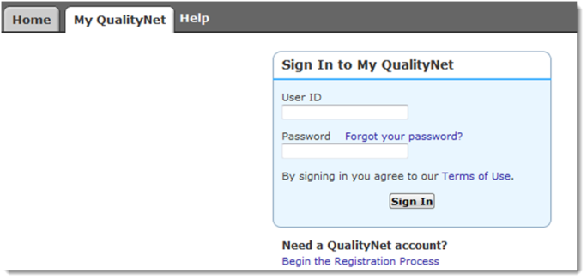

Manage Measures
After selecting the “View / Edit Population and Sampling” link under Manage Measures, the user selects the Reporting Period and selects the [Continue] button:
Figure 2 View / Edit Population & Sampling Selections
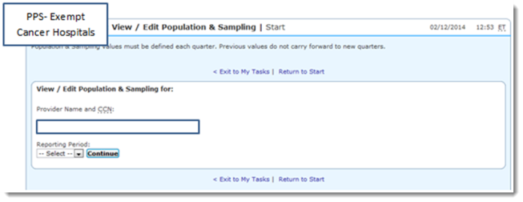

Sampling Frequency Selection
The user will select the sampling frequency: Quarterly, Not Sampling, or Not Applicable.

Reporting – Initial Inpatient Population and Sample Size
The reporting is identified as Medicare and Non-Medicare.
Sample Frequency: Not Sampled
Not Sampled Patient Population | Number
Total Initial Patient Population
Medicare Initial Patient Population
Non-Medicare Initial Patient Population

Figure 3
Initial Inpatient Population | Quarter 1 | Quarter 2 | Quarter 3 | Quarter 4 | Total
Medicare
Non-Medicare
Total
Sample Size | Quarter 1 | Quarter 2 | Quarter 3 | Quarter 4 | Total
Medicare
Non-Medicare
Total

PRA Disclosure Statement
According to the Paperwork Reduction Act of 1995, no persons are required to respond to a collection of information unless it displays a valid OMB control number. The valid OMB control number for this information collection is 0938-1175. The time required to complete this information collection is estimated to average 10 minutes per response, including the time to review instructions, search existing data resources, and gather the data needed, and complete and review the information collection. If you have comments concerning the accuracy of the time estimate(s) or suggestions for improving this form, please write to: CMS, 7500 Security Boulevard, Attn: PRA Reports Clearance Officer, Mail Stop C4-26

