U.S. Bureau of Labor Statistics
International Price Program
Import/Export Price Survey website

Login page
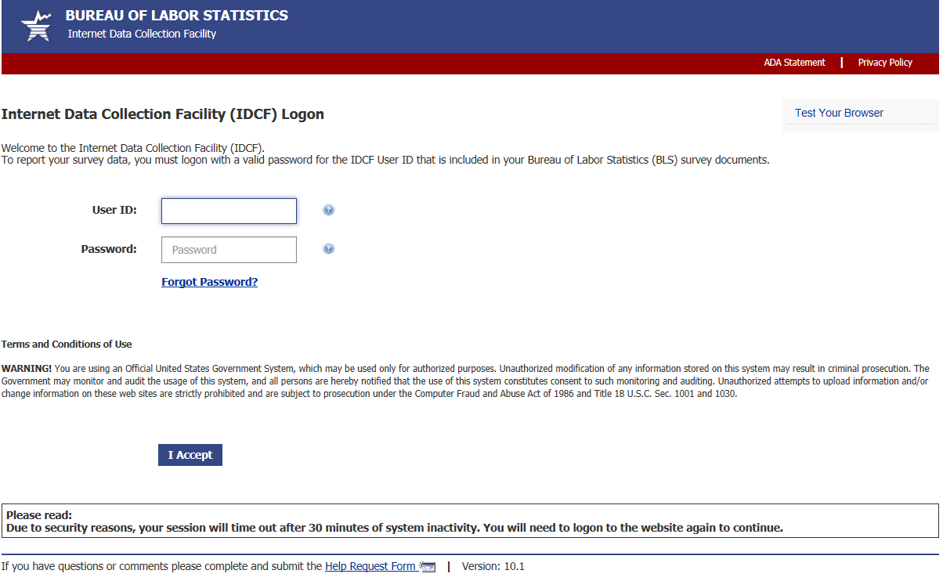

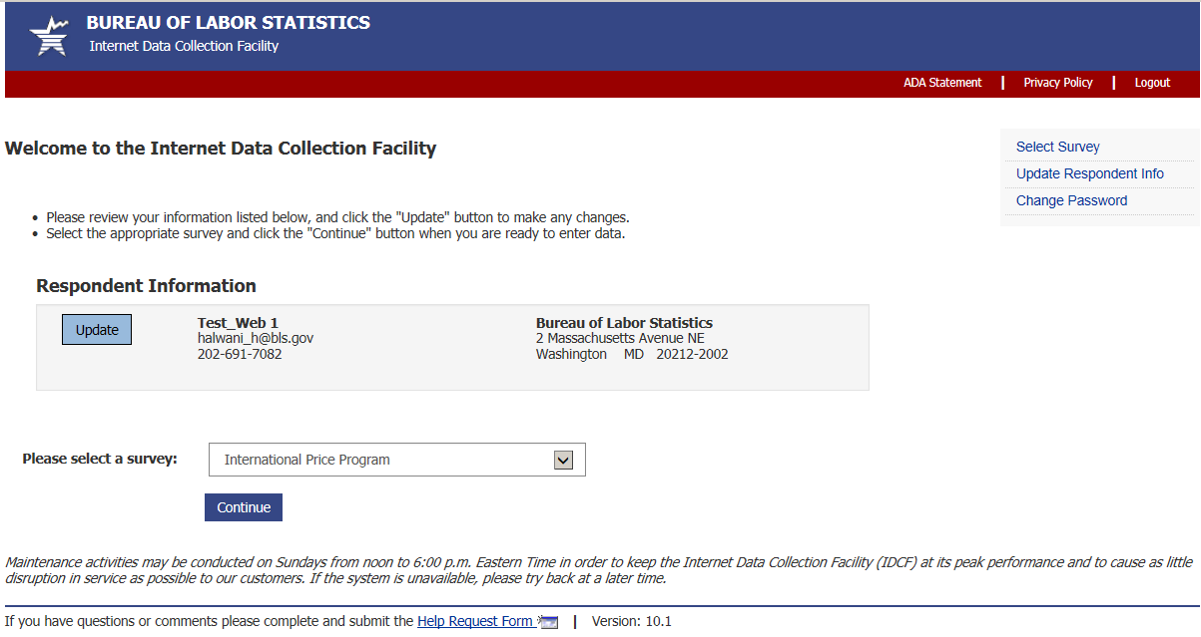

Welcome Screen

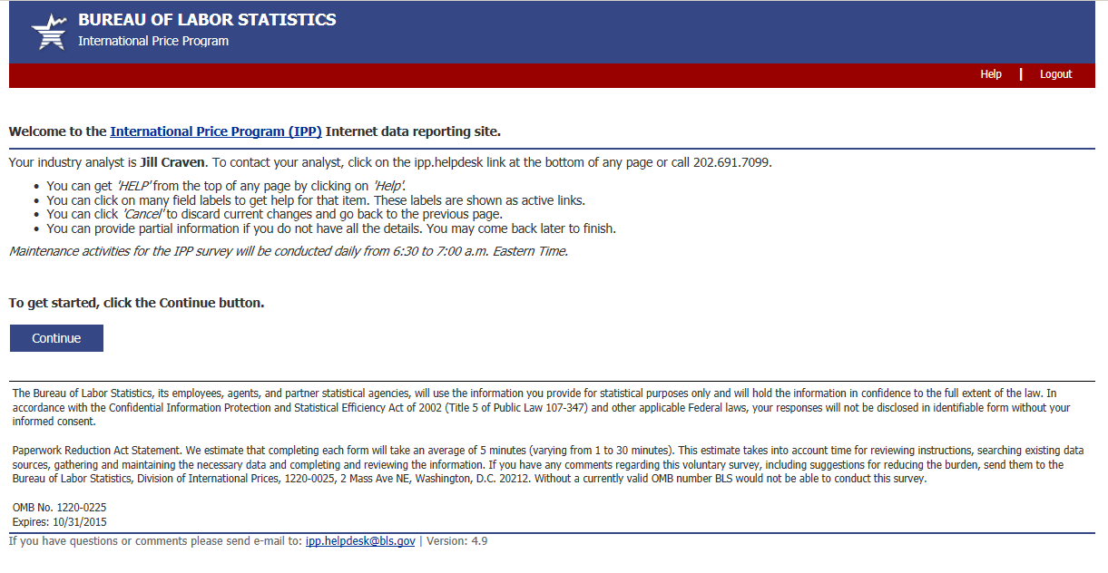 OMB No: 1220-0225
Expires: 10/31/2018

Verify Contact Information screen (Step 1)
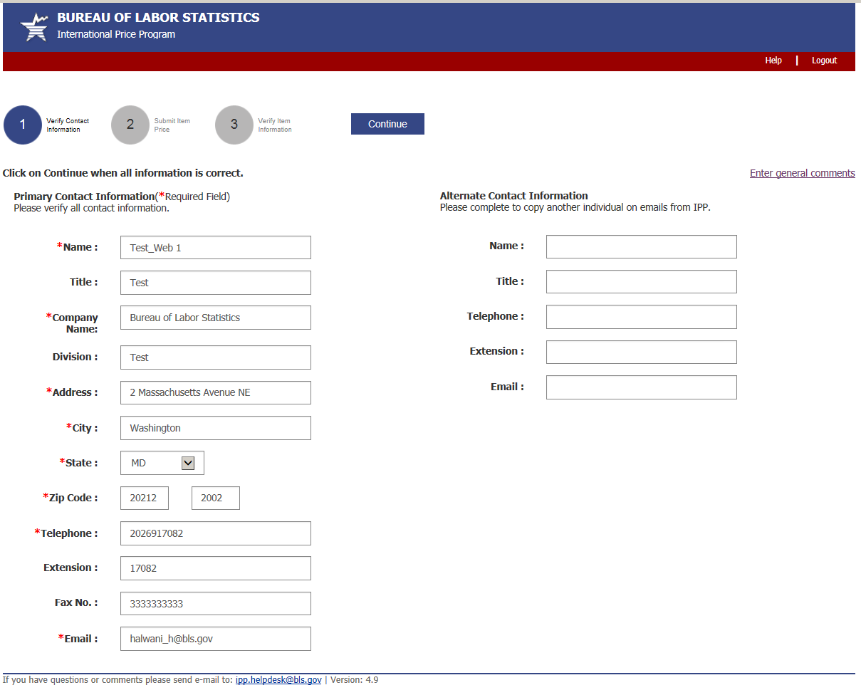

Submit Price Information Screen (Step 2)
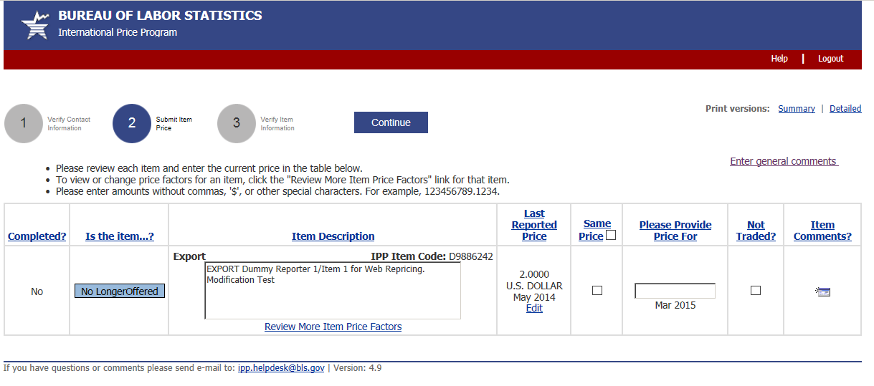

Verify Price Information Screen (Step 3)
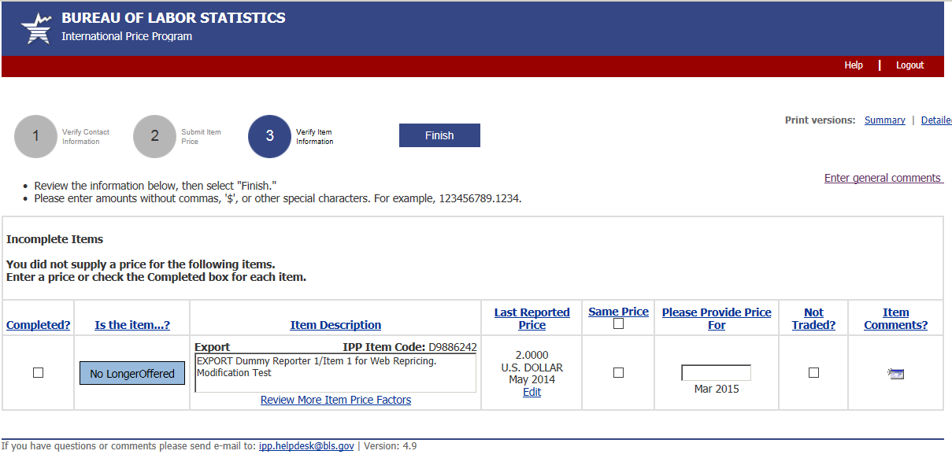

More Item Price Factors screen
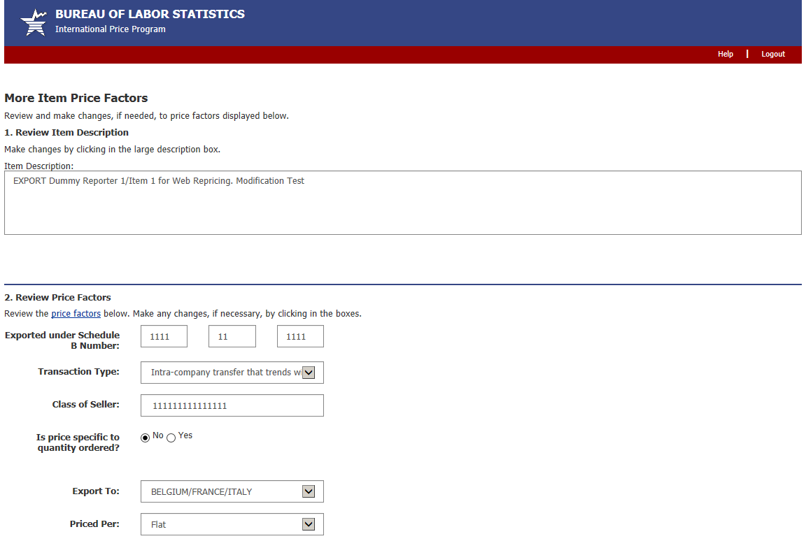
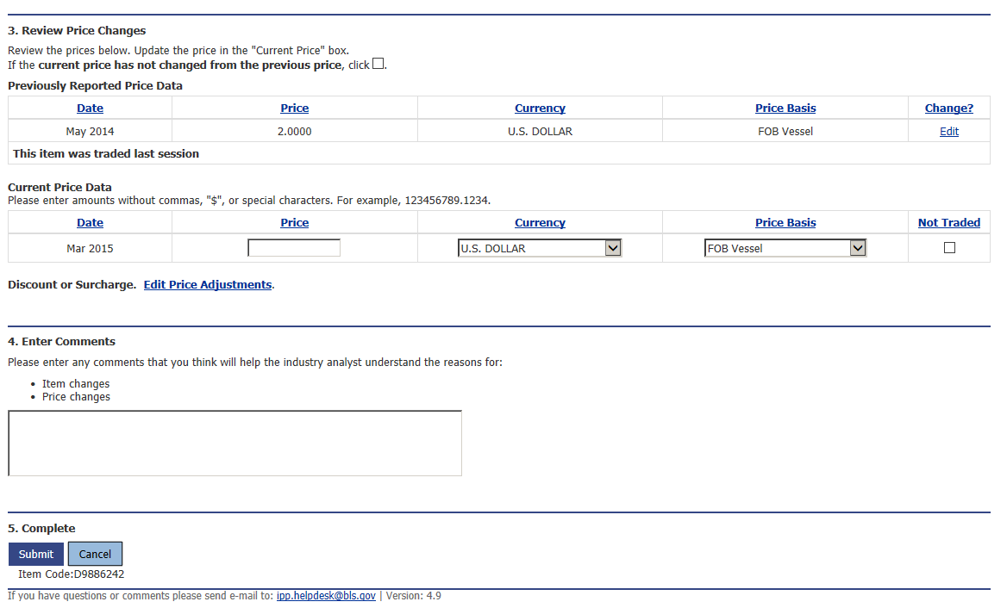
Edit Price Adjustments screen
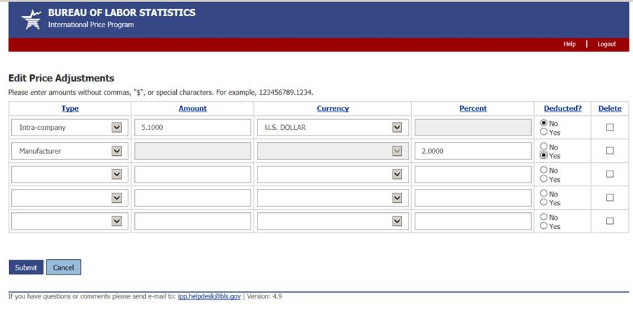
Review/Verify Large Price change screen
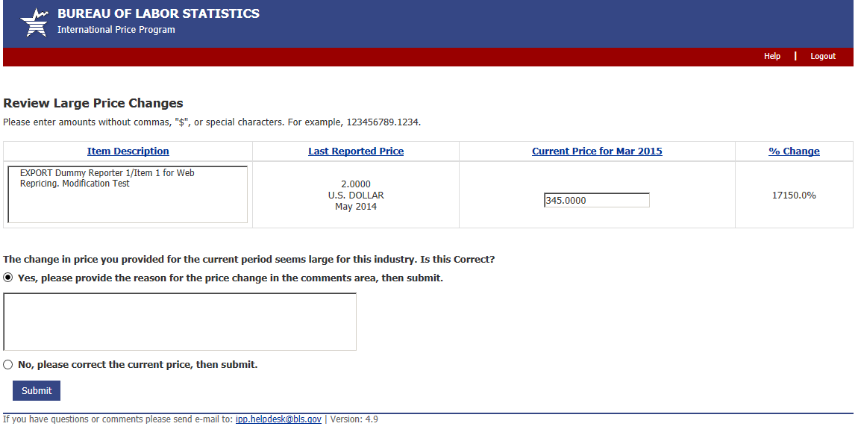

Review/Verify Cost of Modification screen
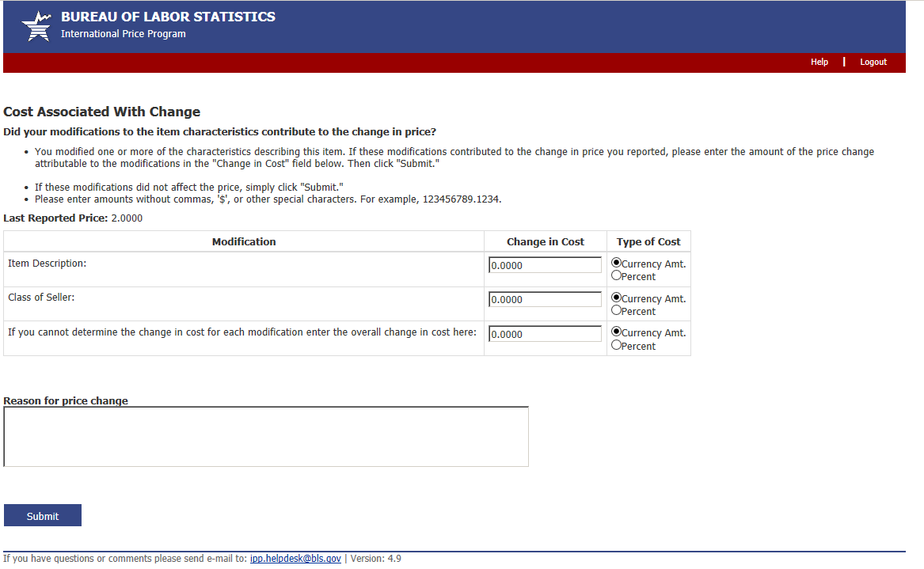

Update Last Reported Price screen
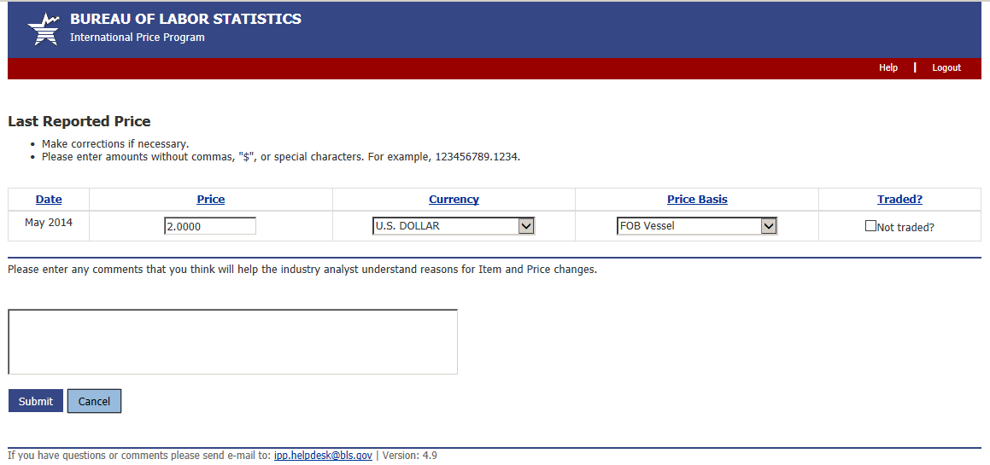

Discontinue/Replace Item screen
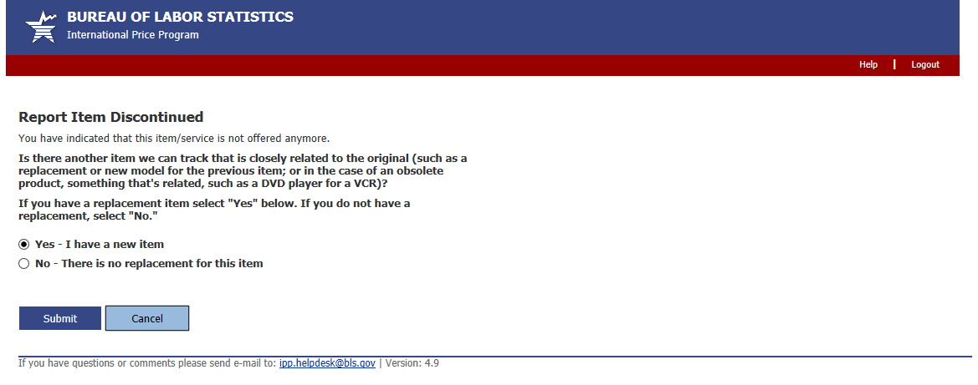

Replaced Item Screen
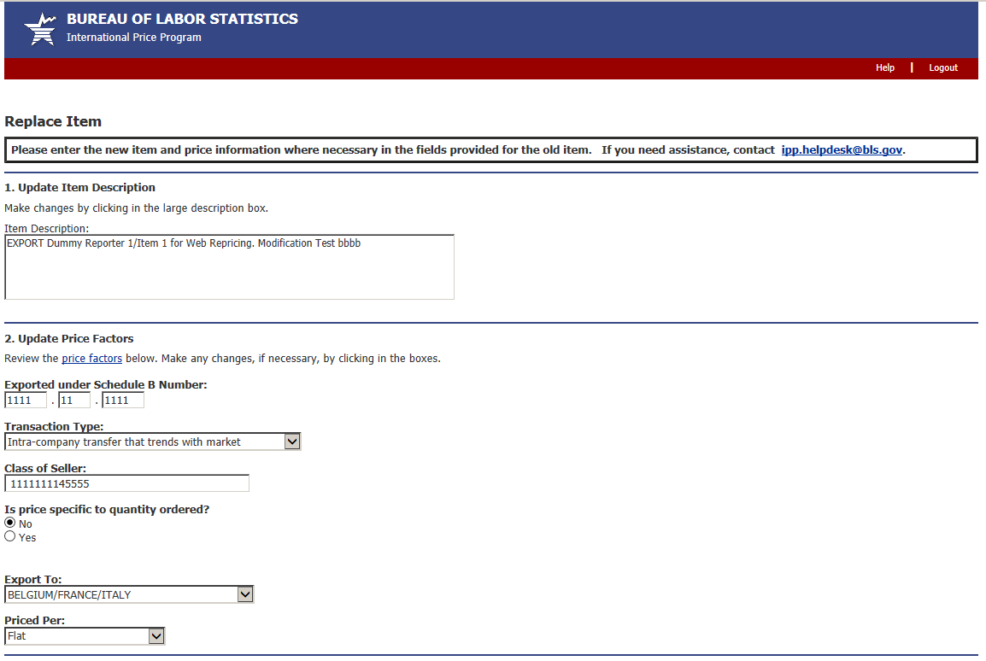
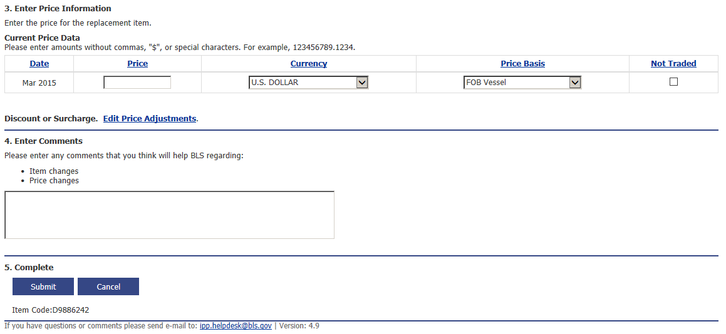

Undo Replacement screen
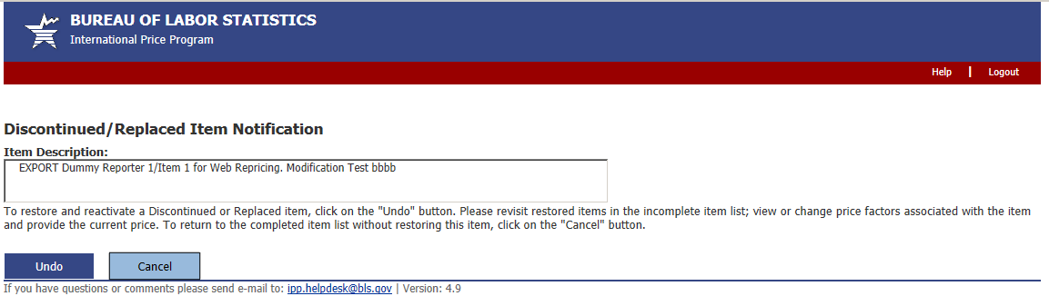

Thank You screen
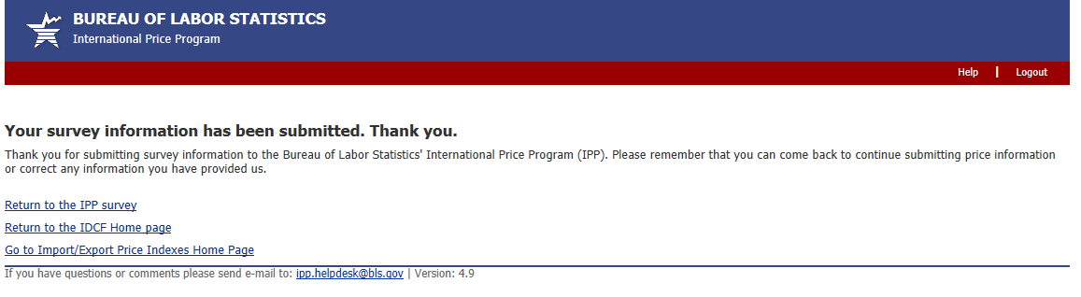

Server Maintenance message
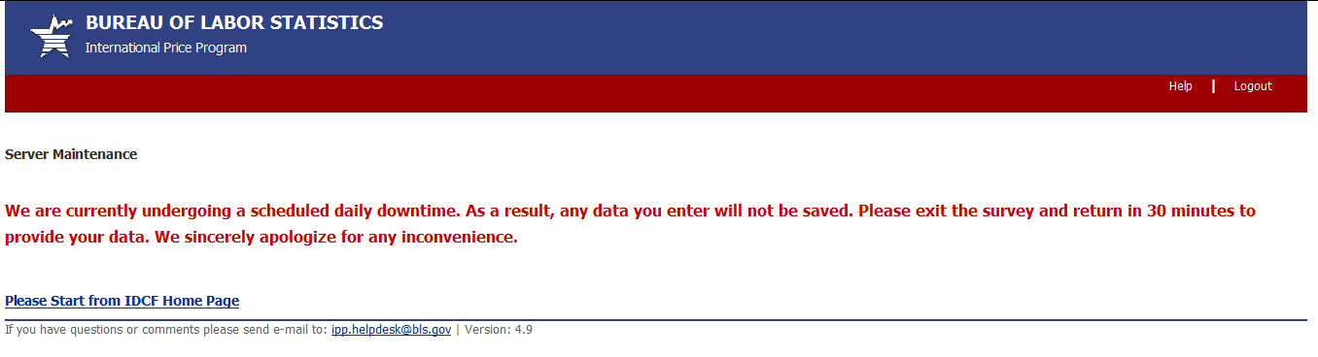

Downtime Message
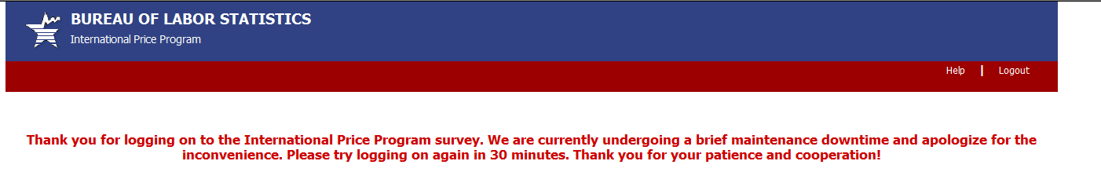
OMB No: 1220-0225
Expires: 10/31/2018

Privacy and Security Statement
