It’s Convenient. It’s Secure.

Respond Online to the Census of Agriculture

2015 Content Test

Responding to your survey online saves time and taxpayer dollars.
The online form:
- lets you skip questions that don’t apply to you
- calculates totals automatically
- eliminates the need for return postage and data entry
To complete your survey online, follow these steps:
- Go to www.agcounts.usda.gov
- Read the “Online Survey Response” message, then click “Complete Your Survey.”
- Enter your unique 17-digit Survey Code from the label on the first page of the paper copy
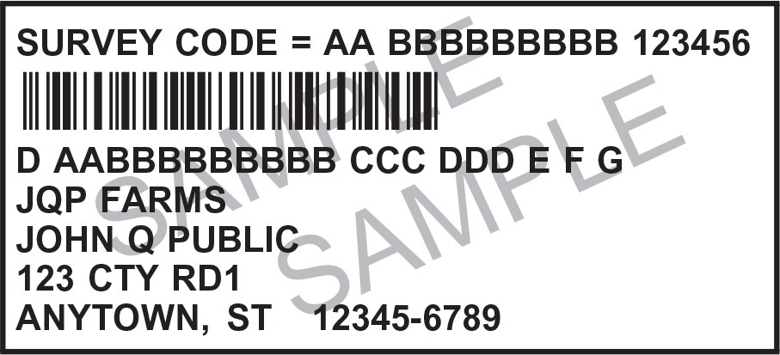
you received in the mail,
then click “Next Page.”
.
- Find the survey you are completing, then press “Click for Survey.”
- Verify and complete your contact information, then click “Continue with Survey.”
- Complete the survey questions.
If you need to stop, press the “Save and Return Later” tab at the top of the page. To return, go back to Step 1.
- When you finish the survey, click “Submit.”
You will receive a confirmation code and have the option to view, save or print your completed survey.

