[SAMPLE LETTER]

[DATE]

Dear Agricultural Producer,

Enclosed is your copy of the [SURVEY NAME]. Your response to the survey is important. For your convenience, we offer the following options to respond:

- Online at www.agcounts.usda.gov. This method is the easiest, fastest, most cost-effective, and most secure way to complete your survey. All you need is the identification number on the enclosed form to begin.
- By mail or fax. Complete the survey questionnaire and return it in the enclosed postage-paid envelope or fax it to [FAX NUMBER].

If we do not hear from you by [REPLY DATE], a representative may contact you to arrange a telephone or personal interview. Please be assured that your responses are completely confidential, as required by federal law. The National Agricultural Statistics Service (NASS) safeguards the privacy of all respondents, ensuring that no individual operation or producer can be identified.

Thank you in advance for your participation and for your support of US agriculture. If you have any questions or concerns, please call NASS customer service at (800)727-9540.

Sincerely,

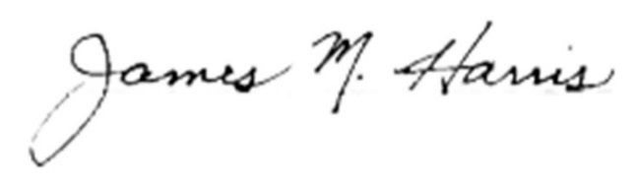
Mark Harris
Chair, Agricultural Statistics Board
U.S. Department of Agriculture
National Agricultural Statistics Service

Enclosures

