July 30, 2015

Dear Farmer or Rancher,

Enclosed is your copy of the 2015 County Agricultural Production Survey (CAPS). This is one of the largest annual survey programs conducted by USDA’s National Agricultural Statistics Service (NASS). I urge you to respond. The results may have a direct impact on you and other farmers and ranchers like you.

For example, USDA’s Risk Management Agency relies on the survey results to determine when to make crop loss insurance payments. In addition, USDA’s Farm Service Agency uses the data in its disaster assistance program calculations. With recent drought, flooding, and disease in areas across the country these data are critical to the agriculture industry.

For your convenience, you have the following options to respond:

- Online at www.agcounts.usda.gov beginning July 31, 2015. Responding online is the easiest, fastest, most cost-effective, and safest way to complete your survey. All you need is the identification number on the enclosed form to begin.
- By mail. Complete the survey questionnaire and mail it back in the return envelope.

If we do not hear from you by August 17, 2015 a NASS representative may contact you to help you complete your form. As required by Federal law, your responses are completely confidential. We safeguard the privacy of all respondents, ensuring that no individual operation or producer can be identified.

Federal county estimates for small grains are released in mid-February. Federal row crop estimates are published from early March through late June. Livestock county estimates are released from mid-May through August. State program county estimates are published by each state according to individual state release schedules. Estimated release dates are available here: http://www.nass.usda.gov/Data_and_Statistics/County_Data_Files/Release_Schedule/index.asp

Thank you for participating in the survey and for your support of our programs and U.S. agriculture.

Sincerely,

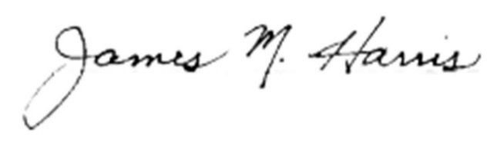
Mark Harris
Chair, Agricultural Statistics Board
U.S. Department of Agriculture
National Agricultural Statistics Service

Enclosures

