Project Code 122 QID 060041 DEALERS |  | OMB No. 0535-0002 Approval Expires 8/31/2015
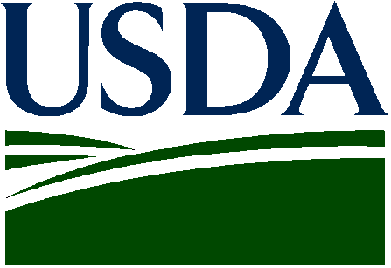 | NON-OIL SUNFLOWER  2015 Crop |  |  |  | 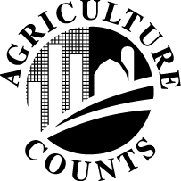 | NATIONAL  AGRICULTURAL STATISTICS  SERVICE
USDA/NASS
Northern Plains Region
Room 298, Federal Bldg
100 Centennial Mall North
Lincoln, NE 68508
Phone: 1-800-582-6443
Fax: 1-855-270-2720
E-mail: NASSRFONPR@nass.usda.gov

The information you provide will be used for statistical purposes only. In accordance with the Confidential Information Protection provisions of Title V, Subtitle A, Public Law 107–347 and other applicable Federal laws, your responses will be kept confidential and will not be disclosed in identifiable form to anyone other than employees or agents. By law, every employee and agent has taken an oath and is subject to a jail term, a fine, or both if he or she willfully discloses ANY identifiable information about you or your operation. Response is voluntary.

According to the Paperwork Reduction Act of 1995, an agency may not conduct or sponsor, and a person is not required to respond to, a collection of information unless it displays a valid OMB control number. The valid OMB control number is 0535-0002 The time required to complete this information collection is estimated to average 10 minutes per response, including the time for reviewing instructions, searching existing data sources, gathering and maintaining the data needed, and completing and reviewing the collection of information.

PLEASE REPORT FOR YOUR OPERATION
(Include acres contracted through agents)
STATE | ACRES CONTRACTED  AND TO BE CONTRACTED
North Dakota
Minnesota
South Dakota
Nebraska
Kansas
Colorado
Oklahoma
Texas
Other (___________________)

Please Return by March 10

Reported by ______________________________________________________ Date _______________________________________

