Project Code 123 QID 060041 DEALERS |  | OMB No. 0535-0002 Approval Expires 8/31/2015
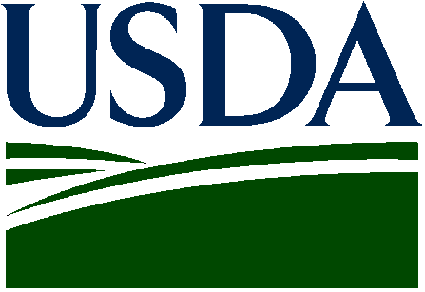 | NON-OIL SUNFLOWER  2015 Crop |  |  |  | 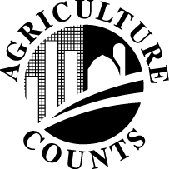 | NATIONAL  AGRICULTURAL STATISTICS  SERVICE
Please make corrections to name, address and Zip Code if necessary. |  |  |  | USDA/NASS  Northern Plains Region  Room 298, Federal Bldg  100 Centennial Mall North  Lincoln, NE 68508  Phone: 1-800-582-6443  Fax: 1-855-270-2720  E-mail: NASSRFONPR@nass.usda.gov

The information you provide will be used for statistical purposes only. In accordance with the Confidential Information Protection provisions of Title V, Subtitle A, Public Law 107–347 and other applicable Federal laws, your responses will be kept confidential and will not be disclosed in identifiable form to anyone other than employees or agents. By law, every employee and agent has taken an oath and is subject to a jail term, a fine, or both if he or she willfully discloses ANY identifiable information about you or your operation. Response is voluntary.

According to the Paperwork Reduction Act of 1995, an agency may not conduct or sponsor, and a person is not required to respond to, a collection of information unless it displays a valid OMB control number. The valid OMB control number is 0535-0002 The time required to complete this information collection is estimated to average 10 minutes per response, including the time for reviewing instructions, searching existing data sources, gathering and maintaining the data needed, and completing and reviewing the collection of information.

PLEASE REPORT FOR YOUR OPERATION
2015 CONTRACTED ACRES
(Include acres contracted through agents)
STATE | ACRES
North Dakota
Minnesota
South Dakota
Nebraska
Kansas
Colorado
Oklahoma
Texas
Other (___________________)

Please Return by June 8

Reported by ______________________________________________________ Date _______________________________________

