Colorado Fall Potato Varieties 2015
San Luis Valley
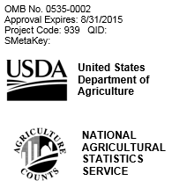

Colorado Field Office
P.O. Box 150969
Lakewood, CO 80215-9917
Phone 1-800-892-3202
Fax 303-236-2299
nass-co@nass.usda.gov

In cooperation with the Colorado Potato Administrative Committee and the San Luis Valley Research Center, USDA, NASS is conducting this survey to provide information on the varieties of potatoes planted in Colorado for the 2015 crop. The information you provide will be used for statistical purposes only. In accordance with the Confidential Information Protection provisions of Title V, Subtitle A, Public Law 107–347 and other applicable Federal laws, your responses will be kept confidential and will not be disclosed in identifiable form to anyone other than employees or agents. By law, every employee and agent has taken an oath and is subject to a jail term, a fine, or both if he or she willfully discloses ANY identifiable information about you or your operation. Response is voluntary.

According to the Paperwork Reduction Act of 1995, an agency may not conduct or sponsor, and a person is not required to respond to, a collection of information unless it displays a valid OMB control number. The valid OMB number is 0535-0213. The time required to complete this information collection is estimated to average 20 minutes per response, including the time for reviewing instructions, searching existing data sources, gathering and maintaining the data needed, and completing and reviewing the collection of information.

 | Acres
- Total Potato acres planted in 2015………………………………………………………… | 100
- Potato Varieties - 2015
Report the acreage of each potato variety planted in 2015.
The sum of the acres by variety should equal the total acres reported in 1.
Record Research Varieties and those not listed as Other in the appropriate varietal group.

Over, please
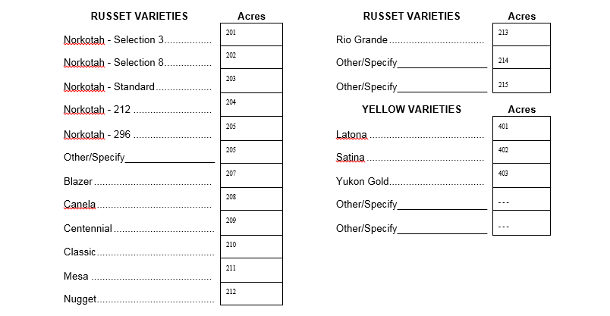 |  |  |  | Acres

Response |  |  |  | Respondent |  |  | Mode |  |  |  |  | Enum. | Eval.
1-Comp | 5- R-Est |  | 9901 | 1-Op/Mgr |  | 9902 | 1-Mail |  | 6-e-mail |  | 9903 | 098 | 100
2- R | 6-Inac-Est |  |  | 2-Sp |  |  | 2-Tel |  | 7-Fax
3- Inac | 7-Off Hold-Est |  |  | 3-Acct/bkpr |  |  | 3-Face to Face |  | 8-CAPI
4-Office Hold | 8-Known Zero |  |  | 4-Partner |  |  | 4-CATI |  | 19-Other
 |  |  |  | 9-Other |  |  | 5-Web
S/E Name

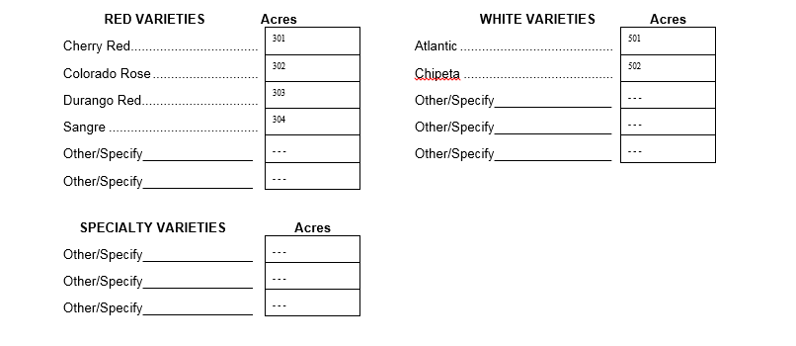
Survey Results: To receive the complete results of this survey in September, 2015, go to http://www.nass.usda.gov/co If you do not have Internet access and/or want a mailed copy please enter a “1” in the 099 box.
⁰⁹⁹
OFFICE USE ONLY
Response |  | Respondent |  | Mode |  | Enum. | Eval. | R. Unit | Change | Office Use for POID
1-Comp  2-R  3-Inac  4-Office Hold  5-R – Est  6-Inac – Est  7-Off Hold – Est | 9901 | 1-Op/Mgr  2-Sp  3-Acct/Bkpr  4-Partner  9-Oth | 9902 | 1-Mail  2-Tel  3-Face-to-Face  4-CATI  5-Web  6-e-mail  7-Fax  8-CAPI  19-Other | 9903 | 9998 | 9900 | 9921 | 9985 | 9989  __ __ __ - __ __ __ - __ __ __
 |  |  |  |  |  |  |  |  |  | Optional Use
 |  |  |  |  |  |  |  |  |  | 9907 | 9908 | 9906 | 9916

2

