Field Crops Production
(OMB # 0535-0002)

Calculations for:
Total responses,
Average response rates, and
Coverage of commodity rates.
October 15, 2015

To calculate the average response rate, OMB Guideline 3.2.2 is used (see below). However, if there is more than one wave of data collection, then the completed cases and in-scope sample cases are summed across the waves. This is shown in the ‘Average Response Rate’ column in the table.
$$RRU= \frac{\sum{C_{k}}}{\sum{\left(C_{k}+ R_{k}+ {NC}_{k}+O_{k}+ {e\left(U\right)}_{k}\right) }}$$
Where C_{k} = number of completed cases or sufficient partials in k^{th} data collection wave
R_{k} = number of refused cases in k^{th} data collection wave
NC_{k} = number of non-contacted sample units known to be eligible in k^{th} data collection wave
O_{k} = number of eligible sample units not responding for reasons other than refusal in k^{th} data collection wave
U_{k} = number of sample units of unknown eligibility, not completed in k^{th} data collection wave and
E_{k} = estimated proportion of sample units of unknown eligibility that are eligible in k^{th} data collection wave.

The ‘Total Responses’ column in table represents the numerator of the response rate above or the sum of completed cases or sufficient partials over all data collection waves.

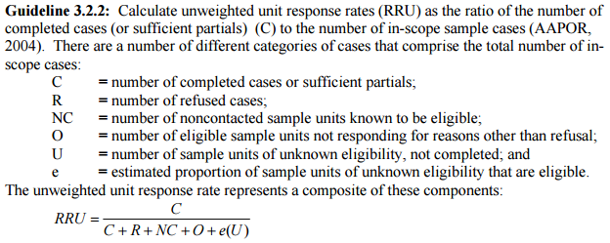

The ‘Coverage of Commodity Rate’ is a weighted item response rate as described in OMB Guideline 3.2.3 (see below). It can also be described as the proportion of a key survey estimate that was reported by respondents who completed the survey. The formula used to calculate the ‘Coverage of Commodity Rate’ in the table is:
$$RRW= \frac{\sum{w_{j}y_{j}}}{\sum{w_{j}}a_{j}y_{j}}$$
Where w_{j} = the inverse probability of selection (or initial sampling weight) for the j^{th} completed report
y_{i} = reported data for key survey item from j^{th} completed report
a_{i} = non-response adjustment for the j^{th} completed report

The units of survey estimate used to calculate the Coverage of Commodity Rate varies by survey. They are specified in the table below:
Survey | Units of Coverage Rate
Sweet Potato Price | Cwt
Sugarbeets | Tons
Sugar Production Survey | Tons
Tobacco Price Inquiry | Lbs.
All other surveys listed | Acres

