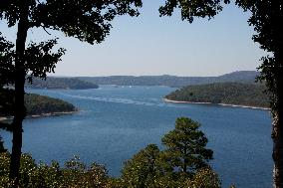
Beaver Lake, located in Northwest Arkansas, is the headwaters of the White River. The U.S. Army Corps of Engineers (Corps) is the steward of the lands and waters around Beaver Lake and is responsible for providing the public with quality outdoor recreation experiences.
As such, the Corps is currently examining future management of recreation and natural resources at Beaver Lake. You are invited to participate in a short survey to better understand your experiences and preferences regarding Beaver Lake!
The survey is brief and will take approximately 10 minutes to complete. You can complete the survey online by entering the following address into any web browser http://beaverlake.boater.sgizmo.com/s3/ or mail back the paper survey in the postage paid envelope provided. The response period will be open for 30 days, so we kindly ask that you complete the survey at your earliest convenience.
If you have questions regarding the survey, please contact the Beaver Lake Operations Project Manager for more information at (479) 636-1210 ext. 1701.

THANK YOU FOR HELPING WITH THIS IMPORTANT EFFORT TO UNDERSTAND PEOPLE’S EXPERIENCES AND PREFERENCES FOR BOATING AT BEAVER LAKE!

Please reference this map when answering Question 2a and Question 7

Beaver Lake Boater Survey

A. User Characteristics
1. Do you own a residence located within 1/4 mile of the Beaver Lake shoreline? (Circle one)
1. Yes (If Yes, please answer Question 1a)
2. No (If No, please continue to Question 2)

1a. Referencing the map included with this survey, please mark the lake zone number below indicating where along the shoreline this residence is located. (Circle one)

Zone 1 | Zone 2 | Zone 3 | Zone 4 | Zone 5

2. What are the City, State, and Zip Code of your permanent residence?
____________________________ _____ __________
City State Zip Code
3. Do you engage in any boating activities on Beaver Lake? (Circle one)
1. Yes
2. No
If No, please skip to Section C, Questions 19-22 and then return this survey in the envelope provided. Characterizing those who are not boating on Beaver Lake is very important to the overall results of the study, so please respond even if you do not boat on Beaver Lake.

4. How often do you engage in boating activities on Beaver Lake? (Mark one)
( ) Less than once per year
( ) 1-5 times per year
( ) 6-10 times per year
( ) 11-15 times per year
( ) 16-20 times per year
( ) 21 times or more per year

Please continue to the next page
5. How many years have you been boating? (Round up) _____ Years

6. How many years have you been boating at Beaver Lake? (Round up) _____ Years

7. During a typical boating trip on Beaver Lake, please indicate the primary area where you do most of your recreation activities. Use the map included with this survey as a reference. (Circle only one)
Zone 1 | Zone 2 | Zone 3 | Zone 4 | Zone 5

8. Please provide the type and size of the primary boat that you use at Beaver Lake and whether this boat was trailered to the lake or launched from the lake.
Boat Type  (Mark one) | Boat Size  (Mark one) | Was this boat transported (e.g., trailered or car/truck roof) to the lake, kept at a marina on the lake, or rented/borrowed? (Mark one)
- I don't know  - Runabout/Speedboat  - Ski or Wake Boat  - Fishing boat/bass boat  - Pontoon boat  - House boat  - Cabin cruiser  - Sailboat/Sailboard  - Personal Watercraft (e.g. Jet Ski)  - Rowboat/Kayak/Canoe  - Other ___________________ | - less than 16'  - 16 - 20'  - 21 - 28'  - 29'+ | - Trailered/transported to the lake  - Kept at a marina on the lake  - Kept at my private or community  boat dock  - Kept at the resort I stayed at  - Rented  - Borrowed  - Other _____________________  ______________________

Please continue to the next page

9. In general, what percent of your time do you spend on the following activities while recreating on Beaver Lake? (Consider time spent getting to or moving between fishing locations as "Fishing")
Fishing _______ %
Cruising _______ %
Swimming _______ %
Water Skiing _______ %
Relaxing/Sunning _______ %
in boat (stationary)
Other activities _______ % ...please describe_______________________
(BE SURE THE TOTAL = 100%)

B. Management Questions
10. Is there a problem from too many boats on Beaver Lake? (Circle one)
1. Yes, there is a problem
2. No, there is not a problem
If Yes, please indicate how serious of a problem there is from too many boats on Beaver Lake. (Circle one)
Minor Problem | Moderate Problem | Serious Problem

11. How safe are boating conditions on Beaver Lake? (Circle one)
Not at All Safe | Slightly  Safe | Somewhat  Safe | Very  Safe | Extremely Safe

Please describe any safety concerns you have: __________________________________________________ _________________________________________________________________________________________________________
12. How serious of a safety problem is the number of boats on Beaver Lake? (Circle one)
Not At All Serious | Slightly Serious | Moderately Serious | Very Serious | Extremely Serious
Please continue to the next page
13. How much do private docks interfere with your use of Beaver Lake? (Circle one)
Do Not Interfere at All | Slightly Interfere | Somewhat Interfere | Seriously Interfere | Tremendously Interfere

14. How much, if at all, has the noise from other boats reduced your enjoyment of Beaver Lake? (Circle one)
Not at All | Slightly | Somewhat | Quite a Bit | Extremely

15. How likely is it that the presence of too many boats would cause you to avoid your favorite parts of Beaver Lake? (Circle one)
Not at All Likely | Slightly Likely | Somewhat Likely | Quite  Likely | Extremely Likely

16. Which of these statements best describes your expectation for the number of boats on Beaver Lake? Please refer to your last outing on the lake when answering this question.
(Mark one)
( ) I saw ABOUT AS MANY boats as I expected to see that day
( ) I saw MORE boats than I expected to see that day
( ) I saw FEWER boats than I expected to see that day
16b. Please indicate the date of your last outing:
______________(month) ______________(day) _____________(year)
17. Which of these statements best describes your preference for the number of boats on the lake? Please refer to your last outing on the lake when answering this question. (Mark one)
( ) I saw ABOUT AS MANY boats as I wanted to see that day
( ) I saw MORE boats than I wanted to see that day
( ) I saw FEWER boats than I wanted to see that day

Please continue to the next page
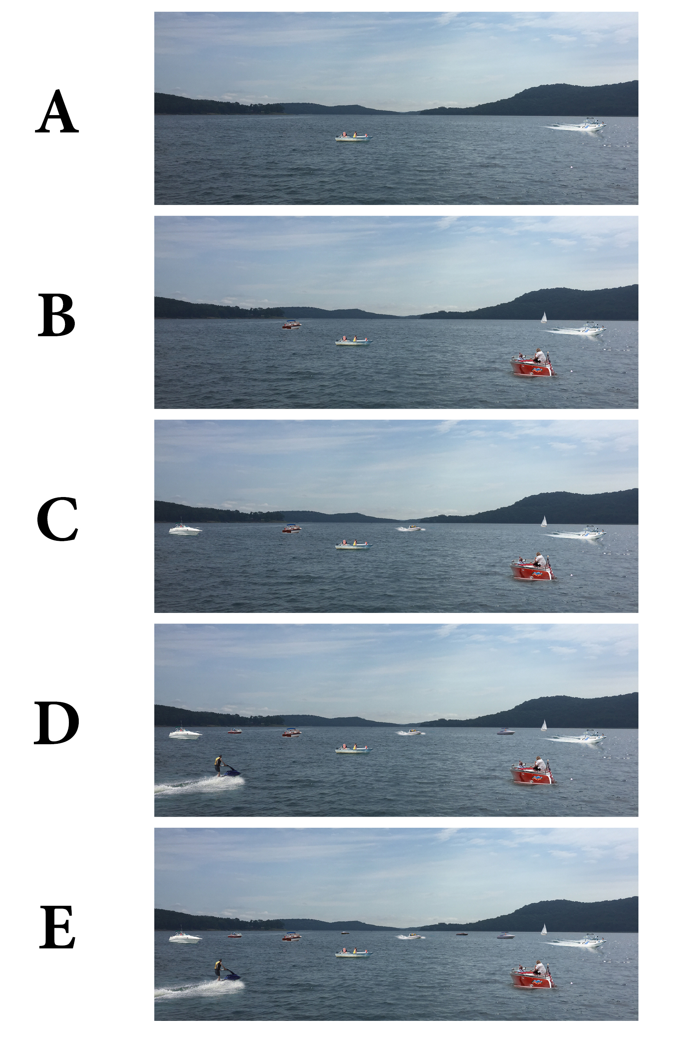
18. Please review the boating conditions depicted in the photos below. Which photo shows the maximum number of boaters you could see at one time on Beaver Lake without thinking it was too crowded? (Circle one)
A | B | C | D | E | I don’t think it looks crowded in any of the photos
Please continue to the next page

C. Basic Demographics
19. What is your gender? (Mark one) ( ) Female ( ) Male

20. What is your age? (Mark one)
( ) Under 18
( ) 18 – 24
( ) 25 – 44
( ) 45 – 54
( ) 55 – 64
( ) 65+

21. Please indicate the highest level of education you have completed? (Mark one)
( ) Less than high school
( ) High school graduate/GED
( ) Vocational or Technical School certificate
( ) Associates Degree
( ) Some college
( ) Bachelor’s degree
( ) Graduate degree or professional degree (MA, MS, PhD, JD, MBA etc.)

22. Which category best represents your annual household income (before taxes) last year? (Mark one)
( ) Less than $24,999 | ( ) $100,000-$149,999
( ) $25,000-$34,999 | ( ) $150,000-$199, 999
( ) $35,000-$49,999 | ( ) $200,000 or more
( ) $50,000-$74,999 | ( ) Do not wish to answer
( ) $75,000-$99,999
Thank you for taking the time to complete this survey.
Your responses are important and will help inform the
future management of Beaver Lake.

Please return your completed survey in the
postage paid envelope provided.

