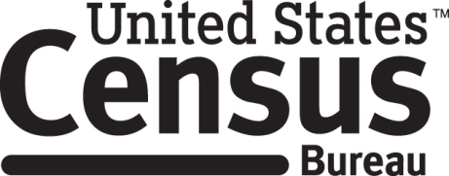

Consent Form

2015 Census Test Focus Groups

Every ten years the Census Bureau conducts a census of the United States population. In preparation for this task, the Census Bureau conducts smaller tests in limited geographic areas in order to improve how data is collected. The 2015 Census Test Focus Group is part of the effort to improve the 2020 Census.

______________________ [NAME] consents to take part in a focus group to improve the Census in 2020. In order to have a complete record of all comments, the interview session will be audio and video recorded. The Census Bureau plans to use the tapes to improve the next Census. Staff directly involved in the questionnaire design research project will have access to the recordings. Participation is voluntary and answers will remain strictly confidential.

This study is being conducted under the authority of Title 13 USC. The OMB control number for this study is 0607-0981 and it expires on 3/31/2016. This valid approval number legally certifies this information collection.

I have agreed to participate in this Census Bureau focus group, and I give permission for my tapes to be used for the purposes stated above.

____________________________ ___________________________
Participant's Signature Researcher's Signature

____________________________ __________________________
Printed Name Printed Name

___________________________ _______________________
Date Date

