**Whale Watching Operator Survey**

**Channel Islands Region, California**

**This is a voluntary survey.**

The public reporting burden for this collection of information is estimated to average 2.5 hours including the time for reviewing instructions, searching for existing data sources, gathering and maintaining the data needed, and completing and reviewing the collection of information. Send comments regarding this burden estimate or any other suggestions for reducing this burden to: Dr. Theresa L. Goedeke, NOAA National Ocean Service, National Centers for Coastal Ocean Science, 1305 East-West Highway, Silver Spring, MD 20910. Responses provided for this survey will be anonymous. No personally identifiable information is being collected with this survey; responses will not be attributed to individual businesses. Notwithstanding any other provisions of the law, no person is required to respond to, nor shall any person be subjected to a penalty for failure to comply, with a collection of information subject to the requirements of the Paperwork Reduction Act unless that collection of information displays a currently valid OMB Control Number.

**GENERAL INFORMATION**

Respondent ID Number_______

(assigned by interviewer)

1. Which of the following includes your age?

18-30        31-40        41-50        51-60        over 60

2. Are you Hispanic or Latino? ___YES ___NO

3. What is your race? (Mark one or more)

__ White     __ Black or African American     __ American Indian or Alaska Native

__ Asian     __ Native Hawaiian or Other Pacific Islander

__ Other

4. How many family members do you support (including yourself)?

Myself only     2     3    4     5     6     7    Greater than 7

5. What is your primary port/marina? ___________________________________________

6. Do you have a secondary port/marina from where you operate part of the year?

YES ___ NO ___

6a. If YES, which one? __________________________________________________

7. How many years have you been a whale watching vessel operator? ___ (number of years)

8. How many years have you been a whale watching vessel operator in the Santa Barbara Channel? ___ (number of years)

9. Do you visit marine reserves/conservation areas specifically during your tours?

(Interviewer—Please show map to identify specific quadrants)

YES ____ NO ____

9a. Why? ___________________________________________________________________

9b. How often? _______________________________________________________________

9c. If YES, how many years have you taken whale watchers to the Channel Islands

National Marine Sanctuary? ___ (number of years)

10. Do you currently have a naturalist on board during whale watching trips?

YES____ NO_____

10a. If NO, would you be interested in having one on board if you had more information about the role they play with whale watching operators? YES____ NO_____

11. Do you use Spotter Pro to record your whale watching expeditions and whale sightings?

YES____ NO_____

12. Are customers targeting particular whale species when they go on a whale watching trip?

YES____ NO_____

12a. If YES, please list:__________________________________________________

13. Are you aware that whales in the region are at risk of being struck by vessels and that encounters with vessels 65 feet or greater in length can lead to the serious injury or death of the animal?

YES_____NO____

13a. If YES, on a scale of 1 to 5, with 1 being not concerned and 5 being extremely concerned, how concerned are you that whale strikes are currently having a negative impact on your business?

1 – not at all concerned

2 – Slightly concerned

3 – Somewhat concerned

4 – Moderately concerned

5 – Extremely concerned

No opinion

14. In your opinion, on a scale of 1 to 5, how has the quality of whale watching changed in the last 10 years?

1- much worse

2- somewhat worse

3-no change

4-somewhat better

5-much better

No opinion

14a. If you believe that the quality of whale watching has changed, could you tell me why you think this is true (e.g. change in the abundance of whales, overcrowding from other operators, new regulations, etc.).

**________________________________________________________________________**

**________________________________________________________________________**

**________________________________________________________________________**

**ECONOMIC INFORMATION**

15. What approximate percentage of the TOTAL business income is derived from whale watching operations? ____%

16. What approximate percentage of your TOTAL household income is derived from whale watching operations? ____%

17. How would you describe the whale watching operation? (Mark one or more)

___ Full-time whale watching operation

___ Part-time whale watching operation

___ Seasonal whale watching operation. If seasonal, which months?_______________________

__ Full-time Combination whale watching, recreational cruises, kayaking, diving/snorkeling, and wildlife observation operation

__ Part-time Combination whale watching, recreational cruises, kayaking, diving/snorkeling, and wildlife observation

__ Seasonal Combination whale watching, recreational cruises, kayaking, diving/snorkeling, and wildlife observation.

17a. If seasonal, which months?______________________________________

18. Number of boats/vessels at the operation: ____ (number of vessels)

19. Number of whale watchingparticipants per vessel in operation (capacity):

Vessel 1: ____watchers     Vessel 2: ____watchers

Vessel 3: ____watchers      Vessel 4: ____watchers

20. Number of participants per vessel in recreational cruise operation (capacity):

Vessel 1: ____ participants    Vessel 2: ____participants

Vessel 3: ____ participants      Vessel 4: ____participants

21. Number of kayakers per vessel in operation (capacity):

Vessel 1: ____kayakers     Vessel 2: ____kayakers

Vessel 3: ____kayakers     Vessel 4: ____kayakers

22. Number of divers/snorkelers per vessel in operation (capacity):

Vessel 1: ____divers/snorkelers     Vessel 2: ____divers/snorkelers

Vessel 3: ____divers/snorkelers     Vessel 4: ____divers/snorkelers

23. Number of wildlife observers per vessel in operation (capacity):

Vessel 1: ____wildlife observers     Vessel 2: ____wildlife observers

Vessel 3: ____wildlife observers     Vessel 4: ____wildlife observers

24. Number of employees at the operation:

a. Full time ____ b. Part time ____ c. Seasonal _____

25. Number of vessel trips per day:

Whale watching ___________

Recreational cruise ___________

Fishing ___________

Kayaking ___________

Diving/snorkeling ___________

Wildlife cruises ___________

26. Please provide your best estimate for annual operating expenses (i.e.  docking fees, permits/licenses, maintenance and repair, and office expenses) last year.

$ ______________

27. Please provide your best estimate for trip related expenses (i.e. food/supplies, bait, captain and crew wages, equipment costs) last year.

$ ______________

28. Please provide your best estimate of total business revenues last year:

$ ______________

29. Please provide your best estimate of total revenues and/or percent of total revenues

last year by each geographic area: (See map for definitions of each area)

Channel Islands National Marine Sanctuary $ ______________ % _____

Outside Channel Islands National Marine Sanctuary $ ______________ % _____

30. What is the minimum number of whales that need to be seen in order to make the trip worthwhile financially? ______________

31. If you do not see any whales on the trip, do you reimburse customers? ___YES  ___NO

31a. If YES, how do you reimburse customers? ______________________

32. Use by activity and month

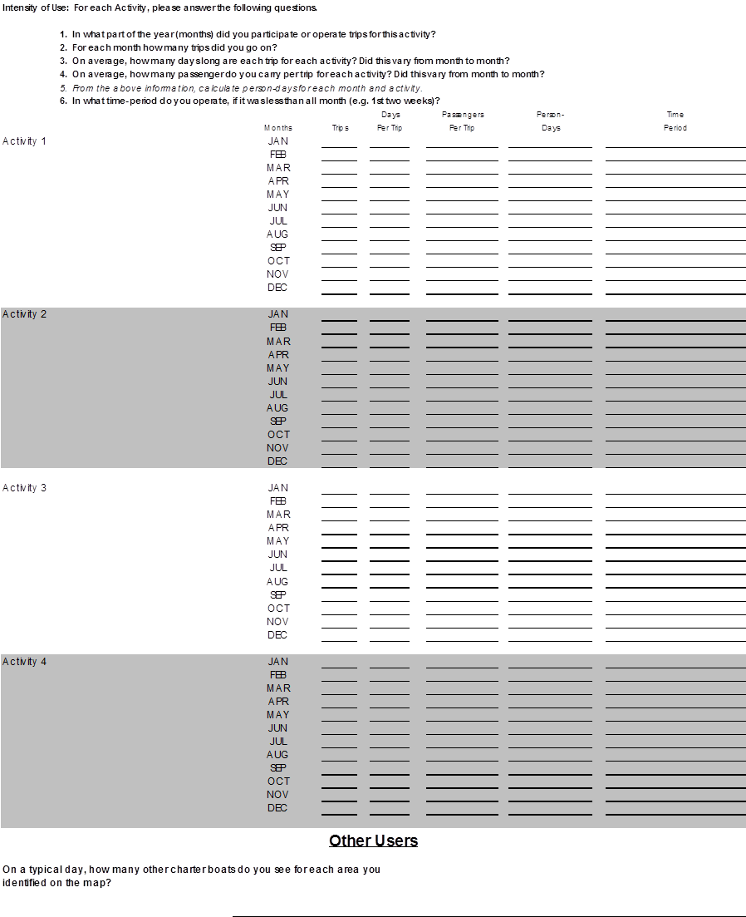

33. Mapping Exercise: Map the Distribution of Each Activity

Respondents should be advised to provide information on their anticipated spatial use of the region. This anticipated spatial use may be the same as their current use or it may be different. Give respondents 100 penny budget meaning one penny equals one percent of passenger activity. Have respondent allocate their budget across all map cells. Record codes on the coding sheet.

Map cells should be referenced by column and row: For example, C1R1 1% means 1% of activity is in cell Column 1 Row 1. Percent of each activity must add up to 100.

34. Does this map reflect where you presently operate? Y/N

If no is selected, please explain why future operations may be different than where you have historically operated.