OMB Control No. 0648-0456
Expiration Date: XX/XX/XXXX
SHORT-TAILED ALBATROSS RECOVERY DATA FORM
I. CAPTURE INFORMATION
Date: |  | Time: |  |  |  | GPS Location:  Lat.: Long.:
Vessel Name:  Official Number: |  | Left Leg Band:  Color:  Number: |  |  |  | Right Leg Band:  Color:  Number: |  |  | Photograph (circle one):  Yes No
Bird alive at capture? (circle one) Yes No (If “No”, do not fill out Sections II through V. Instead, please refer to the dead short-tailed albatross instructions on the “Short-tailed Albatross Handling Guidelines” placard.)
Bird captured during (circle one):  Haul Soak Unknown |  |  |  |  | Hook Type (circle one): Circle J-hook Tuna  Hook Size (if known):
II. ASSESS BIRD’S CONDITION
Answer the following questions by marking an “x” in the Yes or No column. If all questions are answered “Yes,” the bird may be released following the release guidelines on the “Short-tailed Albatross Handling Guidelines” placard. Please indicate location of injury on bird diagram (Page 3).
Observation Checklist |  |  | Yes | No |  |  | Comments
1. Can the bird stand and hold head upright?
2. Is the bird alert, responsive, aware of surroundings?
3. Are the eyes open?
4. Does the bird breathe with its bill closed?
5. Does the bird breathe quietly, without noises?
6. Is the bird holding its wings in a normal position up and against the body, without drooping?
7. Can the bird flap its wings?

8. Is the bird free from visible damage? (If “No,” note the wounds on bird diagram.)
9. Is the bird free from hooks or entangled fishing line? If the hook has been swallowed, please note in comments. (If “No,” note location of fishing gear on bird diagram)?
III. TREATMENT
Name of veterinarian contacted: |  |  |  |  |  |  |  | Date: |  | Time:
Date/Time: | Treatment Administered:
IV. RECOVERY
Observation Period (Check bird at 30 minutes, 1 hour, and every few hours. Use more sheets if necessary)
Date/Time: | Bird Behavior/Condition:
V. RELEASE (Note: Follow release criteria and guidelines in the “Handling and Release Guidelines for Short-tailed Albatross” placard.)
Release Date: |  |  |  |  | Release Time:
Release Location (Lat. / Long.):
Bird Behavior After Release:

Short-tailed Albatross Figures for Noting Wounds, Hooks, and Lines

(Circle or draw where injury or fishing gear is located on bird. If the hook has been swallowed, please note this in Section II, Item 9)

Drawings by Ronald L. Walker
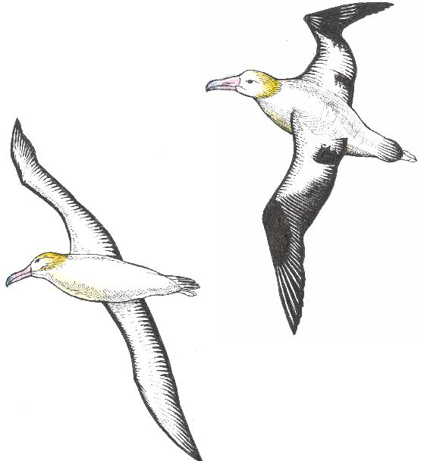

Bottom Top

Left Right

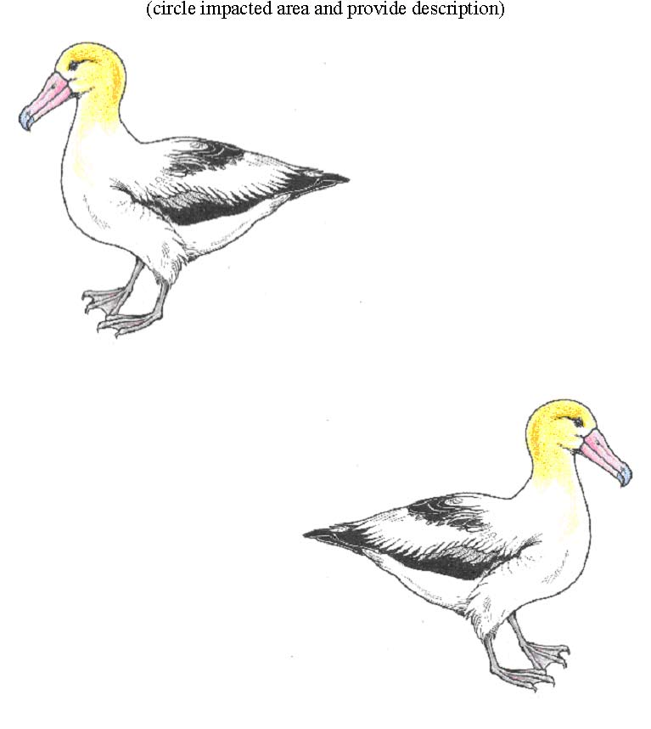

OMB Control Num. 0648-0456
Expiration Date: 07/31/2015

Paperwork Reduction Act Information

Public Reporting burden for this collection is estimated to average 60 minutes per response, including the time for reviewing instructions, searching existing data sources, gathering and maintaining the data needed, and completing and reviewing the collection of information. Send comments regarding this burden estimate or any other aspect of this collection of information, including suggestions for reducing this burden, to Regional Administrator, Pacific Islands Regional Office, NOAA Inouye Regional Center (IRC), NMFS/PIRO, 1845 Wasp Blvd., Building 176, Honolulu, HI 96818.

This information is being collected to provide the information needed to maximize the probability of long-term survival of an injured short-tailed albatross that is incidentally hooked or entangled by longline gear during fishing operations conducted by a Hawaii-based longline fishing vessel.

Responses to the collection are required by the January 6, 2012, biological opinion issued by the U.S. Fish and Wildlife Service under the authority of the Endangered Species Act and regulations implementing the Fishery Ecosystem Plan for Pacific Pelagic Fisheries of the Western Pacific Region (ref. 50 CFR 665.815. Data provided concerning the vessel operators are handled as confidential under the Magnuson-Stevens Fishery Conservation and Management Act (sec.402(b)). Notwithstanding any other provisions of the law, no person is required to respond to, nor shall any person be subject to a penalty for failure to comply with, a collection of information subject to the requirements of the Paperwork Reduction Act, unless that collection of information displays a currently valid OMB Control Number.

