OMB Control Number: 0651-0080
Expiration Date: 8/31/2018
Welcome to the [xxxxxxxxxxxxx] Feedback Survey. This brief survey is designed to gather feedback to enable us to design and present future programs that best meet your needs.

OMB No: xxxx-xxxx Expires: m/dd/yyyy

Under the Paperwork Reduction Act of 1995, no persons are required to respond to a collection of information unless it displays a valid OMB Control Number. The data collected from this survey will be used for planning efforts to ensure that future outreach efforts are productive and positive experiences. The responses will be aggregated. This collection of information is voluntary in accordance with
E.O. 12862, “Setting Customer Service Standards.” All responses will remain confidential and are protected under the “Confidential Information Protection and Statistical Efficiency Act of 2002.” The USPTO estimates that it takes approximately 5 minutes (0.08 hours) to complete this survey.

Were you able to attend the [workshop; seminar; conference; program; event] on [date]?

Yes No

Overall, how would you rate the (workshop, seminar, conference, program, or event)?

Excellent
Good
Fair
Poor
Very Poor

How likely would you be to recommend the (workshop, seminar, conference, program, or event) to a colleague?
Definitely Would Probably Would May or May Not Probably Would Not Definitely Would Not

Did you get the information you needed at the (workshop, seminar, conference, program, or event)?

All of the information Some of the information None of the information

How satisfied were you with the following aspects of the (workshop, seminar, conference, program, or event)?
Very Satisfied Satisfied Neutral Dissatisfied Very Dissatisfied N/A

Length: appropriate for topic(s) presented
Content: relevant and current

Content: appropriate for experience levels of participants
Materials provided can be used as reference material

Materials provided are clear and easily understood

Facilities
Presenter(s): knowledge of subject matter

Presenter(s) presentation skills

How did you hear about the (workshop, seminar, conference, program, or event)? Check all that apply.

USPTO.gov website

Social media (e.g. Facebook, Twitter)
Host other than USPTO
Email announcement
Colleague / Friend

Attendance at a previous event Other (please specify)

Have you used (are you familiar with) any of the following resources offered by the USPTO?

Yes No

USPTO.gov website
USPTO Contact Center

Trademark Assistance Center
Inventors Assistance Center

Ombudsman Program
Pro Se Assistance Program

Other (please specify)

My knowledge of this topic area prior to the (workshop, seminar, conference, program, or event) was:

Novice

Basic knowledge of content

Competent to explain content to others Expert in the field

After this (workshop, seminar, conference, program, or event) my knowledge of this topic area can best be described as:
Novice

Basic knowledge of content

Competent to explain content to others Expert in the field

I would attend a future (workshop, seminar, conference, program, or event) offered by the USPTO.

Strongly Agree
Agree
Neutral
Disagree
Strongly Disagree

I gained new information about the topic area covered in this (workshop, seminar, conference, program, or event).
Strongly Agree Agree
Neutral
Disagree
Strongly Disagree

Please indicate to what extent the information you received will aid you in your work or field of study.

Great extent Moderate extent
Limited extent
Not at all

Is there anything else you’d like to share about the (workshop, seminar, conference, program, or event)?

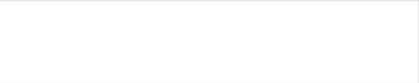

- You indicated that you were unable to attend the (workshop, seminar, conference, program, or event). Which of the following best describes the reason for not attending?
Schedule conflict

Obtained the information elsewhere

Time of the workshop was not convenient Location of the workshop was not convenient Other (please specify)

What other kinds of events surrounding intellectual property and U. S. Department of Commerce resources would be of interest to you?
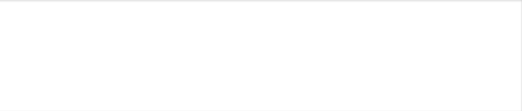

Thank you for participating in the survey. Click the "Done" button below to submit your responses.
The United States Patent and Trademark Office (USPTO) is conducting this survey to gather feedback on IP Education Outreach Council events. This survey is strictly voluntary, includes 15 questions and should take approximately 10 minutes to complete. This information collection contains requirements subject to the Paperwork Reduction Act (PRA). Notwithstanding any other provisions of the law, no person is required to respond to, nor shall any person be subject to penalty for failure to comply with, a collection of information subject to the requirements of the PRA, unless that collection of information displays a currently valid OMB control number.

